08 lecture

Worksheet 1

Index | 0 | 1 | 2 | 3 | 4 | 5
Letter | b | a | n | a | n | a
- What is a String and what are indices?

- A String is made up of individual characters.
- Strings are immutable, meaning once a String is created, it cannot be changed.
- An index refers to the position of a character in a String.
- Indices in Java start at 0, not 1.

- What is a char and how is it different from a String? How do you declare a char?

- A char in Java is a primitive data type used to store a single character.
- Uses single quotation marks ' '
- Char data type is mutable
- Strings are objects, Strings use double quotes.
- char firstInitial = 'A';
- char number = '7';
- char punctuation = '!';

- What is Unicode and how does it relate to char in Java?

Unicode is a universal character encoding standard that assigns a unique number (code point) to characters from nearly every written language, as well as symbols and emojis.

- A char stores a Unicode character
- Java uses the UTF-16 encoding
- Each char stores a Unicode value
- Unicode ensures Java programs work correctly with international text.

- Please refer to the truncated char to unicode table below, and evaluate the following:

char | Unicode (integer mapping)
. | 46
/ | 47
0 | 48
1 | 49
… | …
9 | 57
… | …
A | 65
B | 66
… | …
Z | 90
… | …
a | 97
b | 98
… | …
z | 122

- System.out.print((char) 65);
A

- System.out.println((int) ‘e’);
101

- What does this print out?
char letter = ‘B’;
if (letter == ‘A’) {
System.out.println("It's A!");
}

Nothing
- What is the result of (char) (‘a’ + 2) ?
c

- What does this print out?
char letter = ‘?’;
if ((letter > ‘A’ && letter < ‘Z’) || (letter > ‘a’ && letter < ‘z’) {
System.out.println("It’s in the English alphabet!");
} else {
System.out.println(“It’s non-alphabet or from another writing system.”)
}

It’s non-alphabet or from another writing system.

- Please view the diagram below and review this information with your fellow group members.

Primitive type variables (int, double, char, boolean) hold data in the variable box. Object type variables (String, Scanner, Random) hold memory addresses in the variable box… that point/reference to the actual data… because they are TOO BIG!
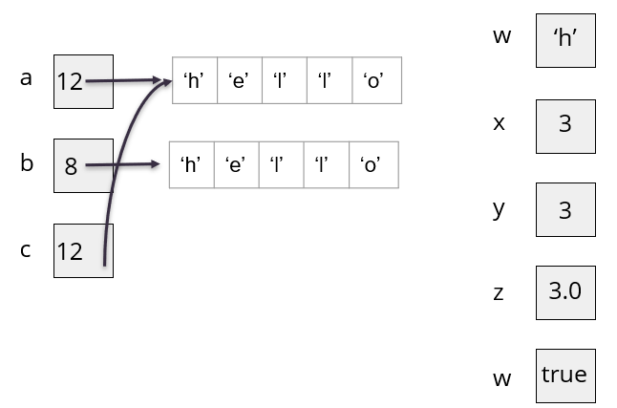
// Objects
String a = “hello”;
String b = “hello”;
String c = a;
// Primitives
char w = ‘h’;
int x = 3;
int y = 3;
double z = x;
boolean v = true;

- When working with objects, the problem with the == operator, is that it checks whether the two operands refer to the same object in memory. This is because == checks for the value held inside the variable’s memory box… whether that is a primitive data or an object’s address.

Evaluate the following:
- a == b
false

- a == c
true

- x == y
true

- y == z
false

- y == (int) z
true

- a.equals(b)
true

- a.equals(c)
true

- Let’s say I reassign the c variable.
c = b
a == c // false
a.equals(c) // true

- When you have an object, you can call special methods that are made for the object on it for functionality (actions). Primitives can’t have methods. Please evaluate the following:
- “hello”.equalsIgnoreCase(“hello”);

true

- “hello”.equalsIgnoreCase(“Hello”);

true

- “hello”.equalsIgnoreCase(“jello”);

false

- String fruit = "banana";
char letter = fruit.charAt(0); // ‘b’

- int length = fruit.length(); // 6

- What is wrong with the following code? Explain and then fix it.
String fruit = “banana”;S
int length = fruit.length();
char last = fruit.charAt(length);

- fruit.length() returns the number of characters, not the last index.
- String indices start at 0.
- For "banana":
- Length = 6
- Last index = 5

char last = fruit.charAt(length - 1);

- Write a code snippet that reads in a char from user input and evaluates to see if it’s not in the English alphabet. Try using .toLowerCase().
Scanner scanner = new Scanner(System.in);
System.out.print("Enter a character: ");
String input = scanner.next();

// convert to lowercase
input = input.toLowerCase();

char c = input.charAt(0); // pull first character out
if (c < 'a' || c > 'z') {
System.out.println("The character is NOT in the English alphabet.");
} else {
System.out.println("The character IS in the English alphabet.");
}
- Write a code snippet that reads in a char from user input and evaluates to see if it’s a number.

Scanner scanner = new Scanner(System.in);
System.out.print("Enter a character: ");
// convert to lowercase
input = input.toLowerCase();

char c = input.charAt(0); // pull first character out

if (c >= '0' && c <= '9') {
System.out.println("The character is a number.");
} else {
System.out.println("The character is NOT a number.");
}

- Write a code snippet that reads in a char from user input and evaluates whether it’s ‘y’ or ‘n’

Scanner scanner = new Scanner(System.in);
System.out.print("Enter y or n: ");
// convert to lowercase
input = input.toLowerCase();

char c = input.charAt(0); // pull first character out

if (input == 'y' || input == 'n') {
System.out.println("Valid input.");
} else {
System.out.println("Invalid input.");
}

- Write a code snippet that reads in a String from user input and evaluates whether it’s “yes” or “no”

Scanner scanner = new Scanner(System.in);

System.out.print("Enter yes or no: ");
String input = scanner.nextLine();

// normalize input
input = input.toLowerCase();

if (input.equals("yes") || input.equals("no")) {
System.out.println("Valid response.");
} else {
System.out.println("Invalid response.");
}

