08 lecture

Worksheet 1

Index | 0 | 1 | 2 | 3 | 4 | 5
Letter | b | a | n | a | n | a
- What is a String and what are indices?

- What is a char and how is it different from a String? How do you declare a char?

- What is Unicode and how does it relate to char in Java?

- Please refer to the truncated char to unicode table below, and evaluate the following:

char | Unicode (integer mapping)
. | 46
/ | 47
0 | 48
1 | 49
… | …
9 | 57
… | …
A | 65
B | 66
… | …
Z | 90
… | …
a | 97
b | 98
… | …
z | 122

- System.out.print((char) 65);

- System.out.println((int) ‘e’);

- What does this print out?
char letter = ‘B’;
if (letter == ‘A’) {
System.out.println("It's A!");
}

- What is the result of (char) (‘a’ + 2) ?

- What does this print out?
char letter = ‘?’;
if ((letter > ‘A’ && letter < ‘Z’) || (letter > ‘a’ && letter < ‘z’) {
System.out.println("It’s in the English alphabet!");
} else {
System.out.println(“It’s non-alphabet or from another writing system.”)
}

- Please view the diagram below and review this information with your fellow group members.

Primitive type variables (int, double, char, boolean) hold data in the variable box. Object type variables (String, Scanner, Random) hold memory addresses in the variable box… that point/reference to the actual data… because they are TOO BIG!
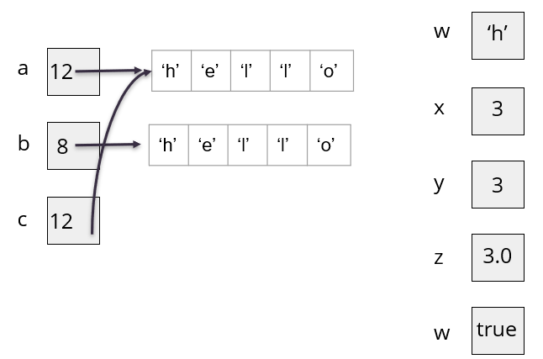
// Objects
String a = “hello”;
String b = “hello”;
String c = a;
// Primitives
char w = ‘h’;
int x = 3;
int y = 3;
double z = x;
boolean v = true;

- When working with objects, the problem with the == operator, is that it checks whether the two operands refer to the same object in memory. This is because == checks for the value held inside the variable’s memory box… whether that is a primitive data or an object’s address.

Evaluate the following:
- a == b

- a == c

- x == y

- y == z

- y == (int) z

- a.equals(b)

- a.equals(c)

- Let’s say I reassign the c variable.
c = b
a == c
a.equals(c)
- When you have an object, you can call special methods that are made for the object on it for functionality (actions). Primitives can’t have methods. Please evaluate the following:
- “hello”.equalsIgnoreCase(“hello”);

- “hello”.equalsIgnoreCase(“Hello”);

- “hello”.equalsIgnoreCase(“jello”);

- String fruit = "banana";
char letter = fruit.charAt(0);

- int length = fruit.length();

- What is wrong with the following code? Explain and then fix it.
String fruit = “banana”;
int length = fruit.length();
char last = fruit.charAt(length);

- Write a code snippet that reads in a char from user input and evaluates to see if it’s not in the English alphabet. Try using .toLowerCase().

- Write a code snippet that reads in a char from user input and evaluates to see if it’s a number.

- Write a code snippet that reads in a char from user input and evaluates whether it’s ‘y’ or ‘n’

- Write a code snippet that reads in a String from user input and evaluates whether it’s “yes” or “no”

