**OMM500N Exam**

**Problem 1. Product Mix**

Problem Formulation:

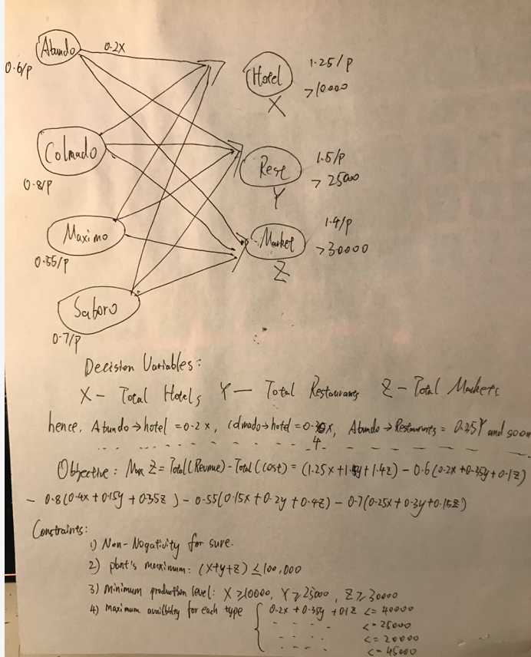

(a) In order to maximize weekly profit, how many pounds of each component should be purchased?  How many pounds of each blend should be produced?

The output of my python script:

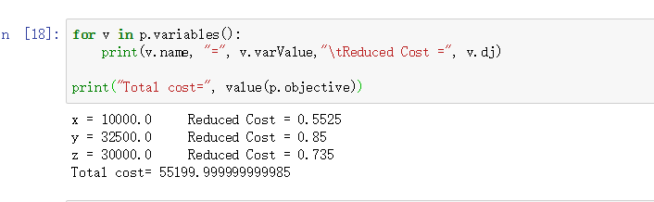

Which means the maximum profit is 55200, and 10000 pounds are produced for hotel type, 32500 are produced for restaurants type, 30000 are produced for supermarket type.

And hence we can get the amount need to purchase for each component by simple calculation, which are : Abundo = 16375, Colmado = 19375, Maximo = 20000, Saboro = 16750

(b)

In order to raise total profit, Hill-O-Beans be willing to pay at most 4.25(shadow price) for additional pound Maximo beans.

**Problem 2. Workforce Training**

Problem Formulation:

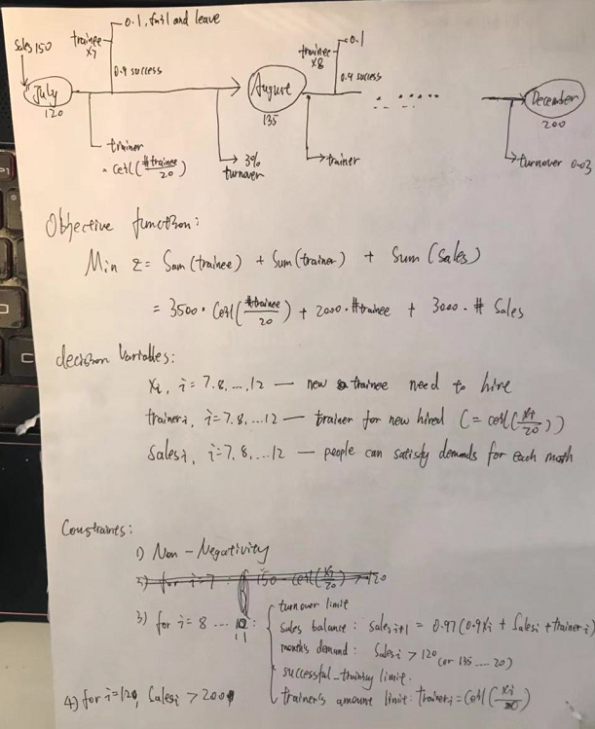

I have tried implement this problem by both Excel and Python, but I haven’t got a meaningful solution to this problem. I am so sorry.

(a)

(b)

Given fractional decisions allowed, then we can treat decision variables as continuous variables.

(c)

**Problem 3. Employee Schedule**

Problem Formulation:

It’s an linear programming problems, the objective is to minimize the cost under the tellers amounts demand.

decision variables:

x1 – full-time and eat on 12-1 , x2 – full-time and eat on 1-2

x9 – part time and start on 9, x10 – part time and start on 10

x11 – part time and start on 11, x12 – part time and start on 12

x13 – part time and start on 13, x14 – part time and start on 14

 objective  function:

Minimize Z = Cost(full-time)+ Cost(part-time) = 8*8*Num(full-time) + 3*5*Num(part-time)

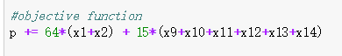

constraints:

1. Non-negativity
2. Less or equal than 5 part-time tellers
3. Satisfy each hours’ demands

Result: total cost = 459,

full-time who eat on 12-1 : 2, full-time who eat on 1-2: 4

part-time begin on 12:3, part-time begin on 14: 2

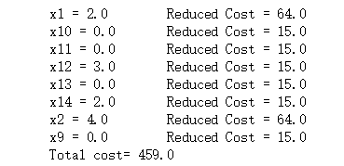

**Problem 4. Assignment**

**Problem Formulation:**

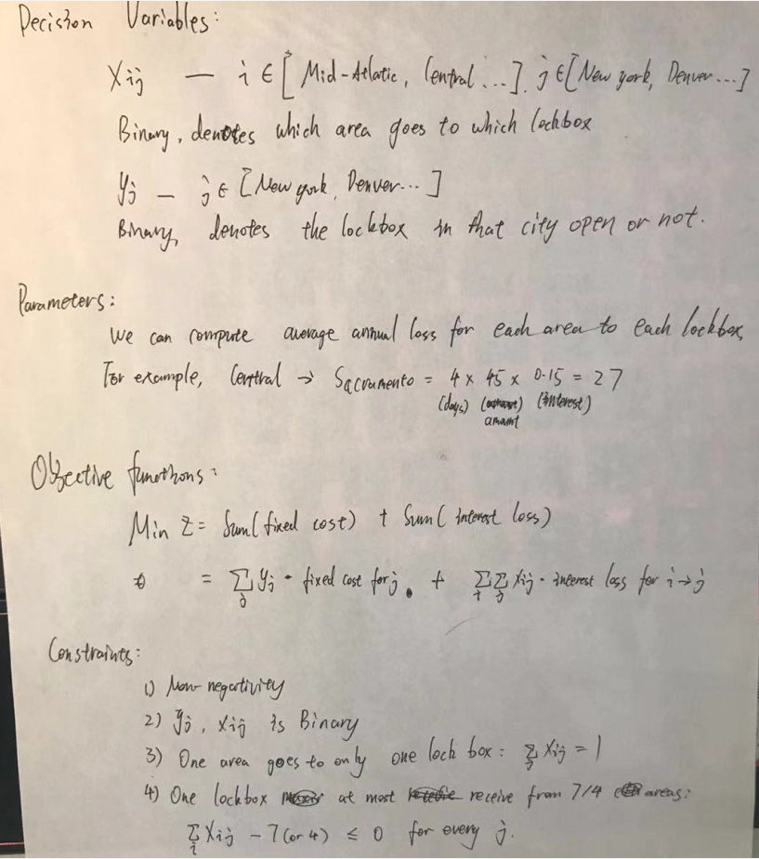

**a)**

Dallas and New York should be used, and below is the assignment

Central -> Dallas

Midwest -> Dallas

Northwest -> Dallas

Southeast - > Dallas

Southwest -> Dallas

Mid-Atlantic -> New York

Northeast -> New York

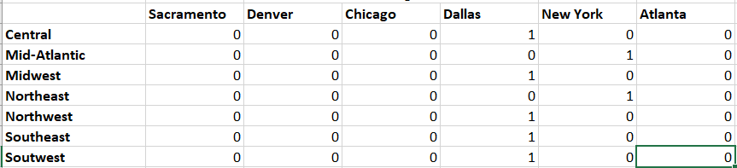

**(in 1000$)**

**b)**Below is how it will change when set 4 as maximum for one lockbox

