Backend for blog

Libraries and tools used
- Node
- Express
- PostgreSQL(and pgadmin)
- CORS
- JWT
- Bcryp
Functionalities and Features
- User Registration and Login with JWT authentication
- Follow and Unfollow
- Create read update and delete blog
- Rate blog
- Create edit and delete comment on blogs
- like unlike blogs
- Search blog by title or by user

All the mentioned functionalities and features have been implemented and tested using postman extesion on vs code and proved to be working, however from the required features I had trouble including profile pictures and did not include it, every other thing is done and here are few SELECTED screenshots.

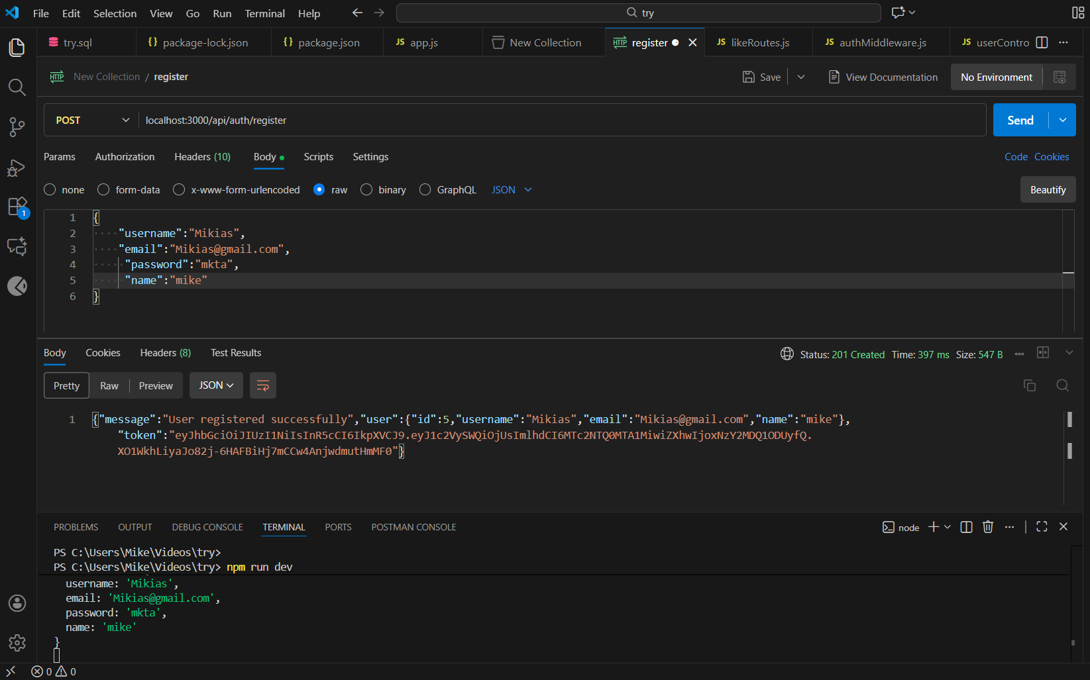
register
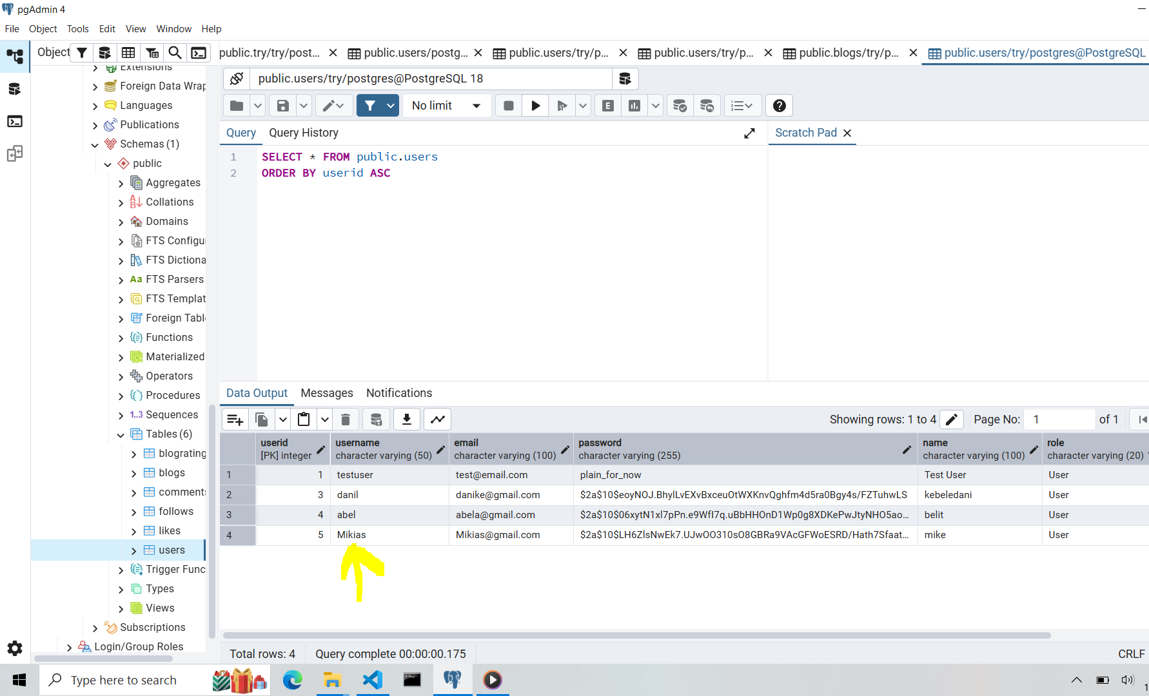
create blog
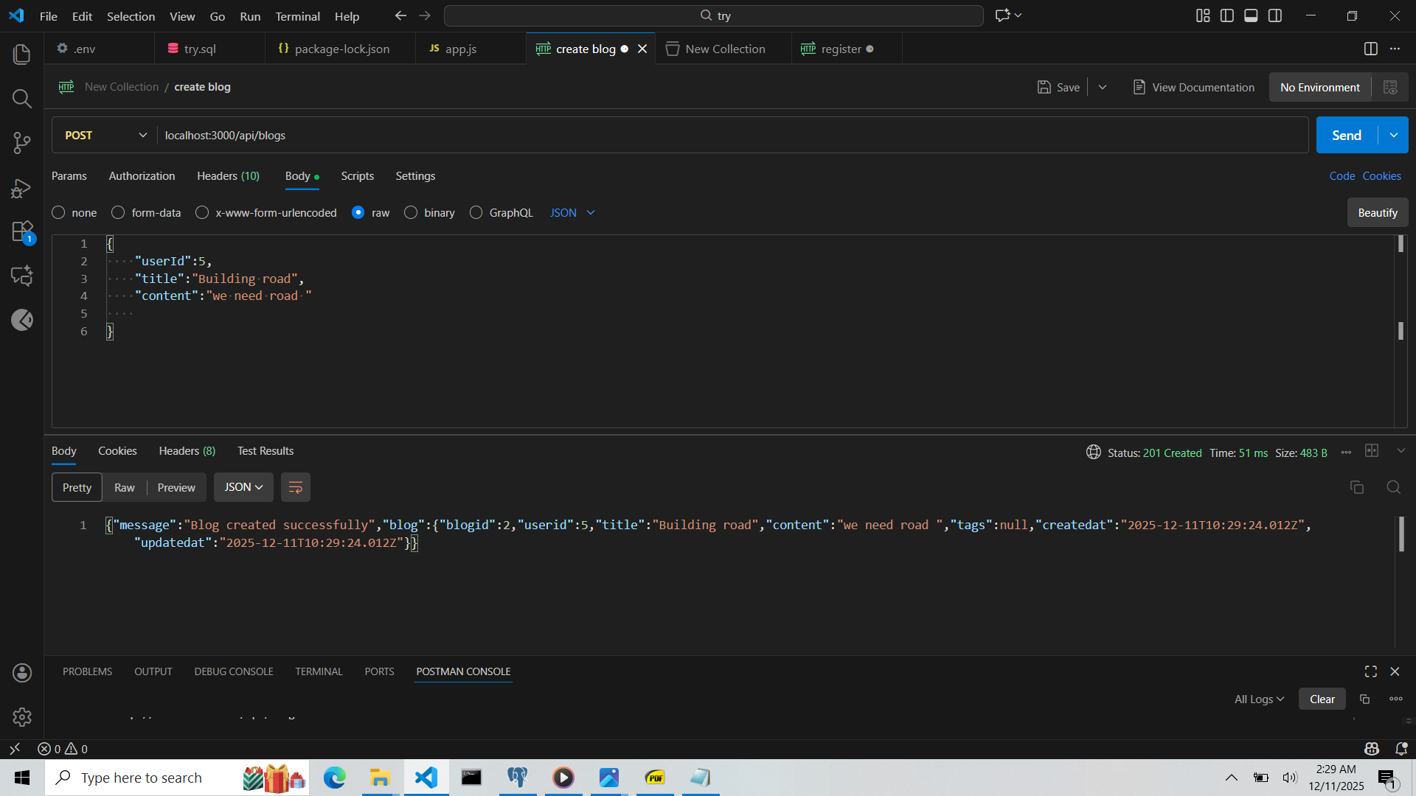
Blog created

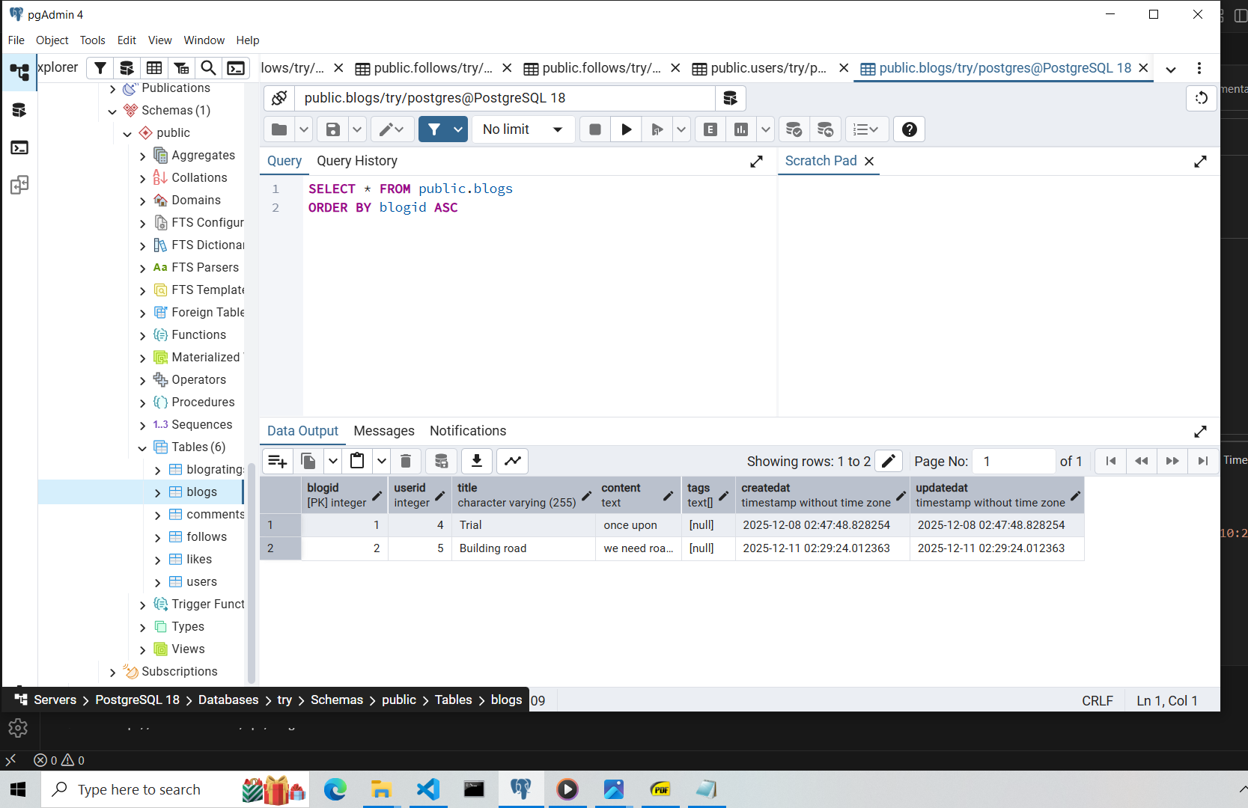
then follow /unfollow
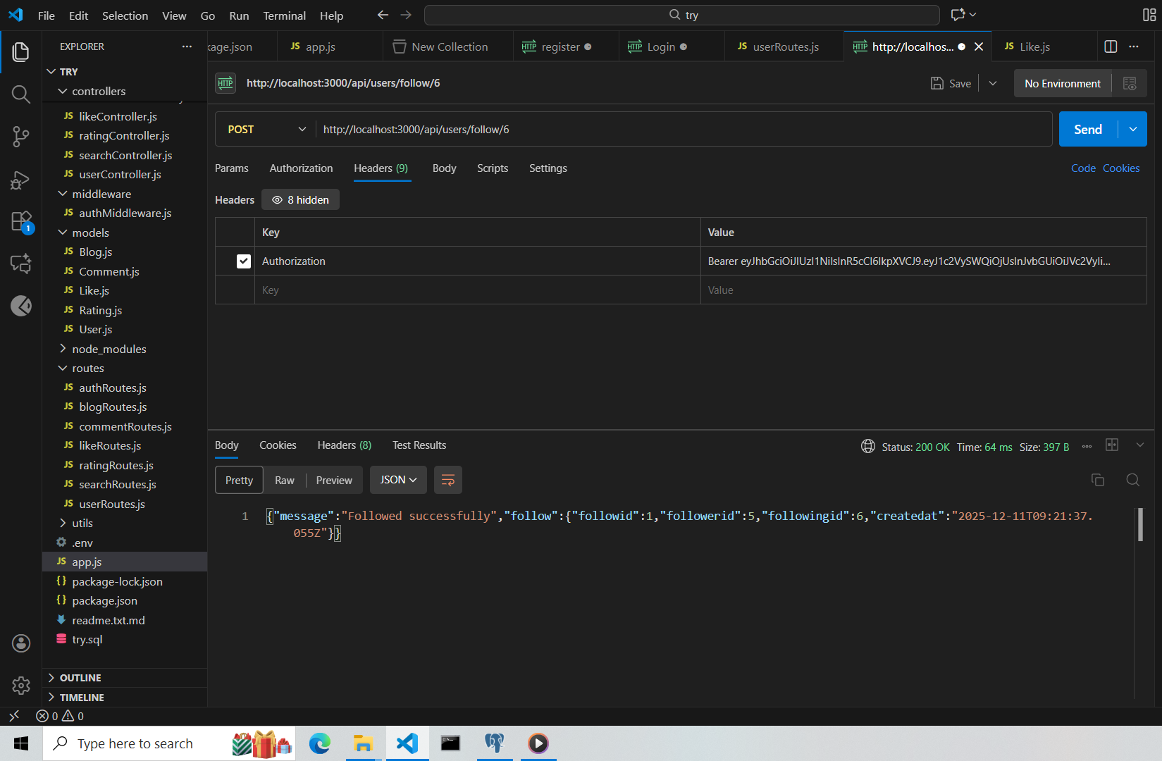
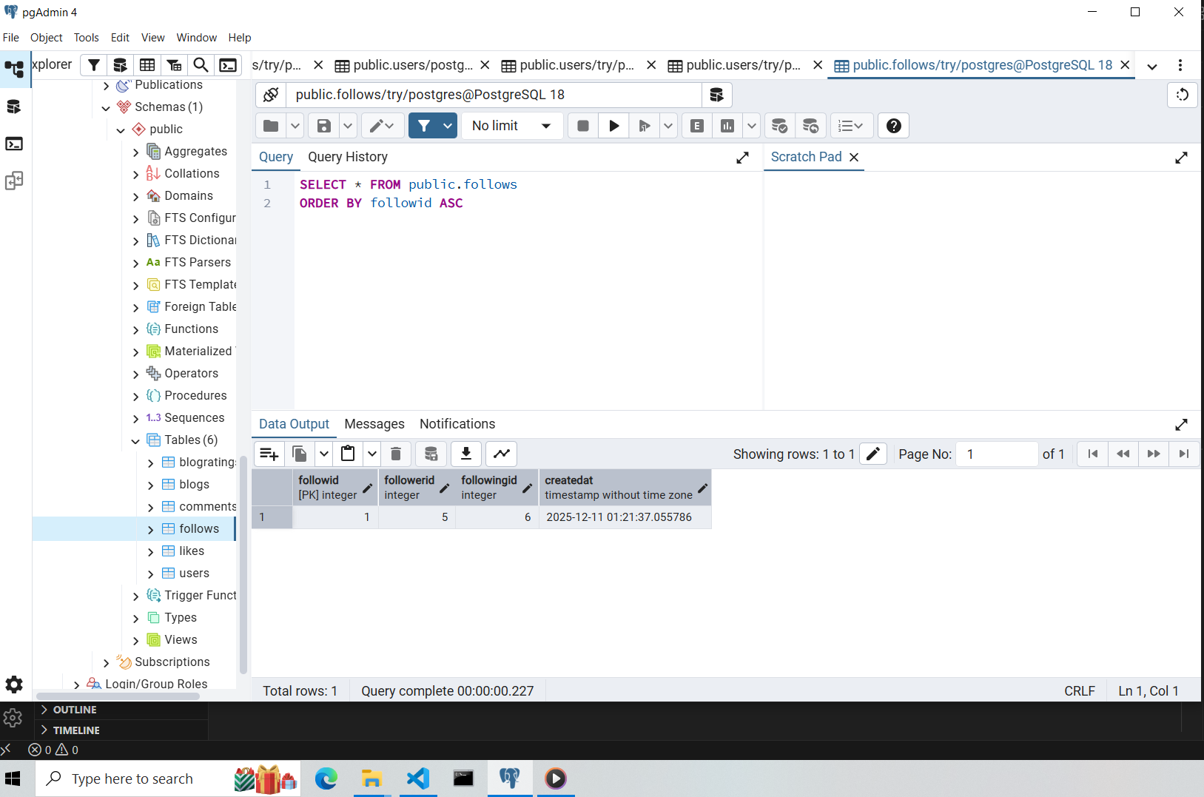
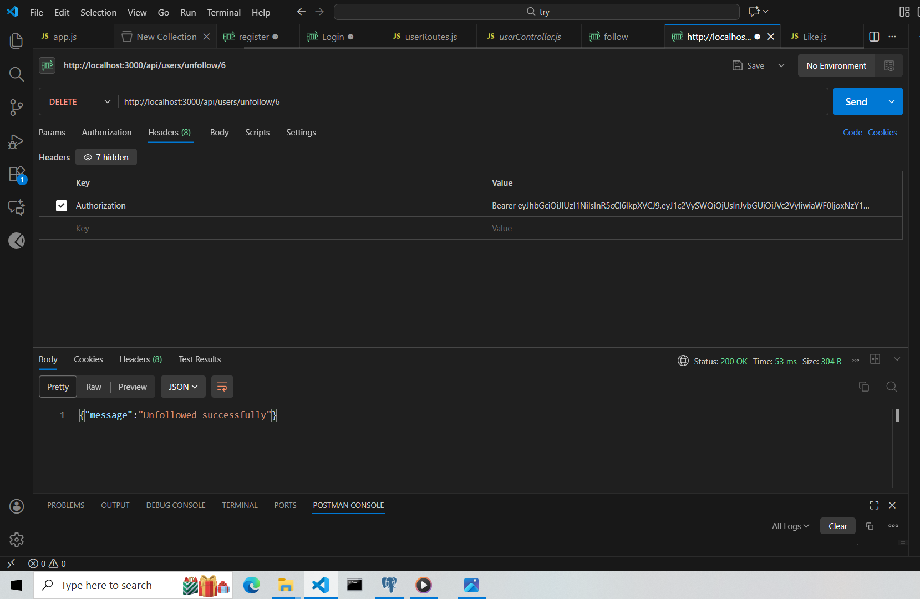
Ready to explain and answer questions.

