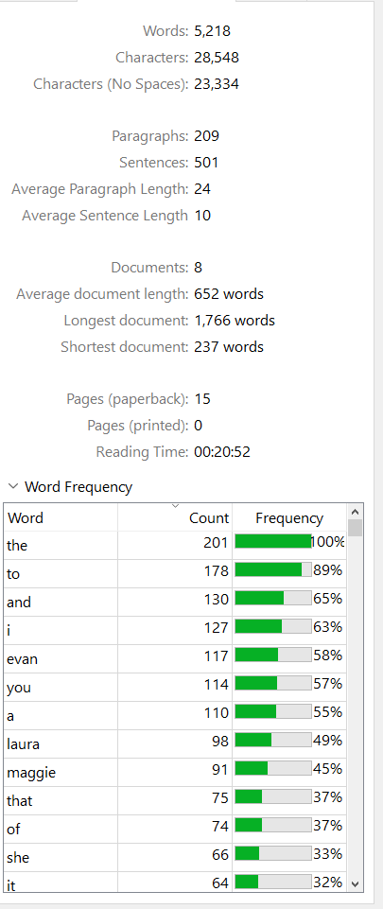
- Make sure we have a scene where Evan shows his conflict after the scholarship

