Air Hockey

Project

By Michael Vacchina, Arthur LeVesque, and Anthony Royle

Content

Project Overview…………………………………………………………………………………………………………………………………….3

User Manual……………………………………………………………………………………………………………………………………………4

Tech Manual……………………………………………………………………………………………………………………………………………9

Project Overview

Our program uses gl, glut, glm, and assimp. The physics and collisions in my program were inherited from Mike’s Labyrinth project and a few changes to work properly with the new objects. The project follows the same framework as Mike’s Labyrinth project; the code is object oriented utilizing inheritance when acceptable. Our project does contain a few bugs such as when a paddle pushes the puck into a wall; the puck will generally hide itself in the paddle. We also experienced many problems getting some functionality to work (textures, text on screen). They would not run on Mike’s computer but would work on Arthur’s computer. Our project does complete every required part that we remember being discussed in class for undergraduates and for graduates.

User Manual

Contents

Getting Started………………………………………………………………………………………………………………………………………..5

The Menu…………………………………………………………………………………………………………………………………..……………6

Controls…………………………………………………………………………………………………………………………………..………………8

Getting started

When a user first starts our program they will be presented with the screen as shown in figure 1.

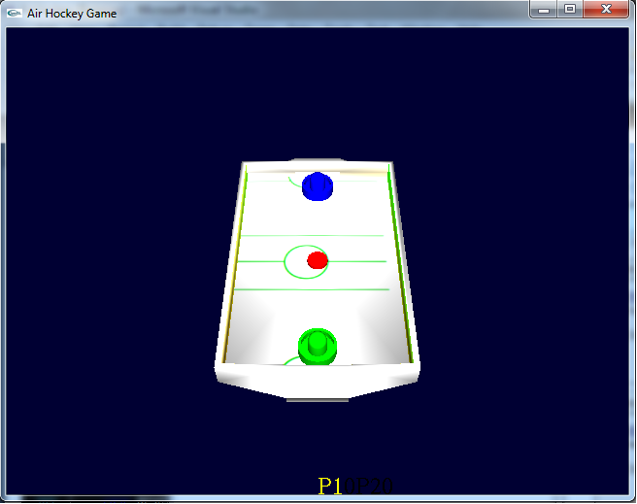

Figure 1

The user can then begin playing against another human immediately. In order to bring up the menu, the user must right click within the window. Once done the user will be presented with a screen similar to Figure 2.

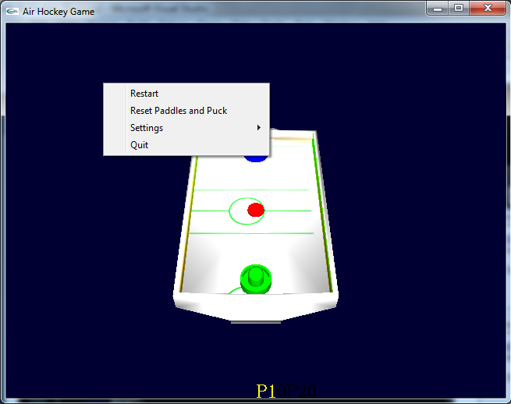

Figure 2

From the menu the user can restart the game entirely (this includes the current score), or they can reset the current paddle positions and puck position. This is very helpful for when the puck gets stuck in the corner of the table. The user can also change settings within the game, or quit the game. The goal of the game is to hit the red puck into the opponent’s goal by using your paddle. The first player controls the green paddle while the second player controls the blue paddle.

The Menu

Restart

This menu option puts the paddles and puck back to their starting positions and resets the score between the two players.

Reset Paddles and Puck

This menu option puts the paddles and puck back to their starting positions. It is intended to be used when the puck get stuck in the corner.

Settings

This menu option shows a submenu where the user can alter settings in the game which will take effect immediately. The submenu is shown in figure 3. Each option in the submenu is explained further below. It is important to note that the paddle sensitivity does not have a constraint on how much it can change one way or the other. It is not recommended to be moved too far from the starting value.

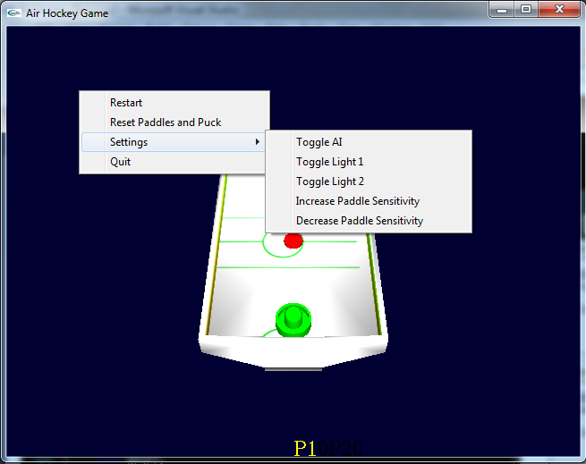

Figure 3

Toggle AI

This setting will enable an AI as player two when first selected, as it is defaulted to off. Selecting it again will disable the AI.

Toggle light 1

This setting option will turn the first light on and off.

Toggle light 2

This setting option will turn the second light on and off.

Increase Paddle Sensitivity

This setting option will increase the paddle sensitivity when using the keyboard to control it.

Decrease Paddle Sensitivity

This setting option will decrease the paddle sensitivity when using the keyboard to control it.

Quit

This menu option will exit the game.

Controls

Displaying the Menu

Right clicking in the screen brings up the menu. This causes the display to be paused but the puck will keep on moving. In this state, the collision detection does not work so the ball will move through walls and over holes. This is an undesired affect so it is not recommended to right click when the ball is moving.

Player 1 Paddle Controls

The player 1 paddle can be controlled by left clicking with the mouse and dragging. It can also be controlled using the arrow keys.

Player 2 Paddle Controls

The player 2 paddle can be controlled by the “ASDW” keys like arrow keys.

Camera Control

The camera position can be controlled using the “JKLI” keys like arrow keys. They will rotate the camera position around the center of the table.

Quitting

In addition to being able to quit from the menu, the user can also quit by pressing ESC.

Tech Manual

Contents

Known Bugs…………………………………………………………………………………………………………………………………………..13

General Issues……………………………………………………………………………………………………………………………………….13

General Comments………………………………………………………………………………………………………………………………..13

Known Bugs

* The right click menu causes they system to “pause” but the delta time does not pause meaning the next dt will be quite large and the puck can pass through walls, goals, and paddles.
* Mouse controls and key controls used as the same time have weird effects.
* Since there are no caps on the settings that the user can change, it is possible to increase the paddle speeds enough that collisions will not be properly detected.
* The paddles can push the puck into the wall where the puck will go through the wall or into the paddle.
* Rarely the puck suddenly disappears. We are unaware as to the cause of this.
* Text does not display on the screen properly.
* Texture on table is offset slightly.

General Issues

It seems that OpenGL 4.2, which is what is on Mike’s computer, does not support the older methods for displaying text or textures. Both of those would not display properly on Mike’s computer but worked fine on Arthur’s computer.

The group was unable to locate the grading rubric online and thus had to go off of memory from what was displayed in class briefly. As a result some things might not be complete that we did not remember needed to be done.

General Comments

We would have spent more time looking into textures and text on screen for OpenGL 4.x instead of using a broad search for OpenGL. We would have also taken more time to test the game and flush out the ai, collision and physics bugs.