2018 Screenshot

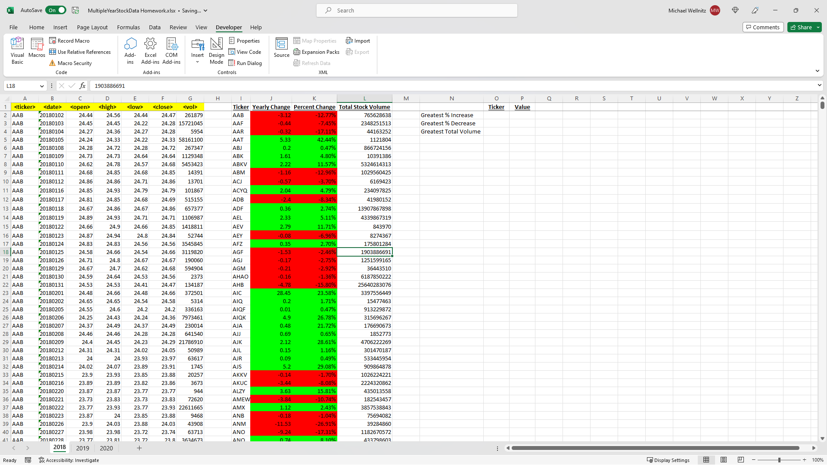

2019 Screenshot

2020 Screenshot

