MicroTik

192.168.25.3

admin

toor.125

Script:

:local wanInterfaceName "e21-bswitch"

:local uploadBandwidth 700k

:local queueName ("DSCP_" . $wanInterfaceName)

:local dscpClass [:toarray "Network Control,Internetwork Control,Critical,Flash Override,Flash,Immedate,Priority,Routine"]

:local dscp 64

:for thisDscp from 63 to 00 do={

/ip firewall mangle add action=mark-packet chain=postrouting comment=("dscp_" . $thisDscp) \

disabled=no dscp=$thisDscp new-packet-mark=("dscp_" . $thisDscp) passthrough=no

}

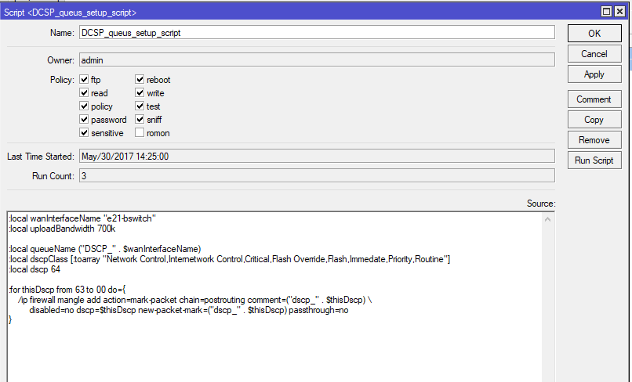

<https://three65.blog/2015/09/07/skype-for-business-configuring-quality-of-service-qos/>

<https://technet.microsoft.com/en-us/library/jj205076(v=ocs.15).aspx>

