<https://github.com/plotly/plotly.js/pull/439>

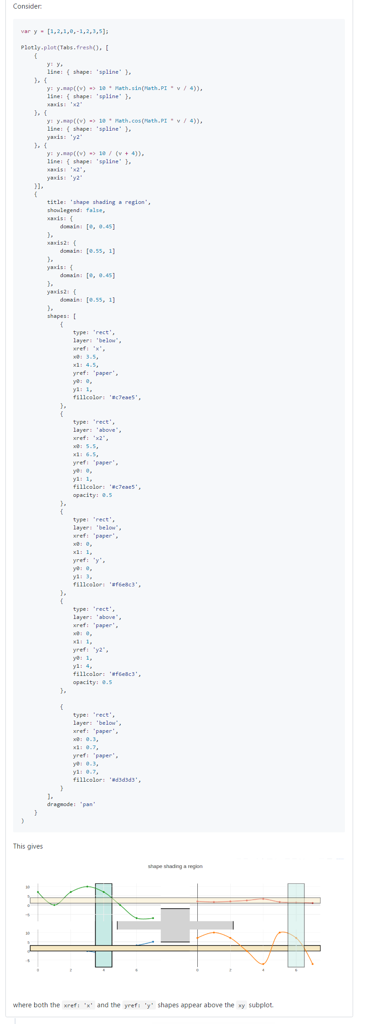

<https://cpsievert.github.io/plotly_book/#>

<https://cpsievert.github.io/plotly_book/extending-ggplotly.html>