

Peer Comparison Analysis for peugeot

April 18, 2012

Prepared For:
Valued Customer Name
peugeot
Address
Phone Number
Web Site
E-mail address

Prepared By:
deepti manne
Microsoft/Enterprise Services/Redmond
April 18, 2012

Third party model, methodology and data provided by:

Disclaimer: The information contained in this presentation represents the current view of Microsoft Corporation on the issues discussed as of the date of publication. Because Microsoft must respond to changing market conditions, it should not be interpreted to be a commitment on the part of Microsoft, and Microsoft cannot guarantee the accuracy of any information presented after the date of publication. This white paper is for informational purposes only. MICROSOFT MAKES NO WARRANTIES, EXPRESS, IMPLIED, OR STATUTORY, AS TO THE INFORMATION IN THIS DOCUMENT. Complying with all applicable copyright laws is the responsibility of the user. Without limiting the rights under copyright, no part of this document may be reproduced, stored in or introduced into a retrieval system, or transmitted in any form or by any means (electronic, mechanical, photocopying, recording, or otherwise), or for any purpose, without the express written permission of Microsoft Corporation. Microsoft may have patents, patent applications, trademarks, copyrights, or other intellectual property rights covering subject matter in this document. Except as expressly provided in any written license agreement from Microsoft, the furnishing of this document does not give you any license to these patents, trademarks, copyrights, or other intellectual property of Microsoft. © 2010 Microsoft Corporation. All rights reserved.
Model Version # v1.49 and Report Version Number # v1.3
1. Peer Comparison Analysis

In this Peer Comparison, Peugeot SA ( ), was compared against a select group of peers to determine comparative IT spending, IT performance and RETURN ON ITTM.

This report is based on independent data sources, including IT spending and benchmarks from IT value consultancy Alinean (http://www.alinean.com), and financial annual report data from Morningstar, Inc. (http://www.morningstar.com).

2. Peer Comparison Summary

The Peer Comparison Summary provides an executive overview of ABC Company's position in comparison with the average of the selected peers, High Tech (Systems and Software OEMs) industry average and High Tech (Systems and Software OEMs) industry Top RETURN ON ITTM Performers average on key performance indicators.
Business Focused Metrics | Peugeot SA | Selected Peer Average |  | Automotive and Vehicle Manufacturing Industry Average |  | Automotive and Vehicle Manufacturing Industry Top ROIT™ Performers
Revenue growth (over prior year) | 18.8% | 5.8% | ↑ | 87.8% | ↓ | 35.7% | ↓
Revenue / employee | $426,470 | $507,609 | ↓ | $403,060 | ↑ | $287,010 | ↑
Net income growth (over prior year) | 115.9% | 141.6% | ↓ | 84.8% | ↑ | 98.9% | ↑
Net income / employee | $12,327 | $22,911 | ↓ | $48,327 | ↓ | $27,894 | ↓
Net operating margin | 2.9% | 4.2% | ↓ | 12.0% | ↓ | 9.7% | ↓
IT Focused Metrics | Peugeot SA | Selected Peer Average |  | Automotive and Vehicle Manufacturing Industry Average |  | Automotive and Vehicle Manufacturing Industry Top ROIT™ Performers
RETURN ON IT™ | 187.3% | 329.1% | ↓ | 930.3% | ↓ | 996.2% | ↓
IT efficiency rating | 24.9 | 24.6 | ↑ | 47.7 | ↓ | 58.8 | ↓
IT spending / revenue | 1.5% | 1.4% | ↓ | 1.3% | ↓ | 1.0% | ↓
IT spending / overall spending | 1.6% | 1.5% | ↓ | 1.5% | ↓ | 1.1% | ↓
IT spending / employee | $6,583 | $6,785 | ↑ | $5,195 | ↓ | $2,800 | ↓
IT spending / knowledge worker | $7,744 | $8,180 | ↑ | $7,361 | ↓ | $5,426 | ↓
IT spending growth (over prior year) | 4.4% | -0.1% | ↓ | 0.0% | ↓ | 0.0% | ↓
Number of IT operations admin staff | 3,811 | 3,428 | ↓ | 508 | ↓ | 91 | ↓
Number of IT development staff | 3,285 | 2,955 | ↓ | 437 | ↓ | 79 | ↓
Formal IT control spending | 69.7% | 71.4% | ↓ | 76.9% | ↓ | 79.1% | ↓
IT innovation spending | 19.2% | 18.0% | ↑ | 19.0% | ↑ | 21.4% | ↓
Business intelligence infrastructure investment | 12.2% | 11.0% | ↑ | 12.1% | ↑ | 14.4% | ↓
Front office application spending | 40.5% | 38.0% | ↑ | 40.0% | ↑ | 44.7% | ↓
Percentage of successful projects | 35.2% | 34.0% | ↑ | 35.0% | ↑ | 37.4% | ↓
Legend:
If Peugeot SA's performance is equal to or better than performances of Selected Peer Average, Industry Average or Top RETURN ON IT™ performers Average then there will be an up arrow ( ↑ ) behind the specified average metric. If Peugeot SA's performance is worse, a down arrow ( ↓ ) will be displayed.
Selected Peer Average is the average of the peers selected for use in the analysis.
Industry Average is specific to the Target Company's Industry and Size.
Industry Top RETURN ON IT™ Performers is an average of companies in the first quartile of RETURN ON IT(tm) performance.
IT Efficiency Rating is Number of Knowledge Workers per Number of IT Staff.

3. PeerMapTM Assessment

The PeerMap™ Assessment compares and correlates financial performance with IT spending. The PeerMap™ provides a quadrant analysis to indicate which companies are leaders and followers with regard to getting the most efficiency and effectiveness from their IT investments and practices. In the analysis, companies are plotted on a quadrant comparing their performance versus peers (with peer average forming the quadrant axis). Those companies positioned in the upper left quadrant are Frugal Leaders; upper right are Investing Leaders; lower left are Frugal Followers; and lower right are Investing Followers.
 | Company Name |  |  | ROIT™ |  | Revenue (in millions) |  | Revenue Growth |  | Net Income (in millions) |  | Net Income Growth |  | Net Operating Margin |  | Overall Spending (in millions) |  | Number of Employee |  | Number of Knowledge Workers |  | IT Spending (in millions) |  | IT Spending Growth
 | Peugeot SA |  |  |  | 187.3% |  | $88,620.4 |  | 18.8% |  | $2,561.5 |  | 115.9% |  | 2.9% |  | $86,058.9 |  | 207,800 |  | 176,630 |  | $1,367.9 |  | 4.4%
 | Selected Peer Average |  |  |  | 329.1% |  | $89,406.0 |  | 5.8% |  | $3,638.9 |  | 141.6% |  | 4.2% |  | $85,767.1 |  | 195,878 |  | 161,491 |  | $1,259.6 |  | -0.1%
 | Industry Average |  |  |  | 930.3% |  | $13,828.6 |  | 87.8% |  | $1,658.1 |  | 84.8% |  | 12.0% |  | $12,170.5 |  | 34,309 |  | 24,214 |  | $178.2 |  | 0.0%
 | Top ROIT™ Performers |  |  |  | 996.2% |  | $2,974.0 |  | 35.7% |  | $289.0 |  | 98.9% |  | 9.7% |  | $2,685.0 |  | 10,362 |  | 5,347 |  | $29.0 |  | 0.0%
 | Audi AG |  |  |  | 732.2% |  | $47,135.3 |  | 18.8% |  | $3,497.8 |  | 95.2% |  | 7.4% |  | $43,637.5 |  | 58,182 |  | 49,454 |  | $477.7 |  | 0.3%
 | Renault |  |  |  | 576.8% |  | $51,830.0 |  | 15.6% |  | $4,641.6 |  | 213.8% |  | 9.0% |  | $47,188.5 |  | 124,749 |  | 106,036 |  | $804.7 |  | 0.0%
 | Volkswagen AG |  |  |  | 360.8% |  | $168,739.2 |  | 20.6% |  | $9,090.3 |  | 612.0% |  | 5.4% |  | $159,648.9 |  | 427,184 |  | 363,106 |  | $2,519.5 |  | 8.8%
 | Fiat Group S.p.A. |  |  |  | 89.2% |  | $47,719.1 |  | -28.4% |  | $798.0 |  | 171.6% |  | 1.7% |  | $46,921.1 |  | 195,728 |  | 136,340 |  | $894.2 |  | -9.7%
 | Nissan Motor |  |  |  | -181.2% |  | $85,420.4 |  | -21.7% |  | ($2,366.2) |  | -148.7% |  | -2.8% |  | $87,786.6 |  | 160,422 |  | 136,358 |  | $1,306.1 |  | 0.0%
 | General Motors Co |  |  |  | 396.9% |  | $135,592.0 |  | 29.6% |  | $6,172.0 |  | -94.1% |  | 4.6% |  | $129,420.0 |  | 209,000 |  | 177,650 |  | $1,555.2 |  | 0.0%

3.1. RETURN ON ITTM (EVA vs. Est. IT Spending)

The RETURN ON ITTM analysis compares the ratio of the overall financial performance, summarized as net income to the Est. IT Spending. The RETURN ON ITTM metric is a singular indicator of overall effectiveness of IT and other investments compared to overall efficiency of Est. IT spending.

ROIT™ to IT Spending/Revenue
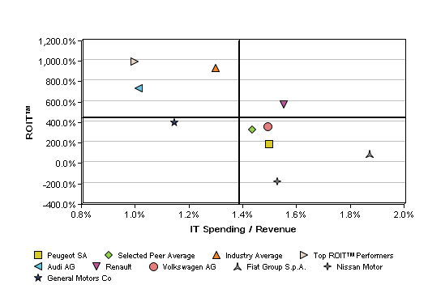
ROIT™ to IT Spending/Employee
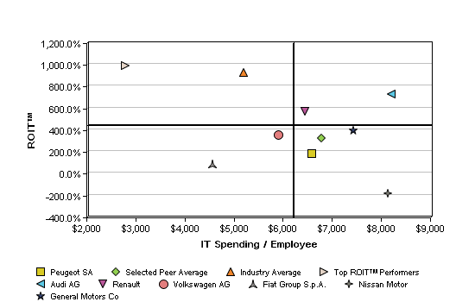

ROIT™ to IT Spending / Knowledge Worker
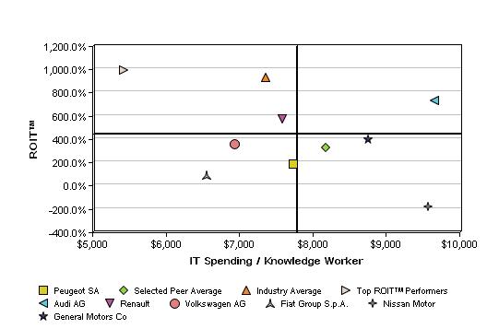

ROIT™ to IT Spending Growth
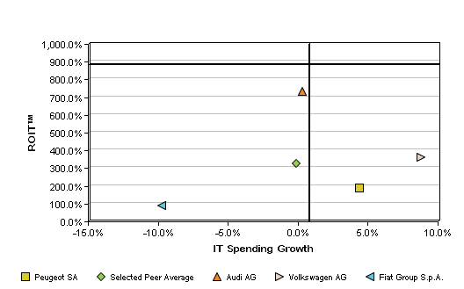

ROIT™ to IT Spending/Overall Spending
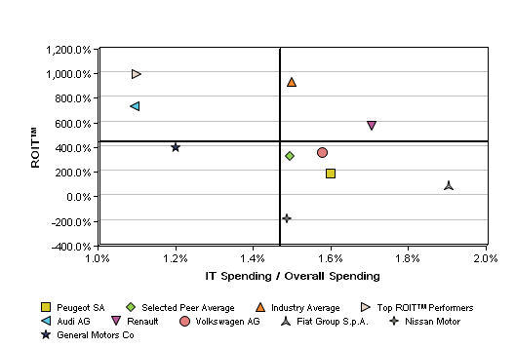

3.2. Revenue vs. Est. IT Spending Graphs

The Revenue versus Estimated IT Spending Analysis compares Revenue and Revenue growth with Estimated IT Spending ratios.

Revenue to IT Spending/Revenue
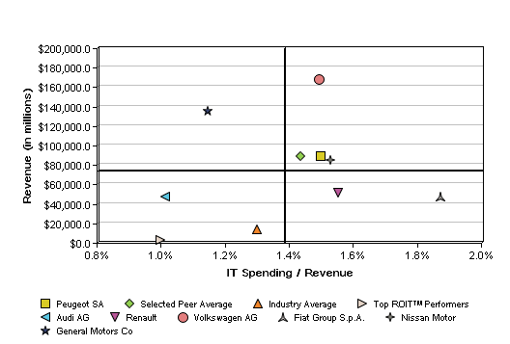

Revenue to IT Spending/Employee
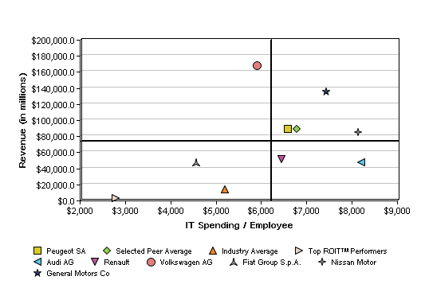

Revenue to IT Spending / Knowledge Worker
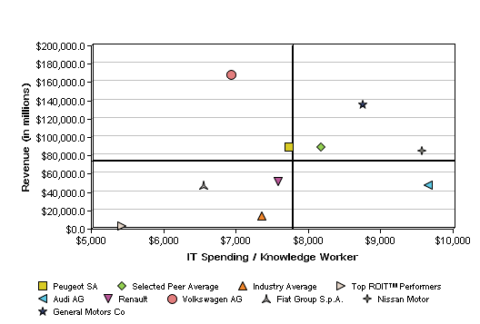

Revenue to IT Spending Growth
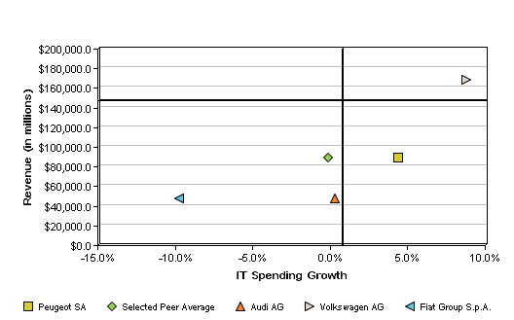

Revenue to IT Spending/Overall Spending
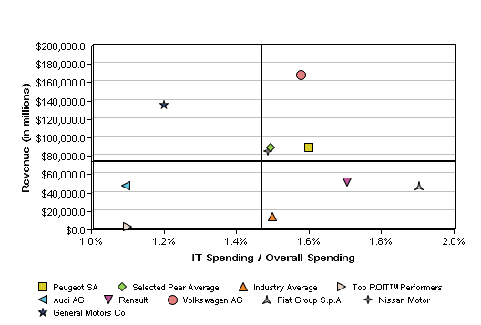

Revenue Growth to IT Spending/Revenue
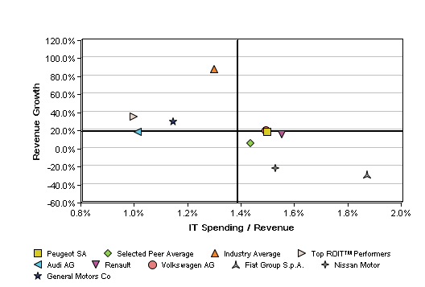

Revenue Growth to IT Spending/Employee
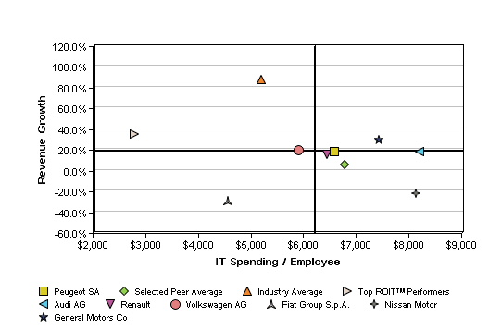

Revenue Growth to IT Spending / Knowledge Worker
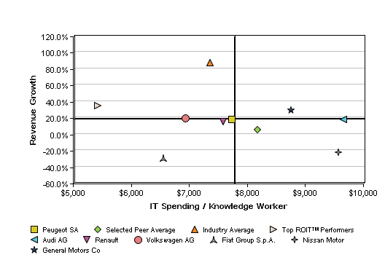

Revenue Growth to IT Spending Growth
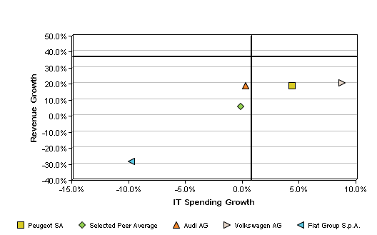

Revenue Growth to IT Spending/Overall Spending
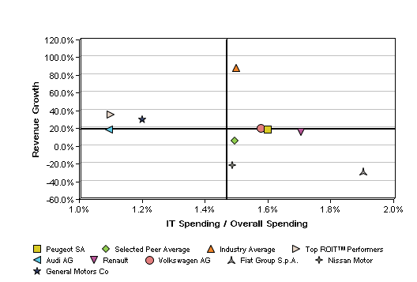

3.3. Net Income vs. Est. IT Spending Graphs

The Net Income Growth versus Estimated IT Spending Analysis compares Net Income and Net Income Growth (where net income represents the after-tax earnings from ongoing operations available for dividends to preferred and common shareholders) with Estimated. IT Spending ratios for the company and each of the peers.

Net Income to IT Spending/Revenue
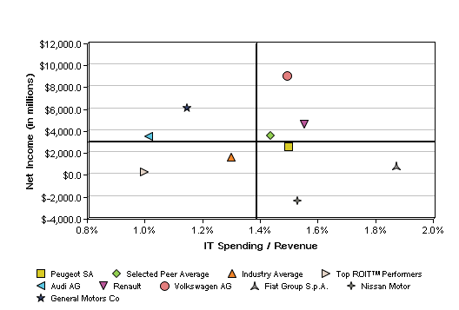

Net Income to IT Spending/Employee
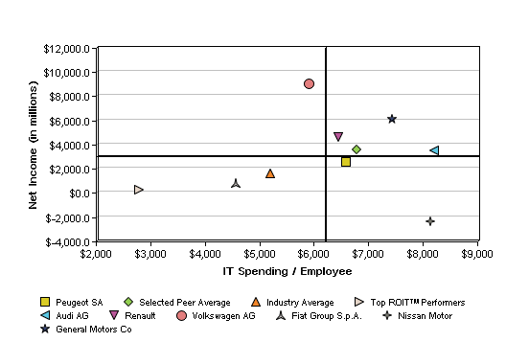

Net Income to IT Spending / Knowledge Worker
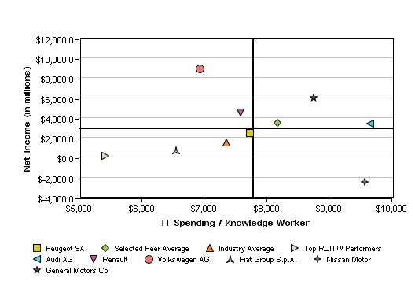

Net Income to IT Spending Growth
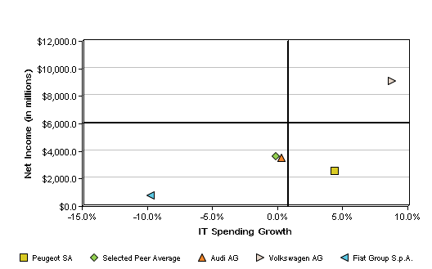

Net Income to IT Spending/Overall Spending
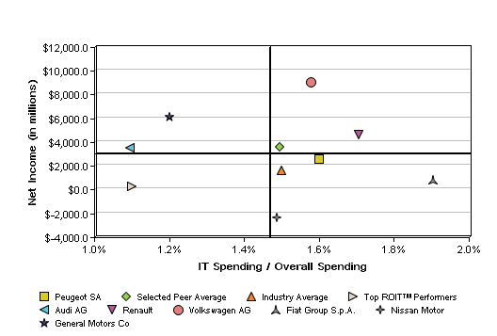

Net Income Growth to IT Spending/Revenue
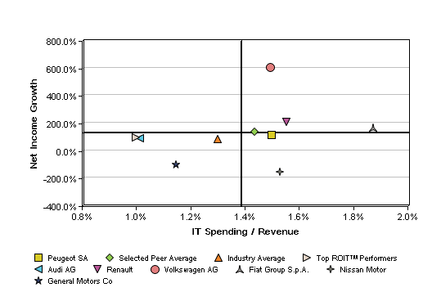

Net Income Growth to IT Spending/Employee
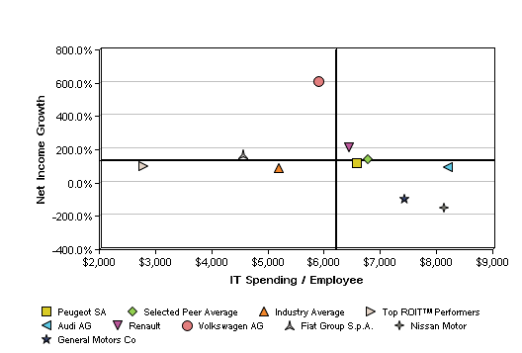

Net Income Growth to IT Spending / Knowledge Worker
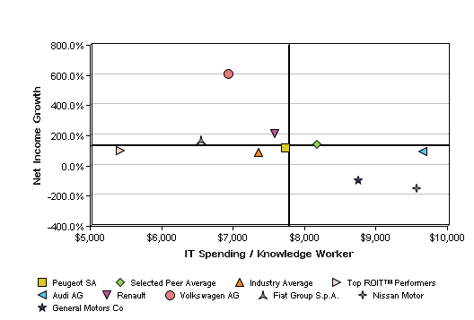

Net Income Growth to IT Spending Growth
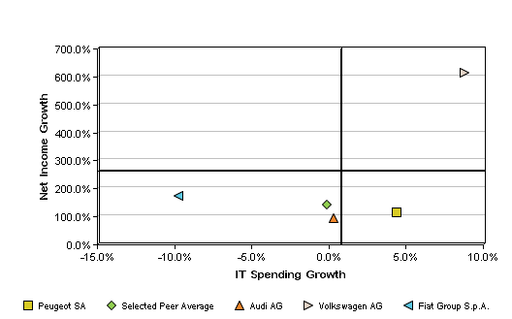

Net Income Growth to IT Spending/Overall Spending
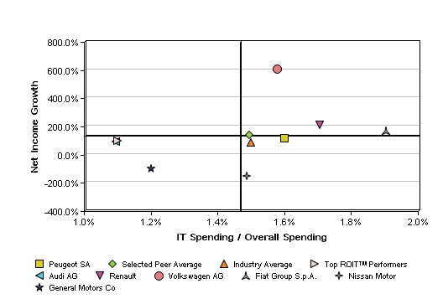

Net Operating Margin to IT Spending/Revenue
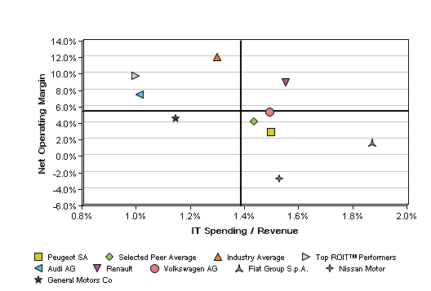

Net Operating Margin to IT Spending/Employee
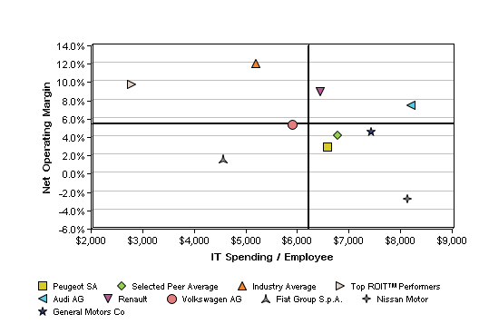

Net Operating Margin to IT Spending / Knowledge Worker
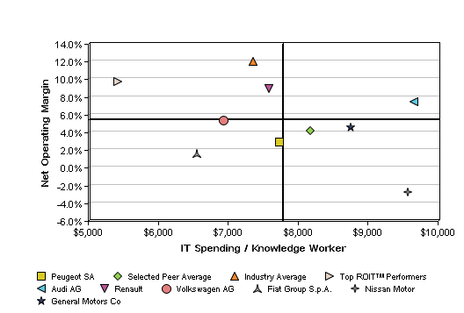

Net Operating Margin to IT Spending Growth
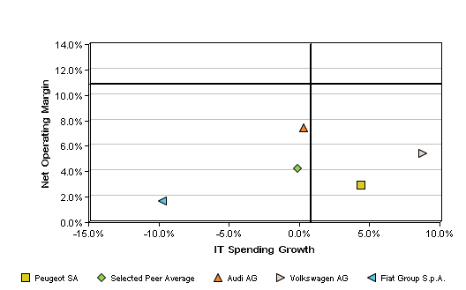

Net Operating Margin to IT Spending/Overall Spending
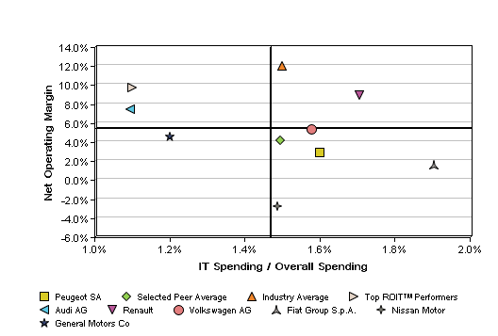

4. IT Spending Profile

The IT Spending Profile provides an overview and details of IT Spending comparing ABC Company to selected peers, Selected Peers Average, Industry Average and Top RETURN ON ITTM Performers on key IT spending metrics.

 | Company Name |  | ROIT™ | IT Spending (in millions) | IT Spending Growth | IT Spending / Revenue | IT Spending / Overall Spending | Number of IT Oper. Admin Staff | Number of IT Dev. Staff | IT Spending / Employee | IT Spending / Knowledge Worker
 | Peugeot SA |  | 187.3% | $1,367.9 | 4.4% | 1.5% | 1.6% | 3,811 | 3,285 | $6,583 | $7,744
 | Selected Peer Average |  | 329.1% | $1,259.6 | -0.1% | 1.4% | 1.5% | 3,428 | 2,955 | $6,785 | $8,180
 | Industry Average |  | 930.3% | $178.2 | 0.0% | 1.3% | 1.5% | 508 | 437 | $5,195 | $7,361
 | Top ROIT™ Performers |  | 996.2% | $29.0 | 0.0% | 1.0% | 1.1% | 91 | 79 | $2,800 | $5,426
 | Audi AG |  | 732.2% | $477.7 | 0.3% | 1.0% | 1.1% | 1,288 | 1,110 | $8,211 | $9,660
 | Renault |  | 576.8% | $804.7 | 0.0% | 1.6% | 1.7% | 2,242 | 1,933 | $6,451 | $7,589
 | Volkswagen AG |  | 360.8% | $2,519.5 | 8.8% | 1.5% | 1.6% | 6,794 | 5,856 | $5,898 | $6,939
 | Fiat Group S.p.A. |  | 89.2% | $894.2 | -9.7% | 1.9% | 1.9% | 2,491 | 2,147 | $4,568 | $6,558
 | Nissan Motor |  | -181.2% | $1,306.1 | 0.0% | 1.5% | 1.5% | 3,853 | 3,321 | $8,142 | $9,579
 | General Motors Co |  | 396.9% | $1,555.2 | 0.0% | 1.1% | 1.2% | 3,900 | 3,361 | $7,441 | $8,754

ROIT™ and IT Spending
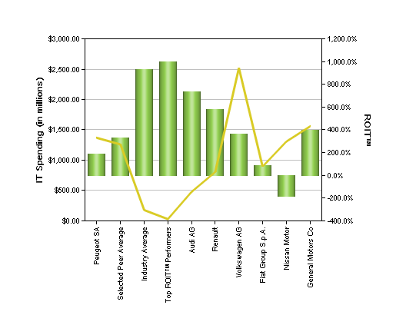

IT Spending Growth and IT Spending
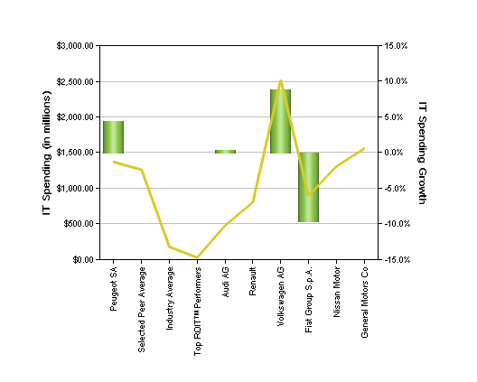
IT Spending/Revenue and IT Spending
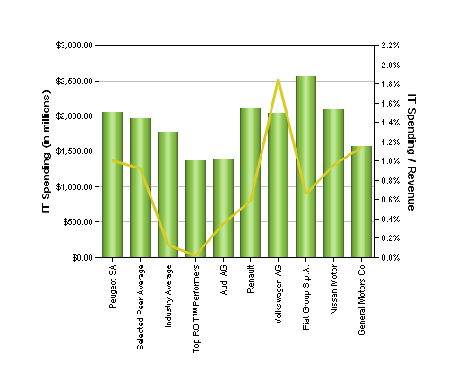

IT Spending/Employee and # Employees
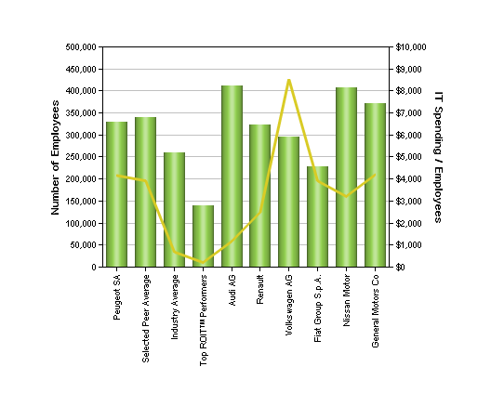
IT Spending / Knowledge Worker and # Knowledge Workers
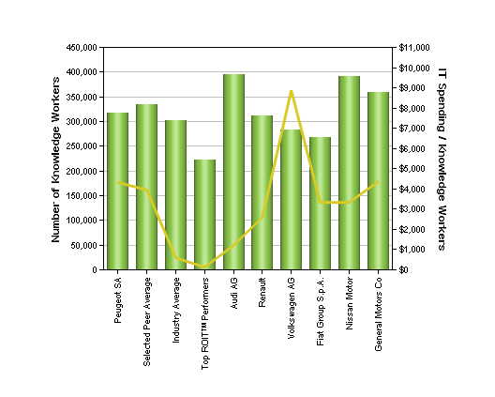

IT Spending/Overall Spending and Overall Spending
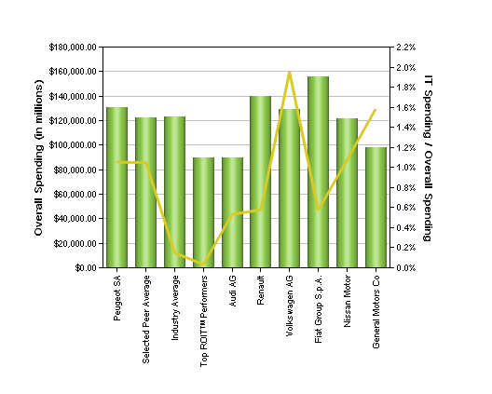

5. IT Spending Analysis

The IT Spending Analysis examines four key indices of IT spending comparing ABC Company to selected peer companies. These include IT Innovation Index, IT Spending Control Index, Front and Back Office Spending Index and IT Hierarchy of Needs Index.

5.1. IT Innovation Index

The best companies reduce spending on ongoing IT operations as much as possible in order to maximize spending on IT Innovation. IT Innovation is unique or novel and intended to differ in a significant and inventive way from prior software implementations or methods. Upgrades and Migrations Spending is focused on improving an existing business system or application by upgrading hardware, software or applications and/or moving an application from a legacy platform to a new platform. Ongoing Operational Spending sustains and executes the existing IT environment which is sometimes called "keeping the lights on".

 |  | Innovation Spending |  |  | Upgrades and Migrations Spending |  |  | Ongoing Operational Spending |  |  |  |  | Total IT Spending
 | Company Name | (in millions) | (%) | (in millions) |  | (%) | (in millions) |  | (%) |  |  | (in millions) |  | (%)
 | Peugeot SA | $263.1 | 19.2% | $307.1 |  | 22.5% | $797.7 |  | 58.3% |  |  | $1,367.9 |  | 100.0%
 | Selected Peer Average | $225.7 | 18.0% | $287.4 |  | 22.8% | $746.4 |  | 59.2% |  |  | $1,259.6 |  | 100.0%
 | Industry Average | $33.8 | 19.0% | $40.1 |  | 22.5% | $104.2 |  | 58.5% |  |  | $178.2 |  | 100.0%
 | Top ROIT™ Performers | $6.2 | 21.4% | $6.3 |  | 21.9% | $16.5 |  | 56.8% |  |  | $29.0 |  | 100.0%
 | Audi AG | $98.4 | 20.6% | $105.5 |  | 22.1% | $273.9 |  | 57.3% |  |  | $477.7 |  | 100.0%
 | Renault | $163.8 | 20.4% | $178.2 |  | 22.1% | $462.7 |  | 57.5% |  |  | $804.7 |  | 100.0%
 | Volkswagen AG | $501.1 | 19.9% | $561.1 |  | 22.3% | $1,457.3 |  | 57.8% |  |  | $2,519.5 |  | 100.0%
 | Fiat Group S.p.A. | $165.3 | 18.5% | $202.6 |  | 22.7% | $526.2 |  | 58.8% |  |  | $894.2 |  | 100.0%
 | Nissan Motor | $114.9 | 8.8% | $331.1 |  | 25.4% | $860.0 |  | 65.8% |  |  | $1,306.1 |  | 100.0%
 | General Motors Co | $310.8 | 20.0% | $345.9 |  | 22.2% | $898.4 |  | 57.8% |  |  | $1,555.2 |  | 100.0%

IT Innovation Index
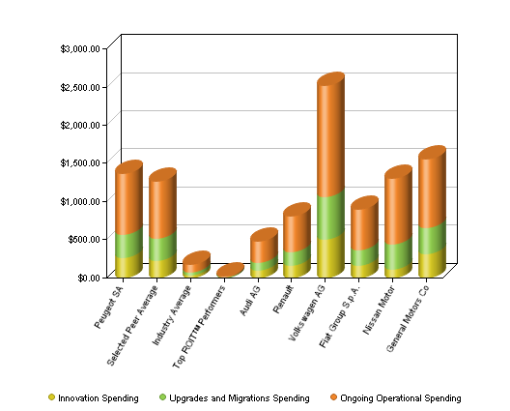

Peugeot SA IT Innovation
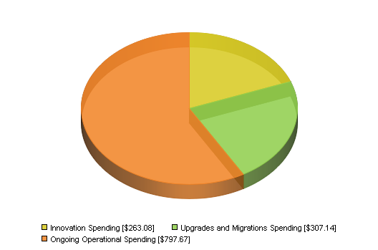

Peer Average IT Innovation
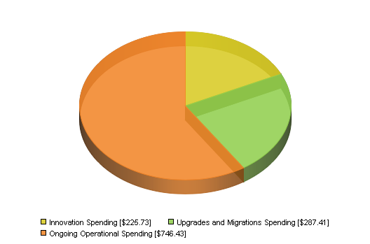

Industry Average IT Innovation
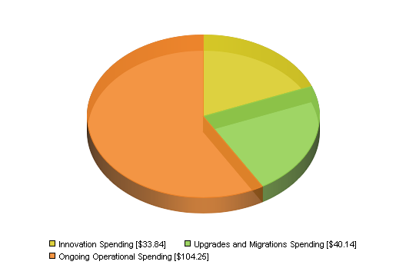

Top ROIT™ Performers IT Innovation
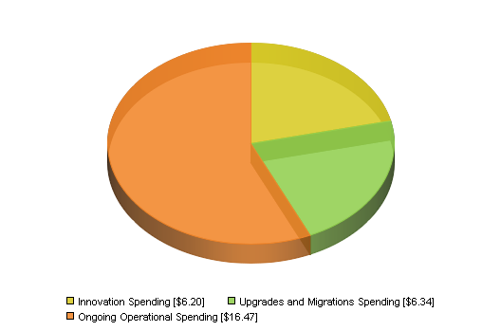

5.2. IT Spending Control Index

There are 3 types of spending controls: Formal IT, Business Unit IT, and Shadow IT. Formal IT spending is under the direct control of the CIO and IT department. Business Unit IT spending is under the control of Business leaders and units. Shadow IT spending is not classified as IT spending.
 |  | Formal IT Spending |  |  | Business Unit IT Spending |  |  | Shadow IT Spending |  |  |  |  | Total IT Spending
 | Company Name | (in millions) | (%) | (in millions) |  | (%) | (in millions) |  | (%) |  |  | (in millions) |  | (%)
 | Peugeot SA | $953.4 | 69.7% | $342.0 |  | 25.0% | $72.5 |  | 5.3% |  |  | $1,367.9 |  | 100.0%
 | Industry Average | $137.0 | 76.9% | $33.6 |  | 18.9% | $7.6 |  | 4.3% |  |  | $178.2 |  | 100.0%
 | Top ROIT™ Performers | $22.9 | 79.1% | $5.0 |  | 17.3% | $1.0 |  | 3.6% |  |  | $29.0 |  | 100.0%

IT Spending Control
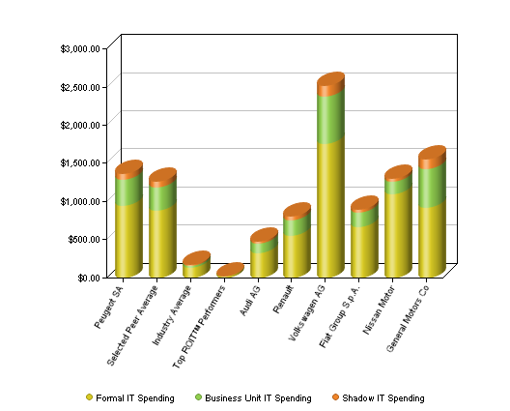

Peugeot SA IT Spending Control
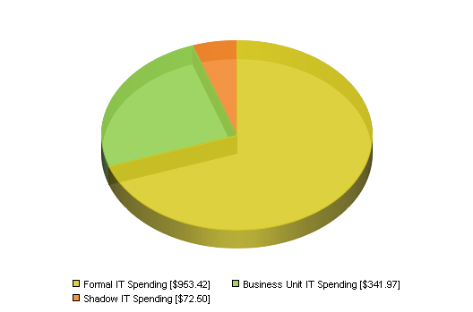

Peer Average IT Spending Control
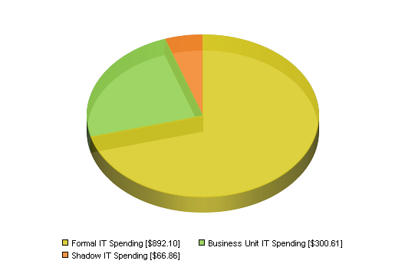

Industry Average IT Spending Control
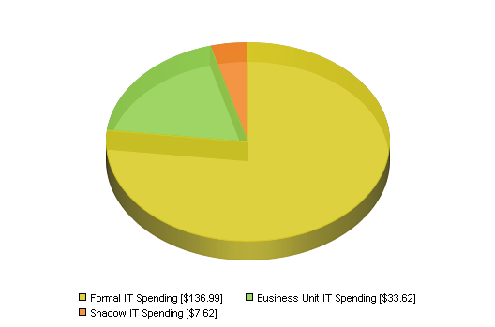

Top ROIT™ Performers IT Spending Control
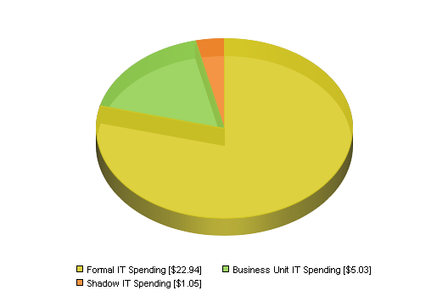

5.3. Front and Back Office Spending Index

Higher performing companies understand that they need to align their IT investments with the company's strategic business goals, in particular making sure that investments are being made in Front-Office customer facing IT and not just Back-Office investments. Front-Office refers to new and existing spending on customer-facing functions that have a direct or indirect impact on customer experience. Back-Office refers to new and existing spending on internal applications that affect SG&A efficiency but have limited impact on customer experience.

 |  |  | Front-Office IT Spending |  | Back-Office IT Spending |  | Total IT Spending
 | Company Name |  | (in millions) | (%) | (in millions) | (%) | (in millions) | (%)
 | Peugeot SA |  | $553.5 | 40.5% | $814.4 | 59.5% | $1,367.9 | 100.0%
 | Industry Average |  | $71.3 | 40.0% | $107.0 | 60.0% | $178.2 | 100.0%
 | Top ROIT™ Performers |  | $13.0 | 44.7% | $16.0 | 55.3% | $29.0 | 100.0%

Front and Back Office IT Spending
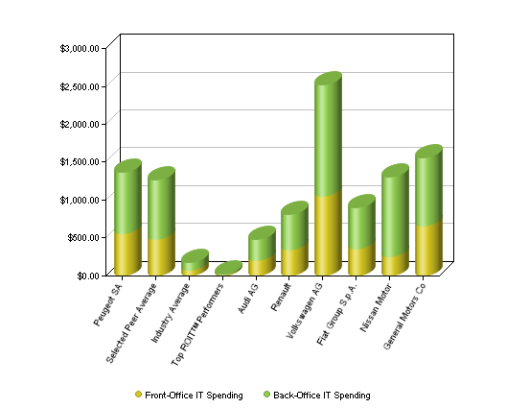

Peugeot SA Front and Back Office IT Spending
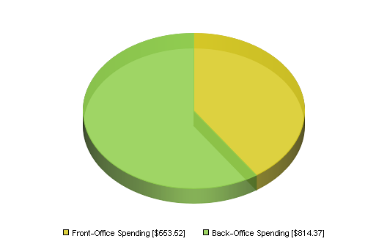

Peer Average Front and Back Office IT Spending
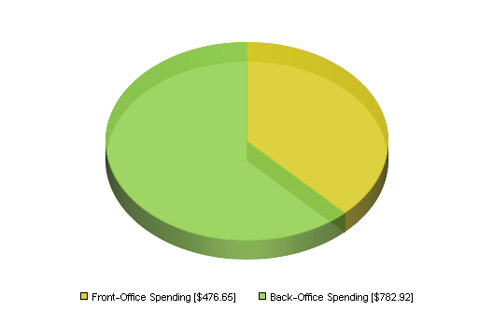

Industry Average Front and Back Office IT Spending
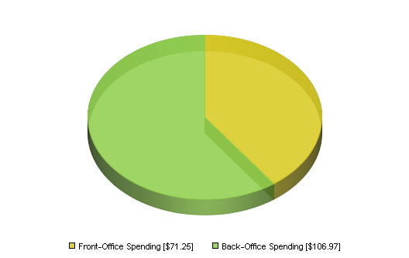

Top ROIT™ Performers Front and Back Office IT Spending
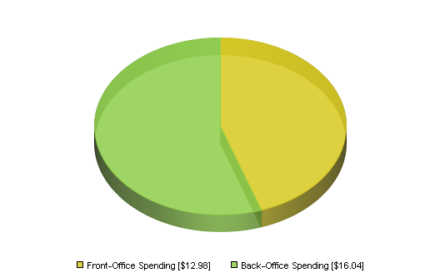

5.4. Current IT Hierarchy of Needs vs. Average IT Hierarchy of Needs

IT spending and investments can be classified based on the Alinean IT Hierarchy of Needs, documenting which investments are tactical - forming the core infrastructure, and which are more strategic - helping to deliver competitive advantage. By selecting investments across the IT hierarchy of needs, spending can be optimized such that IT costs can be reduced, business operating efficiency can be improved and business strategic advantage can be maintained.

Classifying investments into their proper place in the hierarchy will help to determine the proper criteria for head to head comparison of various spending scenarios, as each investment classification has a different goal, business contribution and value - with certain foundation spending designed to lower cost of ownership and provide a solid foundation for growth, while higher order investments are designed to progressively deliver lower operating costs up to competitive advantage.

The IT Hierarchy of Needs provides a model for investing in Information Technology. Each of the upper tiers being successful is dependent on the capability and stability of the tiers below.

- Tier 1, IT Services Infrastructure, delivers the under pinning Information and Communication Technology (ICT) and Service Management infrastructure with which to deliver effective and efficient IT services.
- Tier 2 - Application Lifecycle Infrastructure - provides development tools, platforms and methodologies to improve the effectiveness and efficiency of developing business systems and processes.
- Tier 3 - Enterprise Productivity Infrastructure - delivers business productivity and operating efficiency including supply chain management, HR, ERP, CRM and other productivity and process management business systems.
- Tier 4 - Business Intelligence Infrastructure - empowers the organization's decision making and actionable information enabling employees to track key performance indicators and utilize business information to inspire new business programs for new ventures, M&A, go-to-market, channel and competitive programs.

 |  |  | Business Intelligence Infrastructure Investments |  |  | Enterprise Productivity Infrastructure Investments |  |  | Application Lifecycle Infrastructure Investments |  |  |  |  | IT Services Infrastructure Investments |  |  |  |  | Total IT Spending
 | Company Name |  | (in millions) | (%) | (in millions) |  | (%) | (in millions) |  | (%) |  |  | (in millions) |  | (%) |  |  | (in millions) |  | (%)
 | Peugeot SA |  | $167.3 | 12.2% | $192.1 |  | 14.0% | $408.2 |  | 29.8% |  |  | $600.3 |  | 43.9% |  |  | $1,367.9 |  | 100.0%
 | Industry Average |  | $21.6 | 12.1% | $25.1 |  | 14.1% | $53.3 |  | 29.9% |  |  | $78.4 |  | 44.0% |  |  | $178.2 |  | 100.1%
 | Top ROIT™ Performers |  | $4.2 | 14.4% | $4.0 |  | 13.7% | $8.4 |  | 29.1% |  |  | $5.8 |  | 20.0% |  |  | $29.0 |  | 77.2%

IT Hierarchy of Needs Index
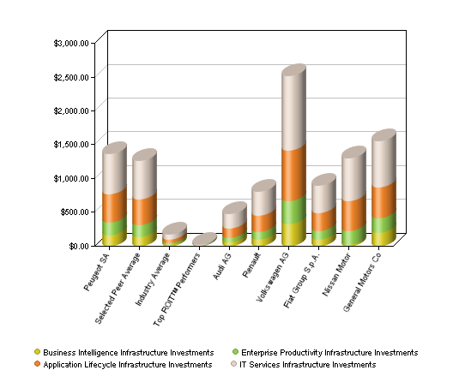

Peugeot SA IT Hierarchy of Needs
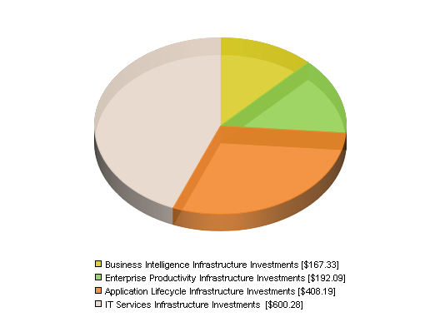

Peer Average IT Hierarchy of Needs
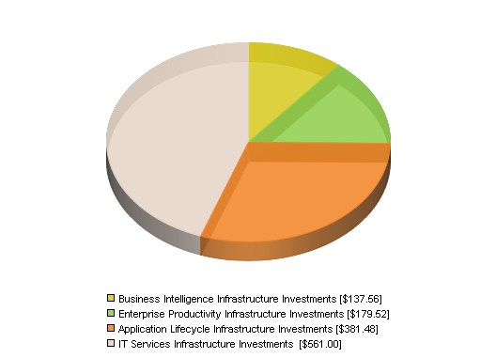

Business Intelligence Infrastructure Investments
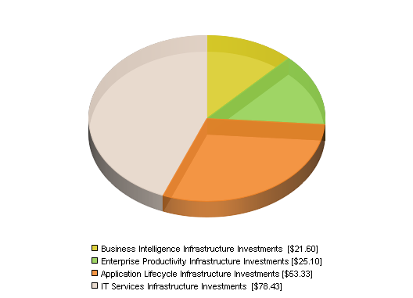

Business Intelligence Infrastructure Investments
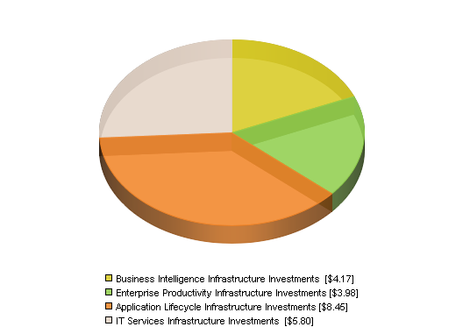

5.5. Project Risk Profile

Successful projects are those projects which are delivered on-time, on-budget, meeting specified requirements and ultimately delivering the business value expected from the project deliverable. Clearly the more projects that succeed the more business value is derived from IT Investments to improve business performance. Companies with superior IT project management capabilities and higher success rates have been proven to be better RETURN ON ITTM performers.

 | Company Name |  | Projects canceled before completion |  |  | Projects behind schedule, over budget, short features |  |  | Projects successful delivery, but short on promised value |  |  |  |  | Projects successful delivery and value realization
 | Peugeot SA |  | 11.0% |  |  | 21.4% |  |  | 32.4% |  |  |  |  | 35.2%
 | Industry Average |  | 11.1% |  |  | 21.5% |  |  | 32.5% |  |  |  |  | 35.0%
 | Top ROIT™ Performers |  | 10.6% |  |  | 20.7% |  |  | 31.3% |  |  |  |  | 37.4%

IT Project Risk Index
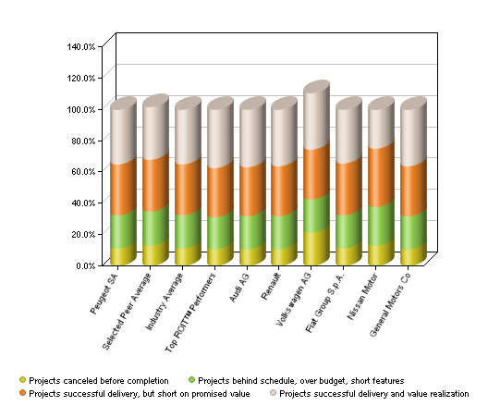

Peugeot SA Project Risk
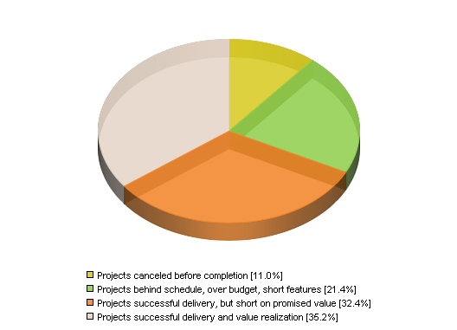

Peer Average Project Risk
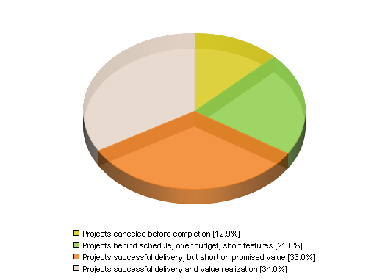

Industry Average Project Risk
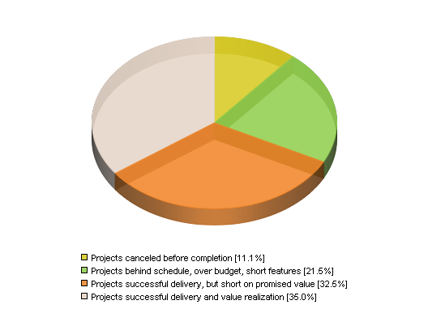

Top ROIT™ Performers Project Risk
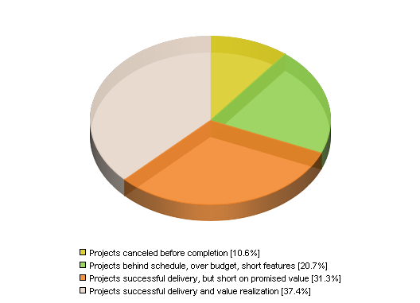

5.6. IT Total Cost of Ownership (TCO) Spending Details

IT TCO Spending Details compares ABC Company's IT spending to Selected Peers Average, Industry Average and Top RETURN ON ITTM Performers across a number of key IT spending categories.

 |  |  |  |  | Peugeot SA |  |  |  |  | Selected Peer Average |  |  |  |  |  |  | Industry Average |  |  |  |  |  | Top ROIT™ Performers
 | Company Name |  |  |  |  | (in millions) |  | (%) |  |  | (in millions) |  | (%) |  |  |  | (in millions) |  | (%) |  |  |  | (in millions) |  | (%)
 | IT hardware spending |  |  |  |  | $205.2 |  | 15.0% |  |  | $188.9 |  | 15.0% |  |  |  | $26.7 |  | 15.0% |  |  |  | $4.4 |  | 15.0%
 | IT software spending |  |  |  |  | $246.2 |  | 18.0% |  |  | $226.7 |  | 18.0% |  |  |  | $32.1 |  | 18.0% |  |  |  | $5.2 |  | 18.0%
 | IT operations and admin labor and services spending |  |  |  |  | $399.4 |  | 29.2% |  |  | $367.8 |  | 29.2% |  |  |  | $52.0 |  | 29.2% |  |  |  | $8.5 |  | 29.2%
 | Application development labor and services spending |  |  |  |  | $366.6 |  | 26.8% |  |  | $337.6 |  | 26.8% |  |  |  | $47.8 |  | 26.8% |  |  |  | $5.5 |  | 19.0%
 | Data and voice communications spending |  |  |  |  | $95.8 |  | 7.0% |  |  | $88.2 |  | 7.0% |  |  |  | $12.5 |  | 7.0% |  |  |  | $2.0 |  | 7.0%
 | Facilities and overhead spending |  |  |  |  | $54.7 |  | 4.0% |  |  | $50.4 |  | 4.0% |  |  |  | $7.1 |  | 4.0% |  |  |  | $1.2 |  | 4.0%
 | Total IT Spending |  |  |  |  | $1,367.9 |  | 100.0% |  |  | $1,259.6 |  | 100.0% |  |  |  | $178.2 |  | 100.0% |  |  |  | $29.0 |  | 92.2%

IT Spending Details
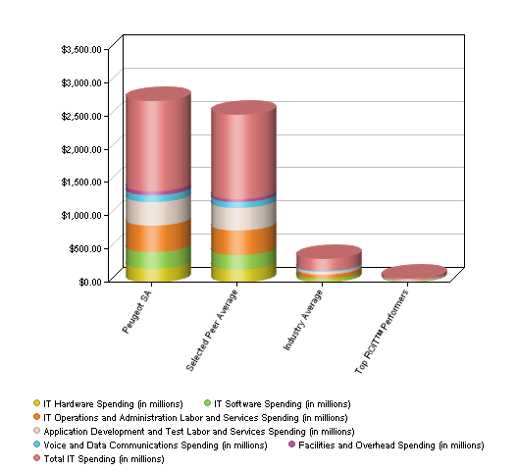

Peugeot SA IT Spending Details
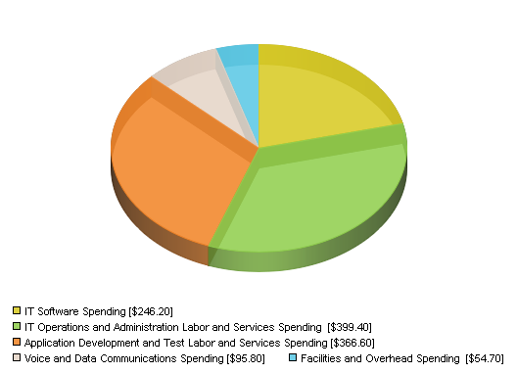

Peer Average IT Spending Details
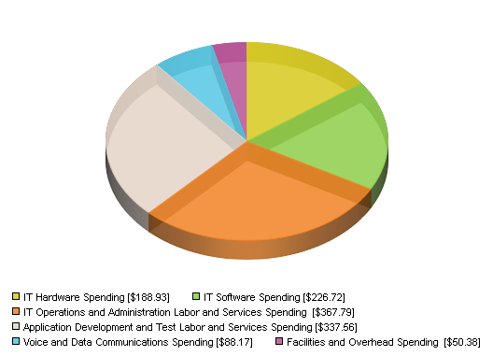

Industry Average IT Spending Details
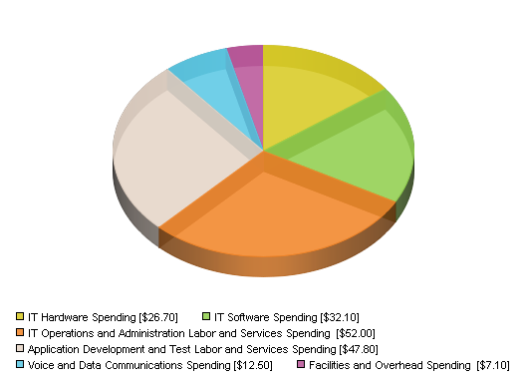

Top ROIT™ Performers IT Spending Details
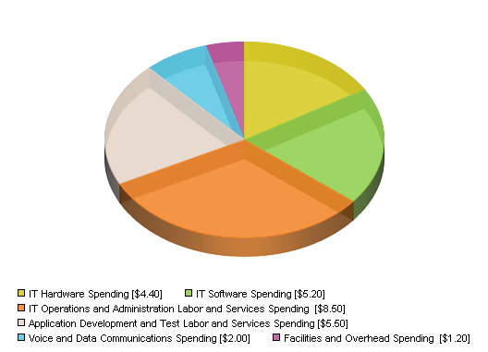

6. IT Opportunity Review

Improving the IT organization capability and maturity can lead to a more efficient and effective organization, and drive business value. The organization is measured across several areas of competency to determine the largest opportunities for improvement.

Peugeot SA's Adoption Scores
The Adoption Score indicates the current adoption level of IT value acceleration strategies within each tier of the IT Hierarchy of Needs compared to Peer Benchmarks.
IT Hierarchy of Needs Category | Peugeot SA Adoption Score | Peer Benchmark Adoption Score | Possible Points
IT services infrastructure value acceleration strategies | 0 | 165 | 250
Application lifecycle infrastructure value acceleration strategies | 0 | 180 | 250
Enterprise productivity infrastructure value acceleration strategies | 0 | 150 | 250
Business intelligence infrastructure value acceleration strategies | 0 | 125 | 250
Overall IT Value Acceleration Strategies | 0 | 620 | 1,000

Acceleration Strategies Adoption Scores
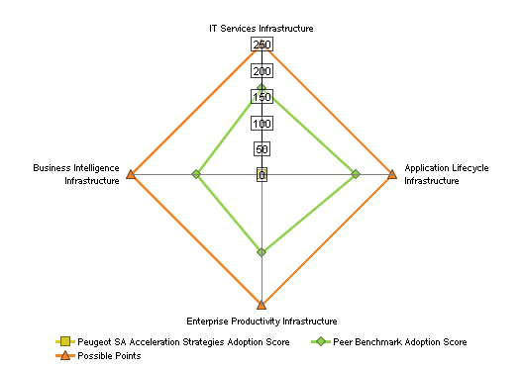

Peugeot SA's Improvement Opportunity
The following provides the type of improvement and the expected level of improvement as percentage over the existing environment by adopting the surveyed Value Acceleration Strategies and implementing solutions within each tier of the IT Hierarchy of Needs.
 | Level of Improvement
Type of Improvement | IT Services Infrastructure | Application Lifecycle Infrastructure | Enterprise Productivity Infrastructure |  | Business Intelligence Infrastructure
Business Advantage
Increase revenue opportunities |  |  | 20% |  | 30%
Reduce business expenses |  | 27% | 60% |  | 30%
Improve customer and partner care and user experience | 22% | 30% | 70% |  | 90%
Improve business processes & agility | 30% | 90% | 40% |  | 80%
Improve business productivity & efficiency | 48% | 33% | 90% |  | 50%
IT Advantage
Reduce business & IT risks | 58% | 25% | 35% |  | 43%
Improve IT development productivity & efficiency | 27% | 87%
Reduce IT spending | 88% |  |  |  | 14%
Improve IT operations productivity & efficiency | 84% |  |  |  | 17%
Improve IT quality of service | 90%

Peugeot SA's Improvement Opportunity
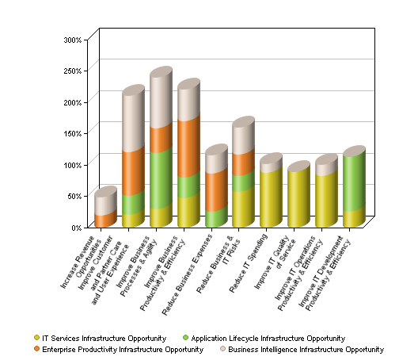

7. Peer Comparison Data and Methodology

7.1. Application

Peer Comparison is designed as a strategic tool to be used for "top down" analysis of the effectiveness of a company's IT spending relative to a user-defined set of peer companies ("Peer Universe").

The high-level gap analysis produced by Peer Comparison is designed to identify areas of IT spending effectiveness or ineffectiveness relative to the Peer Universe. These gaps are intended to catalyze further discussion and detailed analysis of areas where the selected company can close competitive gaps or expand competitive advantage.

7.2. Source Data

Peer Comparisons global company database is comprised of three years' publicly reported information from more than 15,000 U.S. public companies, and 5,000 non-U.S. public companies in 100 countries. This information is compiled from company annual reports by Morningstar, Inc. and updated quarterly to reflect newly published financial information. Due to differences in financial reporting practices between companies, industries, and countries, Peer Comparison depends upon Morningstar’s currency exchange rates, taxonomy and reconciliation for purposes of consistency.

For the analysis, the following criteria was used to define key comparison groups:

- Selected Peers Average is the average of the peers selected for use in the analysis.
- Industry Average is specific to the Target Company's Industry and Size.
- Industry Top RETURN ON ITTM Performers is an average of companies in the first quartile of RETURN ON ITTM performance.

7.3. Estimated IT Spending

Total IT spending compares the total investment in IT and measures overall spending efficiency and effectiveness. For this analysis, data from Alinean is used to estimate the IT Spending analysis using the following components:

IT Spending = Formal IT Spending + Business Unit IT Spending + Shadow (Indirect) IT Spending

Where:
a. Formal IT spending is the formal budget under direct management of the CIO
b. Business Unit IT Spending is the formal spending under business unit control
c. Shadow (Indirect) IT Spending is the informal, under the radar spending on IT from individual users (peer and self-support) and unofficial business unit IT expenditures

Total IT spending is estimated based on industry research from Alinean and data collected annually on over 500 companies worldwide. The survey results of the annual IT budget and total cost of ownership (TCO) studies are statistically extrapolated across Alinean's Value BaseTM of over 20,000 companies worldwide. Because IT spending is not reported, the analysis utilizes a statistical extrapolation - utilizing known financials and a proprietary algorithm - to accurately predict IT spending for any company.

The statistical formula for extrapolation of IT spending uses known financial information from organization filings and an estimation formula as follows:

IT Spending = ((A * B * Number of Employees) + (C * D * Operating Expenses)) * E * F * G

Where the coefficients A-F represent proprietary coefficients that are used to derive total IT spending from known financial reports and metrics, and are defined as follows:

A = Contribution of per Employee TCO to IT spending

B = per employee TCO

C = Contribution of IT spending as a percentage point of Operating Expenses to IT spending

D = the unit cost IT spending as a percentage of Operating Expenses

E = the industry factor in IT expenditures

F = the geographic factor in IT expenditures

G = company size factor in IT expenditures

Comparing Peer ComparisonTM predictive model estimates of IT Spending with the survey results provides a +/- 7% accuracy against actual IT spending.

As described, the Alinean IT spending model is a predictive simulation, utilizing known company factors to estimate IT spending. Based on 500 surveyed company's IT spending, the model has been tested and fine tuned to be as accurate as possible, but it is still a simulation. The simulation is statistically significant, within a few percentage points in some cases, but not predicting actual expenditures in others. The model is accurate with the following caveats:

1. The model reflects the company's IT spending if it were a typical company with the same operating expenses, employee count, industry, geographic location and company size. Unique short term differences in spending such as special projects, massive outsourcing projects, or drastic cost cutting measures would not be reflected accurately in such as model as the model averages such outliers to form a typical average around company characteristics. If the company of interest does not match the model there is usually a logical reason for the over / under condition - the difference in the company from what an average look-alike company would be.

2. The model reflects total IT spending not just formal IT spending. Looking only at formal IT spending and comparing the figure to the total spending is not accurate as the model predicts total spending as Formal IT spending, Business Unit IT spending and Shadow IT spending, and then estimates allocations of these based on the unique company characteristics. If the company of interest does not match the model often the scope of the spending analysis did not include all factors of spending including business unit spending (from 10-30% of total IT spending) and Shadow spending (often 10-20% of total IT spending).

7.4. Currency

All figures are expressed in the indicated currency. All currency data is converted by financial data provider Morningstar, Inc. into USD using the spot rate (exchange rate) at the time the annual report was filed. The currency is converted from USD to the selected currency based on current exchange rates as specified in the tool.

7.5. Peer Selection Criteria

Up to 10 companies may be defined in the Peer Universe for purposes of head-to-head comparison. A list of potential peer companies can be identified individually by name, from a list based on primary SIC code, revenue, number of employees, or geographic location.

While the selection of companies in the Peer Universe is discretionary and subjective, results are typically most meaningful when the Peer Universe is comprised of relevant market leaders within specific industries and with similar business models. Relevant market leaders typical come from the same industry and geographic location but may often include "best in class" companies from other industries.

8. About Alinean

Alinean, the leading provider of dynamic sales and marketing tools, empowers B2B vendors to better sell to today's economic-focused buyer. Alinean-powered interactive white papers, assessments, ROI calculators and TCO comparison tools create more compelling value-based connections, workshops, presentations and proposals — delivering customized diagnostics, benchmarks, solution recommendations, benefits, investments, ROI, payback and TCO advantage proof points.

Leading B2B firms leveraging Alinean tools include: HP, IBM, Microsoft, EMC, Dell, Intel, IDC/IDG, AT&T, Siemens, Unisys, Thomson Reuters, NetApp, Citrix, Symantec, Novell, Cisco, Oracle, Sybase, and CA.
Learn more at the Fight FrugalnomicsTM Resource Center http://www.fightfrugalnomics.com, or by visiting http://www.alinean.com, or calling 407.382.0005
Rev 3/11
Appendix A:

 | If required, Peugeot SA details may be edited.
 | Company Name |  | Peugeot SA
 | Company Ticker symbol
 | Company Description
 | Company Industry |  | Automotive and Vehicle Manufacturing
 | Company Geographic Region |  | France
 | Publish Year of Performance Data (Annual Report): |  | 2007
 | Annual sales revenue |  | $88,620,416,460
 | Annual growth in sales revenue (over prior year) |  | 18.8%
 | Annual net income |  | $2,561,545,702
 | Annual net income growth (over prior year) |  | 115.9%
 | Number of employees |  | 207,800
 | Number of knowledge workers (less than # of employees) |  | 176,630
 | Number of IT Staff |  | 7,096
 | Number of IT operations admin staff |  | 3,811
 | Number of IT development staff |  | 3,285
 | Total IT Spending |  | $1,367,891,044
 | Annual IT Spending Growth (over prior year) |  | 4.4%
 | RETURN ON IT(tm) |  | 187.3%
 | Spending Control Type |  |  | (in millions)
 |  | Formal IT Spending | 69.7% | $953.4
 |  | Business Unit IT Spending | 25.0% | $342.0
 |  | Shadow IT Spending | 5.3% | $72.5
 | Total (should equal 100%) |  | 100.0%
 | Innovation versus Ongoing Operations |  |  | (in millions)
 |  | Innovation | 19.2% | $263.1
 |  | Migrations and Upgrades | 22.5% | $307.1
 |  | Ongoing Operations | 58.3% | $797.7
 | Total (should equal 100%) |  | 100.0%
 | IT Hierarchy of Needs |  |  | (in millions)
 |  | Business Intelligence Infrastructure Investments | 12.2% | $167.3
 |  | Enterprise Productivity Infrastructure Investments | 14.0% | $192.1
 |  | Application Lifecycle Infrastructure Investments | 29.8% | $408.2
 |  | IT Services Infrastructure Investments | 43.9% | $600.3
 | Total (should equal 100%) |  | 100.0%
 | Front / Backoffice Spending |  |  | (in millions)
 |  | Front Office Applications | 40.5% | $553.5
 |  | Back Office Applications | 59.5% | $814.4
 | Total (should equal 100%) |  | 100.0%
 | IT Project Risk |  |  | (in millions)
 |  | Projects canceled before completion | 11.0% | $150.6
 |  | Projects behind schedule, over budget, short features | 21.4% | $292.4
 |  | Projects successful delivery, but short on promised value | 32.4% | $443.0
 |  | Projects successful delivery and value realization | 35.2% | $481.9
 | Total (should equal 100%) |  | 100.0%
 | IT Spending TCO Details |  |  | (in millions)
 |  | IT Hardware | 15.0% | $205.2
 |  | IT Software | 18.0% | $246.2
 |  | IT Operations and Administration Labor and Services | 29.2% | $399.4
 |  | Application Development and Test Labor and Services | 26.8% | $366.6
 |  | Data and Voice Communications | 7.0% | $95.8
 |  | Facilities and Overhead | 4.0% | $54.7
 | Total (should equal 100%) |  | 100.0%

 | If required, Audi AG details may be edited.
 | Company Name |  | Audi AG
 | Company Ticker symbol |  | NSU
 | Company Description
 | HanseYachts AG manufactures and markets sailing and motor yachts. It offers sailing yachts under the Hanse brand and motorboats under the FJORD brand. The company also operates a marina and a restaurant. It markets and distributes its products through independent franchised dealers and an independent network of dealers primarily in northern and southern Europe, as well as in Australia, continental America, and Asia. The company was founded in 1993 and is based in Greifswald, Germany.
 | Company Industry |  | Automotive and Vehicle Manufacturing
 | Company Geographic Region |  | Germany
 | Publish Year of Performance Data (Annual Report): |  | 2010
 | Annual sales revenue |  | $47,135,257,348
 | Annual growth in sales revenue (over prior year) |  | 18.8%
 | Annual net income |  | $3,497,805,559
 | Annual net income growth (over prior year) |  | 95.2%
 | Number of employees |  | 58,182
 | Number of knowledge workers (less than # of employees) |  | 49,454
 | Number of IT Staff |  | 2,398
 | Number of IT operations admin staff |  | 1,288
 | Number of IT development staff |  | 1,110
 | Total IT Spending |  | $477,705,390
 | Annual IT Spending Growth (over prior year) |  | 0.3%
 | RETURN ON IT(tm) |  | 732.2%
 | Spending Control Type |  |  | (in millions)
 |  | Formal IT Spending | 69.7% | $333.0
 |  | Business Unit IT Spending | 25.0% | $119.4
 |  | Shadow IT Spending | 5.3% | $25.3
 | Total (should equal 100%) |  | 100.0%
 | Innovation versus Ongoing Operations |  |  | (in millions)
 |  | Innovation | 20.6% | $98.4
 |  | Migrations and Upgrades | 22.1% | $105.5
 |  | Ongoing Operations | 57.3% | $273.9
 | Total (should equal 100%) |  | 100.0%
 | IT Hierarchy of Needs |  |  | (in millions)
 |  | Business Intelligence Infrastructure Investments | 13.6% | $64.9
 |  | Enterprise Productivity Infrastructure Investments | 13.8% | $66.0
 |  | Application Lifecycle Infrastructure Investments | 29.4% | $140.3
 |  | IT Services Infrastructure Investments | 43.2% | $206.4
 | Total (should equal 100%) |  | 100.0%
 | Front / Backoffice Spending |  |  | (in millions)
 |  | Front Office Applications | 43.2% | $206.3
 |  | Back Office Applications | 56.8% | $271.4
 | Total (should equal 100%) |  | 100.0%
 | IT Project Risk |  |  | (in millions)
 |  | Projects canceled before completion | 10.8% | $51.5
 |  | Projects behind schedule, over budget, short features | 20.9% | $100.0
 |  | Projects successful delivery, but short on promised value | 31.7% | $151.4
 |  | Projects successful delivery and value realization | 36.6% | $174.8
 | Total (should equal 100%) |  | 100.0%
 | IT Spending TCO Details |  |  | (in millions)
 |  | IT Hardware | 15.0% | $71.7
 |  | IT Software | 18.0% | $86.0
 |  | IT Operations and Administration Labor and Services | 29.2% | $139.5
 |  | Application Development and Test Labor and Services | 26.8% | $128.0
 |  | Data and Voice Communications | 7.0% | $33.4
 |  | Facilities and Overhead | 4.0% | $19.1
 | Total (should equal 100%) |  | 100.0%

 | If required, Renault details may be edited.
 | Company Name |  | Renault
 | Company Ticker symbol |  | RNO
 | Company Description
 | Company Industry |  | Automotive and Vehicle Manufacturing
 | Company Geographic Region |  | France
 | Publish Year of Performance Data (Annual Report): |  | 2010
 | Annual sales revenue |  | $51,830,030,589
 | Annual growth in sales revenue (over prior year) |  | 15.6%
 | Annual net income |  | $4,641,574,677
 | Annual net income growth (over prior year) |  | 213.8%
 | Number of employees |  | 124,749
 | Number of knowledge workers (less than # of employees) |  | 106,036
 | Number of IT Staff |  | 4,175
 | Number of IT operations admin staff |  | 2,242
 | Number of IT development staff |  | 1,933
 | Total IT Spending |  | $804,749,843
 | Annual IT Spending Growth (over prior year) |  | 0.0%
 | RETURN ON IT(tm) |  | 576.8%
 | Spending Control Type |  |  | (in millions)
 |  | Formal IT Spending | 69.7% | $560.9
 |  | Business Unit IT Spending | 25.0% | $201.2
 |  | Shadow IT Spending | 5.3% | $42.7
 | Total (should equal 100%) |  | 100.0%
 | Innovation versus Ongoing Operations |  |  | (in millions)
 |  | Innovation | 20.4% | $163.8
 |  | Migrations and Upgrades | 22.1% | $178.2
 |  | Ongoing Operations | 57.5% | $462.7
 | Total (should equal 100%) |  | 100.0%
 | IT Hierarchy of Needs |  |  | (in millions)
 |  | Business Intelligence Infrastructure Investments | 13.4% | $107.5
 |  | Enterprise Productivity Infrastructure Investments | 13.9% | $111.6
 |  | Application Lifecycle Infrastructure Investments | 29.5% | $237.1
 |  | IT Services Infrastructure Investments | 43.3% | $348.6
 | Total (should equal 100%) |  | 100.0%
 | Front / Backoffice Spending |  |  | (in millions)
 |  | Front Office Applications | 42.7% | $343.7
 |  | Back Office Applications | 57.3% | $461.0
 | Total (should equal 100%) |  | 100.0%
 | IT Project Risk |  |  | (in millions)
 |  | Projects canceled before completion | 10.8% | $87.1
 |  | Projects behind schedule, over budget, short features | 21.0% | $169.0
 |  | Projects successful delivery, but short on promised value | 31.8% | $256.1
 |  | Projects successful delivery and value realization | 36.4% | $292.6
 | Total (should equal 100%) |  | 100.0%
 | IT Spending TCO Details |  |  | (in millions)
 |  | IT Hardware | 15.0% | $120.7
 |  | IT Software | 18.0% | $144.9
 |  | IT Operations and Administration Labor and Services | 29.2% | $235.0
 |  | Application Development and Test Labor and Services | 26.8% | $215.7
 |  | Data and Voice Communications | 7.0% | $56.3
 |  | Facilities and Overhead | 4.0% | $32.2
 | Total (should equal 100%) |  | 100.0%

 | If required, Volkswagen AG details may be edited.
 | Company Name |  | Volkswagen AG
 | Company Ticker symbol |  | VKW
 | Company Description
 | Provides contract drilling services
 | Company Industry |  | Automotive and Vehicle Manufacturing
 | Company Geographic Region |  | Germany
 | Publish Year of Performance Data (Annual Report): |  | 2010
 | Annual sales revenue |  | $168,739,194,042
 | Annual growth in sales revenue (over prior year) |  | 20.6%
 | Annual net income |  | $9,090,304,562
 | Annual net income growth (over prior year) |  | 612.0%
 | Number of employees |  | 427,184
 | Number of knowledge workers (less than # of employees) |  | 363,106
 | Number of IT Staff |  | 12,650
 | Number of IT operations admin staff |  | 6,794
 | Number of IT development staff |  | 5,856
 | Total IT Spending |  | $2,519,475,573
 | Annual IT Spending Growth (over prior year) |  | 8.8%
 | RETURN ON IT(tm) |  | 360.8%
 | Spending Control Type |  |  | (in millions)
 |  | Formal IT Spending | 69.7% | $1,756.1
 |  | Business Unit IT Spending | 25.0% | $629.9
 |  | Shadow IT Spending | 5.3% | $133.5
 | Total (should equal 100%) |  | 100.0%
 | Innovation versus Ongoing Operations |  |  | (in millions)
 |  | Innovation | 19.9% | $501.1
 |  | Migrations and Upgrades | 22.3% | $561.1
 |  | Ongoing Operations | 57.8% | $1,457.3
 | Total (should equal 100%) |  | 100.0%
 | IT Hierarchy of Needs |  |  | (in millions)
 |  | Business Intelligence Infrastructure Investments | 12.9% | $324.7
 |  | Enterprise Productivity Infrastructure Investments | 13.9% | $351.2
 |  | Application Lifecycle Infrastructure Investments | 29.6% | $746.2
 |  | IT Services Infrastructure Investments | 43.6% | $1,097.4
 | Total (should equal 100%) |  | 100.0%
 | Front / Backoffice Spending |  |  | (in millions)
 |  | Front Office Applications | 41.8% | $1,052.6
 |  | Back Office Applications | 58.2% | $1,466.9
 | Total (should equal 100%) |  | 100.0%
 | IT Project Risk |  |  | (in millions)
 |  | Projects canceled before completion | 10.9% | $274.6
 |  | Projects behind schedule, over budget, short features | 21.2% | $533.0
 |  | Projects successful delivery, but short on promised value | 32.1% | $807.6
 |  | Projects successful delivery and value realization | 35.9% | $904.2
 | Total (should equal 100%) |  | 100.0%
 | IT Spending TCO Details |  |  | (in millions)
 |  | IT Hardware | 15.0% | $377.9
 |  | IT Software | 18.0% | $453.5
 |  | IT Operations and Administration Labor and Services | 29.2% | $735.7
 |  | Application Development and Test Labor and Services | 26.8% | $675.2
 |  | Data and Voice Communications | 7.0% | $176.4
 |  | Facilities and Overhead | 4.0% | $100.8
 | Total (should equal 100%) |  | 100.0%

 | If required, Fiat Group S.p.A. details may be edited.
 | Company Name |  | Fiat Group S.p.A.
 | Company Ticker symbol |  | FIAZY
 | Company Description
 | Provides contract drilling services
 | Company Industry |  | Automotive and Vehicle Manufacturing
 | Company Geographic Region |  | Italy
 | Publish Year of Performance Data (Annual Report): |  | 2010
 | Annual sales revenue |  | $47,719,111,584
 | Annual growth in sales revenue (over prior year) |  | -28.4%
 | Annual net income |  | $797,978,455
 | Annual net income growth (over prior year) |  | 171.6%
 | Number of employees |  | 195,728
 | Number of knowledge workers (less than # of employees) |  | 136,340
 | Number of IT Staff |  | 4,638
 | Number of IT operations admin staff |  | 2,491
 | Number of IT development staff |  | 2,147
 | Total IT Spending |  | $894,180,306
 | Annual IT Spending Growth (over prior year) |  | -9.7%
 | RETURN ON IT(tm) |  | 89.2%
 | Spending Control Type |  |  | (in millions)
 |  | Formal IT Spending | 74.7% | $668.0
 |  | Business Unit IT Spending | 21.5% | $192.2
 |  | Shadow IT Spending | 3.8% | $34.0
 | Total (should equal 100%) |  | 100.0%
 | Innovation versus Ongoing Operations |  |  | (in millions)
 |  | Innovation | 18.5% | $165.3
 |  | Migrations and Upgrades | 22.7% | $202.6
 |  | Ongoing Operations | 58.8% | $526.2
 | Total (should equal 100%) |  | 100.0%
 | IT Hierarchy of Needs |  |  | (in millions)
 |  | Business Intelligence Infrastructure Investments | 11.5% | $102.8
 |  | Enterprise Productivity Infrastructure Investments | 14.2% | $126.6
 |  | Application Lifecycle Infrastructure Investments | 30.1% | $269.1
 |  | IT Services Infrastructure Investments | 44.3% | $395.7
 | Total (should equal 100%) |  | 100.0%
 | Front / Backoffice Spending |  |  | (in millions)
 |  | Front Office Applications | 39.0% | $348.6
 |  | Back Office Applications | 61.0% | $545.6
 | Total (should equal 100%) |  | 100.0% | $894.2
 | IT Project Risk |  |  | (in millions)
 |  | Projects canceled before completion | 11.1% | $99.6
 |  | Projects behind schedule, over budget, short features | 21.6% | $193.3
 |  | Projects successful delivery, but short on promised value | 32.8% | $292.9
 |  | Projects successful delivery and value realization | 34.5% | $308.4
 | Total (should equal 100%) |  | 100.0%
 | IT Spending TCO Details |  |  | (in millions)
 |  | IT Hardware | 15.0% | $134.1
 |  | IT Software | 18.0% | $161.0
 |  | IT Operations and Administration Labor and Services | 29.2% | $261.1
 |  | Application Development and Test Labor and Services | 26.8% | $239.6
 |  | Data and Voice Communications | 7.0% | $62.6
 |  | Facilities and Overhead | 4.0% | $35.8
 | Total (should equal 100%) |  | 100.0%

 | If required, Nissan Motor details may be edited.
 | Company Name |  | Nissan Motor
 | Company Ticker symbol |  | NSANY
 | Company Description
 | Manufactures and sells automotives
 | Company Industry |  | Automotive and Vehicle Manufacturing
 | Company Geographic Region |  | Japan
 | Publish Year of Performance Data (Annual Report): |  | 2009
 | Annual sales revenue |  | $85,420,411,056
 | Annual growth in sales revenue (over prior year) |  | -21.7%
 | Annual net income |  | ($2,366,194,189)
 | Annual net income growth (over prior year) |  | -148.7%
 | Number of employees |  | 160,422
 | Number of knowledge workers (less than # of employees) |  | 136,358
 | Number of IT Staff |  | 7,174
 | Number of IT operations admin staff |  | 3,853
 | Number of IT development staff |  | 3,321
 | Total IT Spending |  | $1,306,113,274
 | Annual IT Spending Growth (over prior year) |  | 0.0%
 | RETURN ON IT(tm) |  | -181.2%
 | Spending Control Type |  |  | (in millions)
 |  | Formal IT Spending | 84.7% | $1,106.3
 |  | Business Unit IT Spending | 12.5% | $163.3
 |  | Shadow IT Spending | 2.8% | $36.6
 | Total (should equal 100%) |  | 100.0%
 | Innovation versus Ongoing Operations |  |  | (in millions)
 |  | Innovation | 8.8% | $114.9
 |  | Migrations and Upgrades | 25.4% | $331.1
 |  | Ongoing Operations | 65.8% | $860.0
 | Total (should equal 100%) |  | 100.0%
 | IT Hierarchy of Needs |  |  | (in millions)
 |  | Business Intelligence Infrastructure Investments | 1.8% | $23.5
 |  | Enterprise Productivity Infrastructure Investments | 15.7% | $205.2
 |  | Application Lifecycle Infrastructure Investments | 33.4% | $436.1
 |  | IT Services Infrastructure Investments | 49.1% | $641.3
 | Total (should equal 100%) |  | 100.0%
 | Front / Backoffice Spending |  |  | (in millions)
 |  | Front Office Applications | 19.6% | $256.0
 |  | Back Office Applications | 80.4% | $1,050.1
 | Total (should equal 100%) |  | 100.0%
 | IT Project Risk |  |  | (in millions)
 |  | Projects canceled before completion | 12.8% | $167.0
 |  | Projects behind schedule, over budget, short features | 24.8% | $324.1
 |  | Projects successful delivery, but short on promised value | 37.6% | $491.1
 |  | Projects successful delivery and value realization | 24.8% | $323.9
 | Total (should equal 100%) |  | 100.0%
 | IT Spending TCO Details |  |  | (in millions)
 |  | IT Hardware | 15.0% | $195.9
 |  | IT Software | 18.0% | $235.1
 |  | IT Operations and Administration Labor and Services | 29.2% | $381.4
 |  | Application Development and Test Labor and Services | 26.8% | $350.0
 |  | Data and Voice Communications | 7.0% | $91.4
 |  | Facilities and Overhead | 4.0% | $52.2
 | Total (should equal 100%) |  | 100.0%

 | If required, General Motors Co details may be edited.
 | Company Name |  | General Motors Co
 | Company Ticker symbol |  | GMM/U
 | Company Description
 | Provides contract drilling services
 | Company Industry |  | Automotive and Vehicle Manufacturing
 | Company Geographic Region |  | United States
 | Publish Year of Performance Data (Annual Report): |  | 2010
 | Annual sales revenue |  | $135,592,000,000
 | Annual growth in sales revenue (over prior year) |  | 29.6%
 | Annual net income |  | $6,172,000,000
 | Annual net income growth (over prior year) |  | -94.1%
 | Number of employees |  | 209,000
 | Number of knowledge workers (less than # of employees) |  | 177,650
 | Number of IT Staff |  | 7,261
 | Number of IT operations admin staff |  | 3,900
 | Number of IT development staff |  | 3,361
 | Total IT Spending |  | $1,555,155,494
 | Annual IT Spending Growth (over prior year) |  | 0.0%
 | RETURN ON IT(tm) |  | 396.9%
 | Spending Control Type |  |  | (in millions)
 |  | Formal IT Spending | 59.7% | $928.4
 |  | Business Unit IT Spending | 32.0% | $497.6
 |  | Shadow IT Spending | 8.3% | $129.1
 | Total (should equal 100%) |  | 100.0%
 | Innovation versus Ongoing Operations |  |  | (in millions)
 |  | Innovation | 20.0% | $310.8
 |  | Migrations and Upgrades | 22.2% | $345.9
 |  | Ongoing Operations | 57.8% | $898.4
 | Total (should equal 100%) |  | 100.0%
 | IT Hierarchy of Needs |  |  | (in millions)
 |  | Business Intelligence Infrastructure Investments | 13.0% | $201.9
 |  | Enterprise Productivity Infrastructure Investments | 13.9% | $216.5
 |  | Application Lifecycle Infrastructure Investments | 29.6% | $460.1
 |  | IT Services Infrastructure Investments | 43.5% | $676.6
 | Total (should equal 100%) |  | 100.0%
 | Front / Backoffice Spending |  |  | (in millions)
 |  | Front Office Applications | 42.0% | $652.7
 |  | Back Office Applications | 58.0% | $902.5
 | Total (should equal 100%) |  | 100.0%
 | IT Project Risk |  |  | (in millions)
 |  | Projects canceled before completion | 10.9% | $169.2
 |  | Projects behind schedule, over budget, short features | 21.1% | $328.5
 |  | Projects successful delivery, but short on promised value | 32.0% | $497.8
 |  | Projects successful delivery and value realization | 36.0% | $559.6
 | Total (should equal 100%) |  | 100.0%
 | IT Spending TCO Details |  |  | (in millions)
 |  | IT Hardware | 15.0% | $233.3
 |  | IT Software | 18.0% | $279.9
 |  | IT Operations and Administration Labor and Services | 29.2% | $454.1
 |  | Application Development and Test Labor and Services | 26.8% | $416.8
 |  | Data and Voice Communications | 7.0% | $108.9
 |  | Facilities and Overhead | 4.0% | $62.2
 | Total (should equal 100%) |  | 100.0%

