ER diagram for employee database

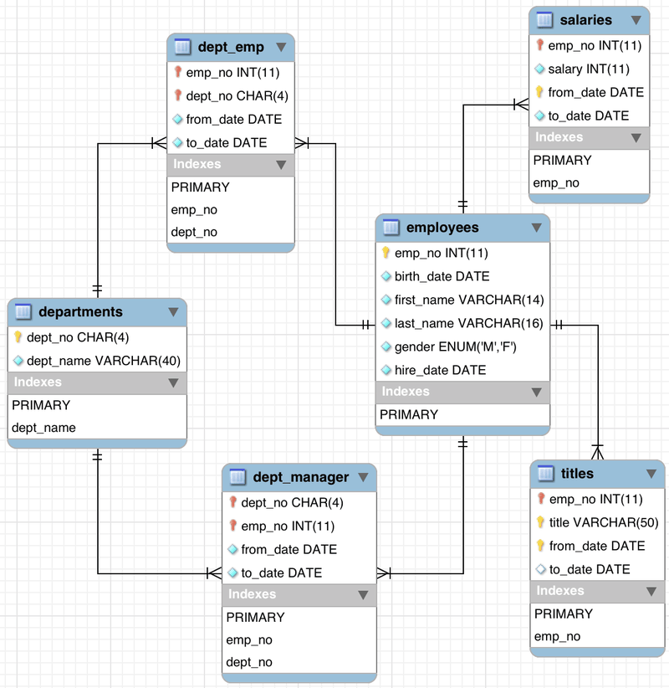

Required: Using the information provided above, specify the SQL syntax for the following:

1. Show a list of all the tables in the database.

SHOW TABLES;

1. Find the names, and gender of all employees.

SELECT first_name, last_name, gender

FROM employees;

1. Find all job titles.

SELECT title

FROM titles;

1. Find all distinct job titles.

SELECT DISTINCT(title)

FROM titles;

1. What is the total number of employees?

SELECT COUNT(emp_no)

FROM employees;

1. How many times were salaries paid?

SELECT COUNT(*)

FROM salaries;

1. How many departments are there?

SELECT COUNT(DISTINCT(dept_name))

FROM departments;

1. What are the names of these departments?

SELECT DISTINCT(dept_name)

FROM departments;

1. Find the names of all female employees.

SELECT last_name, first_name

FROM employees

Where gender = "F";

1. How many male employees are there?

SELECT COUNT(*)

FROM employees

WHERE gender = "M";

1. Find all employees who were hired before the year 1990.

SELECT first_name, last_name

FROM employees

WHERE hire_date < "1990-01-01";

1. Find male employees who were hired after 1995;

SELECT first_name, last_name, gender, hire_date

FROM employees

WHERE hire_date >= "1995-01-01" AND gender = "M";

1. How many employees have their first names as either Adin, Deniz, Youssef and Roded?

SELECT COUNT(first_name)

FROM employees

WHERE first_name IN ("Adin", "Deniz", "Youssef", "Roded");

1. How many employees are:
   1. engineers?

To see what titles are there first:

SELECT distinct(title)

FROM titles;

Finding out how many engineers:

SELECT COUNT(title) AS Number_of_Engineers

FROM titles

WHERE title IN ("Engineer", "Senior Engineer", "Assistant Engineer");

* 1. non-engineers?

SELECT COUNT(title)

FROM titles

WHERE title NOT IN ("Engineer", "Senior Engineer", "Assistant Engineer");

1. How many employees were hired between 1990/01/01 and 1994/01/01.

SELECT COUNT(emp_no)

FROM employees

WHERE "1990-01-01" <= hire_date AND hire_date <= "1994-01-01";

1. Find the list of unique last names of female employees (in alphabetical order), who were born before the year 1970, and hired after 1996.

SELECT DISTINCT(last_name)

FROM employees

WHERE gender = "F"

AND birth_date < "1970-01-01"

AND hire_date >= "1996-01-01"

ORDER BY last_name;

1. For each gender, how many employees were hired before 1989;

SELECT gender, COUNT(gender)

FROM employees

WHERE hire_date < "1989-01-01"

GROUP BY gender;

1. For each gender:
   1. how many employees are in each department?

SELECT dept_name, COUNT(emp_no) AS Number_of_employees, gender

FROM dept_emp

INNER JOIN departments

USING(dept_no)

INNER JOIN employees

USING(emp_no)

GROUP BY dept_name, Gender

ORDER BY gender;

* 1. hired between the years of 1994-1996?

SELECT gender, COUNT(emp_no)

FROM employees

WHERE "1994-01-01" <= hire_date AND hire_date < "1997-01-01"

GROUP BY gender;

1. List the names of all employees with department managers appointed starting from 1992/09/08 and ending at 1996/01/03.

SELECT first_name, last_name

FROM employees

INNER JOIN dept_emp

USING(emp_no)

WHERE dept_no in (

SELECT dept_no

FROM dept_manager

WHERE from_date = "1992-09-08" AND to_date = "1996-01-03"

);

1. List the names of employees and their respective job titles.

SELECT first_name, last_name, title FROM employees INNER JOIN titles USING(emp_no);

1. Find the average salary of every department.

SELECT dept_name, FORMAT (AVG(salary), 2) AS Average_salary

FROM dept_emp

INNER JOIN departments

USING(dept_no)

INNER JOIN salaries

USING(emp_no)

GROUP BY dept_name;

1. Find the average salary of every department and the number of employees.

SELECT dept_name, FORMAT (AVG(salary), 2) AS Average_salary, COUNT(emp_no) AS Number_of_employees

FROM dept_emp

INNER JOIN departments

USING(dept_no)

INNER JOIN salaries

USING(emp_no)

GROUP BY dept_name;

1. Number of employees in every department who make more than $130000.

SELECT dept_name, COUNT(emp_no) AS Number_of_employees

FROM salaries

INNER JOIN dept_emp

USING(emp_no)

INNER JOIN departments

USING(dept_no)

WHERE salary > 130000

GROUP BY dept_name;