**SCHOOL OF TECHNOLOGY**

**COURSE: BACHELOR OF SCIENCE IN INFORMATION SECURITY AND FORENSICS**

**UNIT CODE: BISF 2208**

**UNIT NAME: SECURITY AND FORENSICS PROJECT**

**TITLE: TOP LOCKERS AND SHELVES INVENTORY MANAGEMENT SYSTEM**

**(SYSTEM REQUIREMENT SPECIFICATION)**

**STUDENT: TIFFANY NDUTA GACUCA**

**REGISTRATION NUMBER: 21/08432**

**SUPERVISOR: CLIVE ONSUMU**

Contents

1. INTRODUCTION 4

PURPOSE 4

SCOPE 4

DEFINITION OF ACRONYMS 4

OVERVIEW 4

2. GENERAL DESCRIPTION 6

SYSTEM PERSPECTIVE 6

Block diagram 6

SYSTEM INTERFACES 6

SYSTEM FUNCTIONALITY 7

USER CHARACTERISTICS 7

GENERAL CONSTRAINTS 8

ASSUMPTIONS AND DEPENDENCIES 8

2.5.1 Assumptions 8

2.5.2 Dependencies 9

3. SPECIFIC REQUIREMENTS 10

3.1 FUNCTIONAL REQUIREMENTS 10

3.2 NON-FUNCTIONAL REQUIREMENTS 10

3.3 USER INTERFACE REQUIREMENTS 10

User Registration 10

Payment processing and receipts 10

3.4 HARDWARE INTERFACES 11

3.5 SOFTWARE INTERFACES 11

3.6 COMMUNICATIONS INTERFACES 11

Other requirements 11

4. APPENDICES 13

Appendix A: User Manual 13

Appendix B: Data Security Protocols 13

Appendix C: System Architecture Diagram 13

Appendix D: Training Materials 13

Appendix E: Sample Reports and Analytics 13

# INTRODUCTION

## PURPOSE

This document serves as a comprehensive blueprint outlining the detailed requirements and functionalities of the proposed automated inventory management system for Top Lockers and Shelves (TLS). It aims to clearly define the system's scope, objectives, and constraints, providing a structured framework for all stakeholders, including developers, designers, and end-users, to understand the project's goals and ensure alignment with the business' specific needs. This document functions as a crucial reference point throughout the development process, guiding the design, implementation, and evaluation phases to ensure the successful delivery of a tailored and efficient solution that significantly enhances the business operations of TLS.

## SCOPE

The System Requirement Specification (SRS) document encompasses a comprehensive outline of the functional and non-functional requirements, design constraints, and user expectations for the proposed automated inventory management system tailored for Top Lockers and Shelves (TLS). It delineates the specific features, modules, and interfaces that the system will incorporate, real-time reporting capabilities, user-friendly interfaces, and data security measures. The scope also includes detailed user roles and permissions, system performance benchmarks, and an outline of the necessary hardware and software components, ensuring a clear understanding of the project's boundaries and the expected deliverables for successful system implementation.

## DEFINITION OF ACRONYMS

* **SRS:** System Requirement Specification
* **TLSIMS:** Top Lockers and Shelves Inventory Management System
* **TLS:** Top Lockers and Shelves

## OVERVIEW

The proposed automated inventory management system for Top Lockers and Shelves is a user-centric solution designed to revolutionize the company's operational efficiency and customer service standards. Leveraging technology, the system offers a comprehensive suite of functionalities, including real-time inventory tracking, seamless sales monitoring, and secure data management. Through intuitive interfaces the system streamlines the process of product identification, collection, and customer interaction, facilitating a seamless experience for both the business and its clients. With an emphasis on scalability and data security, the proposed system is poised to elevate TLS’s position in the market, offering a sustainable and cutting-edge solution to meet the evolving needs of the online retail landscape.

# GENERAL DESCRIPTION

## SYSTEM PERSPECTIVE

Top Lockers and Shelves Inventory Management System (TLSIMS) operates as a centralized platform, accessible through both desktop and mobile devices. It functions as an integrated hub, enabling streamlined inventory tracking, sales management, and customer engagement. The system architecture emphasizes scalability, accommodating potential business growth and evolving operational demands. By adhering to industry-standard protocols and data security measures, the system ensures the confidentiality and integrity of sensitive business and client information. Its modular design allows for seamless integration with existing business processes, fostering a cohesive and efficient operational framework for TLS.

### Block diagram

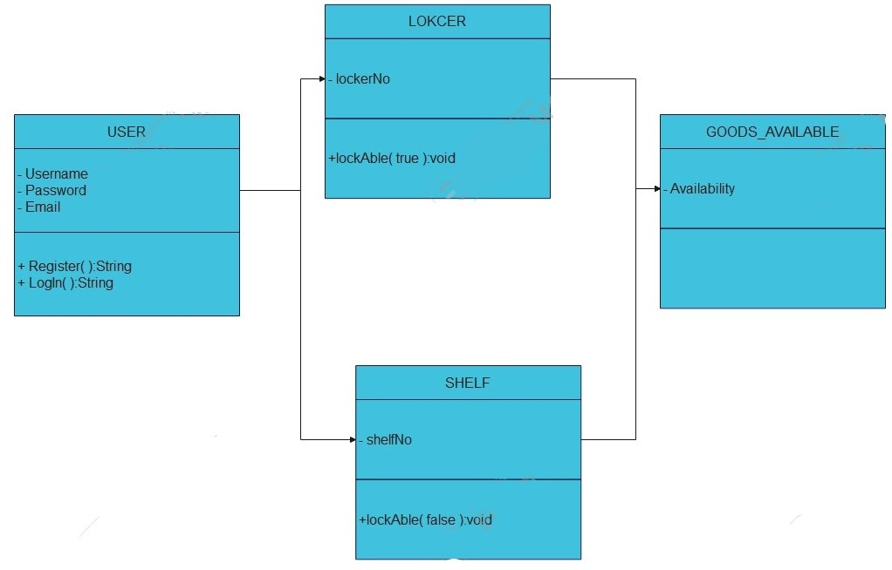

### SYSTEM INTERFACES

The essential system interfaces for TLSIMS include:

* **Inventory Management Interface:** An intuitive interface enabling users to monitor and manage inventory levels, track product movements and update stock information in real-time.
* **Sales tracking Interface:** A comprehensive interface facilitating the recording and analysis of sales transactions, providing insights into customer purchasing behaviour and sales trends.
* **User Management Interface:** A user-friendly interface allowing administrators to manage user accounts, define access privileges and assign specific roles within the system.

## SYSTEM FUNCTIONALITY

The Top Lockers and Shelves Inventory Management System (TLSIMS) is designed to provide the following core functionalities:

* **Inventory Tracking:** Real-time monitoring of product stock levels, allowing for efficient management and timely replenishment.
* **Sales Monitoring:** Accurate recording and analysis of sales transactions, providing insights into customer buying patterns and popular products.
* **User Management:** Customizable user roles and permissions, ensuring secure access control and effective delegation of responsibilities within the system.
* **Data Security Measures:** Implementation of security protocols to safeguard sensitive inventory and transactional data from unauthorized access and potential breaches.
* **Real-Time Reporting:** Generation of reports and analytics, offering insights into inventory turnover, product performance and operational efficiency.

## USER CHARACTERISTICS

The TLSIMS will be used by a variety of users with different roles and responsibilities, including:

* **Administrators:** responsible for overseeing the overall system functionality and configuration.
* **Inventory Managers:** monitor and update inventory levels as well as conduct regular audits and quality checks.
* **Sales Representatives:** process sale transactions and manage customer orders.
* **Warehouse staff:** receive and organize incoming inventory orders.
* **Technical Support Personnel:** provide assistance in resolving system-related issues and technical glitches.

## GENERAL CONSTRAINTS

The development and implementation of TLSIMS will subject to the following constraints:

* **Budgetary constraints:** The availability of financial resources may limit the scope of system features and functionalities, necessitating careful allocation of funds to prioritize essential components.
* **Time constraints:** Tight project timelines may impose limitations on the development and testing phases, requiring efficient project management and adherence to deadlines to ensure timely delivery.
* **Technical constraints:** Compatibility issues with existing hardware and software infrastructure may pose challenges, requiring careful consideration of system integration and potential upgrades.
* **Resource constraints:** Limited availability of skilled personnel and technical expertise may impact the speed and efficiency of system development and implementation, necessitating effective resource management and training initiatives.
* **Data security regulations:** Compliance with stringent data security and privacy regulations may impose constraints on data handling and storage practices, demanding strong security measures and adherence to industry standards.

## ASSUMPTIONS AND DEPENDENCIES

### 2.5.1 Assumptions

* **User acceptance:** Assuming that users will readily accept and adapt to the new system with the provided training and support.
* **Data accuracy:** Assuming that the data entered into the system is accurate and reliable for effective inventory management and reporting.
* **Reliable connectivity:** Assuming consistent and reliable internet connectivity and system accessibility for uninterrupted operations and real-time data processing.
* **Scalability:** Assuming that the system is designed to accommodate potential business growth and increased transaction volumes over time.
* **User compliance:** Assuming that users will adhere to established protocols and guidelines to ensure data security and confidentiality.

### 2.5.2 Dependencies

* **Hardware:** Depending on the availability and proper functioning of compatible hardware components, including computers, scanners, and mobile devices.
* **Software Integration:** Depending on seamless integration with the existing software infrastructure, including the operating system, database management system, and security software.
* **Internet Connectivity:** Depending on reliable and high-speed internet connectivity for real-time data processing, online transactions, and communication between different system interfaces.
* **User Training:** Depending on the effectiveness of user training programs to ensure smooth adoption and proficient utilization of the system's features and functionalities.
* **Vendor Support:** Depending on timely and effective support from system vendors or third-party service providers for technical troubleshooting and system updates.

# SPECIFIC REQUIREMENTS

## 3.1 FUNCTIONAL REQUIREMENTS

Top Lockers and Shelves (TLS) will encompass the following key functionalities of the proposed automated inventory management system:

* **Inventory Tracking:** Implementation of a robust system for real-time tracking of products stored within the facility, enabling efficient monitoring and management of stock levels.
* **Sales Monitoring:** Integration of a sales tracking module to record and analyse customer transactions, facilitating accurate sales data reporting and analysis.
* **User Management:** Development of a comprehensive user management interface, allowing different levels of access and control based on assigned roles and responsibilities.
* **Real-Time Reporting:** Establishment of a dynamic reporting system providing real-time insights into inventory status, sales trends, and operational performance, facilitating informed decision-making.

## 3.2 NON-FUNCTIONAL REQUIREMENTS

* **User-Friendly Interface:** Design and implementation of an intuitive and user-friendly interface to facilitate seamless navigation and ease of use for employees and clients interacting with the system.
* **Data Security Measures:** Implementation of robust data security protocols to safeguard sensitive inventory and transactional information from unauthorized access or breaches.

## 3.3 USER INTERFACE REQUIREMENTS

### User Registration

* Username and password entry fields.
* Log-in button.

**Locker and Shelf availability page**

* Display option of a locker and a shelf space availability.
* Quick access to essential functionalities.

### Payment processing and receipts

* User interface for processing storage payments as well as receipts.
* Interface for selecting payment methods that may be used.

## 3.4 HARDWARE INTERFACES

The system requirements for hardware include:

* Laptop with a minimum of 8GB RAM.
* Processor with a speed of 2.0 GHz or higher.
* Sufficient free disk space for data storage

## 3.5 SOFTWARE INTERFACES

The system will require the following software platforms:

* Operating System: Windows 10 or higher.
* Development Platform: Android studio
* Database: SQL server
* Antivirus software

## 3.6 COMMUNICATIONS INTERFACES

The system will require internet connectivity for real-time updates and communication with external services and devices. It will utilize secure communication protocols to safeguard data.

### Other requirements

* **Frequency of Use:** The system is designed for frequent use especially for stock inventory.
* **Accessing capabilities:** Both desktop and remote access should be supported.
* **Static and dynamic organization:** The system’s data will be organized in a relational database with dynamic updates based on real-time.
* **Data retention requirements:** Data will be retained for a defined period of time.
* **Operations:**
* ***Interactive Operations:*** Users will interact with the system throughout their workday.
* ***Unattended Operations:*** Background processes will handle scheduled maintenance and data updates.
* ***Data Backup and Recovery Operations:*** Regular automated data backups and recovery procedures are in place to ensure data integrity and availability.

# APPENDICES

## Appendix A: User Manual

This appendix includes a comprehensive user manual detailing step-by-step instructions on how to navigate the automated inventory management system. It covers various functionalities, features, and best practices for optimal system utilization.

## Appendix B: Data Security Protocols

This appendix outlines the specific data security protocols implemented within the system, including encryption methods, access controls, and data backup procedures. It emphasizes the measures taken to ensure the confidentiality, integrity, and availability of sensitive inventory and transactional data.

## Appendix C: System Architecture Diagram

This appendix presents a detailed system architecture diagram illustrating the structure and components of the automated inventory management system. It highlights the integration points, data flow, and interaction between different modules and interfaces within the system.

## Appendix D: Training Materials

This appendix contains training materials, such as presentation slides, handouts, and interactive modules, designed to facilitate effective user training sessions. It provides valuable resources for educating employees and stakeholders on the system's functionalities and operational procedures.

## Appendix E: Sample Reports and Analytics

This appendix includes sample reports and analytics generated by the system, showcasing the various insights and data visualizations available to users. It provides a glimpse into the system's reporting capabilities and demonstrates the type of information that can be leveraged for informed decision-making.