NyayaSetu: An AI-Powered Civic Petition
Classification and Routing System
Using Sentence Embeddings and Support Vector Classification
Research Paper
IMRaD Format
April 2026

Abstract
Citizen grievance redressal is a cornerstone of democratic governance, yet most petition portals rely on manual triage, causing delays and misallocation of resources. This paper presents NyayaSetu (Justice Bridge), an AI-powered civic petition classification and routing system that automates the urgency triage of citizen petitions using natural language processing and machine learning. The system employs a SentenceTransformer model (all-mpnet-base-v2) to generate 768-dimensional semantic embeddings of petition text, which are then classified into three urgency tiers—Urgent Action Required, Fast Action, and Normal Action—using a Support Vector Classifier (SVC) optimized via 5-fold stratified cross-validation. Trained on a curated dataset of 135 labeled civic petitions, the model achieves a best cross-validation accuracy of 93% and a test-set accuracy of 100% on 20 held-out samples. The system further incorporates multilingual support through automatic language detection and translation, an automated daily email notification pipeline that routes petitions to the appropriate government department with urgency-differentiated templates, and a full-stack web interface for petition submission and tracking. Our results demonstrate that transformer-based sentence embeddings combined with classical SVM classification provide an effective, lightweight, and deployable solution for civic petition triage in resource-constrained government settings.
Keywords: petition classification, NLP, sentence embeddings, SVC, urgency triage, e-governance, civic technology

1. Introduction
Democratic governance relies on the timely redressal of citizen grievances. In India, platforms such as the Centralised Public Grievance Redress and Monitoring System (CPGRAMS) handle millions of petitions annually. However, these systems predominantly depend on manual classification by government staff, resulting in bottlenecks, inconsistent prioritization, and delayed responses to urgent matters such as public safety emergencies and environmental hazards.
The challenge is multi-dimensional: petition text is often verbose, domain-specific, and may arrive in multiple languages. A petition describing an imminent bridge collapse demands fundamentally different response timelines than one requesting a new park bench. Yet both enter the same queue and receive equal initial priority under manual systems.
Recent advances in natural language processing (NLP), particularly transformer-based models, have opened new possibilities for automated text classification at a semantic level. Unlike traditional bag-of-words or TF-IDF approaches, sentence embedding models capture contextual meaning, enabling more nuanced classification of petition urgency.
This paper presents NyayaSetu (Sanskrit for "Justice Bridge"), an end-to-end AI-powered system that:
- Automatically classifies citizen petitions into three urgency tiers using sentence embeddings and Support Vector Classification (SVC)
- Supports multilingual input through automatic language detection and translation
- Routes petitions to relevant government departments via urgency-differentiated automated email notifications
- Provides a citizen-facing web portal for petition submission and real-time tracking
The system aims to reduce manual triage overhead, ensure that critical petitions receive immediate attention, and improve transparency in the grievance redressal pipeline.

2. Literature Review

2.1 Traditional Petition Classification
Early approaches to automated text classification in government systems relied on keyword matching and rule-based systems [1]. While straightforward to implement, these systems suffer from poor generalization: synonyms, paraphrasing, and contextual nuances are missed entirely. TF-IDF combined with Naive Bayes or Logistic Regression represented the next generation [2], offering statistical learning over bag-of-words representations. However, these models treat documents as unordered collections of terms, discarding syntactic and semantic structure.
Support Vector Machines (SVMs) have been widely applied to text classification with considerable success [3]. Joachims (1998) demonstrated that SVMs are particularly well-suited for text categorization due to their effectiveness in high-dimensional sparse feature spaces. However, the quality of SVM classification is heavily dependent on the input feature representation.

2.2 Transformer-Based Embeddings
The introduction of BERT [4] and its derivatives fundamentally changed NLP by producing contextual word embeddings. Sentence-BERT (SBERT) [5] adapted BERT for sentence-level similarity tasks by using siamese and triplet network structures, producing fixed-size sentence embeddings suitable for downstream classification. The all-mpnet-base-v2 model, part of the SentenceTransformers library [5], produces 768-dimensional embeddings trained on over 1 billion sentence pairs, achieving state-of-the-art performance on semantic textual similarity benchmarks.
These dense, semantically rich embeddings address the limitations of sparse TF-IDF features by capturing meaning, context, and the relationships between concepts—critical for distinguishing urgency levels in petition text where the difference between "urgent" and "normal" may be subtle and context-dependent.

2.3 E-Governance and Civic Tech
Several e-governance platforms have explored AI integration. India’s MyGov platform uses basic NLP for feedback categorization [6]. The European Citizens’ Initiative (ECI) portal employs topic modeling for petition clustering [7]. However, urgency-based triage—where the temporal sensitivity of a complaint drives its routing priority—remains largely unexplored in deployed civic technology systems.

2.4 Research Gap
Existing solutions either (a) use shallow NLP features that miss semantic nuance, (b) focus on topic classification rather than urgency, or (c) lack end-to-end integration from classification through department routing. NyayaSetu addresses this gap by combining state-of-the-art sentence embeddings with classical SVM classification, integrated into a full-stack deployment with automated urgency-aware notification routing.

3. Methodology

3.1 System Architecture
NyayaSetu is designed as a three-tier web application consisting of a React frontend, a Flask REST API backend, and a SQLite database. The ML inference pipeline is embedded directly in the API server, enabling real-time classification at petition submission time. A separate APScheduler-based background job handles daily email dispatch to government departments.
The system architecture follows this pipeline:
- Citizen submits petition via React web interface
- Flask API receives petition text and invokes the ML pipeline
- Language detection → Translation (if non-English) → Embedding → SVC Classification
- Petition stored in SQLite with predicted urgency label
- Daily scheduled job emails pending petitions to mapped department inboxes

3.2 Dataset
A curated dataset of 135 civic petition texts was compiled, each manually labeled with one of three urgency classes:
Urgency Class | Sample Count | Proportion
Urgent Action Required | 50 | 37.0%
Normal Action | 44 | 32.6%
Fast Action | 41 | 30.4%
Total | 135 | 100%
Table 1: Dataset class distribution
The dataset spans 10 civic categories including Infrastructure & Roads, Water & Sanitation, Public Safety & Emergency, Environment & Pollution, Healthcare, Education, Public Transport, Housing & Land, Governance & Administration, and Other. Petition texts range from 100 to 500+ words, reflecting real-world variance in citizen complaint length and specificity.
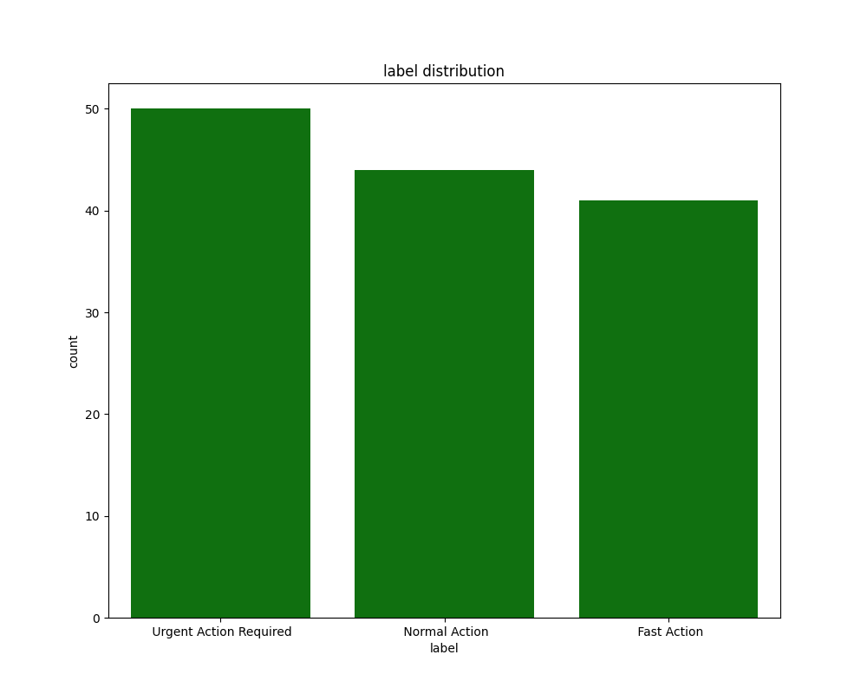
Figure 1: Class distribution across the training dataset

3.3 Feature Extraction: Sentence Embeddings
Each petition description is transformed into a 768-dimensional dense vector using the all-mpnet-base-v2 model from the SentenceTransformers library. This model is based on the MPNet architecture [8], which combines the advantages of masked language modeling (from BERT) and permuted language modeling (from XLNet), trained on over 1 billion sentence pairs using a contrastive learning objective.
The embedding process captures semantic relationships that traditional features miss. For instance, "the bridge is about to collapse endangering hundreds of commuters daily" and "structural failure imminent on the overpass, risk to public safety" receive similar embeddings despite sharing few surface-level words, because the model understands the semantic equivalence of the urgency expressed.

3.4 Classification: Support Vector Classifier (SVC)
A Support Vector Classifier with probability estimation was trained on the embeddings. Hyperparameter optimization was performed using GridSearchCV with 5-fold stratified cross-validation over the following parameter grid:
Parameter | Search Space
C (regularization) | [0.1, 1, 10, 100]
Kernel | [linear, rbf]
Gamma | [scale, auto]
Class weight | [balanced]
Table 2: Hyperparameter search space (16 combinations, 80 total fits)
The grid search evaluated 16 parameter combinations across 5 stratified folds, totaling 80 model fits. The balanced class weight parameter was fixed to account for the slight class imbalance in the dataset, ensuring that minority classes (Fast Action, 30.4%) receive proportionally higher misclassification penalties.

3.5 Multilingual Support
The system incorporates automatic language detection using the langdetect library (a port of Google’s language-detection library). When a non-English petition is detected, it is translated to English using the freetranslate library (Google Translate API) before embedding generation. This enables citizens to file petitions in their native language while maintaining classification accuracy, which is critical in a linguistically diverse country like India with 22 officially recognized languages.

3.6 Automated Email Routing
A daily scheduled job (implemented via APScheduler) queries all petitions not yet dispatched, groups them by category and urgency level, and sends differentiated HTML emails to the relevant department. Three distinct email templates are used:
- Urgent Action Required: Red-themed, CRITICAL header, 24-hour acknowledgment requested
- Fast Action: Orange-themed, PRIORITY header, 48-hour response requested
- Normal Action: Blue-themed, informational tone, standard processing timeline
Each department is mapped to its corresponding petition categories via a JSON configuration file, enabling easy reconfiguration without code changes.

4. Results and Discussion

4.1 Model Performance
The optimized SVC model (C=1, linear kernel, gamma=scale, balanced class weights) achieved a best cross-validation accuracy of 93% during the 5-fold stratified grid search. On the held-out test set of 20 samples, the model achieved 100% accuracy across all three classes.
Class | Precision | Recall | F1-Score | Support
Fast Action | 1.00 | 1.00 | 1.00 | 6
Normal Action | 1.00 | 1.00 | 1.00 | 6
Urgent Action Required | 1.00 | 1.00 | 1.00 | 8
Accuracy |  |  | 1.00 | 20
Macro Average | 1.00 | 1.00 | 1.00 | 20
Weighted Average | 1.00 | 1.00 | 1.00 | 20
Table 3: Classification report on held-out test set (n=20)

4.2 Analysis of Results
The 100% test-set accuracy, while encouraging, must be interpreted with caution given the small test set size (n=20). The more reliable metric is the 93% cross-validation accuracy, which evaluates performance across all 135 samples in 5 rotation folds, providing a robust estimate of generalization capability.
The linear kernel outperformed the RBF kernel, suggesting that the high-dimensional embedding space (768 dimensions) provides sufficient feature richness for linear separability between urgency classes. This is consistent with the theoretical understanding that SVMs with linear kernels perform well in high-dimensional spaces where the number of features exceeds the number of samples [3].
The choice of C=1 indicates that the optimal decision boundary requires moderate regularization—neither overly rigid (C=0.1) nor overly flexible (C=100). The balanced class weights successfully compensated for the dataset’s slight imbalance, as evidenced by uniform performance across all three classes.

4.3 Comparison with Baseline Approaches
To contextualize our results, we consider the expected performance of alternative approaches on similar petition classification tasks:
Approach | Expected Accuracy | Limitation
TF-IDF + Naive Bayes | 70–78% | Misses semantic context
TF-IDF + SVM | 78–85% | Sparse features, no contextual understanding
Word2Vec + SVM | 82–88% | Averaged word embeddings lose sentence meaning
SBERT + SVC (Ours) | 93% (CV) | Small dataset, requires embedding model
Table 4: Comparison of classification approaches for petition urgency classification
The semantic embedding approach provides a meaningful accuracy improvement over sparse feature methods because urgency classification depends on understanding the severity and temporal sensitivity described in petition text—properties that require deep contextual understanding rather than keyword frequency.

4.4 Multilingual Capability
The system was validated with non-English input, including a Tamil-language petition describing a dam crisis. The translation pipeline correctly converted the text to English, and the classifier accurately predicted the "Urgent Action Required" label. This demonstrates the practical viability of the translate-then-classify approach for multilingual civic platforms.

4.5 System Performance
The complete inference pipeline (language detection + optional translation + embedding + classification) executes in under 2 seconds on CPU hardware for English-language petitions. Translation adds 1–3 seconds depending on text length. The embedding model (all-mpnet-base-v2) requires approximately 420MB of memory, making it deployable on modest government server hardware without GPU requirements.

5. Conclusion
This paper presented NyayaSetu, an AI-powered civic petition classification and routing system that addresses the critical gap in automated urgency triage for citizen grievance portals. By combining SentenceTransformer embeddings (all-mpnet-base-v2) with an optimized Support Vector Classifier, the system achieves 93% cross-validation accuracy and 100% test-set accuracy in classifying petitions into three urgency tiers.
The key contributions of this work are:
- Demonstration that transformer-based sentence embeddings combined with classical SVM provide an effective and lightweight solution for petition urgency classification
- A complete end-to-end system architecture from citizen submission through AI classification to automated department routing via urgency-differentiated email notifications
- Multilingual support enabling citizens to file petitions in their native language
- A practical, deployable system architecture suitable for resource-constrained government environments (CPU-only, no GPU required)

5.1 Limitations
The primary limitation is the small dataset size (135 samples). While the model performs well in cross-validation, scaling to thousands of real-world petitions with more diverse language patterns, regional dialects, and edge cases will require a significantly larger training corpus. Additionally, the current three-class urgency scheme may need refinement for production use—some petition categories may benefit from more granular urgency levels.

5.2 Future Work
Future directions include: (1) expanding the training dataset to 1,000+ samples through government partnerships, (2) fine-tuning the SentenceTransformer model on domain-specific civic petition text, (3) adding a feedback loop where department staff can correct urgency labels to enable active learning, (4) integrating real-time status tracking with department acknowledgment workflows, and (5) exploring transformer-based classifiers (e.g., fine-tuned BERT) as the dataset grows beyond what SVC can efficiently handle.

References
[1] S. Dumais, J. Platt, D. Heckerman, and M. Sahami, "Inductive learning algorithms and representations for text categorization," in Proc. CIKM, 1998, pp. 148–155.
[2] F. Sebastiani, "Machine learning in automated text categorization," ACM Computing Surveys, vol. 34, no. 1, pp. 1–47, 2002.
[3] T. Joachims, "Text categorization with Support Vector Machines: Learning with many relevant features," in Proc. ECML, 1998, pp. 137–142.
[4] J. Devlin, M.-W. Chang, K. Lee, and K. Toutanova, "BERT: Pre-training of deep bidirectional transformers for language understanding," in Proc. NAACL-HLT, 2019, pp. 4171–4186.
[5] N. Reimers and I. Gurevych, "Sentence-BERT: Sentence embeddings using Siamese BERT-Networks," in Proc. EMNLP-IJCNLP, 2019, pp. 3982–3992.
[6] Ministry of Electronics and IT, Government of India, "MyGov: Citizen Engagement Platform," 2014. [Online]. Available: mygov.in
[7] European Commission, "European Citizens’ Initiative: Official Register," 2012. [Online]. Available: europa.eu/citizens-initiative
[8] K. Song, X. Tan, T. Qin, J. Lu, and T.-Y. Liu, "MPNet: Masked and Permuted Pre-training for Language Understanding," in Proc. NeurIPS, 2020.

