My approach to unit testing for the three assignments was to develop tests that validated the software requirements. The overall purpose of unit testing is to validate individual features and help prevent failures in the future. For example, when changes are made to the application six months down the road unit tests can identify if those changes unintentionally break the previously working functionality.
Across all three assignments, there was some overlap in the unit testing requirements. Each assignment required testing to validate that an ID was not greater than 10 characters and could not be null. There were also similarities in validating names and descriptions, including checking character limits and rejecting null values. However, each assignment had its own specific requirements. For example, the Contact assignment required validating that a phone number contained exactly 10 digits, where the Appointment assignment required validation that an appointment date was not in the past. I created JUnit tests using assertThrows to confirm that invalid values were rejected, along with assertions to validate a successful operation (see Figure 1). In addition to validating individual objects, I tested the service classes to confirm that records could be added, updated, or deleted as required and that duplicate IDs were rejected.
Figure 1
JUnit Test for Invalid Phone Number Validation
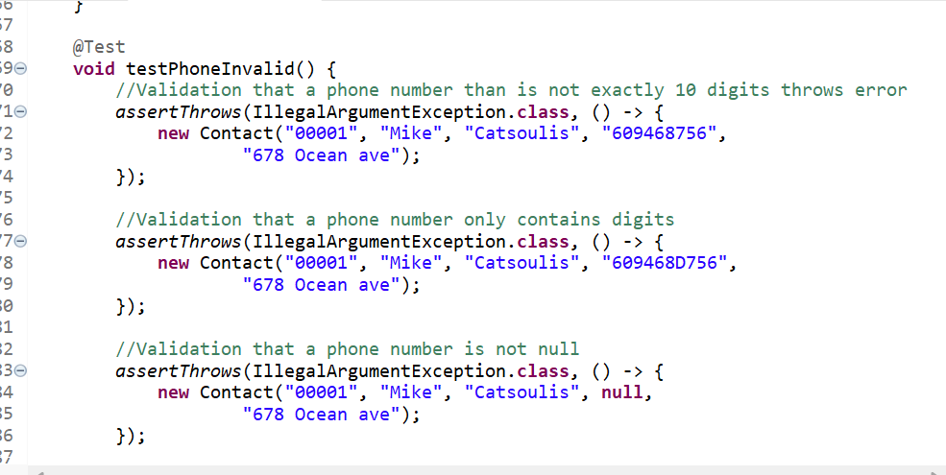
Note: Screenshot of the testPhoneInvalid() method from ContactTest.java showing validation of invalid phone number using JUnit assertions.
I think my unit test was effective because the test validated both successful and failure scenarios, confirming that the application correctly accepted or rejected values based on the requirements. All the assignments had a combined testing coverage above 80%, with an overall coverage percentage of 93%. Although the code coverage exceeded 90% this does not guarantee the application has no defects. The unit testing provides evidence that the methods and functions work as expected in the test scenario. The overall high code coverage percentage combined with testing both the valid and invalid inputs give me confidence that the application functions as the assignments defined.
While developing the unit test for each assignment my focus for each test was to validate the specific requirements and ensure that the tests produced the expected results. I utilized assertions such as assertEquals to validate the expected values and assertThrows to validate that invalid inputs triggered the exceptions. For example, in TaskServiceTest.java, I used assertEquals to verify that a task name was successfully updated (see Figure 2). To ensure the code was efficient, I combined related validation scenarios into individual test methods instead of creating a separate method for every invalid scenario. For example, in AppointmentTest.java, I tested both appointment ID exceeding 10 characters and a null ID within the same test method (see Figure 3). By combining validation scenarios this keeps the code organized and reduces repetitive code.
Figure 2
JUnit Test for Task Name Update Validation
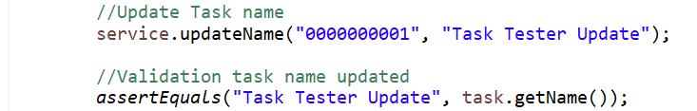
Note: Screenshot from TaskServiceTest.java showing assertEquals to validate successful name update.
Figure 3
JUnit test for Invalid Appointment ID Validation
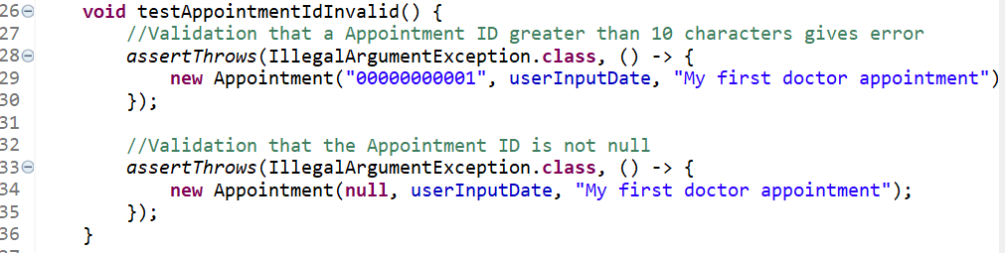
Note: Screenshot from AppointmentTest.java showing similar validation scenarios within a single JUnit test method.
Throughout the assignments and projects the testing technique I used was unit testing with JUnit. I created tests to validate the classes and methods based on the assignment requirements. While utilizing unit testing, I created both positive and negative tests. The purpose of positive testing was to confirm that valid inputs worked as expected, while negative testing confirmed that invalid inputs were rejected. Additionally, I conducted testing on specific fields. For example, testing was conducted to validate that phone numbers only contained digits and appointment dates were not in the past. These techniques helped identify issues that did not meet the requirements and could potentially cause problems if integrated into a larger application.
Some techniques that were not implemented in this project were integration and system testing. The assignments focused on standalone classes and services, not an integrated system with external applications or databases where system to system communication was a hard requirement. Based on the scope of the assignment, unit testing was the predominant methodology. However, if the assignment expanded into an entire application, additional testing and an expanded scope would be necessary. For example, if the application became a mobile or web-based application with a database, authentication, and communication with servers, more robust testing would be required. Integration testing could validate database communication and interactions between services, while system testing could validate that the application works from end to end. This type of testing would provide a more comprehensive testing structure rather than only validating individual components.
While developing the testing portion of the assignments, my approach to testing with caution was to ensure durable execution. When writing tests to validate methods and classes, we do not want testing code just to satisfy the requirements. The purpose of the tests is to provide a safety net, meaning developing tests for long term reliability. Once the code is validated, we can move forward knowing that our tests can identify issues later in development if changes break previously working functionality. Also, it is important to understand the relationships between classes because changes to one class can affect another. For example, in the Contact assignment, the Contact class validates the contact ID, while the ContactService class uses that ID to manage the record. If a future change allows invalid IDs, it could affect how ContactService manages contacts. Depending on the implementation, inconsistent ID validation could cause problems when retrieving, updating, or deleting records. By testing both classes, we can identify potential issues before they become part of a larger application.
A challenge when testing code that I developed was avoiding bias. As the developer, I understand how the code or application should function. This can lead to selective testing or reduced test coverage because we assume that every user will interact with the program as intended, which is rarely the case. To reduce this bias, my focus was on the requirements rather than only testing scenarios that I expected to pass. For example, I tested invalid phone numbers, null values and duplicate IDs to verify that the application correctly rejected inputs that did not meet the requirements rather than only testing successful scenarios. This helped me evaluate the code based on the requirements rather than assuming that users would always enter valid information.
Maintaining discipline when developing and testing software is extremely important for creating robust enterprise systems. Taking shortcuts and skipping testing to ship an application can result in poor software quality that leads to bugs that require constant patching and updates. These shortcuts can also create technical debt because additional development time may be needed in the future to correct the issues that should have and would have likely been caught initially if testing was conducted thoroughly. As an engineering professional, I plan to reduce technical debt by following the stated requirements, creating organized code, and maintaining the testing harness. For example, maintaining the testing harness includes rerunning existing tests whenever code changes and updating or adding tests when new functionality is introduced.

