EMRE KALEM ROBOT ARM
Arduino Uno Beginner Walkthrough
Windows travel laptop setup • first upload • Phase 2 single-servo centering
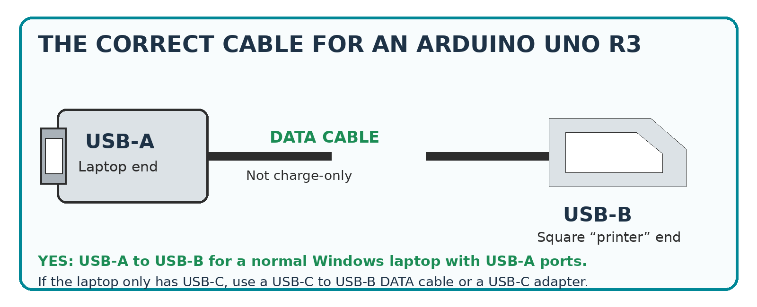
For an Arduino Uno R3, the board end is the square USB-B “printer cable” connector.
DIRECT ANSWER
Yes. For the Arduino Uno R3 shown in this project, buy or use a USB data cable with a USB-B plug on the Arduino end. A laptop with normal rectangular USB ports uses USB-A to USB-B. A laptop with only USB-C uses USB-C to USB-B or a USB-C adapter. The cable must carry data; a charge-only cable will not upload programs.

TODAY’S SAFE GOAL
Set up the Windows laptop, prove that the Uno communicates, upload the Blink example, install or verify the Servo library, and load a calibration or one-servo test sketch. Keep all servo power disconnected until the external 5 V wiring is ready and verified.

The laptop is the programming tool. The Arduino Uno can be powered and programmed from USB before the permanent 5 V servo rails arrive. USB is not the power source for the robot-arm servos.

☐ Windows 10 (64-bit) or Windows 11 travel laptop
☐ Arduino Uno R3 board
☐ USB-A to USB-B data cable, or USB-C to USB-B data cable for a USB-C-only laptop
☐ The robot-arm software files
☐ A small notebook or this printed guide
DO NOT CONNECT YET

- No servo red wire to the Arduino 5V pin.
- No external 5 V positive wire to the Arduino.
- No servo should be mechanically loaded during the first electronics check.
- Leave the KCD1 servo-power rocker OFF.

Item | Required? | Purpose
Arduino IDE 2.3.10 | Yes | Writes, verifies, and uploads programs to the Uno.
Arduino AVR Boards package | Yes | Adds Arduino Uno compiler and upload support inside the IDE.
Servo library | Usually already available | Lets the Uno generate servo control pulses. Install through Library Manager only if Verify reports Servo.h is missing.
emre_kalem_arm_calibrate.ino | Project file | Main calibration program from the robot-arm package.
emre_kalem_arm_uno_controller.ino | Later | Final arm controller. Do not use for first powered motion.
wiring-map.csv | Reference | Confirms servo names and Arduino pin assignments.
emre_kalem_single_servo_bench_test.ino | Included backup | Safe, limited one-servo test program supplied with this walkthrough.
NOT NEEDED
You do not need Arduino PLC IDE, Arduino App Lab, Visual Studio Code, Python, or an Arduino Cloud account for this first bench setup.

- Open File Explorer. Press the Windows key and type File Explorer.
- Open Local Disk (C:). Right-click in an empty area and choose New → Folder.
- Name the folder RobotArm.
- Inside RobotArm, create Software, Documentation, Calibration_Notes, and Backups.
- Copy the project files into Software. Keep the originals unchanged in Backups.
RECOMMENDED FOLDER
C:\RobotArm\Software

CURRENT SOFTWARE
Arduino’s official software page lists Arduino IDE 2.3.10 as the current desktop release on August 1, 2026. Arduino IDE 2 requires 64-bit Windows 10 or newer.

STEP 1 — Check the Windows version
- Press Windows key + R.
- Type winver and press Enter.
- Confirm the laptop says Windows 10 or Windows 11.
- For Windows 10, confirm it is a 64-bit installation: Settings → System → About → System type.
STEP 2 — Download from Arduino only
- Open Microsoft Edge or Google Chrome.
- Go to the official Arduino Software page.
- Find Arduino IDE 2.3.10.
- Choose the Windows 64-bit installer. For a beginner, use the installer rather than the ZIP file.
- The downloaded file will normally appear in the Downloads folder.
Official Arduino Software page
STEP 3 — Run the installer
- Double-click the downloaded Arduino IDE installer.
- When Windows asks whether to allow changes, confirm the publisher is Arduino and click Yes.
- Accept the license terms.
- Keep the normal installation options selected.
- Allow any Arduino driver installation prompts that appear.
- When setup finishes, leave Run Arduino IDE selected and click Finish.
ADMINISTRATOR PERMISSION
A work-managed travel laptop may block installation. In that case, an administrator must approve the Arduino IDE and USB driver installation.

STEP 4 — First launch and internet connection
- Let the IDE finish opening. The first launch may take longer.
- Keep the laptop connected to the internet while board indexes and packages are downloaded.
- Do not connect the robot servos during software installation.
- After the board package and library are installed, the IDE can compile and upload while offline.

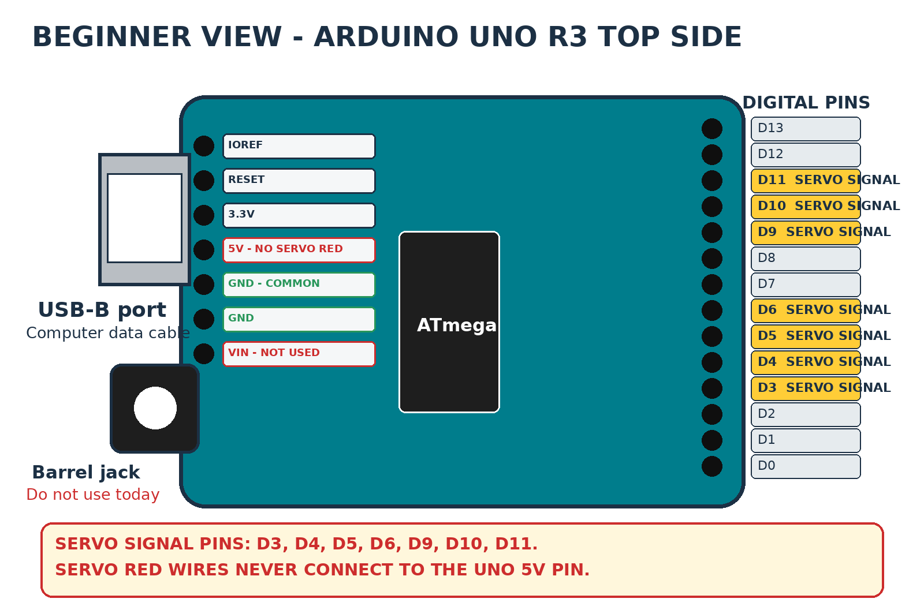
Simplified top view. The highlighted digital pins are the robot-arm servo signal pins.
STEP 1 — Make the board electrically empty
- Disconnect every servo plug and every jumper wire from the Uno.
- Do not connect the external 5 V supply.
- Set the KCD1 servo-power rocker to OFF.
- Place the Uno on a dry, nonconductive surface. Do not place it on bare metal.
STEP 2 — Inspect the USB connector
- Uno R3: large square-ish USB-B socket, normally beside the barrel power jack.
- Uno R4: USB-C socket. The USB-B printer cable does not fit an Uno R4.
- Clone board: may still use USB-B, but Windows may identify it as CH340 or USB-SERIAL.
STEP 3 — Connect the cable directly
- Plug the USB-B end into the Uno. It fits only one orientation; do not force it.
- Plug the laptop end directly into the laptop, not through an unpowered USB hub.
- At least the green ON power LED should light.
- The yellow L LED may blink or stay on because an old program may already be stored in the board.
WHAT USB DOES
The USB cable supplies low-current power to the Arduino logic and carries program data. It does not safely power MG995, MG996R, or MG90S servos.

- In Arduino IDE, click the board selector near the top of the window.
- Look for Arduino Uno, Unknown, or a COM number such as COM3 or COM5.
- When uncertain, unplug the USB cable and note which COM port disappears.
- Reconnect the board and select the port that reappears.
NO COM PORT?
Try a different USB cable first. Many “mystery” failures are charge-only cables. Then try another laptop USB port and connect directly. Do not install random internet drivers. A clone with a CH340 USB chip may need its vendor’s driver; identify the markings on the board before installing one.

STEP 1 — Install Arduino AVR Boards
- In Arduino IDE, open Tools → Board → Boards Manager.
- In the search box, type Arduino AVR Boards.
- Select the package published by Arduino.
- Click Install and wait for it to finish.
- Accept any Windows driver prompt from Arduino.
STEP 2 — Select Arduino Uno
- Open Tools → Board.
- Open Arduino AVR Boards.
- Click Arduino Uno.
- Do not select Uno WiFi Rev2, Uno R4 Minima, Uno R4 WiFi, Nano, or Mega.
STEP 3 — Select the port
- Open Tools → Port.
- Click the COM port that belongs to the connected Uno.
- The IDE status area should now show Arduino Uno and the selected COM port.
CHECKPOINT A — BOARD READY

- Green ON LED is lit.
- Arduino Uno is selected.
- A COM port is selected.
- No servos or external power are connected.

Blink is the standard proof that the laptop, cable, Windows driver, board package, COM port, compiler, and Uno are all working together.
STEP 1 — Open the example
- In Arduino IDE, click File → Examples → 01.Basics → Blink.
- A new sketch window or tab opens.
- Do not edit the code for this first test.
STEP 2 — Verify the sketch
- Click the check-mark Verify button near the top left.
- Wait while the IDE compiles the sketch.
- The output panel should finish without red error text.
STEP 3 — Upload the sketch
- Click the right-arrow Upload button.
- The Uno RX and TX LEDs may flicker during transfer.
- Wait for the message Done uploading.
- The yellow L LED should turn on for about one second and off for about one second repeatedly.
CHECKPOINT B — FIRST UPLOAD PASSED
Do not continue until Blink uploads successfully. A blinking L LED proves the programming connection. It does not test any servo hardware.

Message or symptom | Safe correction
No port / Port menu missing | Reconnect the board, try a known data cable, and try another direct USB port.
Failed uploading: no upload port provided | Select Tools → Port and choose the Uno COM port.
avrdude timeout or programmer not responding | Confirm Tools → Board is Arduino Uno and the correct COM port is selected.
Access denied / port busy | Close Serial Monitor and any other program using the COM port, then upload again.
Unknown board | Select Other board and port, choose Arduino Uno, then choose the COM port.

ARDUINO FOLDER RULE
The main .ino file should normally be inside a folder with the same name. Example: emre_kalem_arm_calibrate.ino belongs inside a folder named emre_kalem_arm_calibrate.

- Create C:\RobotArm\Software\emre_kalem_arm_calibrate.
- Place emre_kalem_arm_calibrate.ino inside that folder.
- Create C:\RobotArm\Software\emre_kalem_arm_uno_controller.
- Place emre_kalem_arm_uno_controller.ino inside that folder.
- Keep wiring-map.csv and conveyor-waypoints-template.csv in the Software folder.
- Copy the included emre_kalem_single_servo_bench_test folder into Software as an optional backup test.

- In Arduino IDE, click File → Open.
- Browse to the emre_kalem_arm_calibrate folder.
- Select emre_kalem_arm_calibrate.ino and click Open.
- If Arduino asks to create or move the sketch into a matching folder, approve the normal folder arrangement.

Index | Servo | Uno pin | First-test note
0 | Base | D3 | Center unloaded
1 | Shoulder left | D4 | Center separately
2 | Shoulder right | D5 | Center separately; mirror only when paired
3 | Elbow | D6 | Support arm link
4 | Wrist pitch | D9 | Low load
5 | Wrist roll | D10 | Best first servo
6 | Gripper | D11 | Linkage loose at first
DO NOT CHANGE PINS CASUALLY
The current arm package uses D3, D4, D5, D6, D9, D10, and D11. D4 does not need a printed ~ PWM mark for the Arduino Servo library to control a hobby servo.

STEP 1 — Keep motion power OFF
- The KCD1 rocker remains OFF.
- No servo red wire is powered.
- The Uno remains powered only through USB.
- Support the arm so gravity cannot drop a joint.
STEP 2 — Find the Serial Monitor speed
- Press Ctrl + F in the sketch.
- Search for Serial.begin.
- Write down the number inside the parentheses, such as 115200.
- Use that exact number later in Serial Monitor. Do not guess.
STEP 3 — Verify the sketch
- Click Verify.
- If the sketch compiles, continue.
- If the error says Servo.h: No such file or directory, install the official Servo library: Tools → Manage Libraries, search Servo, select the library published by Arduino, and click Install.
- Verify again after installation.
STEP 4 — Upload with servo power OFF
- Confirm Arduino Uno and the correct COM port are still selected.
- Click Upload.
- Wait for Done uploading.
- No servo should move because external servo power is OFF.
STEP 5 — Open Serial Monitor
- Click the Serial Monitor icon or open Tools → Serial Monitor.
- Set the baud rate to the exact Serial.begin value.
- Read the startup instructions printed by the sketch.
- Record the exact commands for selecting a servo, centering at 90 degrees, attaching, detaching, and nudging.
- Record the required line-ending setting if the sketch specifies one.
CHECKPOINT C — SOFTWARE READY

- Blink passed.
- Calibration sketch verifies.
- Calibration sketch uploads.
- Serial Monitor displays readable text.
- Servo power is still OFF.

You may program the Uno now. Physical servo movement must wait until you have a safe external 5 V servo power path. The permanent distribution rails are not required for one servo, but a temporary connection must still be fused, insulated, and secure.

☐ Regulated 5 V DC supply
☐ Inline fuse in the positive line
☐ KCD1 rocker switch or another properly rated DC disconnect
☐ Insulated screw terminals, lever connectors, or a proper temporary terminal block
☐ Digital multimeter
☐ Jumper from external supply GND to Arduino GND
☐ Only one servo connected
☐ Servo horn removed or linkage mechanically unloaded
WAIT FOR THE RAILS WHEN NECESSARY
Do not improvise with twisted bare wires, alligator clips that can touch, or a solderless breadboard carrying MG995/MG996R current. When a safe temporary connection cannot be made, stop after the software checkpoints and wait for the distribution hardware.

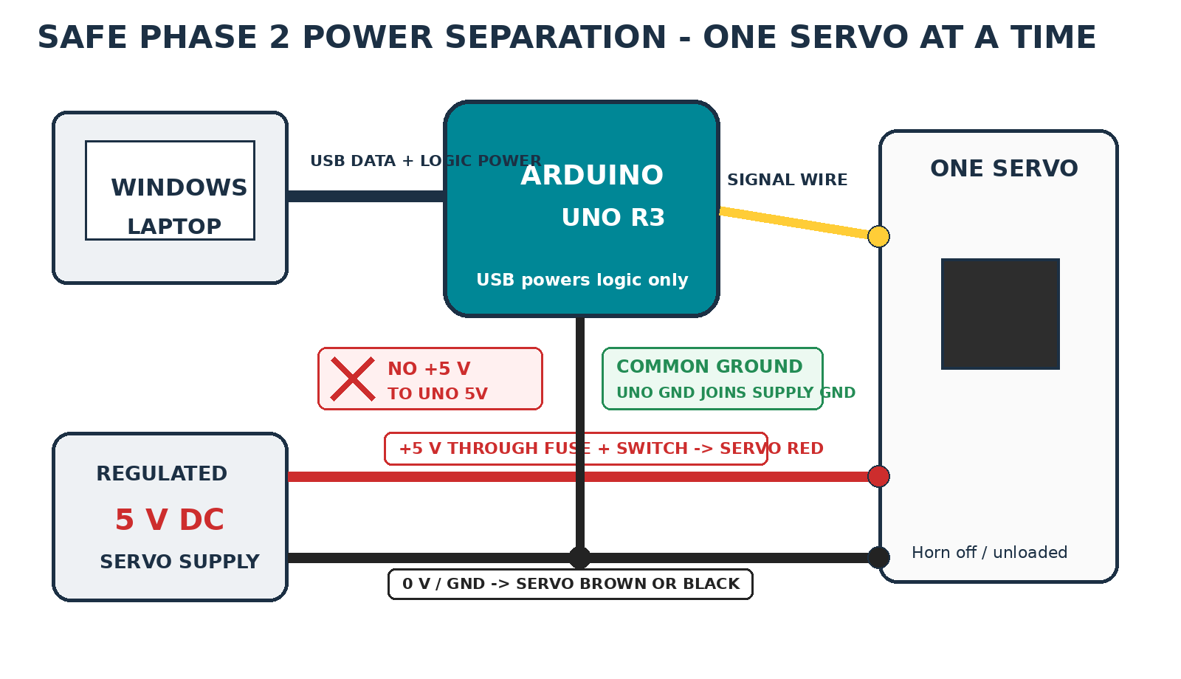
USB powers the Uno. The external regulated supply powers the servo. Only the grounds are joined.

- Red: external regulated +5 V only.
- Brown or black: external supply GND / negative bus.
- Orange, yellow, or white: Arduino signal pin.
MOST IMPORTANT RULE
External +5 V must not connect to Uno 5V, VIN, or the barrel jack during USB-powered servo calibration. External GND must connect to an Uno GND pin.

START WITH WRIST ROLL
Use the wrist-roll MG90S on D10 as the first physical test when practical. It has less mechanical load than the base, elbow, or shoulder.

- Turn the KCD1 rocker OFF.
- Unplug the external 5 V supply from AC power.
- Leave the Uno connected to USB so the program and Serial Monitor remain available.
- Remove or loosen the servo horn. Do not let the servo drive the arm linkage yet.

- Connect servo red to the switched and fused external +5 V output.
- Connect servo brown or black to external GND.
- Connect a wire from external GND to an Arduino GND pin.
- Connect the servo signal wire to its assigned Arduino digital pin. Wrist roll uses D10.
- Confirm no external positive wire touches the Uno.
- Confirm all other servos are disconnected from power.

- With the servo unplugged, energize the external supply.
- Turn the rocker ON.
- Measure between the temporary +5 V and GND terminals.
- Confirm approximately 5.0 V and correct polarity.
- Turn the rocker OFF and remove AC power again before attaching the servo connector.

- In Serial Monitor, select the test servo using the actual calibration sketch command.
- Command 90 degrees or use the sketch’s center command.
- Attach the selected servo signal if the sketch requires an attach command.
- Keep one hand beside the rocker; keep the other hand away from the servo shaft and linkage.

- Reconnect AC to the external supply.
- Stand clear and turn the rocker ON.
- The unloaded servo should rotate toward electronic center and settle.
- Turn the rocker OFF immediately for loud buzzing, repeated clicking, rapid heat, smoke, wire heating, or movement into a hard stop.
- After the servo settles, turn the rocker OFF before installing the horn.

- With power OFF, install the horn as close as possible to the joint’s intended neutral position.
- Tighten the center screw, but do not force a linkage to align.
- Power the servo again while ready at the rocker.
- Test 89°, 90°, 91°, then 88°, 90°, 92°.
- For non-shoulder low-load joints, expand only to about 85°, 90°, and 95° after the tiny test passes.
- Return to 90°, turn the rocker OFF, detach the signal if the sketch supports it, and disconnect AC before changing servo wiring.
NEVER TEST 0° OR 180° NOW
The advertised servo range is not the safe mechanical range of the printed joint. A printed hard stop can be reached far before an electronic command of 0° or 180°.

Use this included sketch only when the main calibration file is unavailable or unclear. It limits commands to 70°–110°, starts with the signal detached, and supports one physically connected servo at a time. It does not test the paired shoulder as a pair.

- Copy the emre_kalem_single_servo_bench_test folder into C:\RobotArm\Software.
- Open emre_kalem_single_servo_bench_test.ino in Arduino IDE.
- Verify and upload with servo power OFF.
- Open Serial Monitor at 115200 baud.
- Use any line-ending setting; the sketch ignores line-ending characters.

Command or action | Meaning
5 | Select wrist roll on D10.
c | Store the center command: 90°.
a | Attach the signal and output 90°. Servo power should still be OFF.
Turn rocker ON | The servo moves to center.
+ then - | Move one degree and return.
] then [ | Move five degrees and return only after the one-degree test passes.
d | Detach the signal before rewiring.
SHOULDER WARNING
Center left shoulder and right shoulder separately at 90°. Do not mechanically couple and move the pair using this one-servo sketch. The final paired test requires the actual arm calibration/controller mirror logic.

- Wrist roll — D10
- Wrist pitch — D9
- Gripper — D11, linkage loose
- Base — D3, arm supported against rotation
- Elbow — D6, forearm supported
- Shoulder left — D4, tested separately
- Shoulder right — D5, tested separately

Servo | Pin | 90° | ±1° | ±2–5° | Noise / heat | Pass
Base | D3 | ☐ | ☐ | ☐ |  | ☐
Shoulder left | D4 | ☐ | ☐ | ☐ |  | ☐
Shoulder right | D5 | ☐ | ☐ | ☐ |  | ☐
Elbow | D6 | ☐ | ☐ | ☐ |  | ☐
Wrist pitch | D9 | ☐ | ☐ | ☐ |  | ☐
Wrist roll | D10 | ☐ | ☐ | ☐ |  | ☐
Gripper | D11 | ☐ | ☐ | ☐ |  | ☐

- Servo reaches center without a violent jump.
- Servo makes tiny movements both directions and returns to the same center.
- No continuous loud buzz, clicking, gear skipping, smoke, or rapid heating.
- The Uno does not reset or disconnect.
- The connector and wires remain cool.
- The mechanism does not bind or approach a hard stop.
STOP AFTER INDIVIDUAL TESTS
Do not power all seven servos together until the permanent distribution rails, fuse, switch, polarity, and branch wiring have been completed and verified.

Problem | Most likely cause | What to do next
No light on Uno | Cable, USB port, or laptop power | Reconnect, try another direct USB port, then try a known data cable.
Uno lights but no COM port | Charge-only cable or driver issue | Try another data cable first. Check Device Manager. Identify a clone USB chip before installing a driver.
Blink will not upload | Wrong board or COM port | Select Arduino AVR Boards → Arduino Uno and the COM port that appears when plugged in.
Serial Monitor shows gibberish | Wrong baud rate | Match the number in Serial.begin(...).
Serial commands do nothing | Wrong command or line ending | Use the sketch startup/help text exactly, including capitalization and spaces.
Servo has power but does not move | Missing common ground, wrong signal pin, detached signal | Power OFF. Confirm external GND to Uno GND, signal pin, connector orientation, and attach state.
Uno resets when servo moves | Servo powered from Uno or supply/wiring voltage drop | Power OFF immediately. Confirm servo red is external only and inspect power distribution.
Servo buzzes loudly | Mechanical load, hard stop, incorrect horn, shoulder conflict | Power OFF. Remove the horn/load and test the servo alone at center.
Servo moves the wrong direction | Mechanical orientation or control mapping | Power OFF before collision. Record direction; correct in documented calibration logic, not by reversing power wires.
DO NOT “TRY A BIGGER FUSE”
A fuse that opens indicates a short, wiring fault, or severe overload. Find the cause before replacing it. Never increase fuse size without verifying the safe current rating of every wire, switch, terminal, and connector.

☐ Rocker OFF
☐ External servo supply disconnected
☐ Arm supported and workspace clear
☐ Only intended servo connected
☐ No external +5 V connected to Uno
☐ Common ground installed
☐ USB connected
☐ Correct board and COM port selected
☐ Correct sketch uploaded
☐ Serial Monitor readable
☐ One hand ready at rocker

- Return the test servo to a safe center if it can do so without binding.
- Turn the KCD1 rocker OFF.
- Detach the servo signal in software when supported.
- Disconnect AC power from the external 5 V supply.
- Wait for the supply output to discharge.
- Only then unplug or move a servo connector.
- USB may remain connected while you read Serial Monitor or upload another sketch.
PHASE 2 COMPLETE WHEN

- Every physical servo has been centered separately.
- Every servo passed tiny movement both directions.
- Both shoulder servos were centered separately.
- No full-arm powered test has been attempted before the permanent distribution system is ready.

UNO R3 CABLE
USB-A to USB-B DATA cable (“printer cable”). For USB-C-only laptops: USB-C to USB-B DATA cable or an adapter.

- Arduino IDE 2.3.10 — current official release when this document was prepared.
- Windows 10 64-bit or newer.
- Arduino AVR Boards package.
- Official Arduino Servo library only when the sketch reports it is missing.

Pin | Servo signal
D3 | Base
D4 | Shoulder left
D5 | Shoulder right, mirrored when paired
D6 | Elbow
D9 | Wrist pitch
D10 | Wrist roll
D11 | Gripper

USB → UNO ONLY | EXTERNAL 5 V → SERVO ONLY | GROUNDS JOIN
Never connect external +5 V or a servo red wire to the Uno 5V pin.

- Center at 90°.
- Begin with ±1°.
- Shoulder begins with approximately 88°–92° only.
- Do not command 0° or 180°.
- One servo at a time.

Official Arduino references checked while preparing this guide:
- Arduino UNO R3 documentation
- Arduino UNO R3 full pinout PDF
- Download and install Arduino IDE
- Arduino software downloads
- Upload a sketch in Arduino IDE
- Board not detected troubleshooting
Project basis: Emre Kalem 6-axis arm, Arduino Uno, 4 × MG995/MG996R, 3 × MG90S, 6 logical axes / 7 physical servos, dual mirrored shoulder, regulated 5 V servo supply, and KCD1 servo-power enable.
LIMIT OF THIS DOCUMENT
This is a supervised hobby-robot bench procedure, not a safety-rated industrial robot commissioning standard. The Uno, servo sketch, rocker switch, and software stop are not safety devices.

