Assignment 9

**Please read turn-in checklist at the end of this document before you start doing exercises.**

**Section 1: Pen-and-paper Exercises**

1. Let vertex **C** be the source. Run Dijkstra's shortest path algorithm on the graph below.

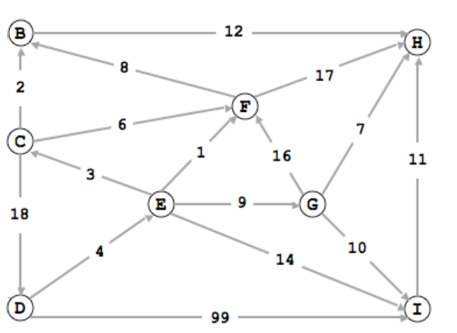

1. Give the order in which the vertices are added to the shortest path tree (7 points).

C, B, F, H, D, E, G, I

1. Give the distance of the shortest path from C to each vertex v (in other words, the final value of d[v] at the end of Dijkstra's shortest path algorithm, 7 points).

v d[v]

------------------

B 2

C 0

D 18

E 22

F 6

G 31

H 14

I 36

1. Given an undirected weighted graph, list the edges in the MST in the order in which they are discovered by Prim's algorithm, starting the search at vertex A. Since all edge weights are distinct, identify each edge by its weight (instead of its endpoints, 9 points).

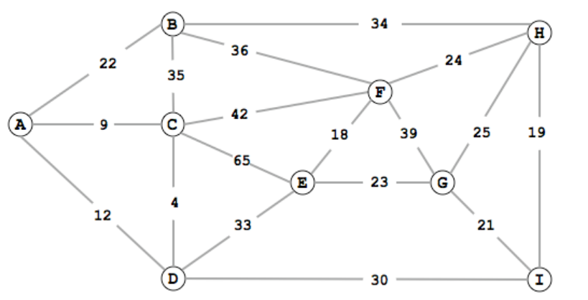

A->C (9), C ->D (4), A->B(22), D->I (30), I->H(19), I->G(21), H->G(25), G->E(23)

AC 9

CD 4

AB 22

DI 30

IH 19

IG 21

HG 25

GE 23

1. Dijkstra’s algorithm finds the shortest path from s to every other vertex in the graph. What if we just want to find the shortest path from s to some particular vertex (not all vertices) in the graph. What is your algorithm? (5 points)

Use Dijkstra’s algorithm and run it until it found the shortest distance to its destination and then return that value. Find the distances to that vertex and return the smallest of those distances.

**Section 2: Java Implementation**

1. Implement the Dijkstra’s Shortest Path Algorithm in Java.

Note:

Find a file called Dijkstra.java in assignment 9 folder.

Complete the method of dijkstra().

Test your method in the main method in WeightedGraph.java provided following the comments.

**TURN-IN CHECKLIST:**

1. **Answers to Section 1 (.doc/.txt/.pdf), and to Section 2 (all your source Code (.java files)). Remember to include your name, the date, and the course number in comments near the beginning of your code/report.**
2. **Create a folder and name it 'FirstName_LastName_assignment_9'. In the newly created folder copy and paste your files (.doc/.txt/.java files). Then compress the folder, and push it to iLearn.**