Final Assignment

Important: The final exam is completed by this assignment, and it is worth 5% of your final grade. Please read turn-in checklist at the end of this document before you start doing exercises.

Section 1: Pen-and-paper Exercises

- Consider the following problem.

Assume you have to take n courses, which are labeled from 0 to n - 1. Some courses have prerequisites, for example to take course 143 you have to first take course 142, which can be expressed as a pair: [142, 143]
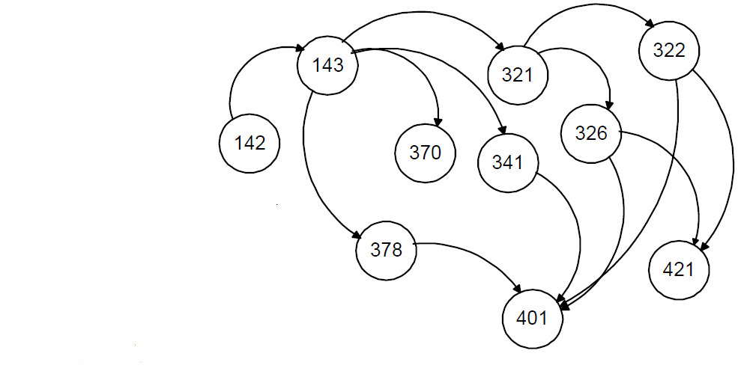
Given the courses and a list of prerequisite pairs, is it possible for you to finish all courses?

For example:
2, [0,1]
There are two courses to take. To take course 1 you should have finished course 0. So it is possible to finish all courses.

2, [0,1],[1,0]
There are two courses to take. To take course 1 you should have finished course 0, however, to take course 0 you should have finished course 1 -- it is impossible.

Outline an algorithm to solve this problem.
(i) describe the idea behind your algorithm in English (2 points);
The algorithm is going to check that the courses do not create a cycle between the nodes as well as checking if there is a path to each node.
(ii) provide pseudocode (5 points);

// From Assignment 8

for (int i = 0; i < nVerts; i++) {
vertexList[i].wasVisited = false;// Reset the wasvisited matrix
vertexcycleflag[i] = -1; //Initially, all nodes are -1
}

//Pick the starting node randomly
//Random rand = new Random();
for(int i = 0; i < nVerts; i++) {
int randNum = i;

//Visit the starting node
vertexList[randNum].wasVisited = true;
vertexcycleflag[randNum] = 0; //finishing cycle
displayVertex(randNum);
theStack.push(randNum);

while (!theStack.isEmpty()) {
int neighbor = getAdjUnvisitedVertex(theStack.peek());
if(neighbor != -1) {
if (vertexcycleflag[neighbor] == -1)
{
theStack.push(neighbor);
vertexcycleflag[neighbor] = 0;
vertexList[neighbor].wasVisited = true;
vertexList[neighbor].cycleflag = 0;
displayVertex(neighbor);
System.out.println(theStack);
}
else if(vertexcycleflag[neighbor] == 0 )
{
displayVertex(neighbor);
return true;
}
else
{
vertexList[neighbor].wasVisited = true;
vertexList[neighbor].cycleflag = 1;
vertexcycleflag[neighbor] = 1;
displayVertex(neighbor);
theStack.pop();
}
}
else
{
return false;
}
}
}
return false;
}
(iii) analyze its running time (3 points).

O(n)

- Consider the following problem about student grade of some test (e.g., SAT) over a long time.

- insert(date, score): insert into the data structure that a student has received score score at date date. For example, assume a student took the test on January 16, 2020, and received 88, the following four operations should be performed: insert(20200116,88).

- average(date1, date2): return the average of all scores that are received between date1 and date2 (inclusive).

- delete(date1, date2): delete scores received between date1 and date2 (inclusive).

The time per each operation should be at most O(log n), where n is the total number of scores. Note that if k scores were received between date1 and date2, delete(date1, date2) should take at most O(k log n) time.

Select a data structure that supports the above operations.
(i) data structure (2 points).

Binary Search Tree

(ii) justification for your choice: analyze the time complexity of insert, average, and delete on the data structure selected (5 points).

Full credit (7 points) will be awarded for a data structure that supports O(logn) insert, average, and delete. Data structures slower will be scored out of 2 points.

The worst case Time Complexity for insert, average, and delete is O(n). All elements need to be traversed for each operation and therefore the worst case will be O(n).

- Optimal storage problem:
Input:
We are given n articles that are to be stored on a computer tape of length L.
Each article i has a length of Li, i.e. article 1’s length is L1, and article 2’s length is L2.
L >= (L1+L2+…+Ln), in other words, the computer tape has enough capacity to store all n articles.

Output:
A permutation of the n articles so that when they are stored on tape in this order, the MRT (mean retrieval time) is minimized assuming that all articles are retrieved equally often.

Suppose the articles are stored in the order (o1, o2, … on).

Then the time needed to retrieve article oj is : Lo1 + Lo2 + …+ Loj. This is because to retrieve article oj, we need to retrieve every article before oj on the tape.

Then the mean retrieval time is
MRT =
{(Lo1) + (Lo1 + Lo2) + (Lo1 + Lo2 + Lo3) + (Lo1 + Lo2 + Lo3 + Lo4) + … + (Lo1 + …+ Lon)}/n

Example:
Let n = 3, (L1, L2, L3) = (8, 12, 2), L = 50.
All the possible permutations and their respective retrieval time are given below:
Permutation | Mean Retrieval Time
1, 2, 3 | {8 + (8+12) + (8+12+2)}/3 = 16.67
1, 3, 2 | {8 + (8 + 2) + (8 + 2 + 12)}/3 = 13.33
2, 1, 3 | {12 + (12 + 8) +(12 + 8 + 2)}/3 = 18
2, 3, 1 | {12 + (12 +2) + (12 + 2 + 8)}/3 = 16
3, 1, 2 | {2 + (2 + 8) + (2 + 8+ 12)}/3 = 11.33
3, 2, 1 | {2 + (2 +12) + (2 + 12 + 8)}/3 = 12.67

The optimal permutation is 3, 1, 2, as it has the minimum mean retrieval time. Our goal is to find a permutation of n articles that can minimize the mean retrieval time (10 points).
- Consider the following greedy algorithm. Sort articles by their length in ascending order, such that Lo1<=Lo2<=Lo3…<=Lon. Store articles on the computer tape in this order. Prove or disprove that this algorithm is correct.

if(Lo1<=Lo2<=Lo3…<=Lon)
Right = Lo1*n + Lo2*(n-1) + Lo3*(n-2) + …. + Lon*(1)
Else if(Lo1>=Lo2>=Lo3…>=Lon)
Wrong = Lon*n + ….. +Lo3*(3) + Lo2*(2) + Lo1*(1)
Right < Wrong

- Consider the following greedy algorithm. Consider the following greedy algorithm. Sort articles by their length in descending order, such that Lo1>=Lo2>=Lo3…>=Lon. Store articles on the computer tape in this order. Prove or disprove that this algorithm is correct.

In the permutation 2,1,3 above, we see that it follows Lo1>=Lo2>=Lo3 and still has the longest mean retrieval time

HINT: One of the above greedy algorithms is correct and the other is not.
Section 2: Java Implementation
- Implement Problem 2 in Java.
Note:
In your program, you should
- use the data structure you selected in Problem 2 to perform insert, average, and delete operations on student test scores.

Note: If you use BST/Graph/Linked List, data structures discussed in this class, feel free to use BST.java (Assignment 7)/Graph.java (Assignment 8)/LinkList.java (Assignment 6) provided in previous assignments, and modify the program to solve this problem.

- create test cases, and display test results.

Note: You need to create test cases for all insert, average, and delete operations.

Full credit (30 points) will be awarded for an implementation of a data structure that supports O(logn) insert, average, and delete. Programs slower will be scored out of 10 points.

TURN-IN CHECKLIST:

- Answers to Section 1 (.doc/.txt), and to Section 2 (all your source Code (.java files)). Remember to include your name, the date, and the course number in comments near the beginning of your code/report.

- Create a folder and name it 'FirstName_LastName_Final'. In the newly created folder copy and paste your files (.doc/.txt/.java files). Then compress the folder, and submit to iLearn.

