REQUIREMENTS

**ROVER DESCRIPTION**

Our rover consists of a Terasic DE1-SoC development board with a Cyclone V FPGA/SOC system. An embedded Linux system runs on the embedded ARM platform while interfacing with our custom bitstream loaded onto the FPGA fabric. The FPGA provides a motor controller interface to allow us to control our motors using an original high-level interface.

**DRAWING**

**CHARACTERISTICS**

**PERFROMANCE AND FUNCTIONAL CHARACTERISTICS**

**Controller Functional Requirements**

**Inputs/Outputs**

**Motor Encoders**

* Each motor shall interface with a rotary encoder that will provide relative position feedback.
* This encoder shall give proper feedback to the user and is used to indicate the distance and location of the rover.

**Camera Module**

* The camera module shall receive a digital image from the environment every TBD fps.
* The images shall be loaded into OpenCV and processed based on color.
* The color of the objects shall be used with the location on the image to determine the movement needed to complete the task of moving a block into a goal.

**Motor Driver**

* There will be a total of four motor drives that will be controlled by a PWM provided from the PWM module.
* There shall be the ability to have individual motor control which will be crucial when taking turns and controlling the rover’s speed.
* There shall be the ability to have all the motors on simultaneously for straight a-way’s and max speed and power.

**Motor Driver Logic Power**

* The motor control board shall interface with a +3.3 VDC battery source.
* The motor control board shall be untethered from a power source and will be able to move freely with power attached.

**Motor Driver Output Power**

* The motor driver output circuit shall interface with a +12 VDC battery source and will be untethered to allow for free movement.

**Controller Power**

* The DE1 board shall interface with a +12 VDC battery source.

**Remote Desktop Interfac**e

* The rover shall allow the ability to remote desktop with the Linux operating system running on the DE1 board.
* The Linux operating system will be running an application that allows the ability to control the rover through Wi-Fi.
* The DE1 board shall have a Wi-Fi dongle attached so that it can be controlled untethered through the network.

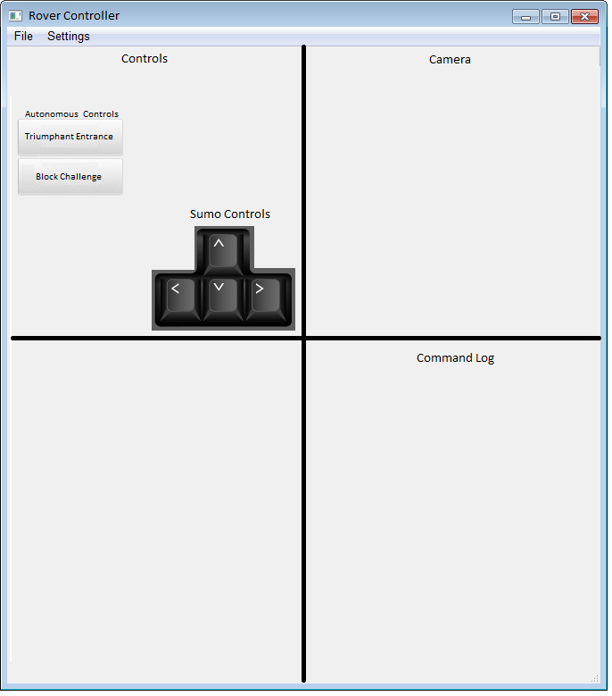

**Motor Commands**

* A command system shall be used to allow for the rover to demonstrate different types of movement.
* The rover shall be able to move forward, backward, and rotate left and right.

**Motor Command Update Rate**

* The motor commands shall update at a rate of TBD Hz.
* This update rate is crucial to have a rover that has good response times and has precise movement.

**Rover Chassis**

* A chassis will be 3D printed that allows the DE1 board to sit firmly on the rover.
* The chassis will allow the ability to mount a camera, battery packs, and motor drive controller board.