**Introduction to Operating System**

Definitions

* A program that acts as an interface or intermediary between a user of computer (Live ware) and the computer hardware.
* An interface that provides an environment in which as user executes programs. Commonly referred to as kernel and installed in hard disk or solid state drive of a computer. Operating systems makes the computer system convenient.
* An operating system is software which performs all the basic tasks like file management, memory management, process management, handling input and output, and controlling peripheral devices such as disk drives and printers.
* Examples: Linux Operating System, Windows Operating System, VMS, OS/400, AIX, z/OS, Android, Unix, Symbian, mac OS,MS-DOS, Windows/NT and iOS

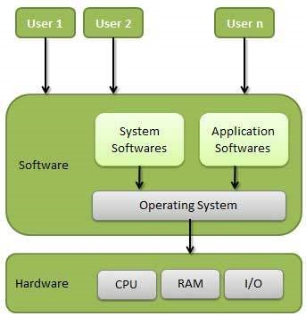

A computer system contains four main parts computer hardware, operating system, application programs and the users.

**Why do we need an Operating System?**

* To provide a pleasant environment and effective interface
* Allocate resources to processes such as I/O devices, memory, file storage and CPU time.

*Resource management is akin to the short blanket problem: everyone wants to be covered, but the blanket is too short to cover everyone at once.*

* To hide details of hardware through abstraction.
* controls and coordinates the use of the hardware among the various application programs for the various users

**Importance of Operating systems**

1. Memory Management-Primary and main memory

* Keeps tracks of primary memory, i.e., what part of it are in use by whom, what part is not in use
* Decides which process will get memory when and how much.
* Allocates the memory when a process requests it to do so (memory frames).
* De-allocates the memory when a process no longer needs it or has been terminated.
* Memory paging is applicable where sum of the requirements of all the applications is more than the available physical memory

1. Process Management(process scheduling)

* Keeps tracks of processor and status of process(Track controller)
* Allocates the processor (CPU) to a process
* De-allocates processor when a process is no longer required

1. Device Management

* Keeps tracks of all devices(I/O controller)
* Decides which process gets the device when and for how much time
* Allocates the device in the efficient way
* De-allocates devices.

1. File Management

* Keeps track of information, location, uses, status (file system).
* Decides who gets the resources
* Allocates the resources
* De-allocates the resources.

1. Security-passwords and other authorization
2. Control over system performance-delays and response
3. Job accounting-track of time and resources
4. Error detecting aids-error messages, traces and debugging
5. Coordination between other software and users- Coordination and assignment of compilers, interpreters, assemblers and other software to the various users of the computer systems

**Operating System Terminologies**

***Processes***

* These are programs in execution which must take place in a sequential manner.
* It is an entity which represents the basic unit of work to be implemented in the system.

When a program is loaded into the memory and it becomes a process, having four sections ─ stack, heap, text and data

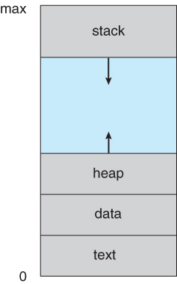

***Files***

* A file is a named collection of related information that is recorded on secondary storage such as magnetic disks, magnetic tapes and optical disks.
* It is a sequence of bits, bytes, lines or records whose meaning is defined by the files creator and user and has a defined structure.
* Files can be classified as text, source and object files

***System Call***

* A system call is a method for a computer program to request a service from the kernel of the operating system on which it is running.
* A system call is a method of interacting with the operating system via programs.
* A system call is a request from computer software to an operating system's kernel.

***Virtual Machines***

* A virtual machine (VM) is a virtual environment which functions as a virtual computer system with its own CPU, memory, network interface, and storage, created on a physical hardware system.
* It has its own operating system and software that will facilitate the resources to virtual computers.
* It encourages the users to go beyond the limitations of hardware to achieve their goals.
* The operating system achieves virtualization with the help of specialized software called a hypervisor, which emulates the PC client or server CPU, memory, hard disk, network and other hardware resources completely, enabling virtual machines to share resources.

**References**

Tanenbaum, A. (2009). *Modern operating systems*. Pearson Education, Inc.,

Walia, E. (2015). *Operating system concepts*. KHANNA PUBLISHING HOUSE.