CS 480 Breedt Production Tooling and Design

Major High-level Features

1. Project Tracking
   1. Tracking hours put towards each project
   2. Tracking bill of materials (BOM) items
2. Project Overview
   1. Visualize statistics on the amount of money and hours dedicated to the project
   2. View project details: Name, customer, deadline, other
3. To-Do List
   1. Boss can create to-do list for the next day
   2. Employees can view to-do list
4. Multiple User Levels

|  |  |  |
| --- | --- | --- |
| View | Employee View | Boss View |
| Dashboard | * Hours recorded for the day so far * Active Tasks for employee * BOM additions from the day * Daily to-do list (Viewable) * Buttons to add hours or BOM | * Overall Hours worked by Employees * Total BOM list for the day * List of currently active tasks * Upcoming project due dates * Daily to-do list (Editable) * Button to settings view |
| Project | * High level project details (Viewable) * List of hours invested into project * List of BOM items purchased for project * Buttons to add both hours and BOM items * Personal Notes (Possibly) * List of employees on project and their roles. | * High level project details (Editable) * List of hours invested into project * List of BOM items purchased for project * Buttons to add both hours and BOM items * Personal Notes (Possibly) |
| Project List | * Filterable list of all currently active projects | * Filterable list of all currently active projects * Button to add new project |
| Settings |  | * Add and remove users and modify their access |

Questions:

BOM: What does a BOM entry represent? Is it a request to be filled? If so do we want to just show the request or also show when it has been purchased?

Project View: What info is important to see as high level info for the project view? What information needs to be saved about the projects? Hour constraints, budget constraints?

Hour Entry: What specific fields do you want to track about each hour entry? Required and optional.

User Levels: How many levels are needed? Will just an admin/boss level and an employee level work?

Taxes: What information needs to be tracked for Tax purposes?

Hour tracking: Can an employee have multiple hour tasks running at once? Should the dashboard for employees show the currently running tasks?

UI: Preference on UI colors or look?

High level project information:

1. Project code
   1. Project name
   2. PO #
2. Hours
   1. Current hours invested
   2. Estimated budgeted hours
3. Bill of materials ready light
   1. Either red for not ready or green for project go

Task creation steps:

User Starts task

Employee ID (Come from User account)

Task ID

Project code

End the task

Hit complete on task

Pause the task

Reason why the task was paused

Estimated hours remaining

Continue Task

Hit continue

Suffixes: (To be included in the project ID)

GE (General Engineering)

GM (General Machine Shop)

GF (General Fabrication Shop)

GB (General Building)

SP (Special Project)

TD (Tooling Design - Client)

TDB (Tooling Design - BREEDT)

TR (Tooling Repair – Client)

TRB (Tooling Repair-BREEDT)

PD(Product Development Client)

PDB (Product Development BREEDT)

EDU (Educational, Interns)

AP (Apprentices)

User Levels

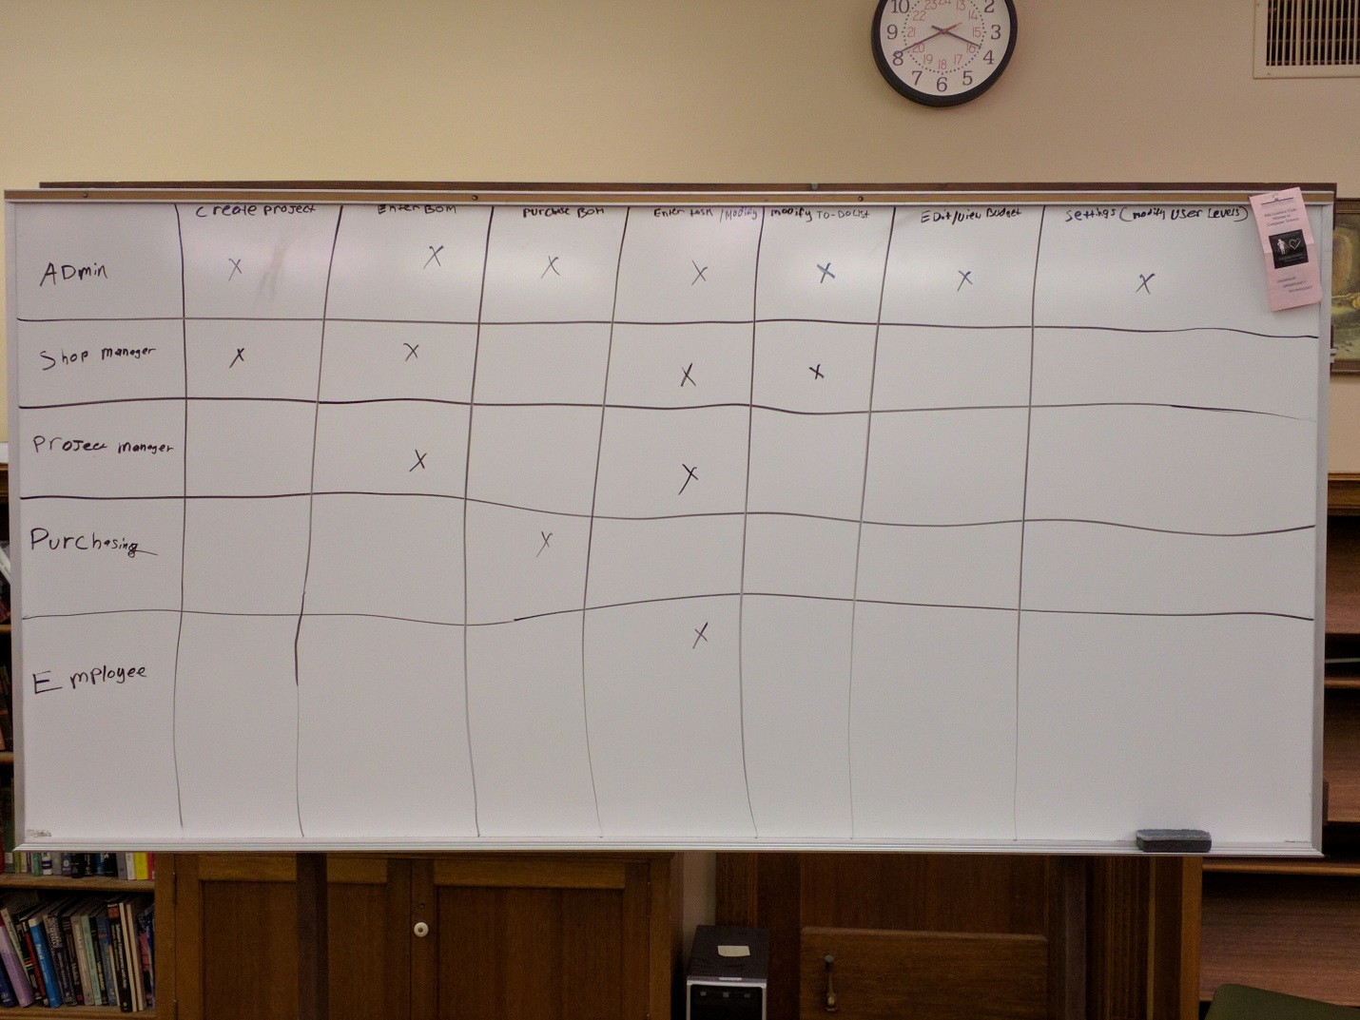

BOM entry

Project id

Employee id

Description of item to be purchased

Check on if it has been purchased or not