# **Mid Exam Challenge: Linux Command Proficiency and File System Navigation**

### **Description:**

This Linux mid exam challenge is designed to assess your proficiency in using basic Linux commands and navigating the file system. The challenge consists of a series of tasks that require you to perform various operations, such as creating and manipulating files and directories, using command-line utilities, and understanding the Linux file system structure.

**Instructions:**

You should download this file, fill it appropriately and submit it as a report. Document each step from the beginning to the end, attaching screenshots for each question. The screenshot should capture your whole screen and display the command you ran to get the answer.

Connect to the machine and answer the following questions: Connecting to the **VM**

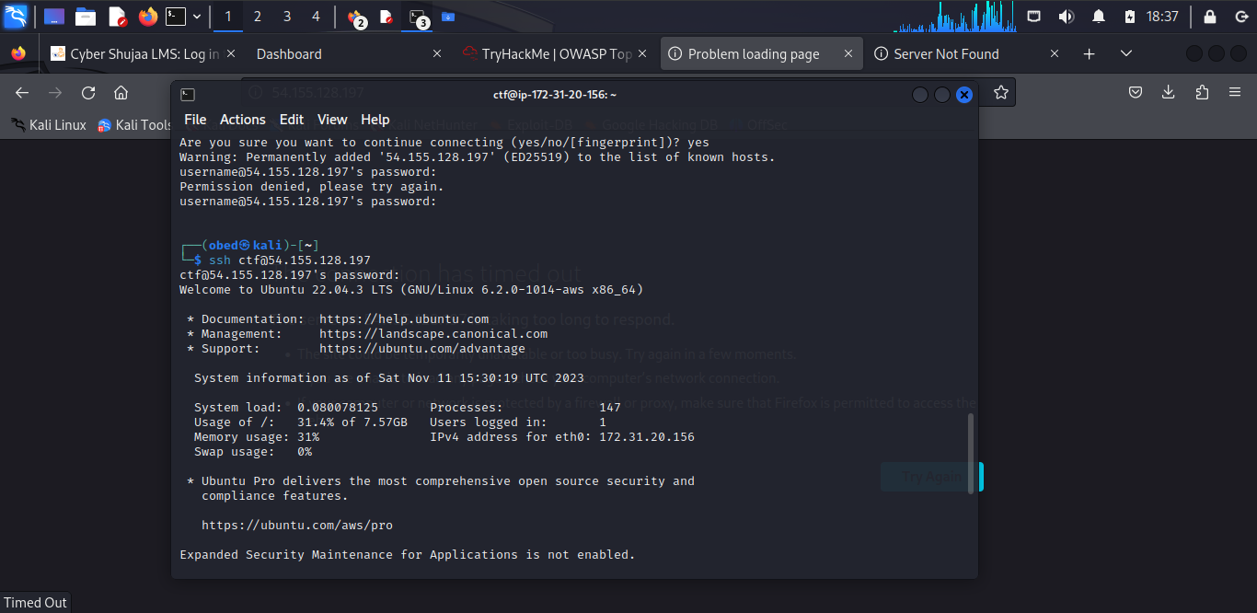

1. **Be careful this Flag is only here temporarily**

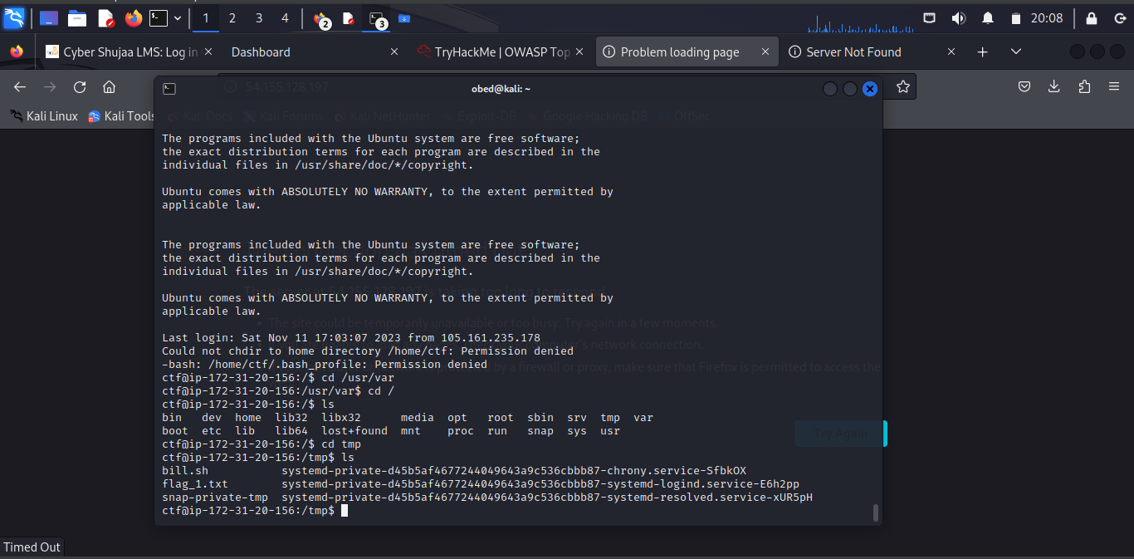

1. **I reside in /usr/var can you see me**

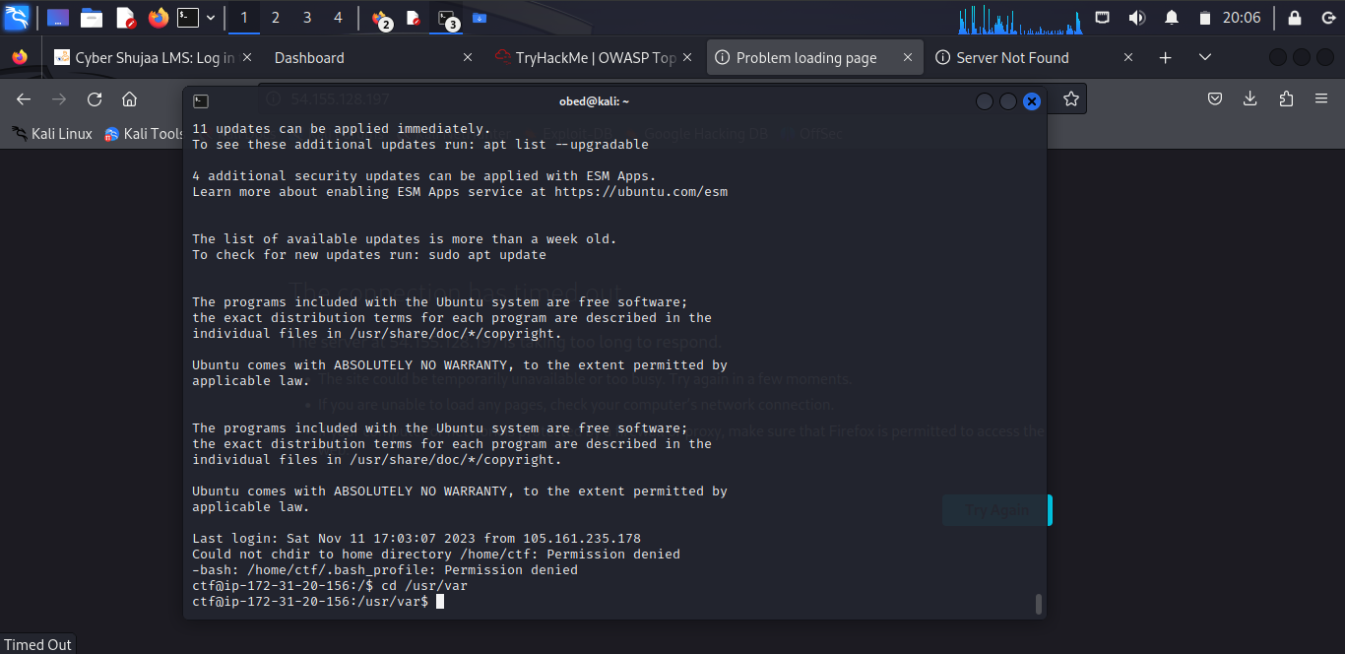

1. **East or west Home is best**

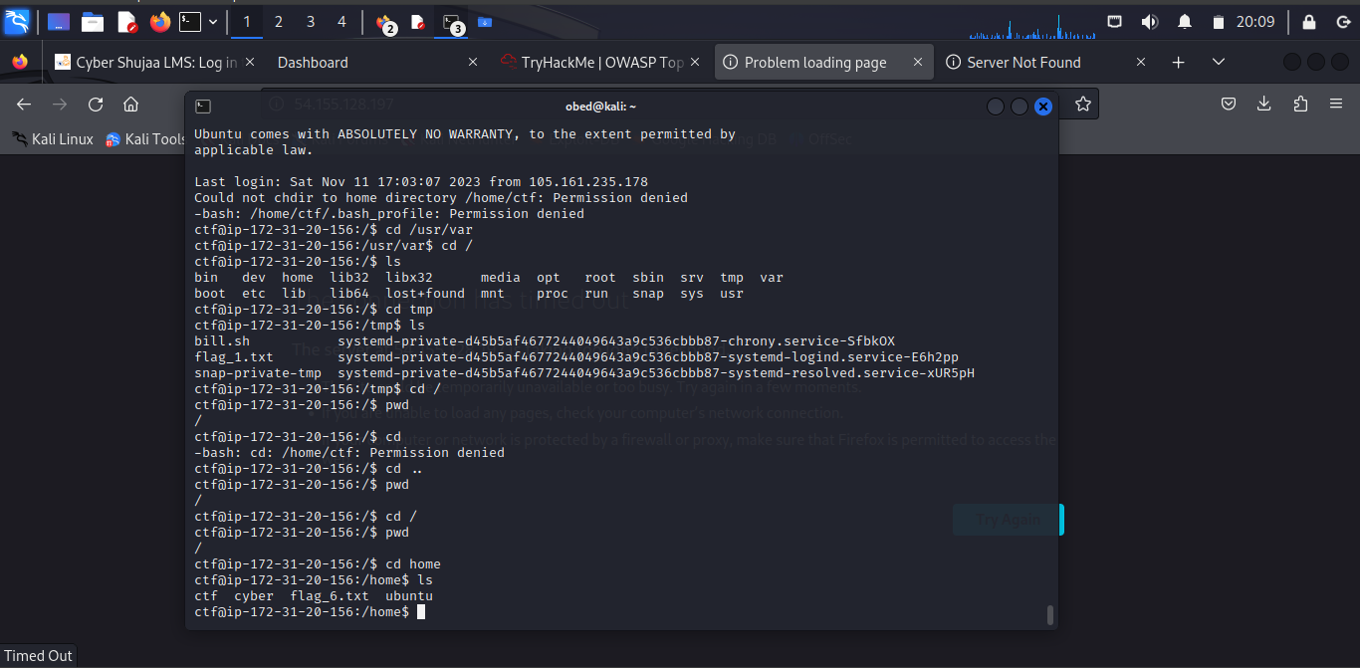

1. **Such an interesting Symbolic concept**
2. **Your senses are an *extension* of your eyes, either trust them or get *misdirected\***
3. **Every adventure starts a step away from home**
4. **Knowing how to *grab* data from a file will save you a lot of *manual* effort**
5. **It's hard to see the *forest* through the trees**
6. **This one is sure to vex you, or is it hex you**
7. **Lost in *the_ocean* Jim desires to move back home**

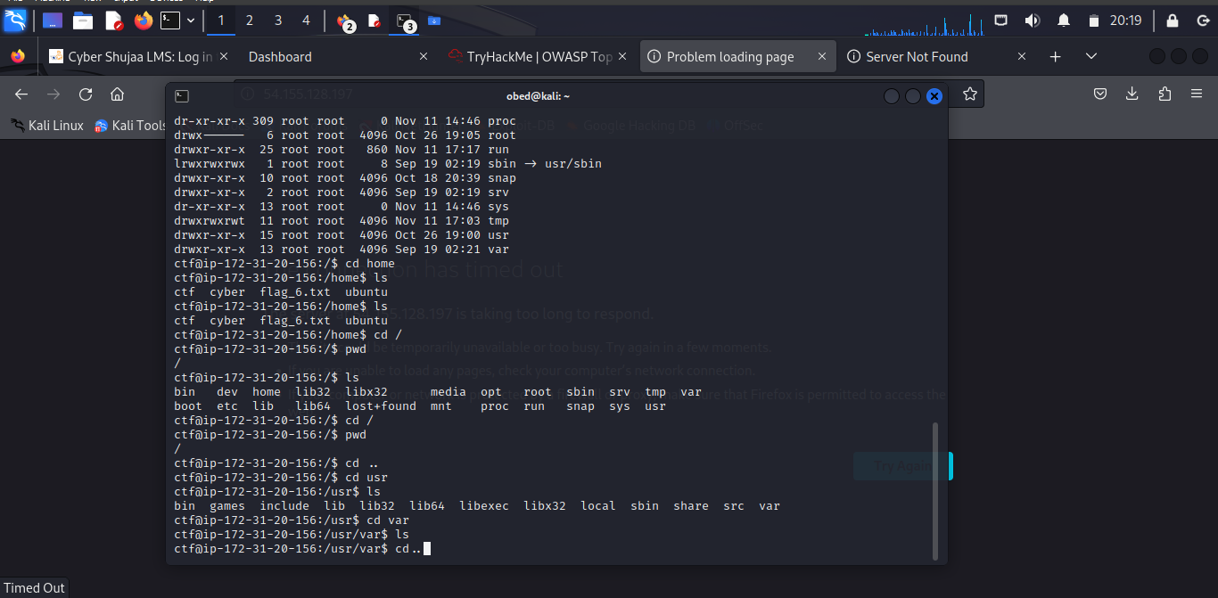

1. **Remove the *boulder* that blocks your path**
2. **Who leaves a box in the middle of the road, get rid of it**
3. **\*thing_1* is identical to *thing_2* the flag will appear once thing_2 is found**
4. **This easy just run the script**
5. **Prison break: break out of the tar coated prison**
6. **Yep another easy one, run the script**
7. **To get the flag help Jim fix the typo in the intput.txt file**
8. **This is embarrassing, i somehow lost flag_18.txt , could you help me *find* it, I swear it is around here somewhere**
9. **This flag is where *ls* lives, find *which* place that is**
10. **You'll need superpowers to read this flag**
11. **Ooh no i think this flag was logged**
12. **Binary data can be a headache to go through unless you use the right tool**
13. **I need your box address so I can send you the flag**
14. **I'm your host for today, what's my name**
15. **Kill Bill**