# What I Need:

A **Python TKinter Project** that sets up a simple GUI according to these guidelines.

# The Python Code Will Start Like This

tabs = [Animals, Cars, People, Weather, Sandwiches, Medicine]

The GUI will be created with 6 tabs in a window:

|  |  |  |  |  |  |
| --- | --- | --- | --- | --- | --- |
| Animals | Cars | People | Weather | Sandwiches | Medicine |
|  | | | | | |
|
|
|
|
|
|
|
|
|
|
|
|
|
|
|
|
|
|

When the Animals tab is clicked, the Animals tab will display its contents. Here are the contents as it will be written by me in Python:

animals_header = [name, age, leg_count, weight, speed]

animals_data_rows = **[** [cleo, 3, 4, 27.5, 22.8], [buddy, 8, 4, 17.5, 12.9], [fishy, 1, 0, 2.5, 8.3] **]**

The GUI should then be populated with this data:

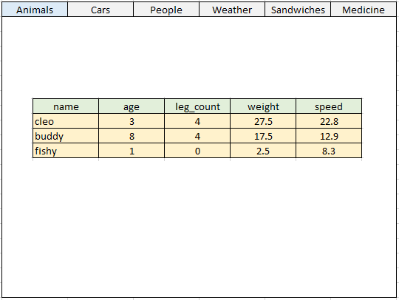

If the Cars tab is clicked, then the application should look at:

cars_header = some list written by me

cars_data_rows = some list written by me

and the GUI should be populated accordingly, and so on for the other tabs.

# Final Requirements

1. There should be vertical scrollbars to accommodate situations where there are many rows.
2. Specify a variable: **time_to_refresh = 5**Then, every 5 seconds, the data should be refreshed if my code decides to change the data in any of the lists.