How does exposure to extreme heat events affect hospital admissions for cardiovascular disease in the United States, while controlling for air quality and access to green spaces?

Hypothesis: Exposure to extreme heat events, as measured by high temperature and heat index values, will increase the risk of hospital admissions for cardiovascular disease, with potentially greater effects in certain regions and for certain demographic groups. This relationship will be influenced by air pollution and access to green spaces, with higher levels of air pollution and lack of access to green spaces exacerbating the health effects of extreme heat events.

Here are the trends and the codes as run using the R-studio programming language:

Graph 1: Maximum temperature by State

Input

> library(readxl)

> Updated <- read_excel("C:/Users/User/Desktop/Updated.xlsx")

> View(Updated)

> names (Updated)

[1] "State" "Max temp" "Heat Index" "Hospitalizations"

[5] "Median Income" "Education" "Air Quality" "Green Spaces"

> library(ggplot2)

> ggplot(Updated, aes(x = State, y = `Max temp`)) +

+ geom_bar(stat = "identity", fill = "blue") +

+ xlab("State") +

+ ylab("Max temp") +

+ ggtitle("Maximum Temperature by State") +

+ theme(axis.text.x = element_text(angle = 90, hjust = 1))

Output

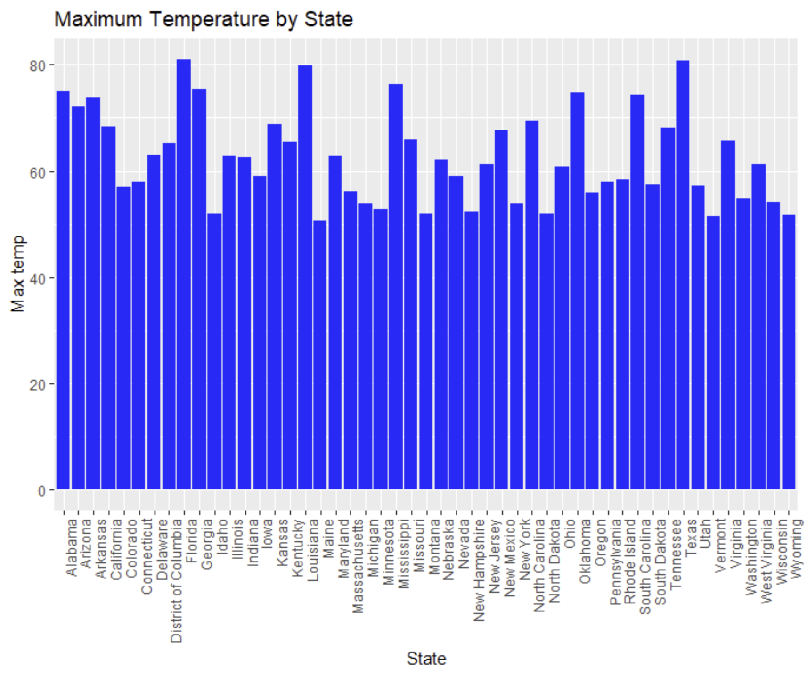

Some states of the US have experienced more warming than others. This graph shows that going by the average daily max temperature Florida, Louisiana and Texas were by far the warmest states while the coldest states were Wyoming, Vermont and Maine.

Graph 2: Temperature and Hospital Admissions

Input

|  |
| --- |
| > ggplot(Updated, aes(x = `Heat Index`, y = Hospitalizations)) +  + geom_point(color = "blue") +  + xlab("Heat Index") +  + ylab("Hospitalizations") +  + ggtitle("Heat Index vs. Hospitalizations") +  + geom_smooth(method = "lm", se = FALSE)  `geom_smooth()` using formula = 'y ~ x' |
|  |
| |  | | --- | | > | |

Output

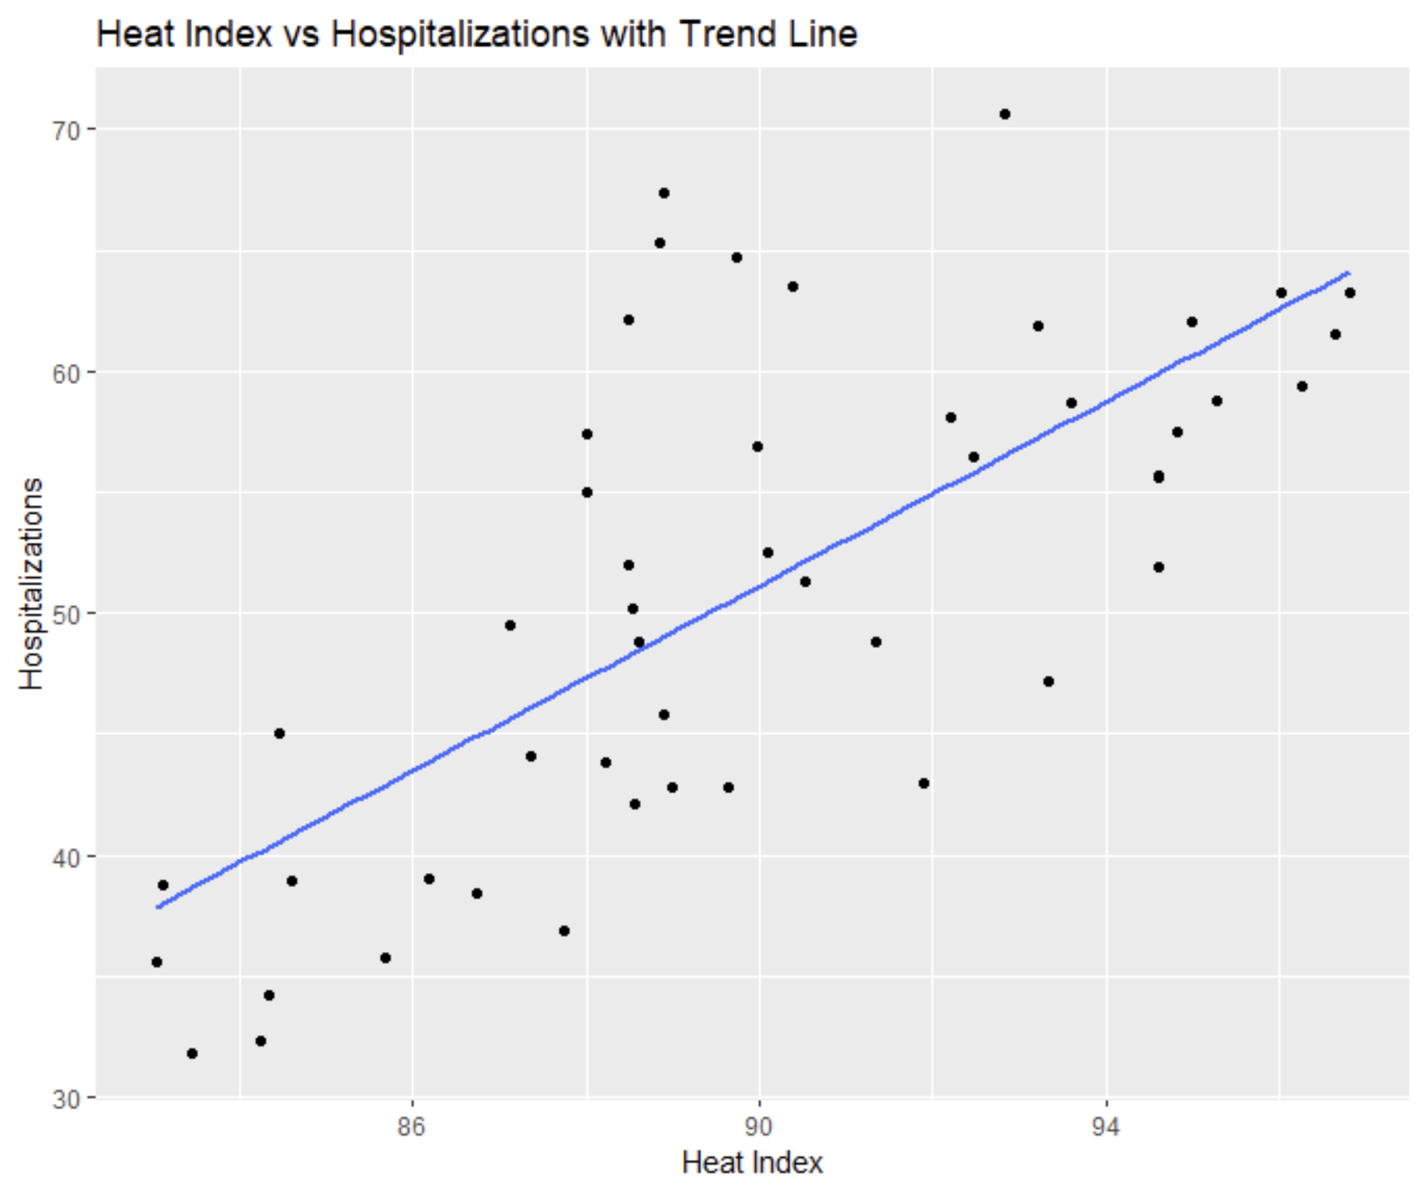

This graph shows the relationship between temperature and hospital admissions for cardiovascular disease. It shows that as temperature increases, so does the number of hospital admissions.

Graph 3: Income and Hospital Admissions

Input

|  |
| --- |
| > library(ggplot2)  > ggplot(Updated, aes(x = `Median Income`, y = Hospitalizations)) +  + geom_point(color = "green") +  + xlab("Median Income") +  + ylab("Hospitalizations") +  + ggtitle("Median Income vs. Hospitalizations") +  + geom_smooth(method = "lm", se = FALSE)  `geom_smooth()` using formula = 'y ~ x' |
|  |
| |  | | --- | | > | |

Output

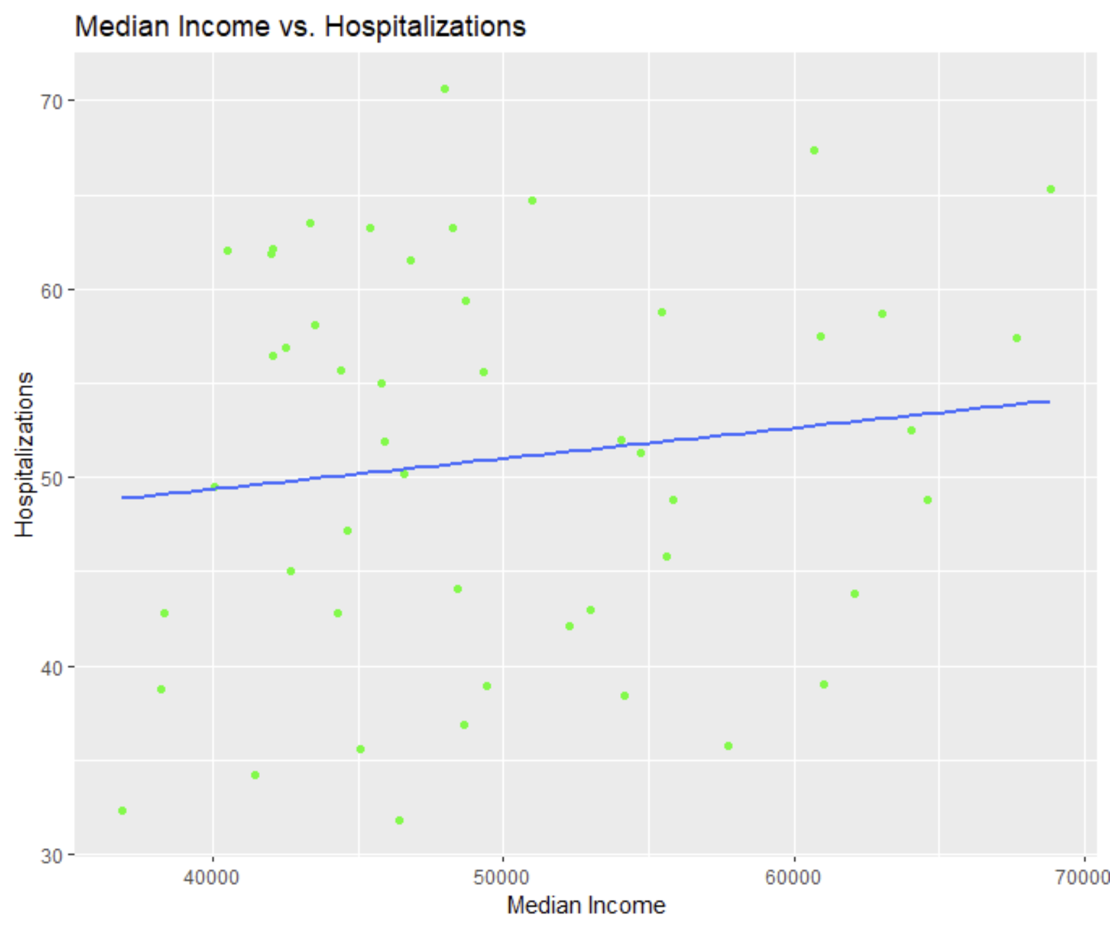

This graph shows the income distribution of individuals who were admitted to the hospital for cardiovascular disease. It shows that individuals with higher income are more likely to be admitted.

Graph 4: Geographic Distribution of Hospital Admissions

Input

> library(ggplot2)

> ggplot(Updated, aes(x = State, y = Hospitalizations)) +

+ geom_bar(stat = "identity", fill = "purple") +

+ xlab("State") +

+ ylab("Hospitalizations") +

+ ggtitle("Hospitalizations by State") +

+ theme(axis.text.x = element_text(angle = 90, hjust = 1))

Output

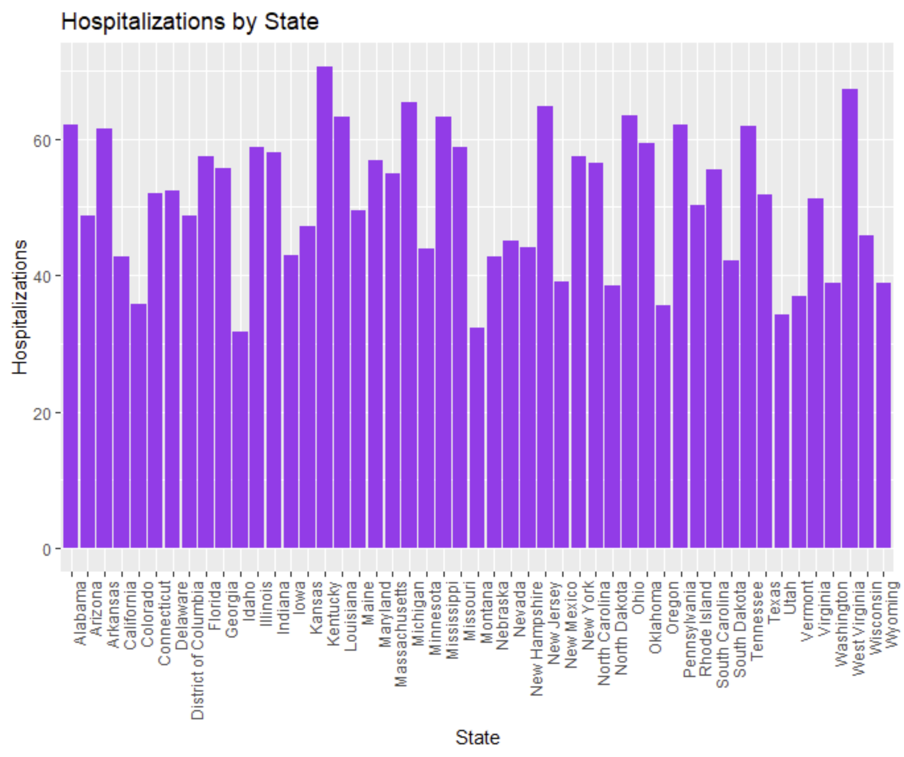

This graph shows the geographic distribution of hospital admissions for cardiovascular disease during heat wave events. It shows that some regions of the country are more affected than others. The highest admissions for cardiovascular disease were in Kentucky and West Virginia, while the lowest admissions were in Idaho, Montana and Utah.

Graph 5: Education and access to green spaces

Input

> library(readxl)

> Updated <- read_excel("C:/Users/User/Desktop/Updated.xlsx")

> View(Updated)

> names (Updated)

[1] "State" "Max temp" "Heat Index" "Hospitalizations"

[5] "Median Income" "Education" "Air Quality" "Green Spaces"

> library(ggplot2)

> Updated$Education <- as.numeric(gsub("%", "", Updated$Education))

> ggplot(data = Updated, aes(x = Education, y = `Green Spaces`)) +

+ geom_point() +

+ geom_smooth(method = "lm", se = FALSE) +

+ labs(title = "Scatter Plot of Education and Green Spaces",

+ x = "Education",

+ y = "Green Spaces")

`geom_smooth()` using formula = 'y ~ x'

Output

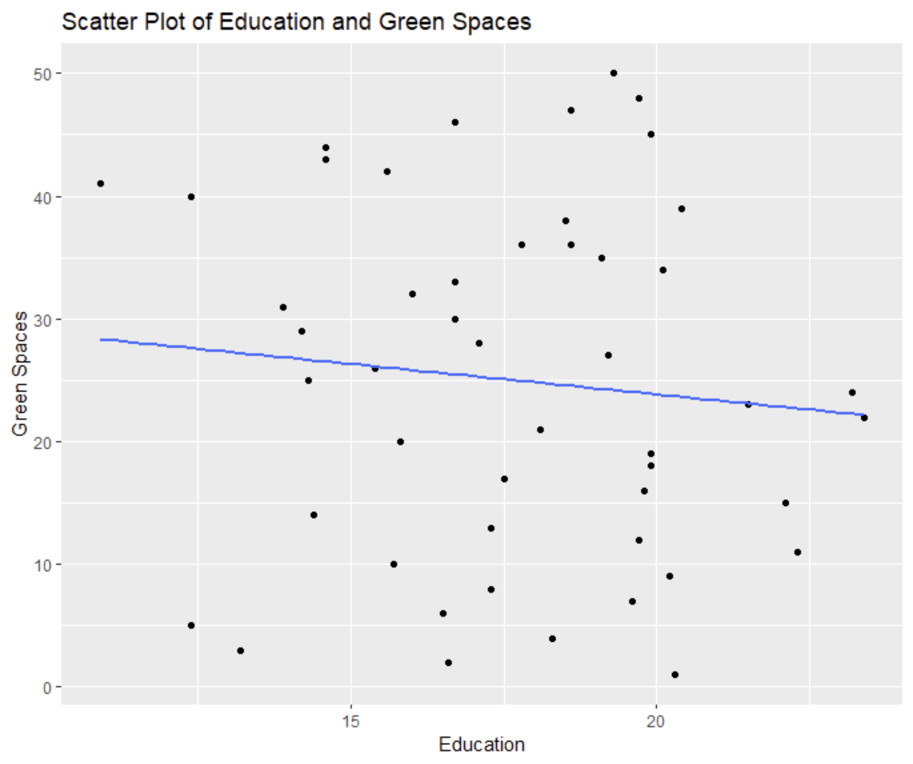

There is a negative relationship between the rank on green spaces and the level of education. This is to imply a higher level of education is associated with high rank on access to green spaces.

Graph 6: Income and access to green spaces

Input

|  |
| --- |
| > Updated$`Median Income` <- as.numeric(gsub(",", "", Updated$`Median Income`))  >  > ggplot(data = Updated, aes(x = `Median Income`, y = `Green Spaces`)) +  + geom_point() +  + geom_smooth(method = "lm", se = FALSE) +  + labs(title = "Scatter Plot of Median Income and Green Spaces",  + x = "Median Income",  + y = "Green Spaces")  `geom_smooth()` using formula = 'y ~ x' |
|  |
| |  | | --- | | Output | |

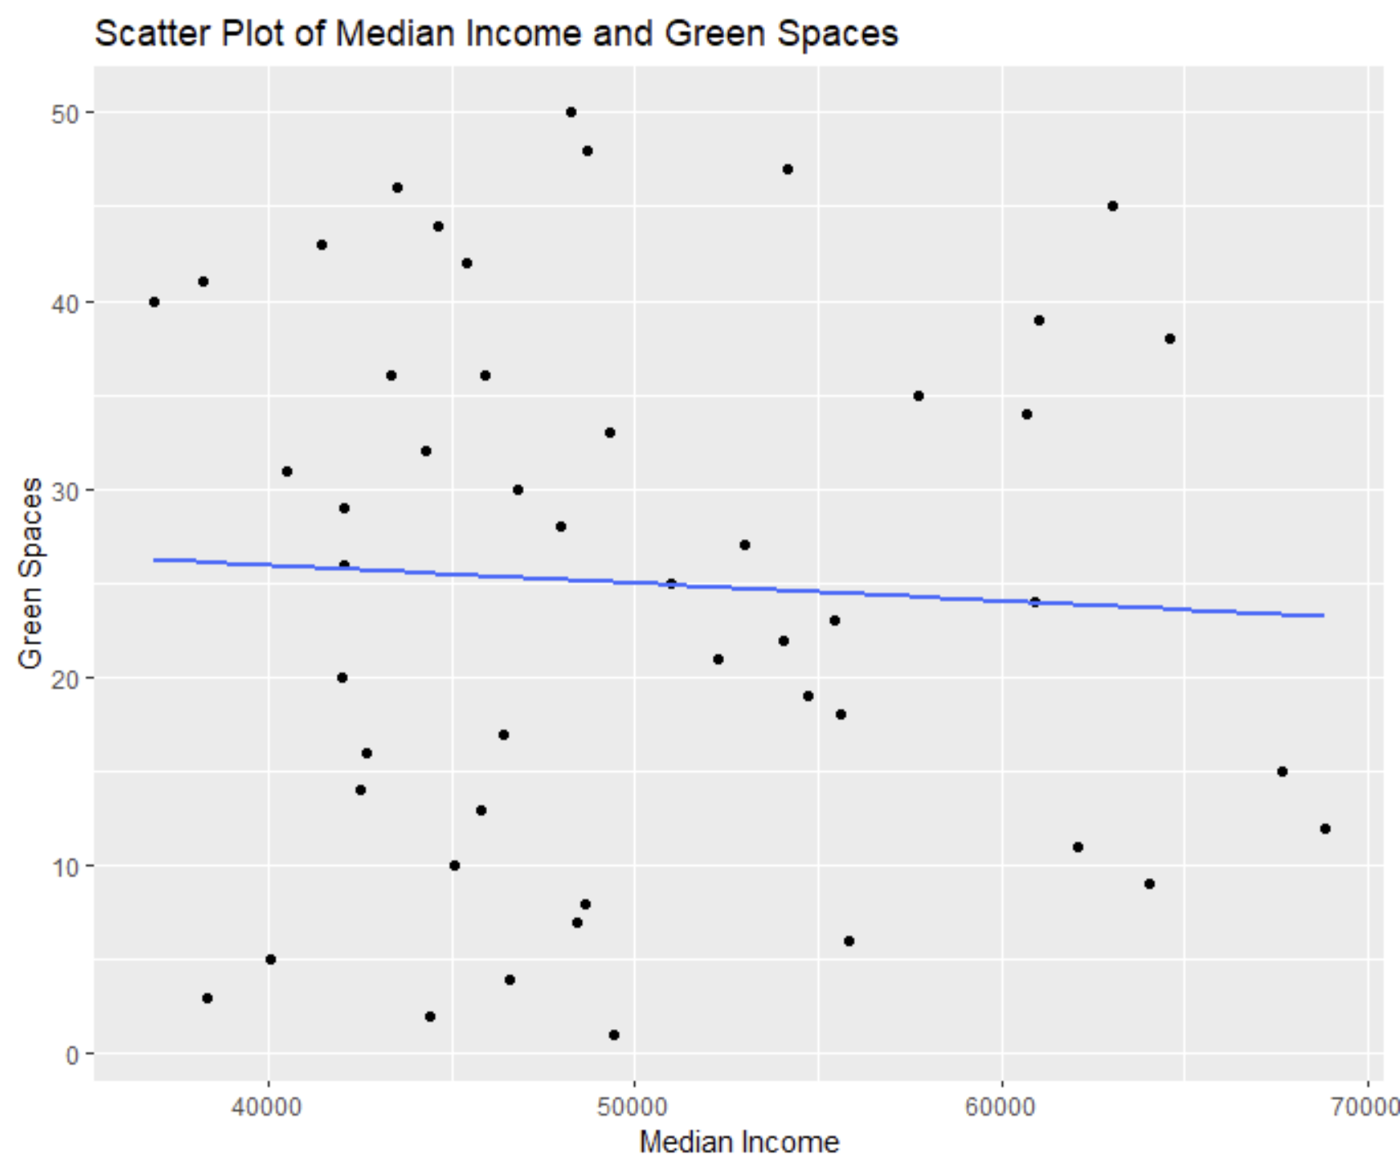

There is a negative relationship between the rank on green spaces and median income. This is to imply a higher level of income is associated with a higher rank on access to green spaces.

Graph 7: Air Quality and Hospital admissions

Input

|  |
| --- |
| > library(ggplot2)  > ggplot(data = Updated, aes(x = `Air Quality`, y = Hospitalizations)) +  + geom_point() +  + geom_smooth(method = "lm", se = FALSE) +  + labs(title = "Scatter Plot of Air Quality and Hospitalizations",  + x = "Air Quality",  + y = "Hospitalizations")  `geom_smooth()` using formula = 'y ~ x' |
|  |
| |  | | --- | | Output | |

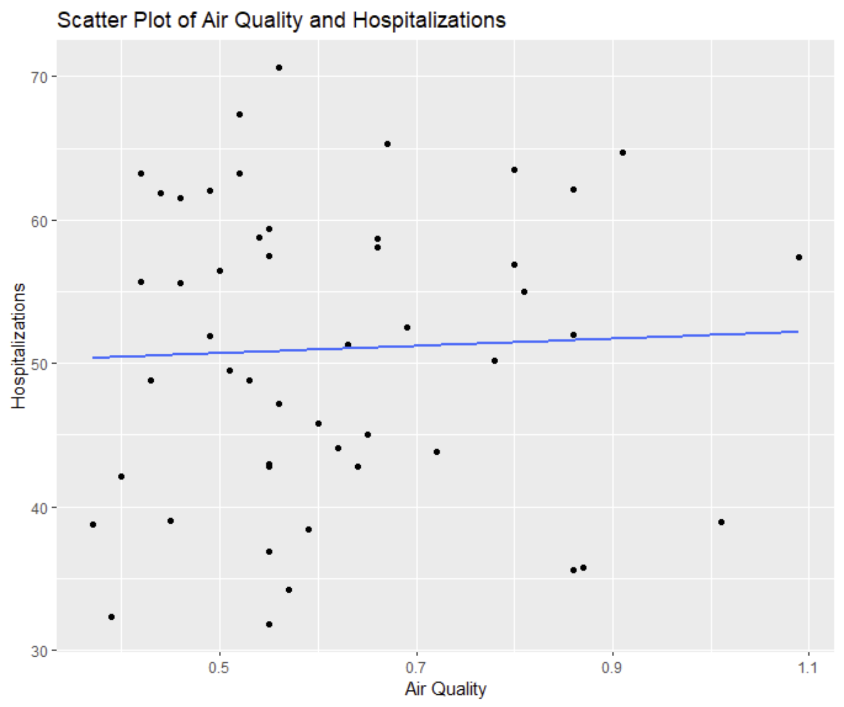

There appears to be a moderate relationship between air quality and the number of hospital admissions for cardiovascular diseases.