Abstract

Heart disease is a killer disease for both women and men in the United States. In 2020 alone, 697,000 people died from the heart disease. This is to imply that out of every five deaths in the US, one was from heart disease. Some of the risk factors for heart disease include gender, household income, race and ethnicity. Using a sample of 100 people from Governors Township we analyze the distribution of heart disease on the basis of the risk factors listed above to see if there are any observable patterns.

Hypotheses

Hypothesis 1: There is a significant relationship between heart disease and race/ethnicity

Hypothesis 2: Heart disease differs significantly by gender

Hypothesis 3: African Americans are at a higher risk of heart disease than their White Counterparts

Hypothesis 4: Households with a larger size are at a higher risk of heart disease

Descriptive statistics

Variable 1: History of Heart disease

> table(mydata$HistoryHD)

0 1

42 58

> barplot(table(mydata$HistoryHD)

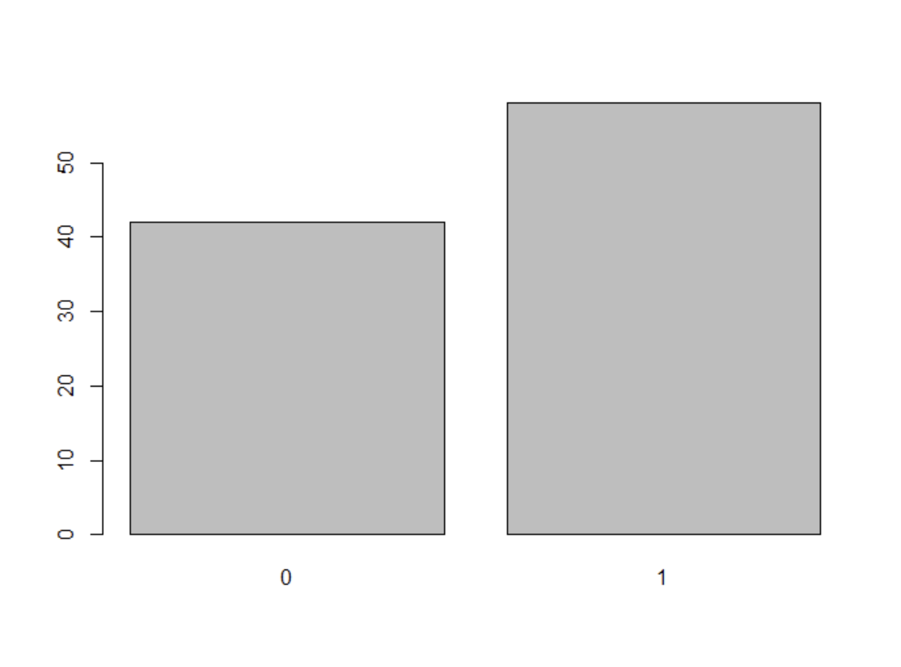

In my sample of 100, 58 (58%) reported history of heart disease while the remaining 42 (42%) reported no history of heart disease.

Variable 2: Annual Household Income

> summary(mydata$AnnualHouseholdIncome)

Min. 1st Qu. Median Mean 3rd Qu. Max.

72400 118813 131350 131313 141675 261750

The average annual household income in the township is $131,313 with minimum income falling at $72,400 and the maximum at $261,750.

Variable 3: Homesize

|  |
| --- |
| > table(mydata$HomeSize)  L M S  35 54 11 |
|  |
| |  | | --- | | > barplot(table(mydata$HomeSize)) | |

Out of a sample of 100 homes, there were 35 large-sized homes, 54 medium-sized homes and 11 small-sized homes.

Variable 4: Race/ethnicity

> table(Township$Race)

1 2 3 4

27 17 41 15

> barplot(table(Township$Race))

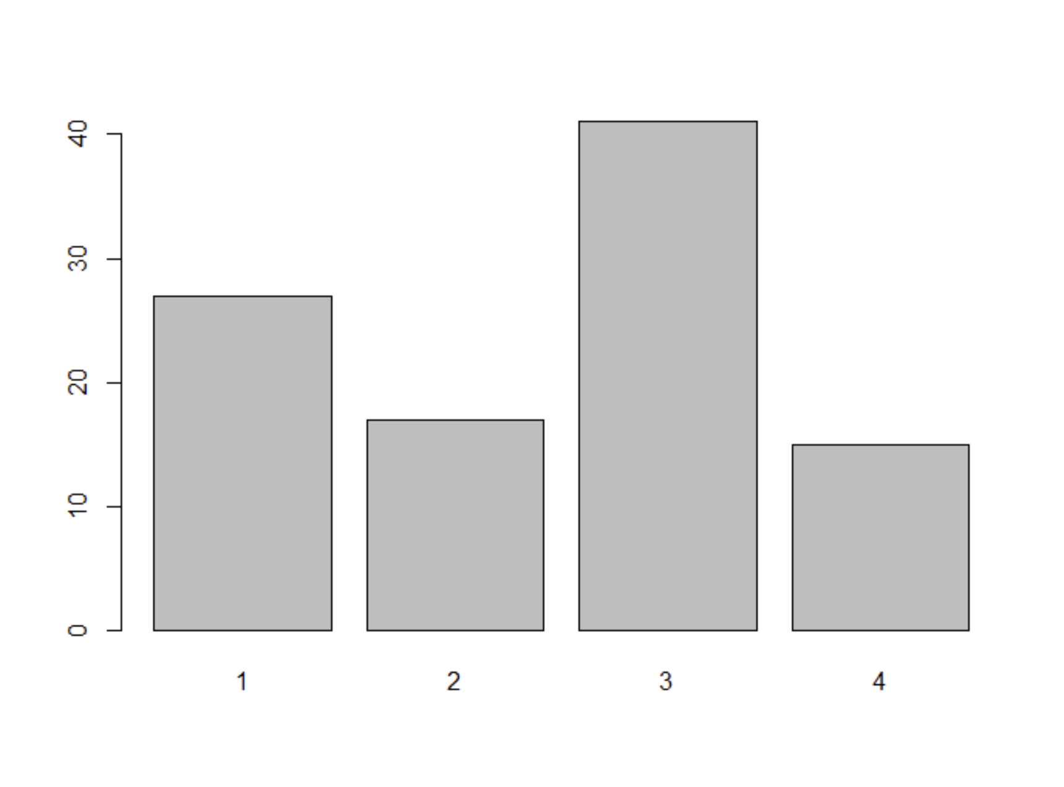

1(Black) 2(Hispanic) 3(White) 4(Asian)

Out of the sample of 100, there were 41 (41%) Whites, 27 (27%) Blacks, 17(17%) Hispanics and 15 (15%) Asians.