

UNIVERSITY OF GHANA

DEPARTMENT OF COMPUTER SCIENCE

DSCD 614: REINFORCEMENT LEARNING (3 CREDITS)

PROJECT-BASED EXAMINATION (GROUP 5)

TITLE: ELECTRIC VEHICLE CHARGING OPTIMIZATION USING TWIN DELAYED DEEP DETERMINISTIC POLICY GRADIENT

MEMBERS:

MICHAEL NIMAKO FREMPONG (ID: 22425053)

NII OBODAI SQUIRE (ID: 22425147)

STEPHEN NARH KORLEY (ID: 22426006)

1. Introduction
Charging stations for electric vehicles have to juggle a few things at once. Drivers want their cars charged quickly, but if too many vehicles pull maximum power at the same time, electricity costs climb and the grid comes under strain. This project looks at whether reinforcement learning, specifically Twin Delayed Deep Deterministic Policy Gradient (TD3) can be used to learn a continuous charging-control policy that manages this trade-off more sensibly than simply charging every vehicle as fast as possible.
The core of the work was building a custom Gymnasium environment to represent an EV charging session, training a TD3 agent to choose an appropriate charging level within that environment, and then comparing its behaviour against a simple immediate-charging baseline.
Three operational goals sit at the centre of the problem: keeping charging cost down, limiting peak/grid contribution, and still making sure vehicles actually get charged. Because these goals pull in different directions, the problem is better framed as a sequential decision-making task than as a standard supervised-learning prediction problem.

2. Dataset
The project draws on an EV charging dataset that captures both session-level and station-level information, things like vehicle type, battery capacity, initial and final state of charge (SOC), charging power, charging duration, waiting time, station load, electricity price, renewable-energy ratio, queue length, charging demand, and charging priority, among other operational variables.
The data was sorted chronologically and split 80/20 into training and testing portions, with the earlier 80% used to train the TD3 agent and the remaining 20% held back purely for evaluation. Keeping the split chronological, rather than random, was a deliberate choice to stop evaluation episodes from leaking into training.

3. Reinforcement Learning Environment
A custom Gymnasium environment, EVChargingEnv, was built to represent the charging problem.

3.1 State representation
Each charging session is represented using six normalized state variables:
- Current SOC
- Target SOC
- Fraction of charging steps remaining
- Electricity price
- Background charging demand
- Vehicle charging-power limit
Together these form a six-dimensional continuous observation vector, giving the agent a picture of where the vehicle currently stands, how much charging it still needs, how much time is left, and what conditions look like on the grid side.

3.2 Action space
TD3 operates on a normalized, continuous action a_t, where 0 means no charging and 1 means charging at the vehicle's maximum available power. The actual charging power delivered is calculated as:
P_t = a_t × P_max
where P_max is the physical charging-power limit of the EV in question. This continuous formulation is a natural fit for TD3, since the algorithm is built specifically for continuous action spaces rather than discrete ones.

3.3 State transition
At each 15-minute step, the energy delivered is:
E_t = P_t × Δt, where Δt = 0.25
SOC is then updated in proportion to the energy delivered relative to battery capacity, and capped at 100% so it can never overshoot.

4. Reward Function
The reward function was designed to weigh charging progress against electricity cost and grid impact, rather than optimizing for any single one of those in isolation. It combines:
- a reward for SOC progress
- a penalty tied to electricity cost
- a penalty tied to grid/peak contribution
- a terminal reward for reaching the charging target
- a terminal penalty for falling short of the target
In effect, the environment nudges the agent toward charging that's genuinely useful without being unnecessarily aggressive. Conceptually, the reward can be written as:
R_t = w_p·R_progress − w_c·C_cost − w_g·C_grid + R_terminal
with the weights setting how much emphasis falls on charging progress, cost, and grid contribution relative to one another.

5. TD3 Model
TD3 made sense here because the charging decision is continuous, not a choice between a handful of fixed charging levels, the agent learns to pick a precise charging intensity directly.
The implementation is built on Stable-Baselines3's TD3 with an MLP policy, and Gaussian action noise was added during training to keep exploration going. Training used a learning rate of 10⁻³, a replay buffer of 200,000 transitions, a batch size of 256, a discount factor of 0.99, and a target-network update coefficient of 0.005. Each seed was trained for 100,000 environment steps, and three independent seeds were run to get a sense of how stable the learned policy actually is.

6. Baseline
TD3's performance was measured against an immediate-charging baseline that always selects a_t = 1, in other words, it charges every vehicle at 100% of its available power. This gives a simple reference point representing the most aggressive strategy possible: charge as fast as the hardware allows, with no regard for cost or grid load.

7. Experimental Evaluation
Final evaluation ran on the held-out test split across all three seeds. For each seed, several episodes were evaluated, and results were summarized as a mean and standard deviation across seeds. The metrics tracked were:
- charging cost
- peak contribution
- percentage of charging requirements satisfied
- constraint violations
- cumulative reward
- mean normalized charging action
Exploration noise was switched off during evaluation, so TD3's predictions were deterministic rather than exploratory.

8. Results

Table 1. Performance comparison
Metric | Immediate Charging | TD3
Charging cost | 0.895 ± 0.031 | 0.730 ± 0.027
Peak contribution | 14.163 ± 0.967 | 7.264 ± 0.606
Target requirement met (%) | 100.0 ± 0.000 | 62.0 ± 4.899
Constraint violations | 0.000 ± 0.000 | 0.000 ± 0.000
Cumulative reward | 7.464 ± 0.712 | 6.412 ± 0.779
Mean normalized action | 1.000 ± 0.000 | 0.821 ± 0.017
The values behind Table 1 are broken out by seed below.

Table 2. Per-seed evaluation results
Policy | Seed | Cost | Peak | Met (%) | Violations | Reward | Mean Action
Immediate Charging | 0 | 0.917 | 14.283 | 100.00 | 0 | 7.181 | 1.000
Immediate Charging | 1 | 0.916 | 15.284 | 100.00 | 0 | 6.769 | 1.000
Immediate Charging | 2 | 0.851 | 12.924 | 100.00 | 0 | 8.442 | 1.000
TD3 | 0 | 0.727 | 6.549 | 56.00 | 0 | 5.699 | 0.798
TD3 | 1 | 0.763 | 8.032 | 62.00 | 0 | 6.040 | 0.826
TD3 | 2 | 0.699 | 7.211 | 68.00 | 0 | 7.496 | 0.840

8.1 Charging cost
TD3 brought the mean charging cost down from 0.895 to 0.730 — roughly an 18.4% reduction. That drop suggests the agent learned not to charge at full intensity throughout the whole session, choosing instead to moderate its power draw.

8.2 Peak contribution
The biggest gain shows up here. TD3 cut mean peak contribution from 14.163 to 7.264, close to a 48.7% reduction. This matters because avoiding a pile-up of charging demand during high-load periods is one of the main reasons to use intelligent charging control in the first place.

8.3 Charging requirement satisfaction
This is where the trade-off shows up. The immediate-charging baseline hit 100% target fulfilment, since it always charges at maximum power, while TD3 only reached 62.0% on average. The learned policy was, at times, too conservative — it held back on charging intensity and didn't always deliver enough energy within the available window.
So while TD3 came out ahead on cost and grid impact, it didn't match the baseline's reliability at actually finishing the job.

8.4 Constraint violations
Both policies recorded zero constraint violations, meaning the action space was respected throughout and the charging-control formulation held up as intended.

8.5 Mean action
The baseline's mean action was, unsurprisingly, exactly 1.000, while TD3 averaged 0.821. That gap backs up the idea that TD3 actually learned a more measured charging strategy rather than just converging back to the same behaviour as the baseline.

8.6 Evaluation and training plots
Figures 1 and 2 visualize the comparison above and the training run that produced it.
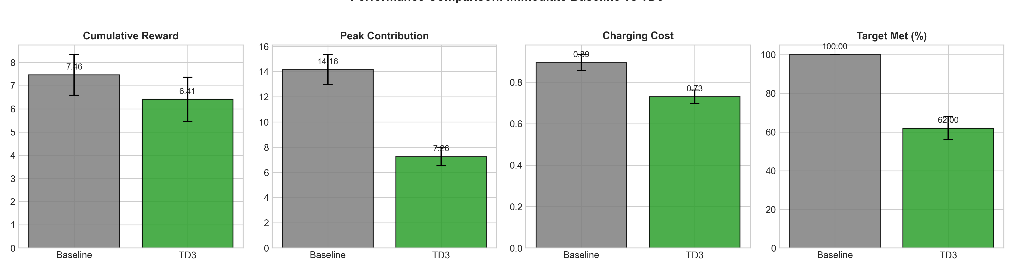
Figure 1. Performance comparison between the immediate-charging baseline and TD3 across cumulative reward, peak contribution, charging cost, and target-met percentage (error bars show standard deviation across seeds).
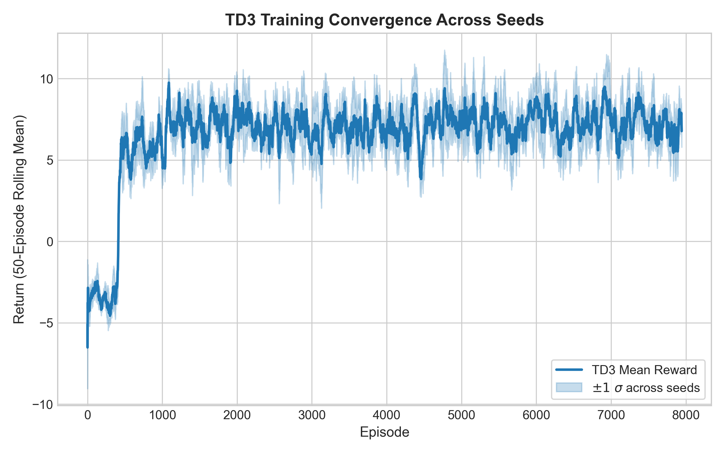
Figure 2. TD3 training convergence across the three seeds, showing the 50-episode rolling mean reward (shaded band: ±1 standard deviation across seeds).

9. Training Behaviour
Looking at the training curves, reward improves quickly early on and then levels off with some fluctuation across episodes. There's noticeable variation between seeds, the learning process clearly isn't perfectly deterministic, but all three runs settle into a similar performance range, which is a reasonable sign that the agent picked up a genuine charging strategy rather than staying stuck near random behaviour.

10. Problems Encountered and Corrections
A few implementation issues came up during development and are worth documenting rather than glossing over.
An early version of the environment used an absolute charging-power interpretation, while the validation code separately (and incorrectly) treated an action of 1.0 as maximum physical charging power. The fix was to rebuild the action space around a properly normalized representation, where 1.0 always means 100% of the current EV's available charging power. Once that was in place, the validation procedure was updated to explicitly test the normalized 100% action, and the environment was checked against Gymnasium API compliance, reproducibility, and physical-feasibility tests.
An earlier reward formulation pushed the agent toward a near-zero charging strategy, it essentially learned to avoid charging altogether. That was a clear sign the reward was discouraging charging far too strongly, so it was redesigned to give a denser, more consistent incentive for making SOC progress, while still accounting for cost, grid impact, and the terminal conditions.
After that first fix, the pendulum swung the other way and the agent started charging at close to maximum power. This showed the charging-progress incentive had become too dominant, so the reward was rebalanced again to bring cost and grid penalties back into the picture alongside progress.
The final version settled into a more balanced strategy, with a mean normalized action of 0.821. That said, the 62% target-fulfilment rate shows the reward formulation still leans a bit too far toward cost and peak reduction in some cases. That's flagged here as an honest limitation of the current setup rather than something to smooth over.

11. Limitations
The reward weights were chosen manually rather than tuned through any systematic search. The learned policy also doesn't yet match immediate charging's reliability when it comes to actually delivering the required charge. On top of that, the environment is a simplified simulation, real charging stations deal with multiple EVs at once, charger availability, dynamic queues, transformer limits, and electricity tariffs that shift over time, none of which are modelled here. Finally, only three random seeds were used; that gives some indication of robustness, but a larger number of runs would make for a stronger statistical case.

12. Future Improvements
Future work should focus mainly on closing the gap between grid efficiency and charging-service reliability. Some directions worth pursuing:
- Increase the reward tied to meeting the target SOC.
- Introduce a stronger terminal penalty when charging requirements go unmet.
- Run a systematic reward-weight tuning process instead of manual selection.
- Add further state variables such as queue length, renewable-energy availability, and charging priority.
- Model multiple EVs charging simultaneously at a station.
- Introduce dynamic electricity prices and station-level constraints.
- Compare TD3 against other RL algorithms, such as SAC and PPO.
- Increase the number of training seeds and evaluation episodes.
- Explore constrained reinforcement-learning approaches, where target fulfilment is treated as an explicit constraint rather than just another reward term.

13. Conclusion
This project set out to apply TD3 to continuous EV charging optimization within a custom Gymnasium environment, and largely succeeded in showing what that trade-off looks like in practice. The trained agent settled on a noticeably less aggressive charging strategy than the immediate-charging baseline, cutting charging cost by 18.4% and peak contribution by 48.7%, all while keeping constraint violations at zero. That improvement came at a cost, though: charging requirement satisfaction dropped from a perfect 100% under the baseline to 62% under TD3. Taken together, the results show that TD3 is capable of learning a genuinely useful balance between charging intensity, cost, and grid contribution, but the current reward formulation doesn't yet place enough weight on guaranteeing that charging requirements are actually met. That gap points clearly toward future work: reward tuning, constraint-aware learning, and a more realistic multi-EV charging environment. On the whole, the experiment captures both what deep reinforcement learning can offer EV charging optimization, and where its current limits are.

