**Dear Mona,**

**Is there any state or region that really has worse drivers? Everywhere I’ve lived I have heard people bemoan the driving ability of others, normally from a neighboring state.**

***Lisa, 31, Asheville, North Carolina***

This is a tricky one. I want to try and answer your question using three types of historic data that could indicate where America’s worst drivers are: The number of car crashes in each state (especially those where the driver was negligent in some way), how much insurance companies pay out, and how much insurance companies charge drivers. All three measures vary a lot across the country and no state is consistently at the bottom, but drivers in Texas don’t do very well on any of them. By contrast, drivers in Iowa, Indiana and Vermont are pretty good across the board.

First, collisions. There were [5.6 million motor vehicle crashes](http://www-nrd.nhtsa.dot.gov/Pubs/812032.pdf) in the United States in 2012, of which 4 million involved solely property damage, 1.6 million involved a personal injury, and 30,800 resulted in a fatality, according to the [National Highway Traffic Safety Administration](http://www-fars.nhtsa.dot.gov/Main/index.aspx) (NHTSA). Texas accounted for 3,021 of those fatal crashes, more than any other state, while Washington, D.C., had 14, fewer than anywhere else.

But a state with more fatal car crashes is not necessarily a state with more bad drivers — it could simply be a state that has more drivers or a state with worse driving conditions. So we need to factor in the total miles traveled in each state and focus on the characteristics of the drivers who were involved in fatal collisions.

North Dakota has the highest number of such drivers for every billion miles traveled. Over the course of the [9.1 billion miles traveled in the state in 2011](https://www.fhwa.dot.gov/policyinformation/statistics/2011/vm2.cfm" \t "_blank) (the latest data available), 218 drivers were involved in 147 crashes. That produces a figure of 23.8 drivers involved in fatal collisions for every billion miles traveled — far higher than the national average of 15.5.

You’re interested in the behavior of those individuals. We know, for example, whether a driver was distracted at the time of a fatal accident. Of the 45,670 drivers involved in fatal road accidents nationwide in 2012, 3,758 were recorded as being distracted at the time (although it’s worth bearing in mind that in 8,991 cases, it was either not known or not recorded whether the driver was distracted). There’s detail on what those distractions were: 397 of those drivers were distracted by their cellphones, 39 were eating or drinking, and 17 drivers were simply “lost in thought/day dreaming.”

In both Ohio and North Dakota, just 1 percent of drivers involved in fatal accidents were recorded as distracted, compared to 10 percent nationally. But those percentages need to be treated with plenty of caution — it might sound pretty impressive that none of the drivers involved in fatal accidents in D.C. were recorded as being distracted at the time, but that’s based on only 10 drivers for which we have information.

Bear in mind, though, that not all drivers who got in fatal crashes in a given state are licensed there — in New York, for example, only 87 percent did.

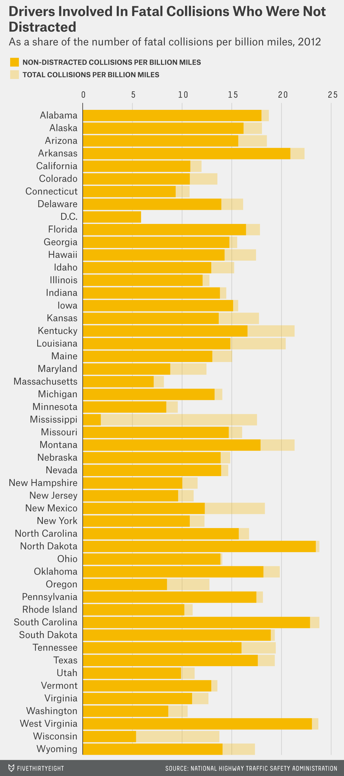

The database also shows whether drivers were involved in previous crashes. For 88 percent of drivers nationally, it was their first crash. That figure varies by state, though. At the high end, in Idaho, 98 percent of drivers hadn’t been involved in any previous collisions, while in New Jersey, at the low end, that figure was 78 percent.

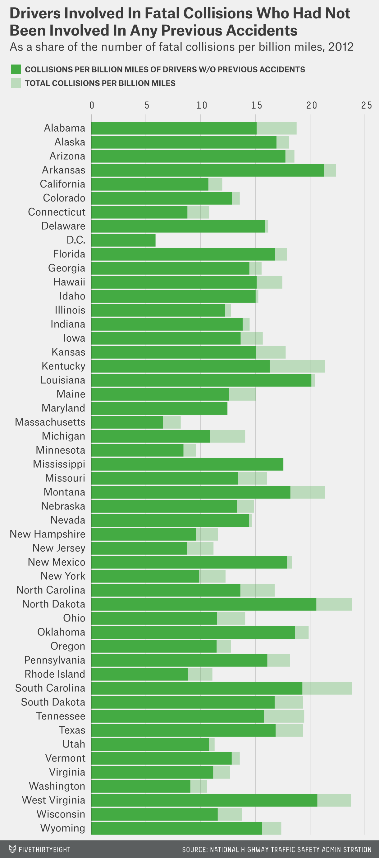

Another way to put those fatal crashes in perspective is to determine whether the driver was speeding at the time. The latest data available for speeding-related fatalities is from 2009, when the NHTSA recorded 33,808 total traffic fatalities, 31 percent of which occurred while a driver was speeding. In Mississippi, just 15 percent of traffic fatalities occurred while a driver was speeding, while in Pennsylvania, the share was 50 percent.

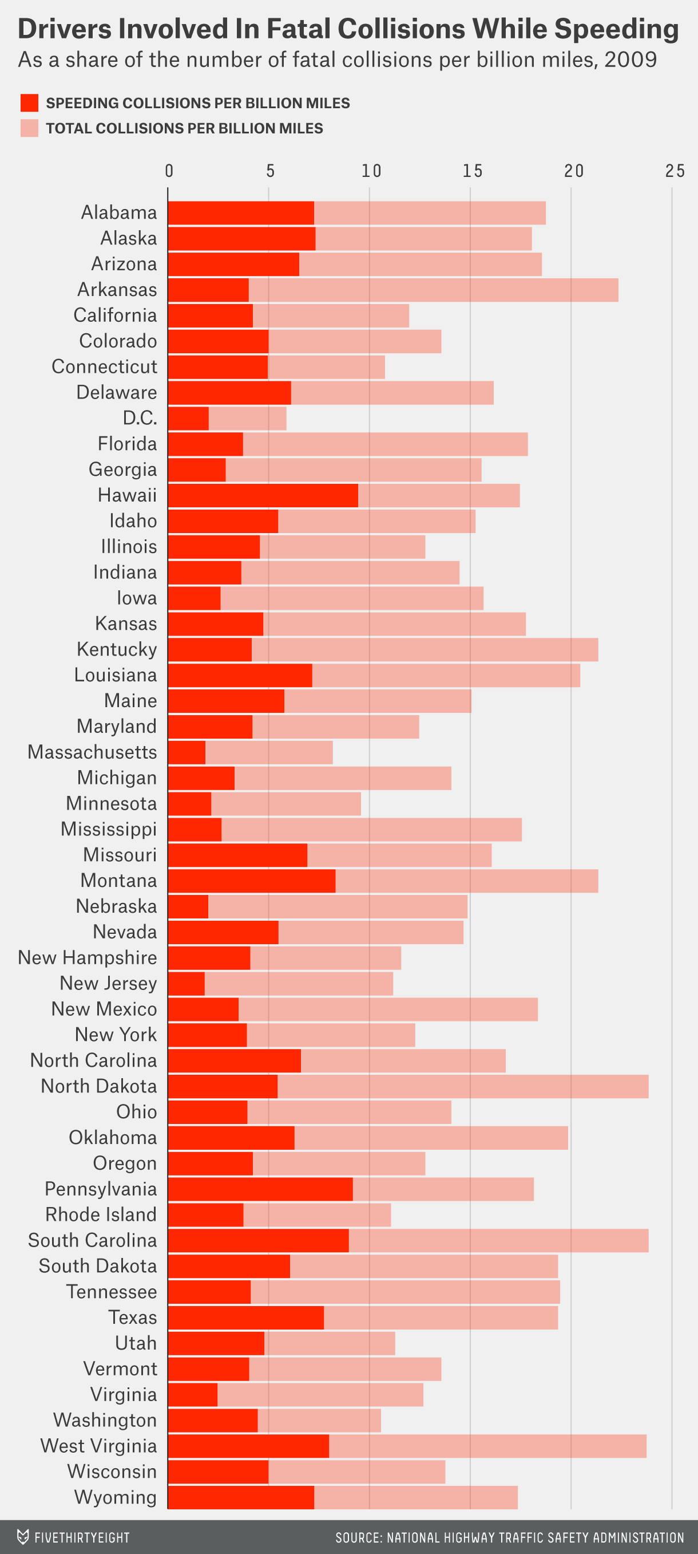

Because it’s an irresponsible behavior, [speeding](http://www.census.gov/compendia/statab/2012/tables/12s1108.pdf" \t "_blank) is a good indicator of who’s a bad driver — so, too, is drunken driving. [Thirty-one percent](http://www-nrd.nhtsa.dot.gov/Pubs/811856.pdf) of all traffic fatalities in 2012 occurred while a driver was alcohol-impaired. In Montana though, 44 percent of traffic fatalities that year involved a driver who was alcohol-impaired, while it Utah, that figure was 16 percent.

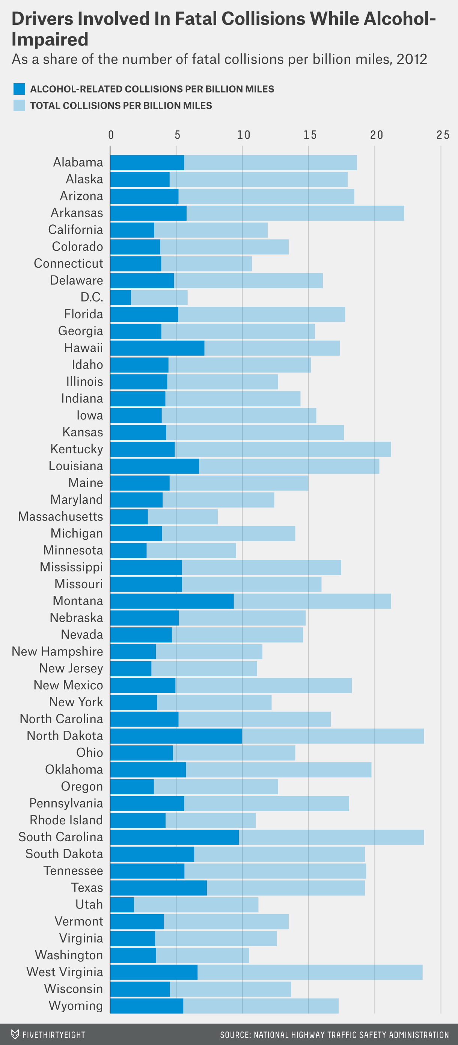

Those numbers probably aren’t news to insurance providers, who base their prices on a multitude of indicators, including driver behavior in accidents that weren’t fatal. So, average premiums in each state could reflect insurance companies’ overall assessment of who is likely to cost them in the future.

According to the latest figures from the National Association of Insurance Commissioners (NAIC), high-risk drivers are to be found in New Jersey, where at $1,302, car insurance is the most expensive in the country. Nationally, the average combined premium (collision, comprehensive, etc.) was $912 in 2011. On that same logic, Idahoans, whose car insurance is on average less than half that, are the best drivers in the country.

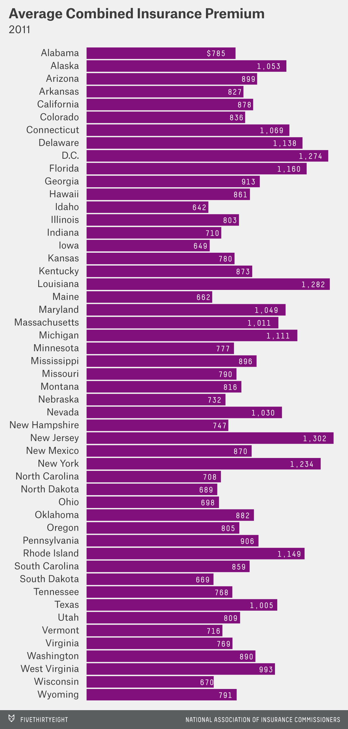

Bad drivers can affect good drivers’ premiums, too. According to the Insurance Research Council, [12.6 percent](http://www.iii.org/fact-statistic/uninsured-motorists) of drivers on American roads were uninsured in 2012. That fraction is highest in Oklahoma, where 1 in 4 motorists doesn’t have insurance.

Not insuring a vehicle certainly makes you “bad” in terms of being irresponsible, but I don’t think that’s what your question is driving at. So, rather than looking at prices, we can use NAIC data on the losses that were incurred by insurance providers in each state.

The sums are vast. For all collisions (and not just fatal ones), insurance companies paid out $26.4 billion in 2010. That figure is unequally distributed among states, but so is the number of insured drivers. To make the comparisons fairer, I’ve divided insurance companies’ losses in each state by the number of insured registered drivers there (which I’ve estimated using the [number of licensed drivers](http://www.fhwa.dot.gov/policyinformation/statistics/2012/) and the [percentage of drivers who are insured](http://www.iii.org/fact-statistic/uninsured-motorists)).

Yet again, Idahoans come out as America’s best drivers, costing insurers on average $83 each for collisions in 2010. New Jerseyans still don’t come off so good, costing insurers $160 apiece for collisions, but they’re still far behind the most expensive state, Louisiana, where it was $195.

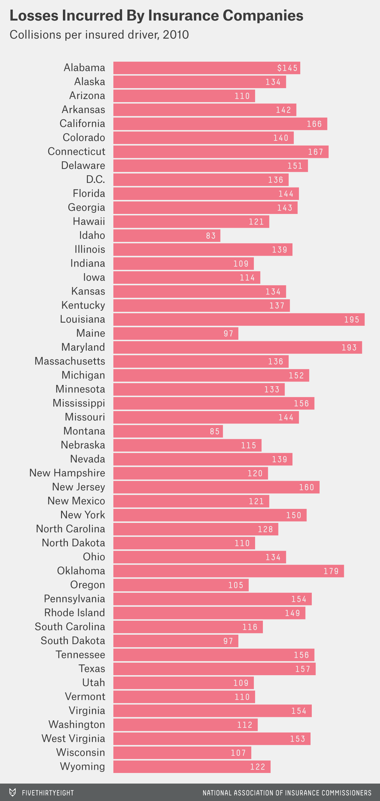

I’m sorry there’s no easy answer here, Lisa. The number of car crashes, even fatal ones, just isn’t a clear-cut way to understand who is and who isn’t a bad driver. But I can say that insurance providers think that you North Carolinians deserve low prices compared to the national average — perhaps because each of your insured drivers only cost them $128 in collision losses in 2010.

Hope the numbers help,

Mona