# name Investigation of hardware Week 7

Task 1: install and Test Netkit Tool

Consult this week’s theory presentation and use the Netkit commands to start and halt a network node as described in the presentation. Netkit and Wireshark are already installed in the preconfigured Linux. If you installed the Linux yourself, then you need to install these tools yourself. (there is a guideline in the Canvas)

Describe the steps you took and provide screenshot of the started node.

1. Download netkit files

Go to <http://wiki.netkit.org/index.php/Download_Official>

* “netkit-2.8.tar.bz2”
* “netkit-filesystem-i386-F5.2.tar.bz2”
* “netkit-kernel-i386-K2.8.tar.bz2”

1. Open terminal and unpack downloaded files using following commands (assuming you’re in the “~$” directory)

* Use this command “tar -xjSf Downloads/netkit-2.8.tar.bz2”
* Use this command “tar -xjSf Downloads/netkit-filesystem-i386-F5.2.tar.bz2”
* Use this command “tar -xjSf Downloads/netkit-kernel-i386-K2.8.tar.bz2”

1. Configuration of variables (assuming you’re still in the “~$” directory)

* The “pwd” command results in current path: /home/<your linux username>
* Use this command “export NETKIT_HOME=/home/<your username>/netkit”
* Use this command “export MANPATH=:$NETKIT_HOME/man”
* Use this command “export PATH=$NETKIT_HOME/bin:$PATH”
* Use this command “. $NETKIT_HOME/bin/netkit_bash_completion”
* Use this command “gedit .bashrc/”. This command opens the bash shell file to save the following variables:
* Insert “export NETKIT_HOME=/home/<your username>/netkit” at the end of the bashrc file.
* Insert “export MANPATH=:$NETKIT_HOME/man” at the end of the bashrc file.
* Insert “export PATH=$NETKIT_HOME/bin:$PATH” at the end of the bashrc file.
* Insert “. $NETKIT_HOME/bin/netkit_bash_completion” at the end of the bashrc file.

1. Check your configuration (assuming you’re still in the “~$” directory)

* “cd netkit”
* Use the command “./check_configuration.sh” in the terminal
* Use the command “sudo apt-get install lib32ncurses5”. Press key “y” on keyboard. If you see this message “Do you want to continue? [Y(es)/n(o)]”.
* Use the command “sudo apt-get install libc6-i386”. Press key “y” on keyboard. If you see this message “Do you want to continue? [Y(es)/n(o)]”
* Use the command “sudo apt-get install xterm”. Press key “y” on keyboard. If you see this message “Do you want to continue? [Y(es)/n(o)]”
* Use the command “./check_configuration.sh” to check if netkit has install successfully

1. Run netkit (assuming you’re still in the “~/netkit$” directory)

Use the command “vstart pc1” (starts virtual machine)

Use the command “vlist” (lists all virtual machines)

Use the command “vhalt -r pc1” (should stop the virtual machine)

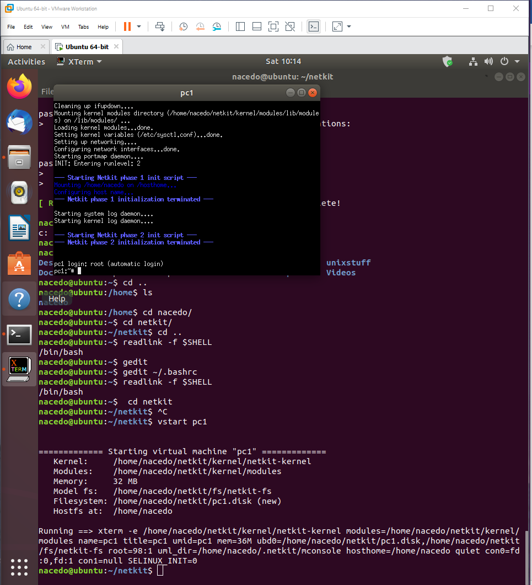

Task 2: TCP/IP Layers in Wireshark

Find a Wireshark Tutorial on the web. Run Wireshark.

Start capturing the network traffic. To generate HTTP traffic, go to <http://courses.codemax.net/w2.html> web browser. Don’t forget to stop capturing as you can get a lot of traffic in your capture. Look at your captured packets and find an HTTP GET packet and Answer the following questions and provide the screenshots:

* What is the source and destination MAC address of this HTTP packet?

Source MAC address: c0:b5:d7:7c:09:65  
Destination MAC address: 50:d4:f7:f5:c7:2b

Provide a screenshot below with the Wireshark snapshot and highlight these addresses:

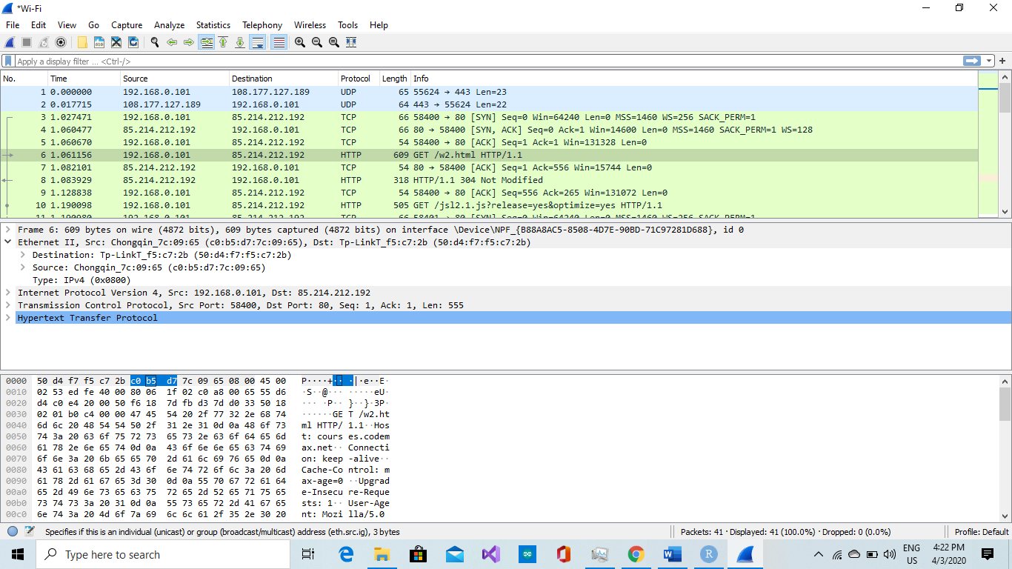

* What is the source and destination IP address of this HTTP packet?

Source IP address : 192.168.0.101  
Destination IP address : 85.214.212.192

Provide a screenshot below with the Wireshark snapshot and highlight these addresses:

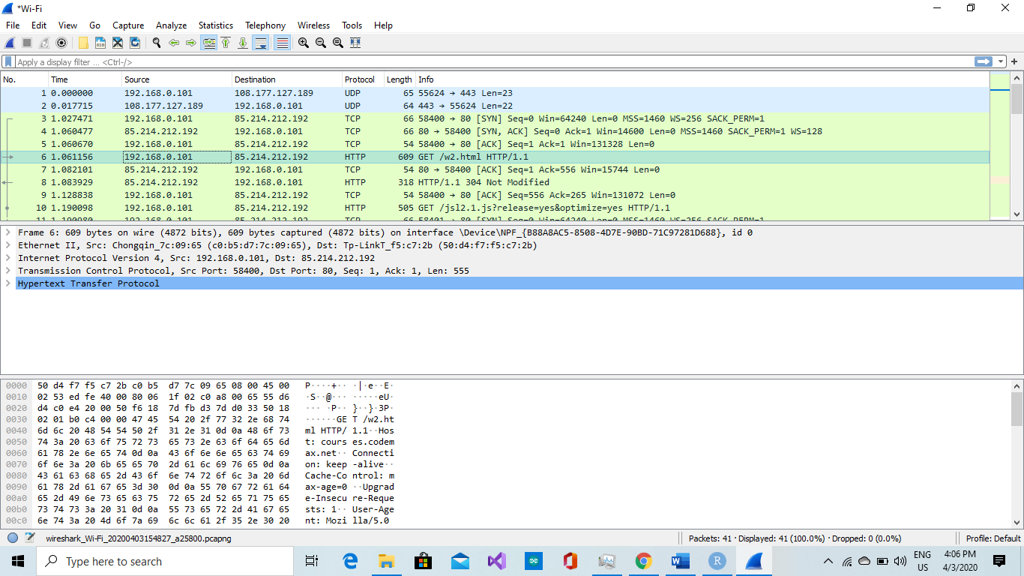

* What is the source and destination port of this HTTP packet? Provide a screenshot to prove it

Source port : 58400  
Destination port: 80

Provide a screenshot below with the Wireshark snapshot and highlight these addresses:

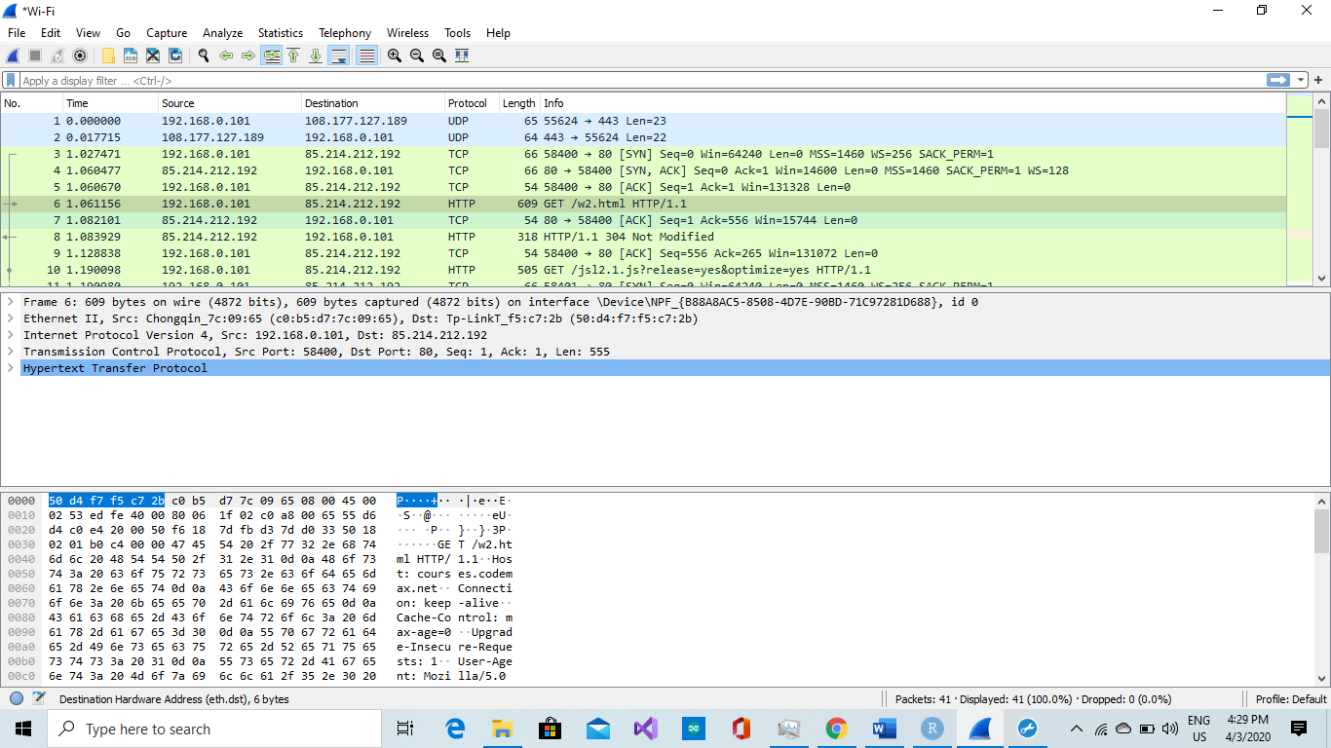

* What is the host name of this HTTP Get packet?

Host name: courses.codemax.net

Provide a screenshot below with the Wireshark snapshot and highlight the host name:

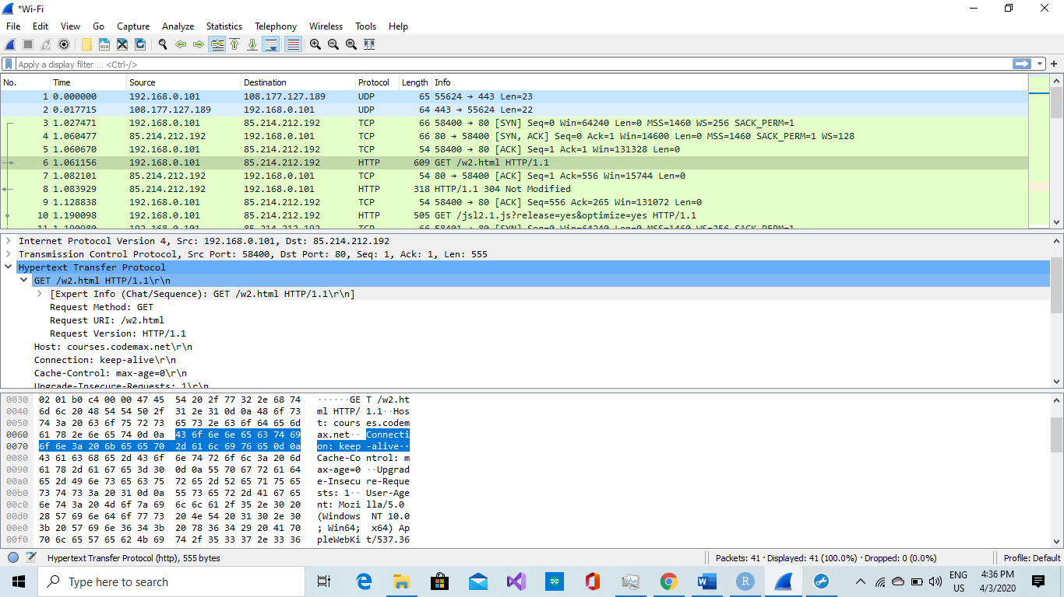

* Find the HTTP Response belonging to the HTTP Get packet. How much time elapsed between the HTTP Get and HTTP response?

Time elapsed: 1.061156000 seconds

Provide a screenshot below with the Wireshark snapshot and highlight the elapsed time:

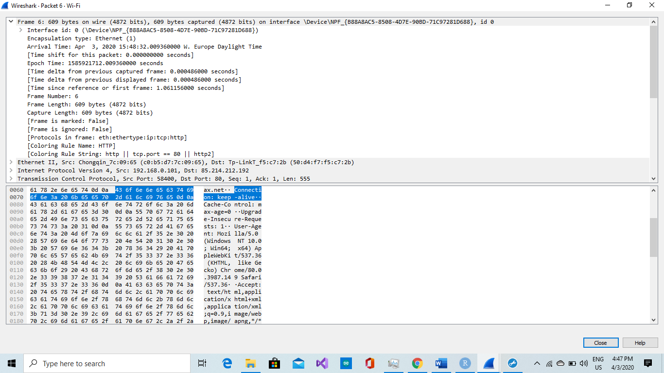

Task 3: Do Linux Tutorial

Go to <http://www.ee.surrey.ac.uk/Teaching/Unix/index.html> and do the tutorial three.

Provide screenshots of all exercises in section 3.4

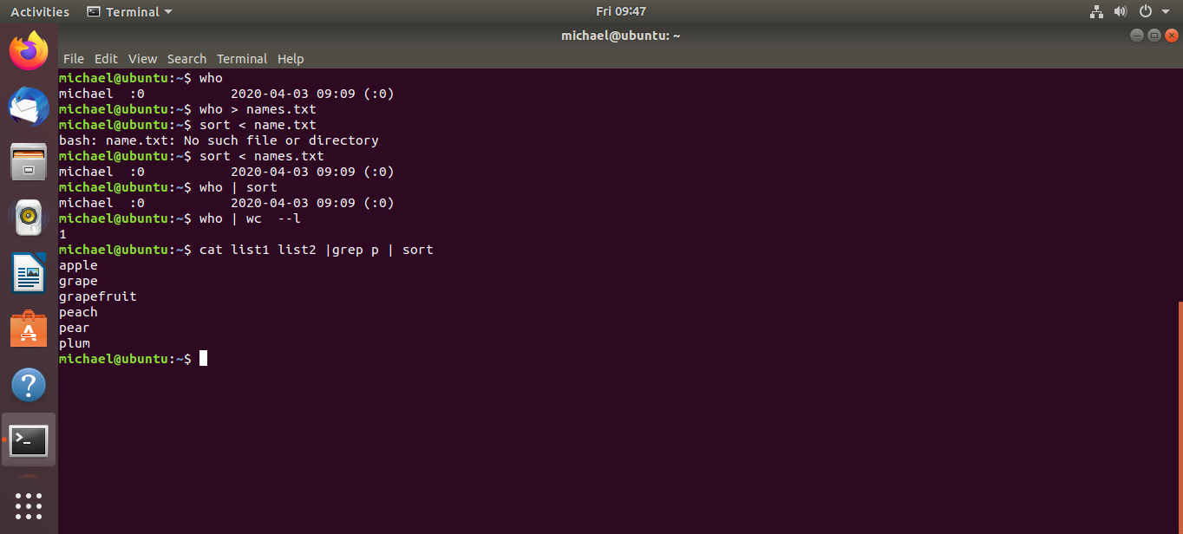

Exercise 3b

# Linux, Static IP address / Subnet configuration Week 8

Linux, Static IP address/subnets configuration

**Task 1a**: Do Linux Tutorial

Go to <http://www.ee.surrey.ac.uk/Teaching/Unix/unix2.html> and do the 2nd basic Unix tutorial.

Provide screenshots of all exercises 2a and 2b. Do all subsections of this tutorial – all of them are really useful! This task should be done individually, so each member of the team should provide his/her evidence(screenshots).

2a.

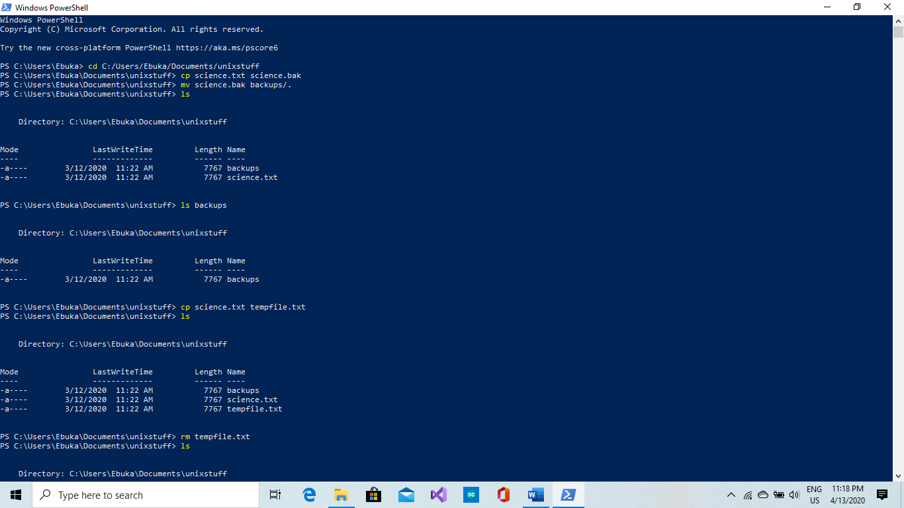

2b.

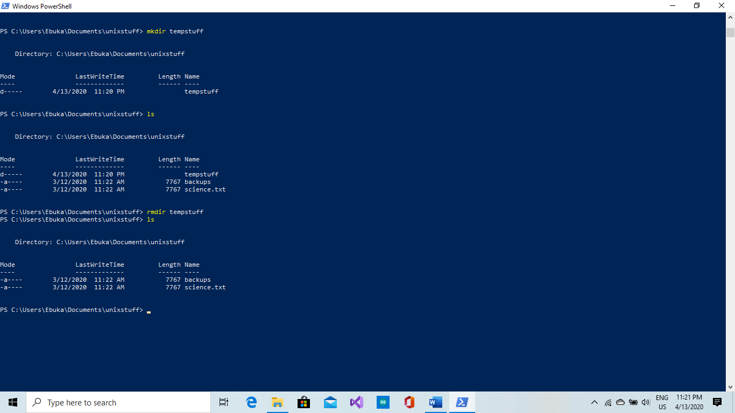

**Task 1b**: Networking exercise

Do the netwoerking online exercises via this link <https://courses.codemax.net/w8.html>.

Provide screenshots of all exercises.

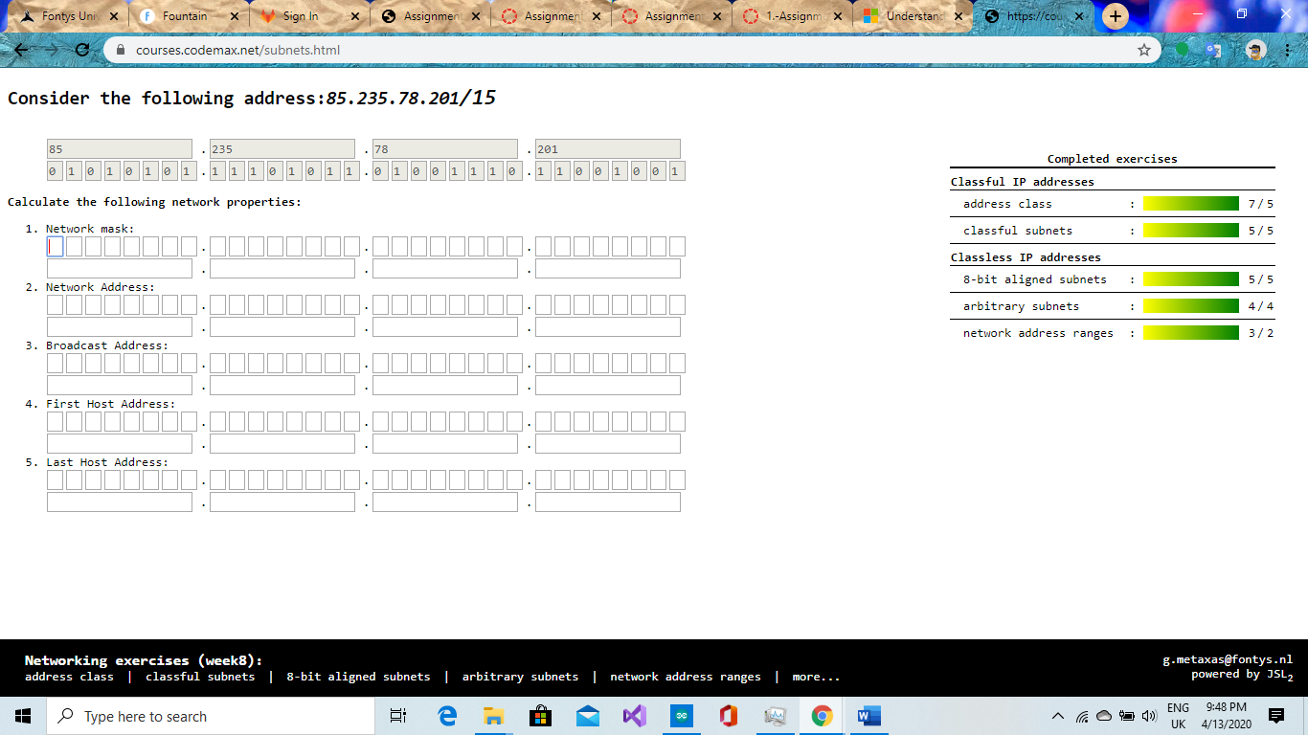

**Task 2:** Build A Simple Netkit Network

Read the explanation of the basic Netkit commands and use them to build a simple network of two nodes connected to a LAN interface.

Try the following configurations:

A) Configure the IP addresses of the 2 nodes by using the “ifconfig” command explained in the theory lesson.

1. Node1 has an IP address 102.10.2.1/24
2. Node2 has an IP address 102.20.2.1/24

Check whether your configuration was successful by using ping command between these two nodes.

1. What is the result of the ping? Can you explain it? Provide a screenshot.

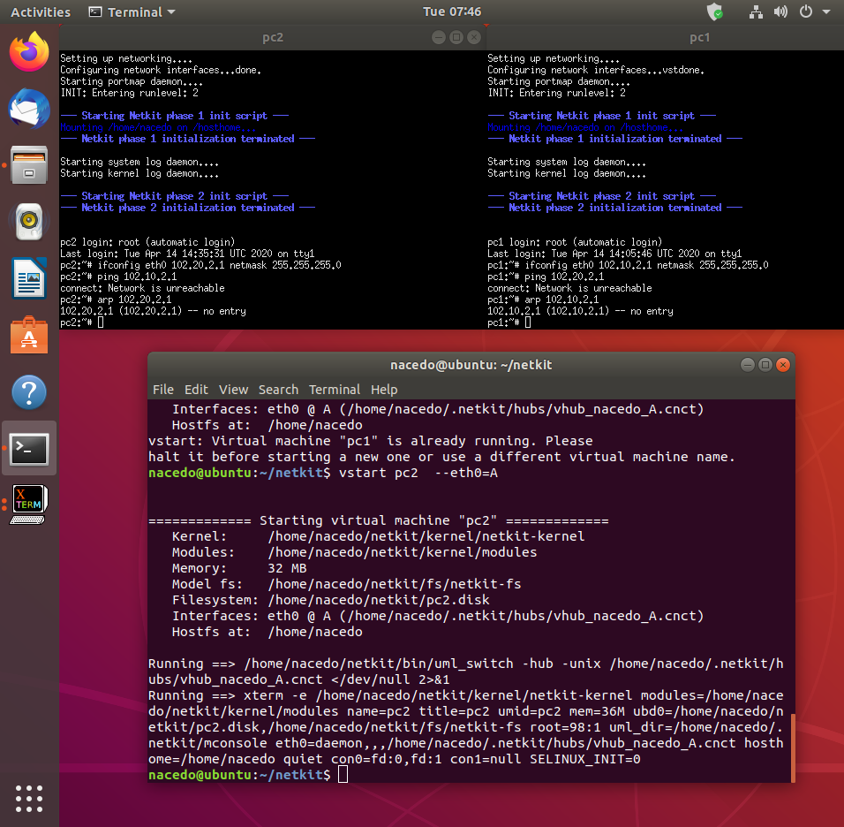

The ping wasn’t successful because the ip addresses are not in the same range.

1. Look at the ARP entries of your Node1 and Node2. Which command do you use? Which ARP entries are there?

“Arp 102.20.2.1” , “Arp 102.10.2.1”. The arp entries are sill empty because there was no connection established between the nodes.

B) Configure the IP addresses of the 2 nodes by using the “ip” command explained in the theory lesson.

1. Node1 has an IP address 102.10.2.1/10
2. Node2 has an IP address 102.20.2.1/10

Check whether your configuration was successful by using ping command between these two nodes.

What is the result of the ping? Can you explain it? Provide a screenshot of your configured interfaces.

The ranges of the ip addresses are wrong that’s why the nodes cannot communicate.

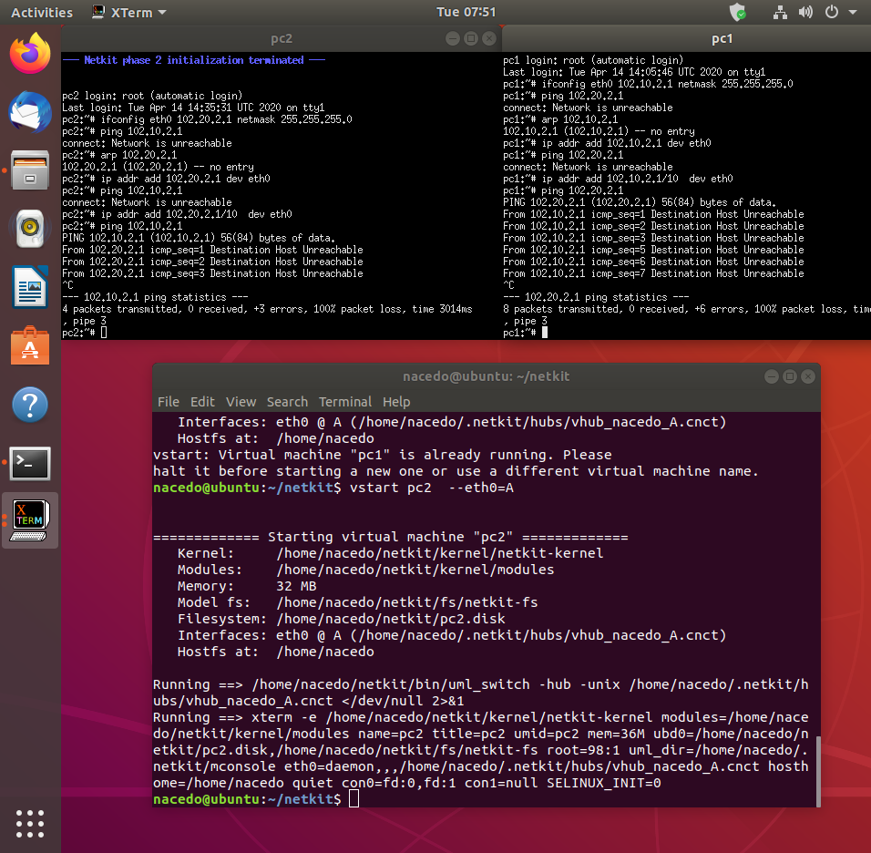

1. Look at the ARP entries of your Node1 and Node2. Which ARP entries are there?

The arp entries are registered as incomplete. The ip addresses “102.20.2.1”, “102.10.2.1” are shown in the register.

C) Configure both nodes to have a subnet mask 255.255.255.0, and change the IP address of Node2 in such a way that the ping between them is successful.

1. Provide a screenshot of your configuration and successful ping.

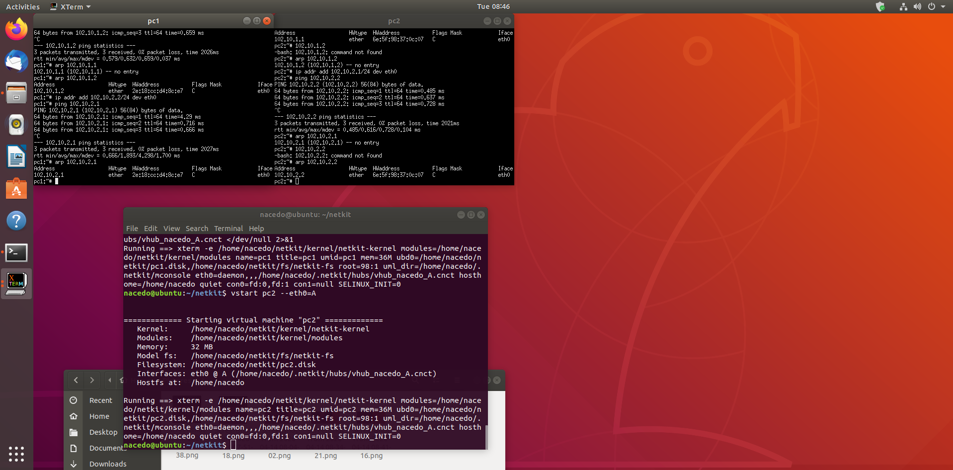

1. After successful ping ARP entries of both nodes should be changed. Provide a screenshot of the new ARP situation and explain it. What is the command to clear the ARP cache again?

The communication between both nodes was successful because the arp situation is not incomplete anymore.

“arp -d 102.10.2.2” and “arp -d 102.10.2.1”



**Task 3**: Configuring Network

For this assignment you can use a preconfigured netkit lab provided in net_routing.zip file. To do this you need to copy the provided zip file somewhere in your Linux environment, e.g. in ~/netkit_labs. Unzip the file. You have now a preconfigured lab Deliver the lab network of this task in your git project. Thus, when you are done write below the URL of your git project (I should be able to access your results using “git clone” and the provided git URL).

Each simulated node has its own directory. Also, each simulated node has a <node>.startup file where any commands can be added that should be executed before startup of the node.

To start the lab issue the following command in the root directory of your lab:

lstart

Note: When you issue this command, you’ll be prompted for a password which in your case is **student**.  
  
Netkit uses the file “labs.conf” in order to initialize the Ethernet devices and their respective collision domains for each node. For example inside the labs.conf there is a line “RouterAC[0]=LANA” and a line “RouterAC[1]=LANC”.   
These two lines have same effect when the node “RouterAC” is initialized, as if we would run the command:  
“vstart RouterAC --eth0=LANA --eth1=LANC”.

Now all the nodes should be started. However, the nodes are not configured yet. You need to configure them as follows:  
Configure the Ethernet devices connected via the collision domain LANA using the IP range 10.X.0.0/16, where X is the number of your pair/group.

Configure the Ethernet devices connected via the collision domain LANB using the IP range 172.16.X.0/24, where X is the number of your pair/group.

Configure the Ethernet devices connected via the collision domain LANC using the IP range 192.168.X.0/24, where X is the number of your pair/group.

For example if your group number is 230 you should use IP address from the range 10.230.0.0/16 for LANA, 172.16.230.0/24 for LANB and 192.168.230.0/24. (see also table 1).

There are 2 ways to configure your interfaces. We recommend you all use the first option and for your own experiment you can use the second option but make sure all your submissions follow the first option:

1. Use either ifconfig or ip commands. Once you know how the commands should look like, it is highly recommended to put them in <node>.startup files, so next time you want to restart and present your lab, you don’t have to reconfigure it by hand again.

Note : Please don’t remove the commands which are already present in the <node>.startup files. They are necessary for starting up Linux networking service.

1. Use <node>/etc/network/interfaces file of the node you want to configure.

In the netkit lab environment you can put any files the contents of which you want to see in the simulated node in the <node> directory. In this way, you can also put there <node>/etc/network/interfaces file. This file is used by Linux system to configure the network interfaces. An example of such a file is provided in the lab for PC1A node.

The network of the lab is as follows:

1. PC1A, PC2A and RouterAC are connected to LANA
2. PC1B, PC2B and RouterBC are connected to LANB
3. PC1C, PC2C, RouterBC, RouterAC and Gateway are connected to LANC
4. Gateway is connected to LANC through fixed eth0 interface with IP address 192.168.1.x/24 and to TAP_LAN through eth1 interface with IP address 192.168.200.1. The TAP_LAN is a Netkit-specific interface used for the connection to your guest Linux system. The Gateway node will be used for the optional part of the Assignment 3.
5. Your guest Linux system is connected to your simulated Netkit node Gateway through Netkit specific tap interface nk_tap_student 192.168.200.254, see the detail of the connection between the Netkit simulated environment and your Guest machine in the picture below.



**Provide the network drawing** of your lab network you can use <https://app.diagrams.net/> and screenshots of the pings which are possible WITHIN LANA, LANB and LANC (PC1A to PC2A, PC1B to PC2B and so on). When creating the network drawing, don’t forget to mention the IP addresses/subnet masks for all nodes of your network. It is also useful to include the names of the network interfaces (eth0, eth1, …).

You don’t need to be able to route between all nodes of this network; that is the second part of the assignment, which will be done next week.

Note 1: In the provided netkit lab there are files HOWTO, interfaces.example and Example.startup which can give you more info on how to use and configure the lab.

Table 1 : IPv4 address ranges per student group

|  |  |  |  |
| --- | --- | --- | --- |
| Group | LANA | LANB | LANC |
| 1 | 10.1.0.0/16 | 172.16.1.0/24 | 192.168.1.0/24 |
| 2 | 10.2.0.0/16 | 172.16.2.0/24 | 192.168.2.0/24 |
| … | | | |
| n | 10.n.0.0/16 | 172.16.n.0/24 | 192.168.n.0/24 |

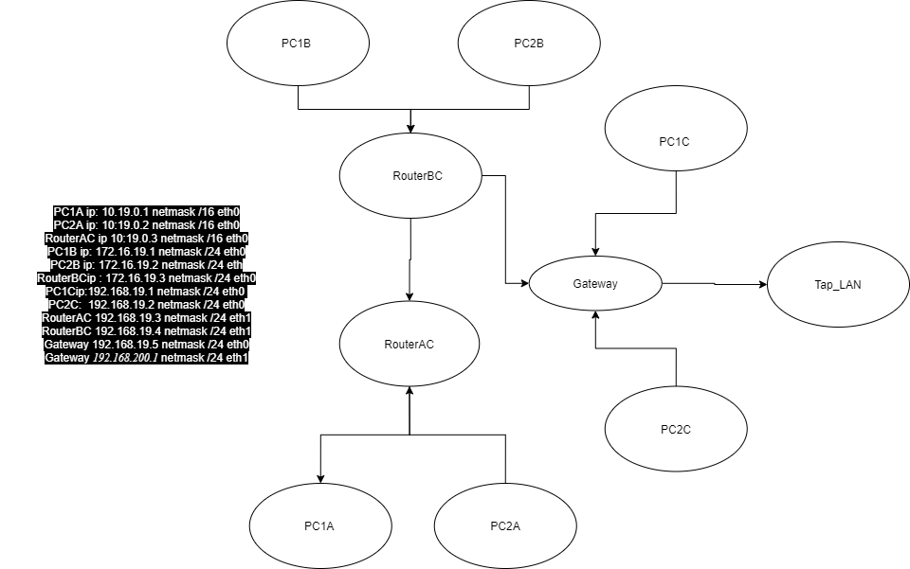

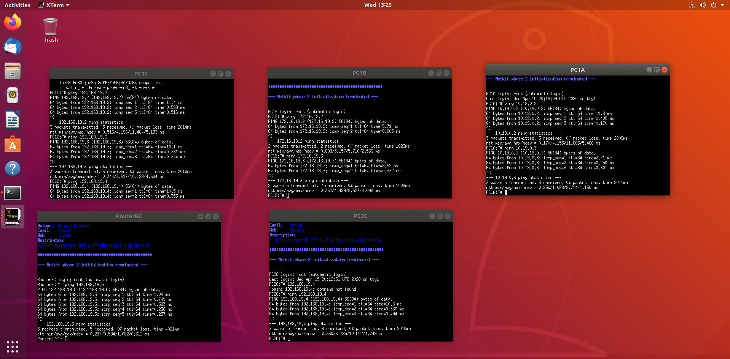

Every node can connect to the nodes within the same collision domain.

**Task 4**: CIDR IP Addressing Exercises

1. Suppose we have IP address 122.33.196.145/24

Fill in the following items for this address:

1. Network Address : 122.33.196.0/24
2. Broadcast Address : 122.33.196.255
3. Subnet Mask : 255.255.255.0

2. Suppose we have IP address 163.249.223.229/25

Fill in the following items for this address:

1. Network Address : 163.249.223.128/25
2. First Host : 163.249.223.129
3. Last Host :163.249.223.254
4. Broadcast Address :163.249.223.255