iSuperviz: Your AI Research Supervisor
Individual Project Report
Course: CISC3003 Web Programming
Team: Team 07 - iSuperviz
Student: Si Tin Iek (DC227126)
Pair: Pair 04
Personal role: Frontend and backend development support, service integration, testing and demo preparation
Submission deadline: 2026 May 10, 11:00 pm
GitHub Archive URL: https://github.com/Mikey-SI/CISC3003-dc227126-2026GitHub
Deployed Testing URL: https://mikey-si.github.io/CISC3003-dc227126-2026GitHub/CISC3003-TeamProject-Team07-iSuperviz/
Reviewer demo account: professor@um.edu.mo / demo1234

Abstract
This individual report explains my personal contribution to Team 07's iSuperviz project, a responsive full-stack web application designed as an AI research supervisor for university researchers. The team project combines React, TypeScript, Ant Design, React Flow, Node.js, Express, SQLite and a GitHub Pages-compatible mock API layer. My contribution focused on supporting the implementation of the website application together with Yang Xu, especially connecting frontend pages with backend service logic and checking that the user workflow could be demonstrated through the deployed URL. The work covered authentication-related flows, paper tracking, dashboard history, credit-aware actions, shopping cart behaviour, and the relationship between UI state and API responses. The individual evidence in this report follows the project requirements: context, goals, services and data requirements, tasks and tools, challenges, deliverables, division of work, individual contribution, success criteria, evaluation, learning, test cases, demo screenshots, references, AI declaration, installation instructions and incomplete items. The report also prepares the material for my individual digital story: a short presentation and screen demo explaining what I did, what services I helped integrate, how the project meets the CISC3003 requirements, and what I learned from building a deployable full-stack artifact.

Table of Contents
- 1. Project Context - Full-Stack Web Application with RWD and Deployed URL
- 2. Personal Project Goals
- 3. Services and Data Requirements I Worked With
- 4. Personal Tasks and Tools
- 5. Personal Challenges
- 6. Deliverables Prepared for Submission
- 7. Project Division of Work
- 8. My Individual Contributions
- 9. Criteria of Success
- 10. Evaluation
- 11. Individual and Team Learning
- 12. Functional Test Cases
- 13. Demo Walkthrough with Screenshots
- 14. Installation, Deployment and Data Instructions
- 15. Project Incomplete
- 16. Citations and References
- 17. Declaration of AI Usage
- 18. Final Submission Checklist

1. Project Context - Full-Stack Web Application with RWD and Deployed URL
iSuperviz is presented as a research-workflow platform rather than a simple static website. The frontend is a React single-page application with responsive layouts and project-specific visual pages. The source archive also includes a Node.js/Express/SQLite backend for authentication, paper data, ideas, chat messages, cart items, orders, search history and hallucination audit jobs. Because GitHub Pages cannot run a Node server, the deployed version uses a mock API adapter that mirrors the backend endpoints so the same workflow can still be tested publicly.
- Deployed testing URL: https://mikey-si.github.io/CISC3003-dc227126-2026GitHub/CISC3003-TeamProject-Team07-iSuperviz/
- GitHub archive URL: https://github.com/Mikey-SI/CISC3003-dc227126-2026GitHub
- Demo account: professor@um.edu.mo / demo1234
- Redeem code for testing credits: TEAM07-ABC

2. Personal Project Goals
- Support the frontend and backend implementation work assigned to Pair 04.
- Help connect UI pages with API/service logic so the demo can show real user workflows.
- Verify that the required modules are visible: login, password reset, dashboard, search, history and cart.
- Make sure project evidence can be explained clearly in the individual digital story.
- Learn how a full-stack project can be adapted for GitHub Pages deployment with mock API parity.

3. Services and Data Requirements I Worked With
Service Area | Data / API Evidence | Purpose
Authentication | users, captchas, /api/login, /api/sendCaptcha | Sign up, login and verification flow.
Password recovery | /api/forgot_password, /api/check_account, /api/reset_password | Recover user accounts.
Paper tracking | papers, paper_notes, /api/get_paper_info, /api/get_paper_notes | Search and read papers.
Idea services | ideas, idea_related_papers | Save ideas and visualise related papers.
Search history | search_history, /api/search_history | Record user activity.
Cart and orders | products, cart_items, orders, /api/cart/* | Support shopping-cart requirements.
Credits | users.credit, /api/consume_credit, /api/redemption | Deduct and top up research credits.
Audit service | hallucination_jobs, /api/hallucination_check | Provide the peculiar AI-audit feature.

4. Personal Tasks and Tools
Task | My Work | Tools
Frontend support | Helped verify and connect pages such as Paper, Dashboard and Cart with service state. | React, TypeScript, Ant Design
Backend support | Worked with service contracts for auth, paper, cart, order and history endpoints. | Node.js, Express, SQLite
Integration | Checked how login state, credits, cart changes and history records update across pages. | Axios, PubSub, localStorage
Responsive/demo QA | Reviewed screenshots and user journey for the individual explanation. | Browser testing, screenshots
Documentation | Prepared individual report, PPT and narration based on team evidence. | Word, PowerPoint, GitHub

5. Personal Challenges
- Keeping frontend state consistent after backend-style actions such as checkout, credit deduction and history updates.
- Explaining full-stack work honestly when the public deployment uses a static mock API due to GitHub Pages limitations.
- Making dense research pages understandable in a short individual digital story.
- Balancing team-level project evidence with my own individual contribution.
- Checking that screenshots, URLs and demo credentials can support assessment without extra setup.

6. Deliverables Prepared for Submission
Deliverable | File / Evidence | Status
Individual report | CISC3003_Team07_DC227126_SiTinIek_Individual_Report.docx | Prepared
Individual PPT | CISC3003_Team07_DC227126_SiTinIek_Individual_PPT.pptx | Prepared
Individual digital-story script | CISC3003_Team07_DC227126_SiTinIek_Individual_Digital_Story_Script.docx | Prepared
Team proposal, report and PPT | iSuperviz_Team07_Proposal (1)(1).docx, final report PDF and CISC3003_Team07_modified(1).pptx | Prepared by team
Coding archive | cisc3003-Team07-ProjectCode.zip | Generated
Deployment folder | CISC3003-TeamProject-Team07-iSuperviz | Prepared for GitHub Pages path

7. Project Division of Work
Member | Pair | Assigned work for final submission
Yang Xu | Pair 08 | Overall lead, integration, deployment, report and major implementation coordination.
Jiang Xingyu | Pair 08 | Public forum communication and written forum responses.
Huang Sofia | Pair 12 | Project PPT materials, visual presentation structure and feature explanation.
Fan Zou Chen | Pair 12 | Project PPT materials and presentation flow.
Si Tin Iek | Pair 04 | Frontend and backend development support with service integration.
Ma Iat Tim | Pair 04 | Citation/reference materials and APA reference organisation.

8. My Individual Contributions
My work was mainly implementation support and integration. I worked with Yang Xu on the website application so that the frontend pages were not isolated screens but connected to service logic. This included checking how authenticated user state is stored, how credits are shown after actions, how the cart and checkout update the dashboard, how search history is recorded, and how paper-related actions move the user toward reflective notes and the idea graph.
- Helped support frontend pages related to user workflow: Login, Forgot Password, Paper, Cart and Dashboard.
- Helped connect UI behaviour with backend/mock endpoints through Axios requests and shared response structures.
- Checked service integration points including login state, cart state, order history, search history and credit updates.
- Supported demo preparation by reviewing screenshots and organising the individual explanation of the deployed workflow.
- Contributed to the final project evidence by aligning personal contribution wording with the team report.

9. Criteria of Success
- The user can open the deployed URL and enter the project without local setup.
- The demo account can access authenticated pages and show dashboard services.
- Paper search, paper detail, idea graph, hallucination audit, shop, cart and order history are demonstrable.
- Credits change visibly after research actions or checkout/redemption.
- Screenshots and narration can explain both team-level requirements and my individual role.

10. Evaluation
Evaluation Area | Evidence | Self-Evaluation
Functional requirements | Login, reset, dashboard, search, history, cart and peculiar services visible. | Meets course scope
Integration | Frontend requests match mock/backend service contracts. | Effective for demo
Responsive design | Ant Design grids and screenshot walkthrough support different pages. | Meets requirement
Deployment | GitHub Pages static bundle uses mock-first API parity. | Testable
Documentation | Individual report, PPT and script explain personal contribution. | Ready for submission

11. Individual and Team Learning
Individually, I learned that frontend and backend development must share clear service contracts. A page is only convincing when UI state, API response, user feedback and stored data agree with each other. For example, cart checkout is not just a button: it must create an order, update credits, clear the cart, publish state changes and appear later in the dashboard. As a team, we learned that full-stack delivery also requires deployment evidence, screenshots, forum responses, references, AI-use transparency and individual accountability.

12. Functional Test Cases
Test Case | Requirement Covered | Expected / Verified Result
Login flow | User login | Demo account logs in and redirects to authenticated pages.
Forgot password | Password recovery | Account checking and reset form are visible.
Paper action | Search and research workflow | Explore/download actions deduct credits and open paper flow.
Cart checkout | Shopping-cart service | Cart accepts items, checkout creates order and updates credits.
Dashboard history | History-related service | Search/order/activity records appear in dashboard.
Idea graph | Peculiar service | Saved ideas and related papers appear as graph nodes.
Responsive view | RWD requirement | Main pages remain usable at desktop/tablet/mobile widths.

13. Demo Walkthrough with Screenshots
The following screenshots are used in my individual digital story. They follow the user journey from entry page to authentication, research workflow, peculiar services, e-commerce workflow and dashboard evidence.
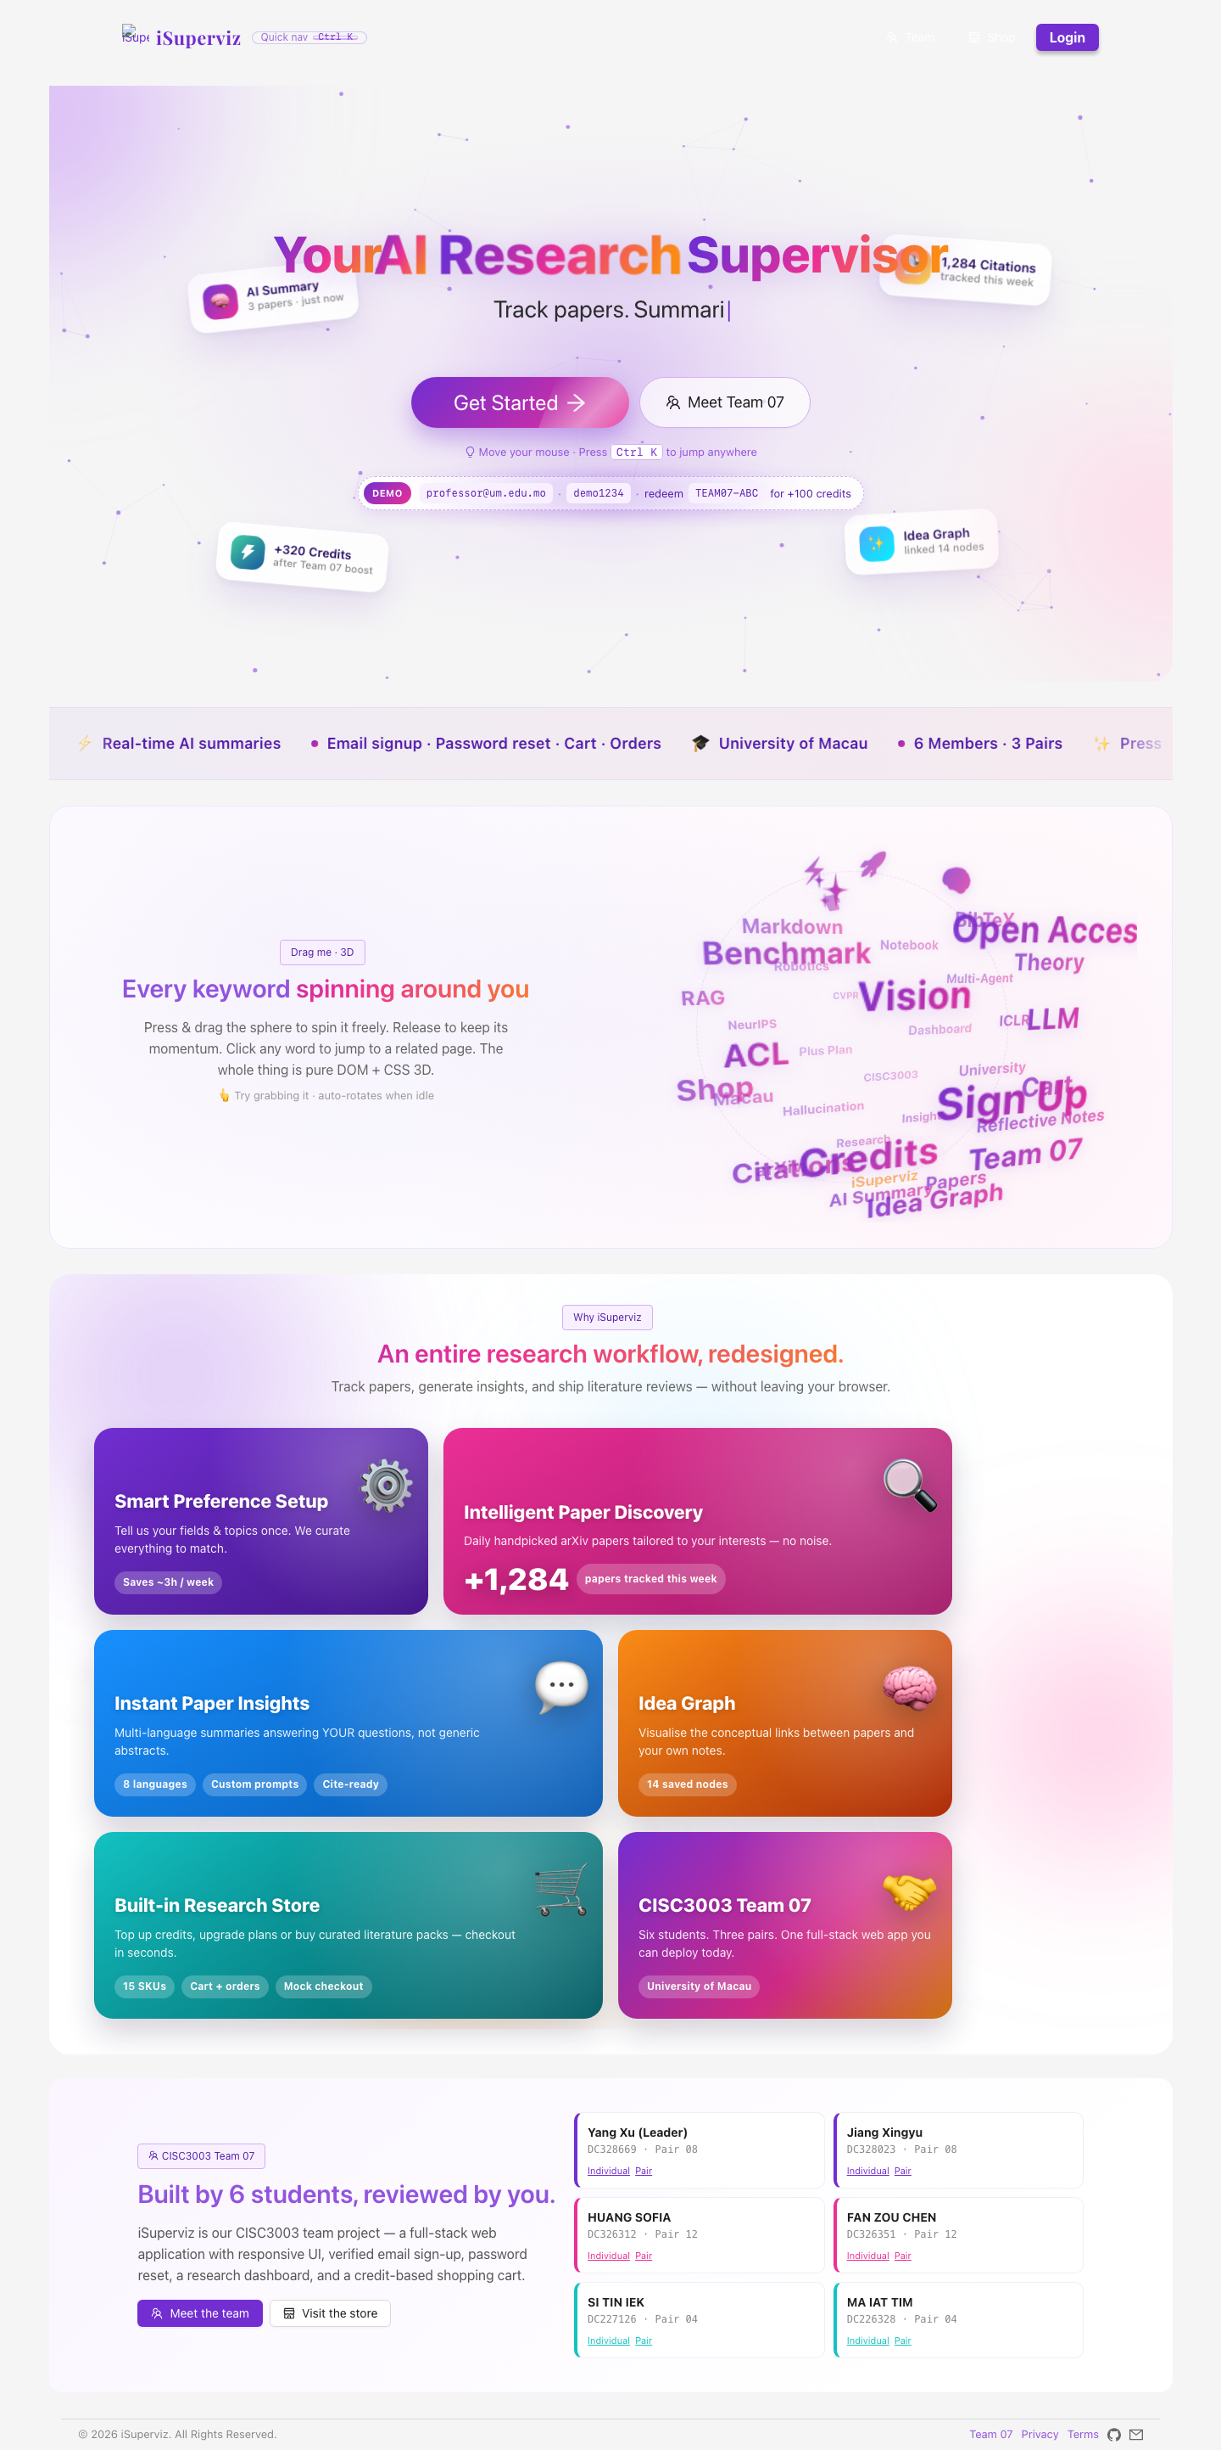
Figure 1. Home and brand entry point.
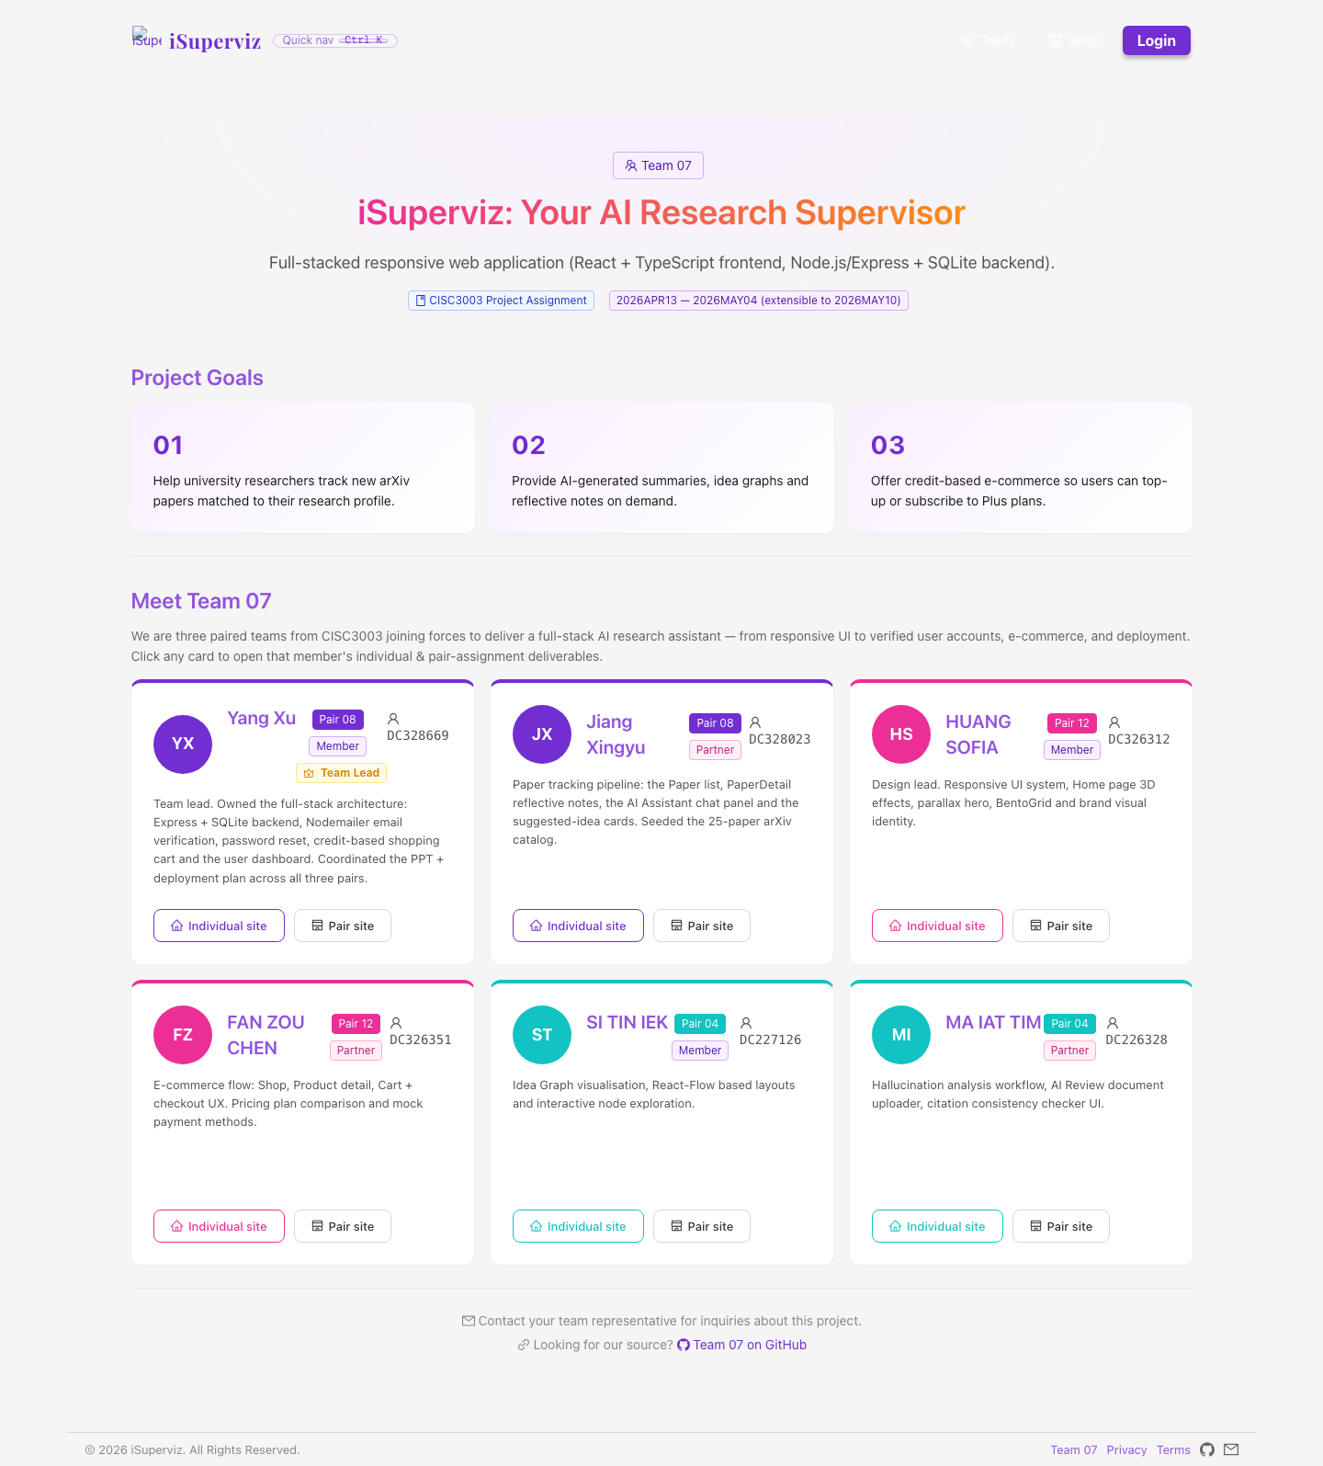
Figure 2. Team 07 roster and project identity.
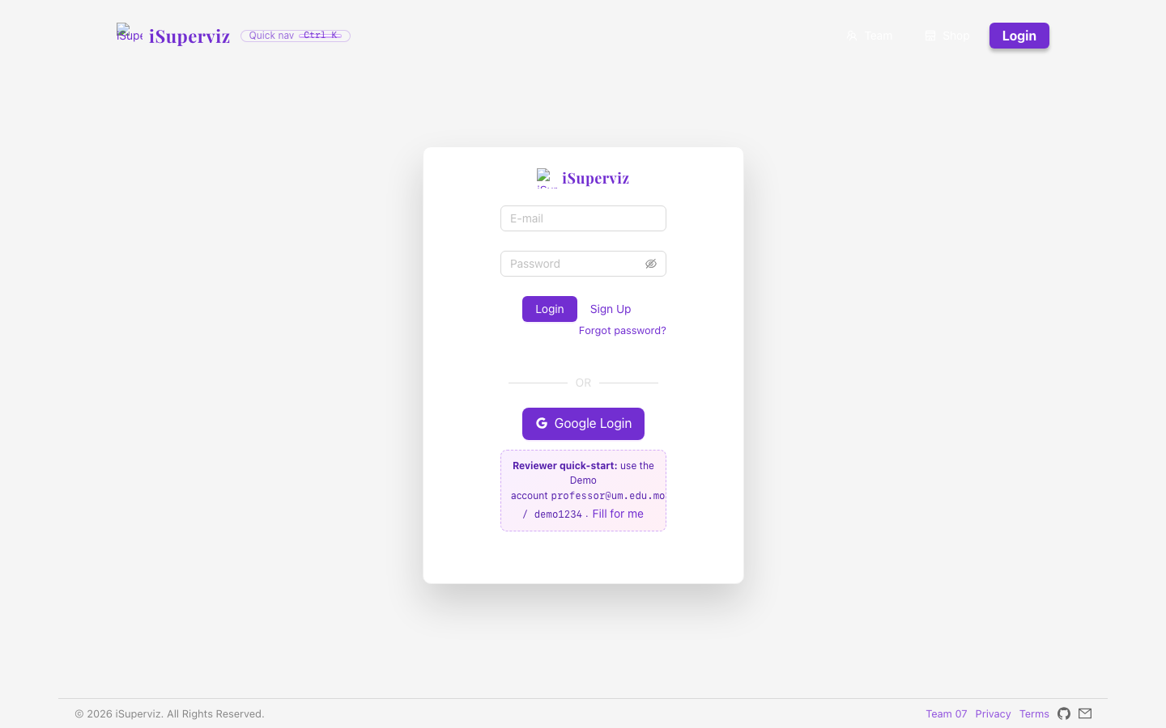
Figure 3. Login and sign-up entry.
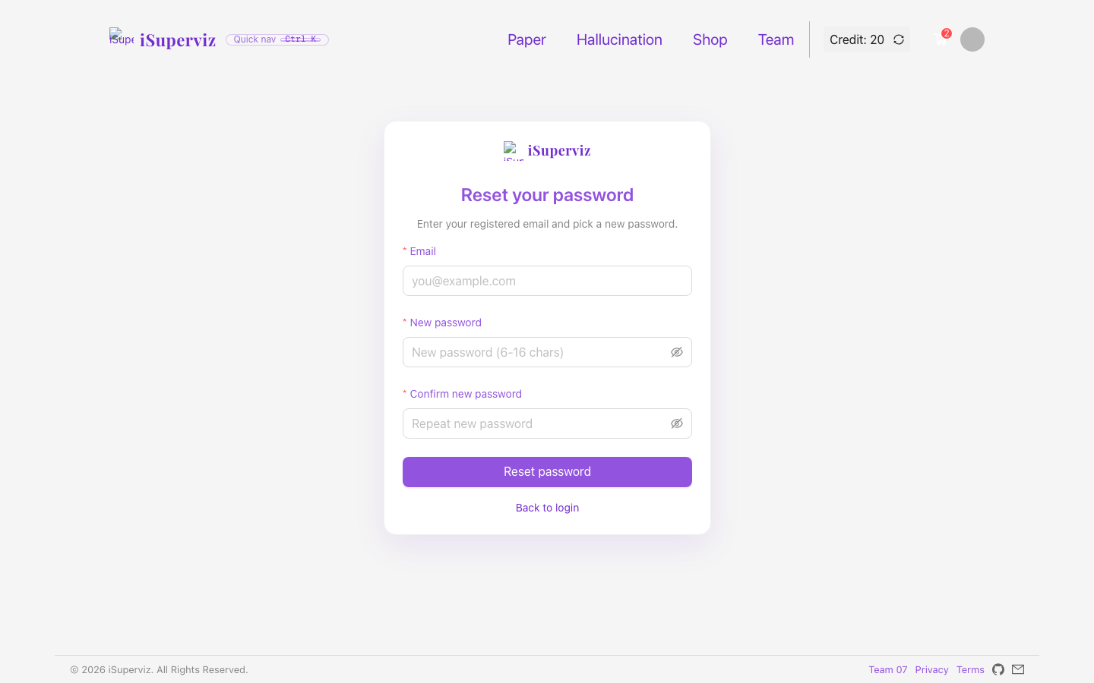
Figure 4. Forgotten-password recovery.
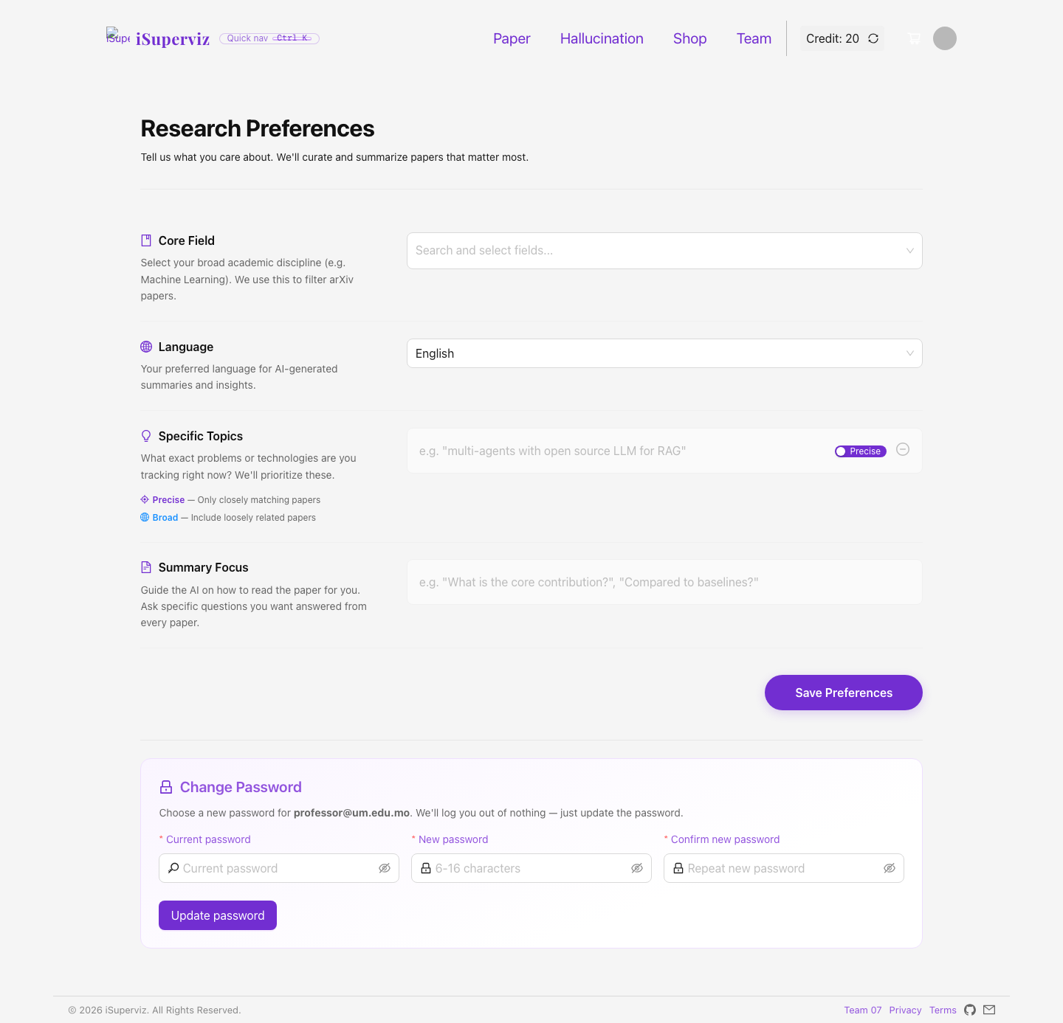
Figure 5. Research preference setting.
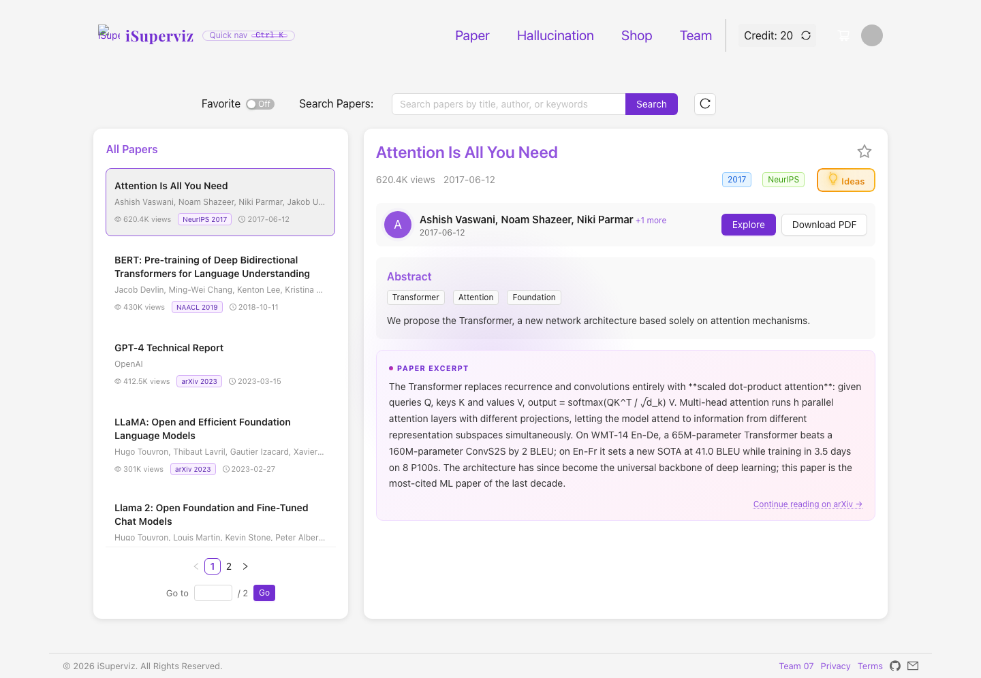
Figure 6. Paper tracking list.
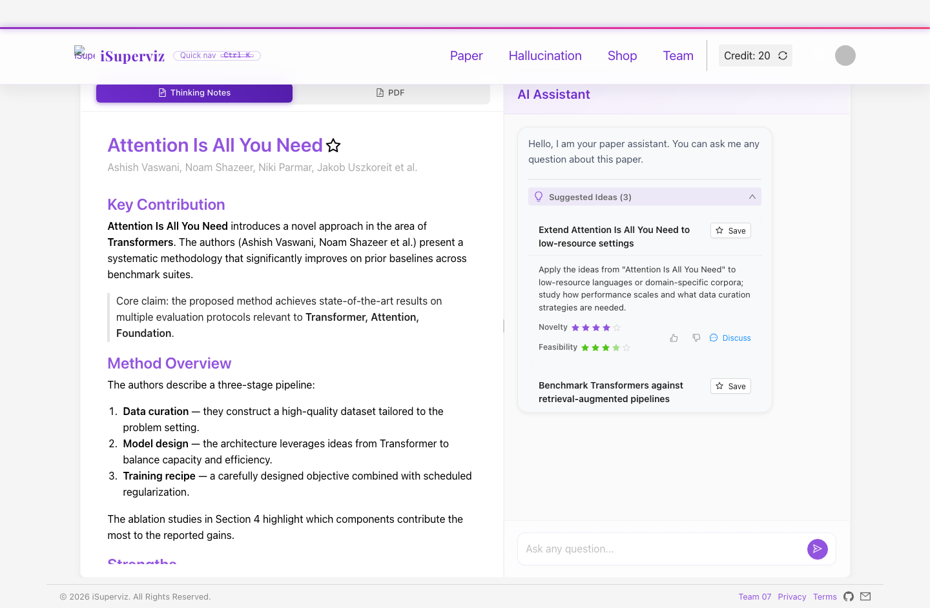
Figure 7. Paper detail, reflective notes and AI chat.
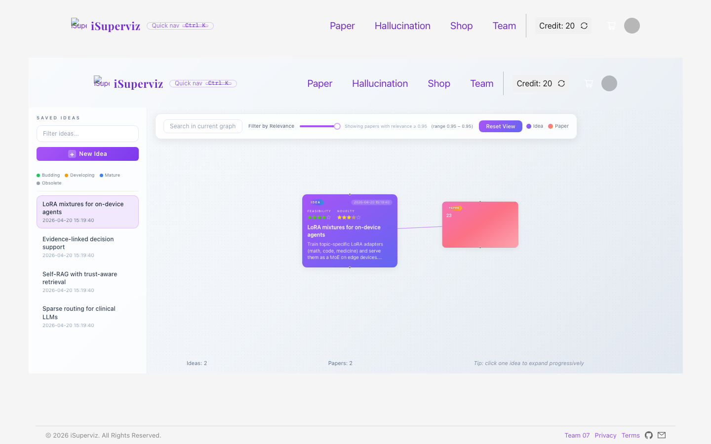
Figure 8. Idea Graph peculiar service.
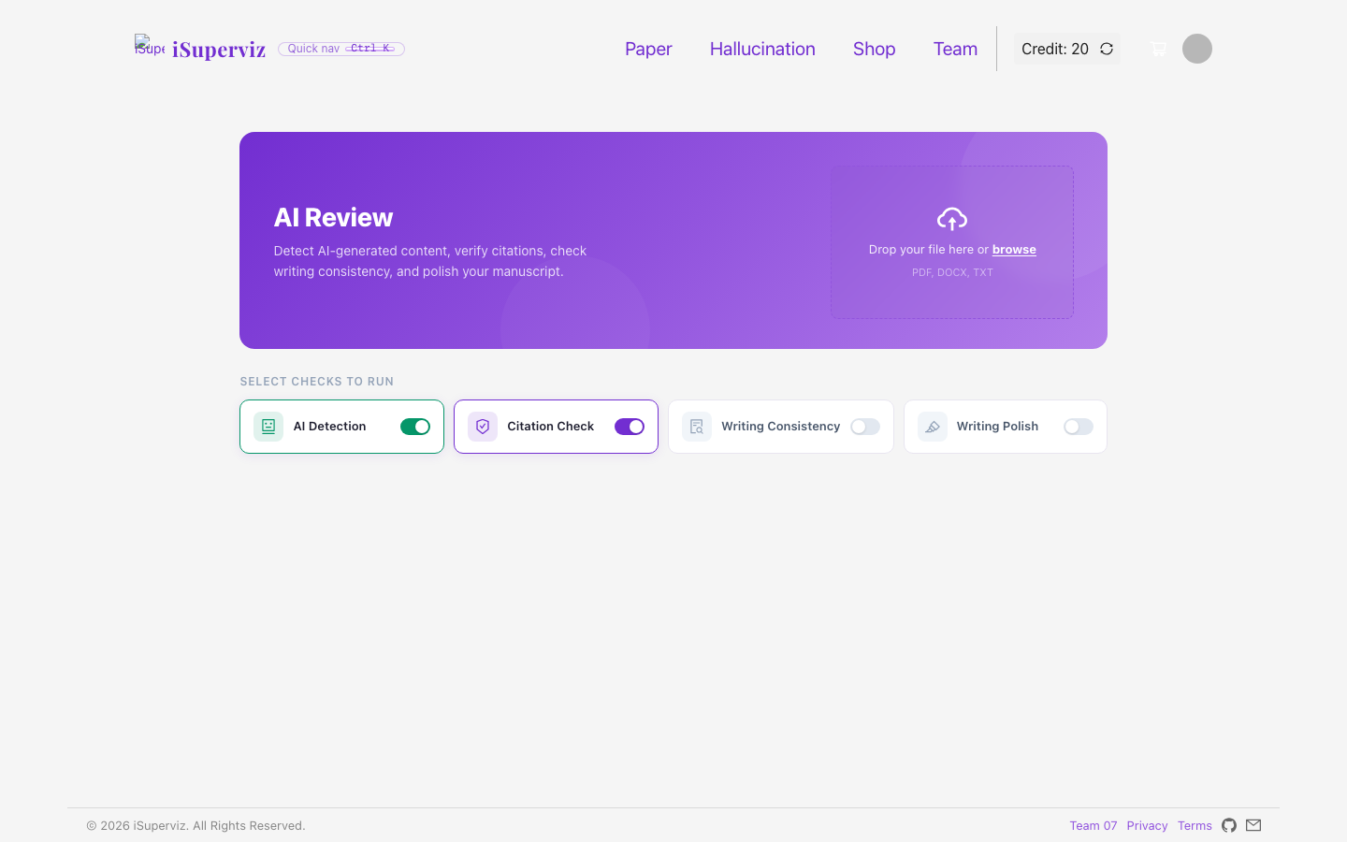
Figure 9. Hallucination Audit peculiar service.
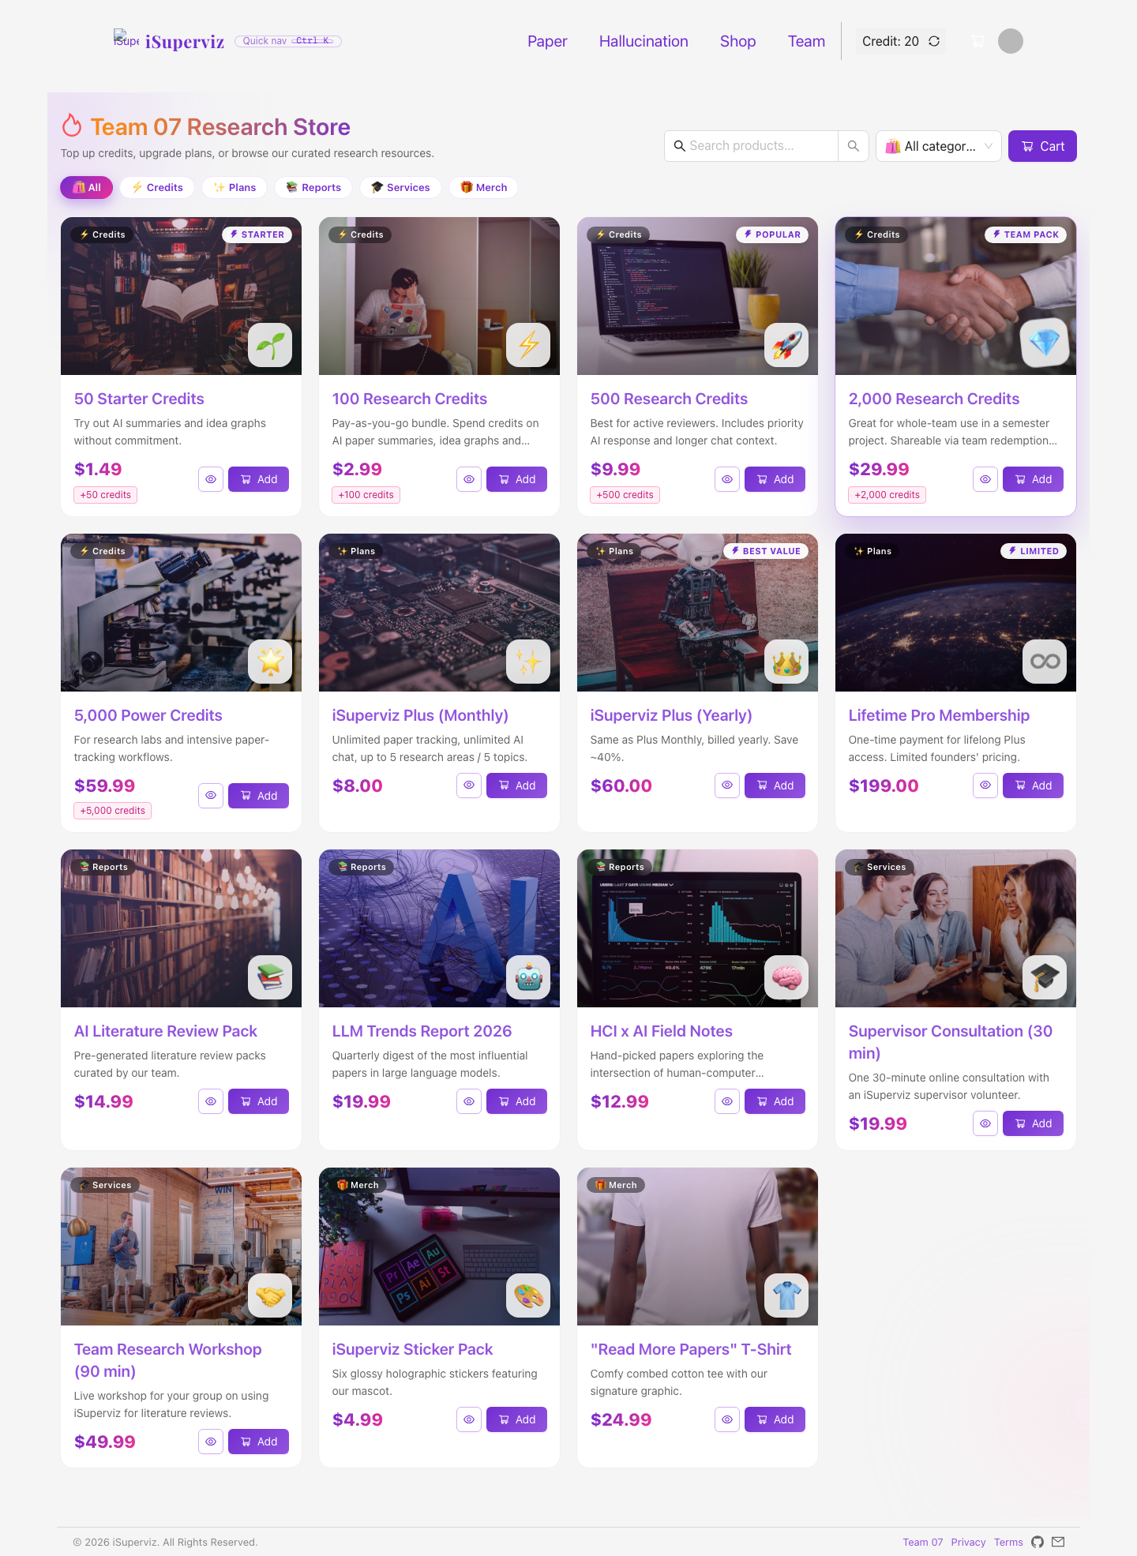
Figure 10. Research store.
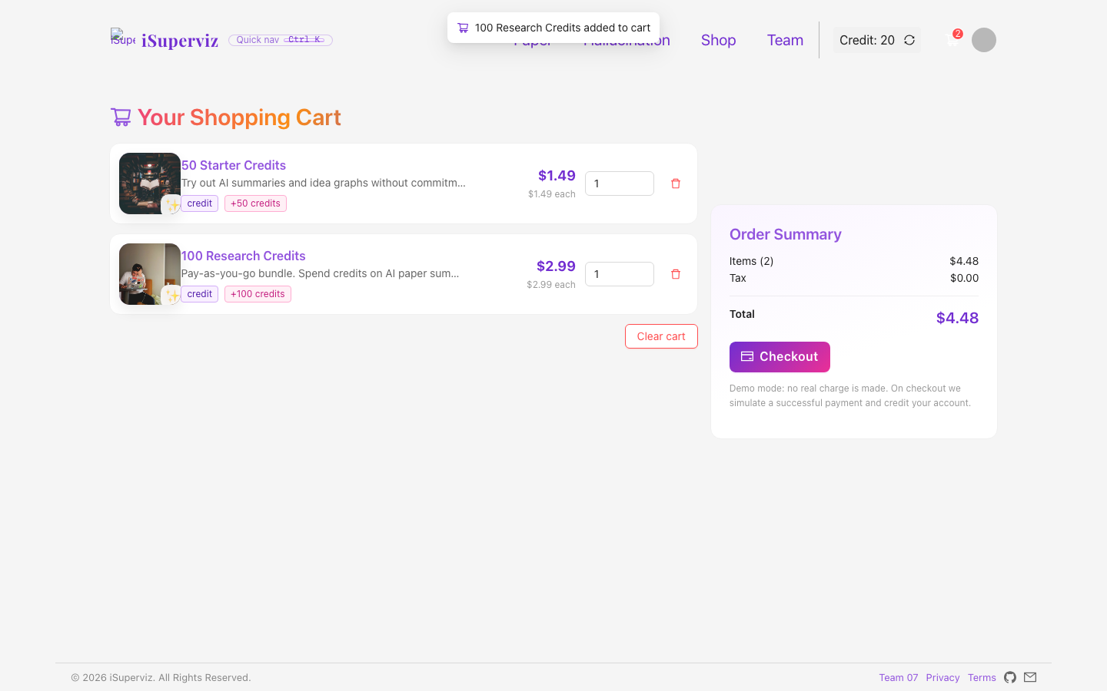
Figure 11. Shopping cart and checkout.
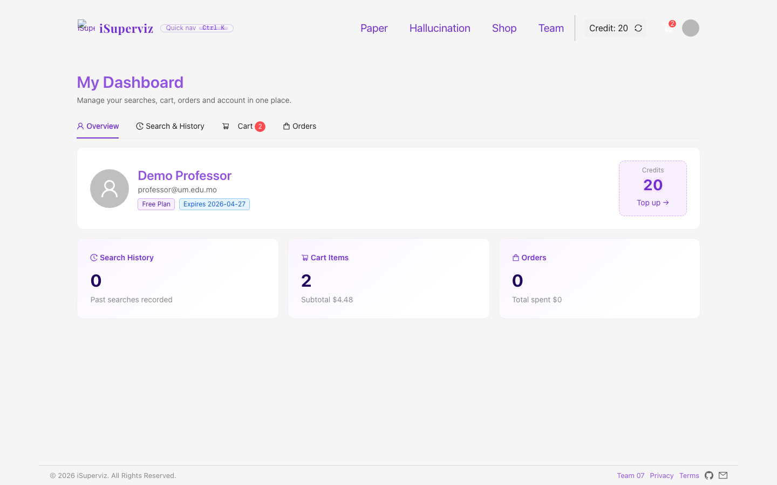
Figure 12. Dashboard, orders and history.

14. Installation, Deployment and Data Instructions
- Install Node.js 18/20/22 and npm.
- Open the project folder iSuperviz-full-source-clean.
- Run npm install in the root folder.
- Run npm install --prefix server for the Express backend dependencies.
- Start the backend with npm start inside server.
- Start the frontend with npm start in the project root.
- Open the deployed URL or local URL and login with professor@um.edu.mo / demo1234.
- For GitHub Pages, build with CI=false and REACT_APP_FORCE_MOCK=1, then publish the build files under CISC3003-TeamProject-Team07-iSuperviz.
Data usage: the backend uses SQLite. Seed/mock data includes products, paper catalogue, demo account, team roster, screenshots and deterministic audit outputs. No sensitive real user data is needed for assessment.

15. Project Incomplete
- The public deployment uses a mock backend because GitHub Pages cannot run Node.js.
- Hallucination Audit uses deterministic demo logic instead of a paid production detector.
- Email verification falls back to console/demo mode unless SMTP credentials are configured.
- The paper catalogue is curated/seeded rather than a live arXiv crawler.
- The individual and team digital story videos must still be recorded as MP4 files from the PPT and screen demo.

16. Citations and References
Ant Design Team. (n.d.). Ant Design - A design system for enterprise-level products. https://ant.design/
Cornell University. (n.d.). arXiv.org e-Print archive. https://arxiv.org/
Express.js. (n.d.). Express - Fast, unopinionated, minimalist web framework for Node.js. https://expressjs.com/
GitHub, Inc. (n.d.). GitHub Pages documentation. https://docs.github.com/en/pages
Meta Open Source. (n.d.). React documentation. https://react.dev/
Microsoft. (n.d.). TypeScript documentation. https://www.typescriptlang.org/docs/
Node.js Foundation. (n.d.). Node.js documentation. https://nodejs.org/en/docs/
Nodemailer. (n.d.). Nodemailer - Send emails from Node.js. https://nodemailer.com/
React Flow. (n.d.). React Flow - Build node-based UIs with React. https://reactflow.dev/
SQLite Consortium. (n.d.). SQLite documentation. https://www.sqlite.org/docs.html
World Wide Web Consortium. (2018). Web Content Accessibility Guidelines (WCAG) 2.1. https://www.w3.org/TR/WCAG21/

17. Declaration of AI Usage
AI assistants, including ChatGPT, Claude and Cursor, were used as assistive tools for wording, debugging support, checklist mapping, report/PPT organisation and review of missing requirements. AI was used under human supervision. Final code, screenshots, design decisions and written content were checked and edited by the student/team. AI was not used as a substitute for learning, judgement or responsibility, and no sensitive personal data was provided to AI services.

18. Final Submission Checklist
- Submit team proposal + team report + team PPT to the teamwork project link.
- Submit cisc3003-Team07-ProjectCode.zip to the coding archive link.
- Submit team digital story MP4/ZIP to the team digital story link.
- Submit individual digital story MP4/ZIP, created from the individual PPT and script, to the individual digital story link.
- Post GitHub archive URL, deployed testing URL, team digital story URL and individual digital story URL in the collaborative forum threads.

