Sum() is used when you need the total of numeric values in a column. For example, sum could be used to aggregate the total payroll of the parks and recreation database.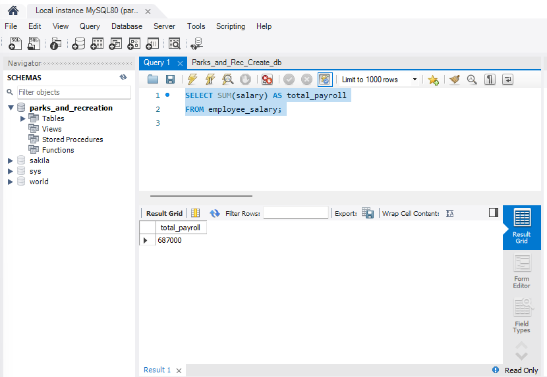

AVG() function can be used to average the values of a particular field. For example, you can use it to find the average age of all the employees in the parks and recreation database.
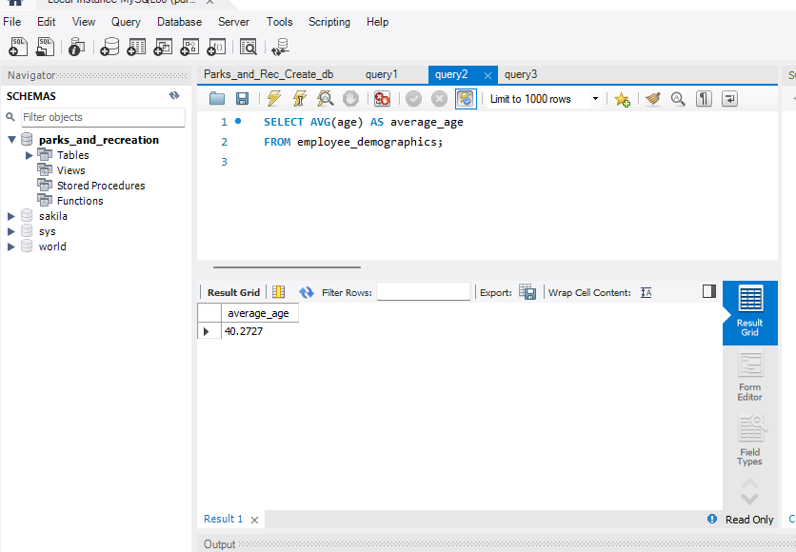
aCount is used when you want to count how many items belong to a specific field. For example, you could count how many employees belong to each department of the parks and recreation example by counting employee_salary.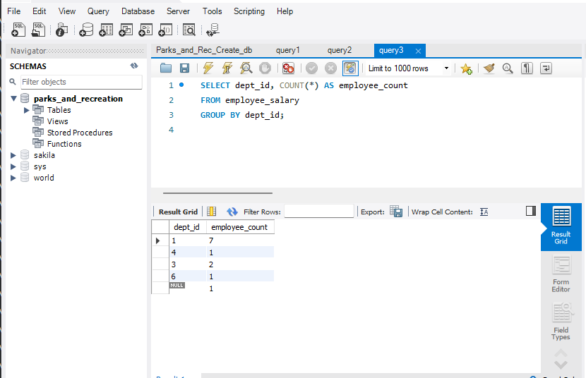s

