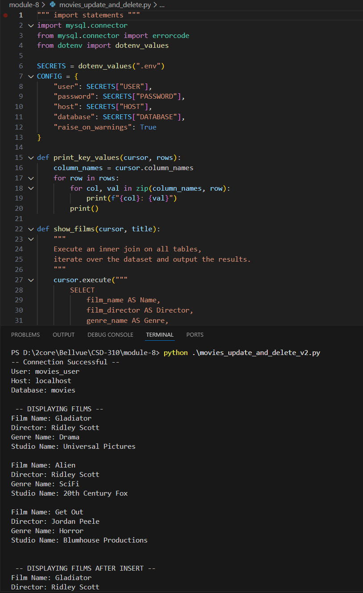https://github.com/alexander-hunt/CSD-310/tree/main/module-8

OUTPUT
-- Connection Successful --
User: movies_user
Host: localhost
Database: movies

-- DISPLAYING FILMS --
Film Name: Gladiator
Director: Ridley Scott
Genre Name: Drama
Studio Name: Universal Pictures

Film Name: Alien
Director: Ridley Scott
Genre Name: SciFi
Studio Name: 20th Century Fox

Film Name: Get Out
Director: Jordan Peele
Genre Name: Horror
Studio Name: Blumhouse Productions

-- DISPLAYING FILMS AFTER INSERT --
Film Name: Gladiator
Director: Ridley Scott
Genre Name: Drama
Studio Name: Universal Pictures

Film Name: Alien
Director: Ridley Scott
Genre Name: SciFi
Studio Name: 20th Century Fox

Film Name: Get Out
Director: Jordan Peele
Genre Name: Horror
Studio Name: Blumhouse Productions

Film Name: Inception
Director: Christopher Nolan
Genre Name: SciFi
Studio Name: Universal Pictures

-- DISPLAYING FILMS AFTER UPDATE - Changed Alien to Horror --
Film Name: Gladiator
Director: Ridley Scott
Genre Name: Drama
Studio Name: Universal Pictures

Film Name: Alien
Director: Ridley Scott
Genre Name: Horror
Studio Name: 20th Century Fox

Film Name: Get Out
Director: Jordan Peele
Genre Name: Horror
Studio Name: Blumhouse Productions

Film Name: Inception
Film Name: Inception
Film Name: Inception
Director: Christopher Nolan
Film Name: Inception
Director: Christopher Nolan
Film Name: Inception
Film Name: Inception
Director: Christopher Nolan
Film Name: Inception
Director: Christopher Nolan
Genre Name: SciFi
Film Name: Inception
Film Name: Inception
Director: Christopher Nolan
Film Name: Inception
Film Name: Inception
Film Name: Inception
Director: Christopher Nolan
Genre Name: SciFi
Studio Name: Universal Pictures

-- DISPLAYING FILMS AFTER DELETING Gladiator --
Film Name: Alien
Director: Ridley Scott
Genre Name: Horror
Studio Name: 20th Century Fox

Film Name: Get Out
Director: Jordan Peele
Genre Name: Horror
Studio Name: Blumhouse Productions

Film Name: Inception
Director: Christopher Nolan
Genre Name: SciFi
Studio Name: Universal Pictures

