Effects of Heat Treatment on 4140 Steel, 1018 Steel, and 360 Brass
Mikey Wiesecke
University of North Carolina Charlotte, Department of Mechanical Engineering, MEGR 3152, Mechanics and Materials Laboratory
Performed 03/20/2024
Reported 03/29/2024

Table of Contents
Table of contents 2
Abstract 2
Objective 2
Introduction 2
Equipment and Procedure 7
Result and Discussion 8
Conclusions 11
References 11
Appendices 11

Abstract
This heat treatment experiment analyzed 4140 Steel, 1018 Steel, and 360 Brass samples that were heat treated. The objective was to determine the effects of different heat treatment methods on different samples. The heat treatments were quenching, annealing, and tempering. The effectiveness of these heat treatments was based on the carbon level; the more carbon the sample had the more it could be hardened. In addition, the cooling rates also determined whether the material would be more ductile or brittle. Annealing was shown to have the greatest ductility while quenching caused the greatest strengthening. Tempering proved to be a way to negate the brittle effects from quenching. Brass on the other hand was not able to be strengthened by heat treatment and even became more ductile after heat was applied, brass seems to be unaffected by cooling rates.

Objective
The objective of this experiment was to learn the process of Heat Treatment and its effect on 4140 Steel, 1018 Steel, and 360 Brass. Performing Metallurgy and hardness test in order to quantify the results and the effects of Heat treatment.

Introduction
The Heat treatment experiment was done to observe the changes that 1018 Steel, 4140 Steel, and 360 Brass underwent when the samples were heat treated. Heat treatment is a manufacturing process done to dramatically change the material properties of different metals to get desirable properties. In the case of this experiment the samples were treated with three different methods: quenching, annealing, and tempering. In order to heat-treat materials, phase diagrams were used to visualize the phase changes that would occur during heating, Figure 1 shows an Iron-Carbide phase diagram from the University of Kiel (Germany)¹
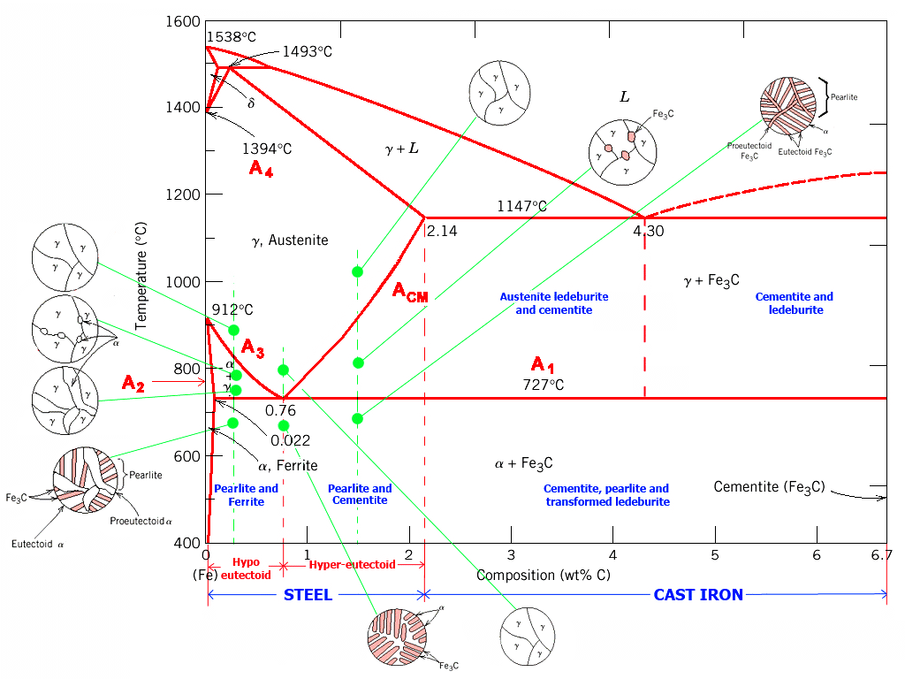
Figure 1. Iron-Carbide Phase Diagram Sourced From Kiel University
The process of quenching involved heating a steel sample to the austenite region, or around 1200 degrees Celsius, and then holding it at this temperature for a prescribed amount of time. The sample was then cooled by dipping it in water, oil, or any other quenching fluid. Annealing is a similar process that heated up a sample to a desired temperature and then held this temperature for a set time. The only difference being that the sample was slowly cooled to room temperature rather than the rapid cooling of quenching. However, to get desired results specific temperatures, times, and cooling rates must be chosen to acquire specific phases in steel. For this a T-T or Time Temperature Diagram such as figure 2 was used.
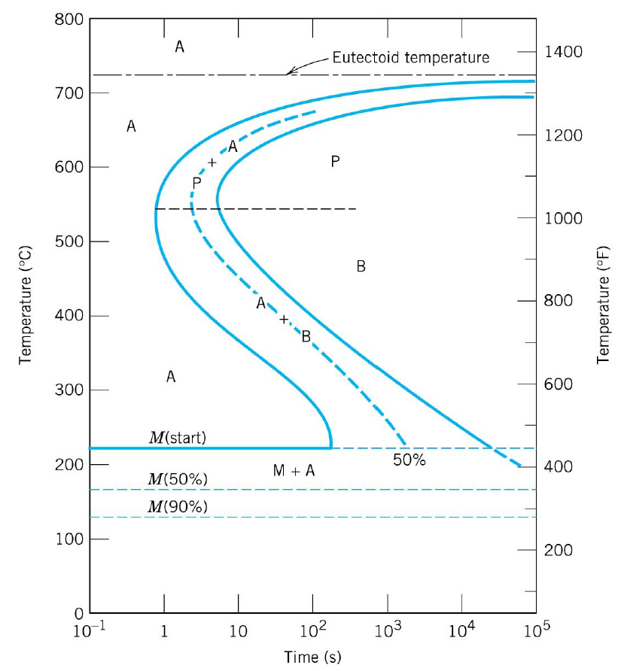
Figure 2. Time Temperature Transformation Diagram
The path to the desired phase was chosen using this diagram. The diagram was employed by tracing across from the starting temperature, at the minimum value of the horizontal axis, and then drawing a straight line down to when quenching and a horizontal line when holding at a temperature. When moved to different phases, the material could no longer be moved out of this phase. For example, if the temperature of a sample was held above 600 for 1000 seconds the material would develop a Pearlite phase and could no longer become Austenite or Bainite. When the material was quenched, the line going across would have to be reset back to the minimum value of the horizontal axis. Using this method, the design for quenching the samples in this experiment was able to achieve their desired properties. Annealing is a process in which the cooling rates are very critical, needing another type of diagram that displays the cooling rates. Figure 3 is a Continuous Cooling rate diagram and was used when annealing a material.
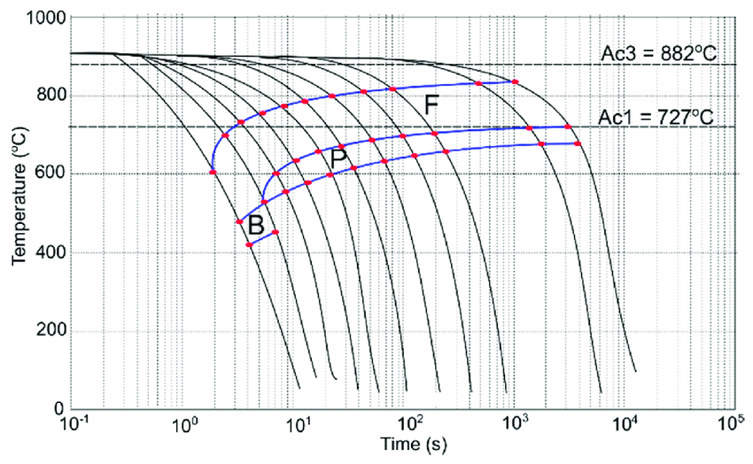
Figure 3. Continuous Cooling Rate Transformation Diagram for Steel
This diagram was used the same way as the T-T diagram, but the Cooling rate diagrams included cooling rates line that could be traced to through phases to ensure that the proper cooling rate was applied in order to get the desired properties. The last heat treatment that this experiment used was tempering, which is a process similar to annealing. When steel is quenched and cooled rapidly it can become Martensite. Martensite was the strongest phase that steel could have while also being the most brittle phase between Martensite, Pearlite and Bainite. In order to negate the brittleness of the steel, it was reheated to 250 – 650 to relieve the stress that was built up during the quenching process. This process also promoted recrystallization and crystal growth leading to better ductility. Once the steel had been adequately reheated it had to be cooled down slowly, often being air cooled as a result. Of course, the steel was not the only material that had a phase diagram. The brass used in this experiment was another diagram that was considered as it was composed of both zinc and copper. Figure 4 shows an T-T diagram of Brass or Copper-Zinc T-T diagram.
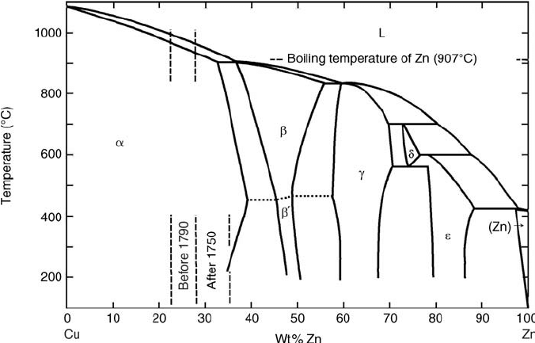
Figure 4: Time Temperature Diagram of Brass
Time temperature diagrams were great for identifying the phases of a material based on the composition and could be used to plan out heat treatment as well. The desired phase in any material was based on the desired mechanical properties. Ferrite was the weakest phase for iron but offered greater ductility than any other phase. Pearlite was stronger than Ferrite but weaker than other phases offering moderate ductility. Bainite was the second strongest phase but only offered limited ductility. Martensite was the strongest phase but was incredibly brittle. The phases could be changed and modified using different heat treatment methods. For steel, the mechanical properties could be modified by adjusting the amount of carbon that was in the steel. In general, more carbon meant a stronger but less ductile steel. This experiment showed that the mechanical properties were changed by the heat treatment applied on the 4140 Steel, the 1018 Steel, and the 360 Brass. Engineers are limited to two things, material and geometry. Heat treatment is a method which allows an engineer to fine tune their material selection.

Equipment and Procedure


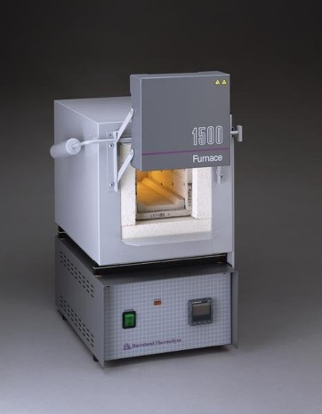
The heat treatment experiment required three samples, 4140 Steel, 1018 Steel and 360 Brass. Each sample was modified using different heat treatment methods with one sample of each being left unmodified as a baseline. The equipment being used consisted of a Barnstead-Thermolyze Model 1500 furnace, ECOMET polishers, Wilson 2000 series Rockwell Hardness Tester, Olympus BX51 optical microscope, sandpaper, polishing cloth, polishing suspension, and etchant. The lab only lasted 3 hours which was not enough time to heat treat the samples and test them, therefore the samples were prepared ahead of time and were tested during the experiment. The following figures, figure 1 and figure 2 are pictures of the Barnstead-Thermolyze 1500 furnace and the Wilson 2000 series Rockwell Hardness test.
Figure 5. Barnstead-Thermolyze 1500 Furnace Figure 6. Wilson 2000 series Rockwell Hardness test
The 1018 Steel was heat treated by being quenched. The process was started by heating the 1018 steel to 950 degrees Celsius and letting it soak for one hour to complete its austenitizing process. The 1018 Steel was cooled rapidly in iced water at room temperature.² The 4140 Steel underwent 4 different heat-treating methods, quenching, normalizing, full annealing, and tempering. Like the 1018 Steel, the 4140 Steel was heated to 950 degrees Celsius and cooled through different methods. Quenching cooled the steel by rapidly cooling the sample in ice water at room temperature. Normalizing simply cooled the steel by taking it out the furnace and letting it cool in air until room temperature was reached. Full annealing left the sample in the furnace while the power was off, and the furnace door was closed until room temperature. The final treatment was tempering which involved heating the quenched sample to 300 degrees Celsius for 15 minutes and them cooling the sample in the air like the normalized sample. As per lab instructions, the samples needed to be heated above the A3 line on the Fe-C phase diagram shown in figure 7.
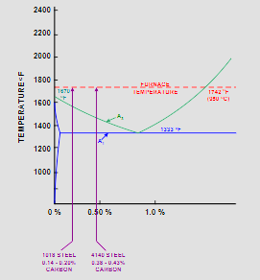
Figure 7. A portion of the Fe-C phase diagram, indicating the heat-treating temperatures
The 360 Brass was only quenched but unlike the steel samples the 360 Brass was heated to 600 degrees Celsius, soaked for one hour, then rapidly cooled in the ice water at room temperature. ²
Once all samples were heat treated, they needed to undergo a metallography examination except for the 360 Brass and 1018 Steel baseline samples. To prepare the samples the “Lab Instruction 3_Metallogrpahy” procedure was used. Like in the previous lab the pictures of the microstructure were taken to be analyzed against the baseline samples. The next thing that was done on the sample was the Rockwell Hardness Test. Each sample had 5 trials done for both the HRC and HRG scales. The procedure for this was taken from “ Lab Instruction 4_Hardness test”. Once all the data had been taken and consolidated the next step was to analyze the microstructure and test results. These would be compared with the baseline data taken in previous samples. For the 4140 Steel Baseline sample the polishing was done using 240, 320,400, and 600 grit sandpaper in that order. The next phase was to use the ECOMET Polishers, one round with 1200 grit and another using a micro cloth with Al₂O₃. Before 4140 Steel was analyzed for its microstructure it needed to be etched for 7 seconds. The Hardness test for the 4140 was a Rockwell Hardness Test using the HRC and HRG scale.

Result and Discussion
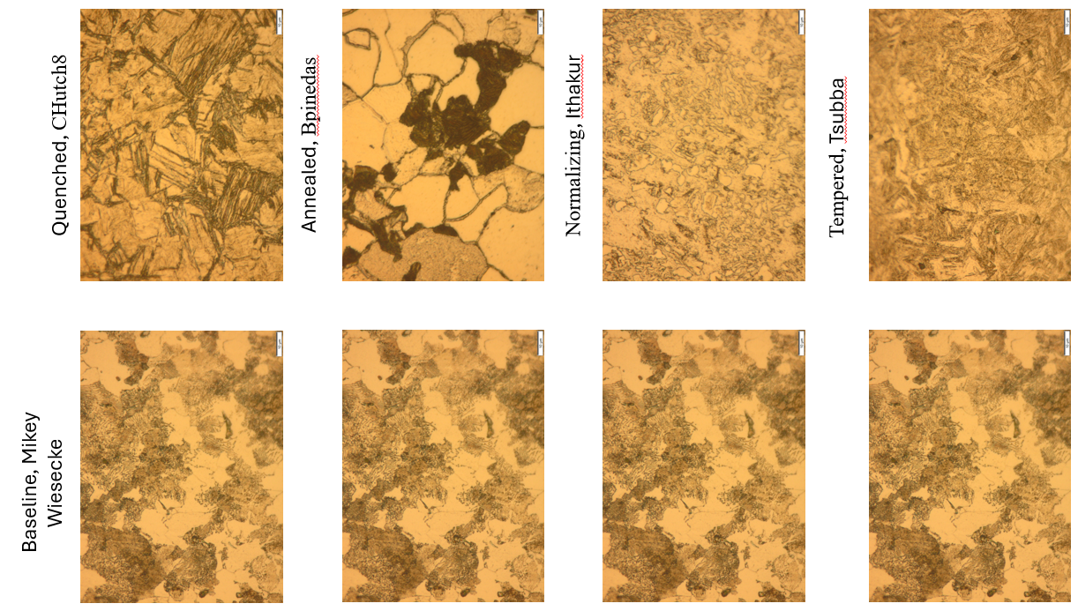
Figure 8. 4041 Steel Metallography Comparison at 100x Magnification
Steel is a material that can be heat treated in which the heat treatment will have huge effects on the mechanical properties of materials. Figure 8. compares the baseline microstructure of 4140 Steel to its heat-treated counterpart. The baseline microstructure shows two phases, a brighter Ferrite phase and a darker pearlite phase. Compared to the 1018 steel which is ferrite dominant 4140 Steel is pearlite dominant and with an .38-.43 wt% carbon compared to the 1018 Steel .14-.2 wt% carbon 4140 Steel is great for heat treating. When the 4140 Steel is quenched the resulting microstructure does not show a phase transformation but rather a Martensite transformation which is independent of time. After being quenched the 4140 Steel shows as having the greatest hardness at the expense of its ductility. The hardness numbers are displayed in Table 1.
Table 1. 4140 Rockwell Hardness Test Results
The starting hardness from the baseline sample is averaged up to 20.4 HRC on the Rockwell Hardness Test C scale. After quenching, the hardness number more than doubles that of the baseline numbers resulting in a hardness number of 46.94 HRC. In the microstructure of the quenched sample, smaller grains can be seen in addition to a needle like structure which represents the martensite that has been formed after quenching. This Martensite makes the 4140 Steel incredibly strong and hard but also extremely brittle. On the opposite side of the Heat treatment spectrum is annealing which results in making the steel much more ductile rather than making it stronger. In the annealed microstructure there is a lot more of the ferrite phase compared to the baseline structure that shows a much more pearlite dominant structure. The grain boundaries are also much clearer and have grown significantly from the baseline sample. This is because annealing promotes recrystallization creating new strain free grains that continue to grow at high temperatures. Ductility is increased by annealing with the downside of significantly decreasing the strength of the material. This effect can be seen in the hardness numbers of 4140 Steel with an annealed average hardness number being 7.62 HRC which is 12.78 HRC lower than the baseline sample. Air cooling has similar effects to quenching but at a much lower degree by only slightly lowering the ductility of the steel. The microstructure of the normalized sample appears to only have a bainite phase with little to no change to the grain size. This can explain the moderate properties of this sample because bainite is harder. This is further proven by the hardness number which is HRC 26.74 which is only about 6 points higher than the baseline sample. Another method to get strength without the expense of ductility is to temper the steel. The tempered sample showed microstructure like that of the quenched sample but with crucial differences. The needle-like structure appears to have been dulled and can be described as blunt. This is because tempering released a lot of the internal energy, relieving built up stress in the sharp needle microstructure from the quenching. The hardness number for the tempered sample is HRC 44.72 which is almost as high as the quenched sample without the problem of being too brittle to be used effectively. The main difference in the different Heat treatments is the cooling rates associated with them. A faster cooling rate, like in quenching, will generally result in a stronger material, this can be seen in the phase diagram which is discussed in the introduction. While a slower cooling rate, like in annealing, makes the material softer and more ductile. The cooling rate also plays a pivotal role in deciding the phases in the microstructure. The phases in the microstructure of a material will drastically affect the mechanical properties. During heat treatment the strength of the material is a function of the cooling rate.
The 1018 Steel sample is a type of steel relatively softer than that of the 4140 Steel, this is because the amount of carbon in 1018 steel is much less than the 4140 Steel. In addition to the carbon percentage the dominant phase in 1018 steel is ferrite dominant, a much weaker phase, rather than pearlite dominant. Figure 9 shows the microstructure of the quenched 1018 steel compared to the microstructure of the non-quenched steel.
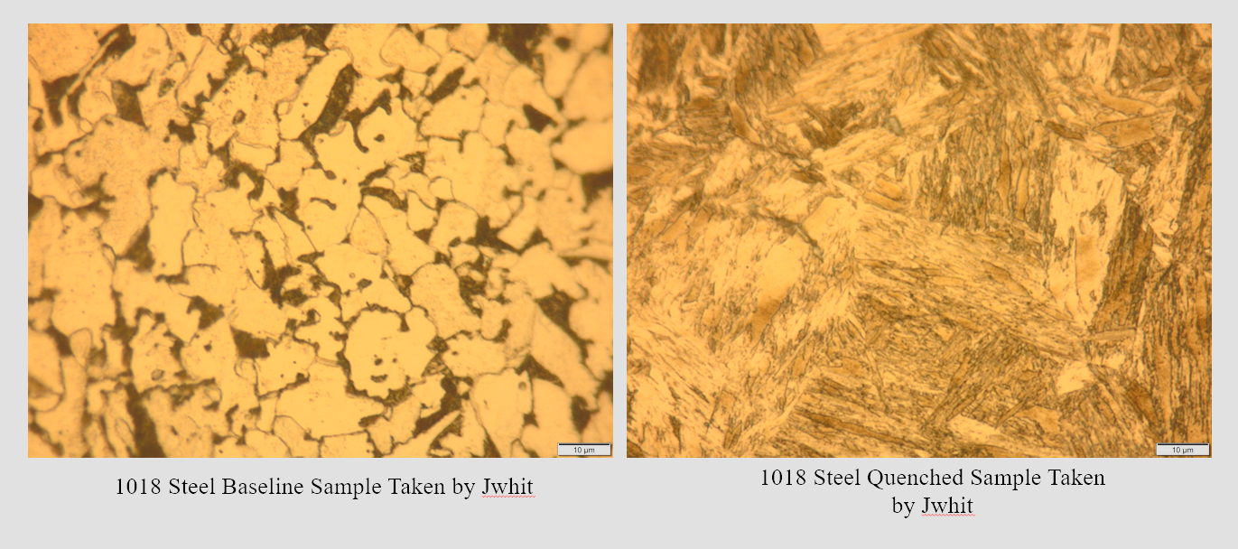
Figure 10. 1018 Steel Microstructure at 100x magnification
After being quenched the 1018 Steel microstructure shows the same needle like Martensite structure as the 4140 Steel with the main difference being the 1018 Steel needles being longer than the ones in the 4140 Steel. Nevertheless the effects of quenching on the 1018 steel are still present and can be seen in the Hardness numbers of the quenched sample. Table 2 shows the hardness comparison of 1018 Steel when using the Rockwell Hardness Test.

Table 2. Rockwell Hardness Numbers of 1018 Steel and quenched 1018 Steel
Similar to 4140 Steel, the hardness more than doubles from the baseline sample when quenching. .However, 1018 Steel is not affected by quenching to the extent that 4140 Steel is. A steel with more carbon will be easier to harden than a steel with less carbon because of hardenability, the ability of a material to be hardened.⁴
The 360 Brass is a very different story compared to that of the steels. As it turns out, brass cannot be heat treated. Figure 11 shows the difference between the microstructure of 360 Brass baseline sample and a quenched sample.
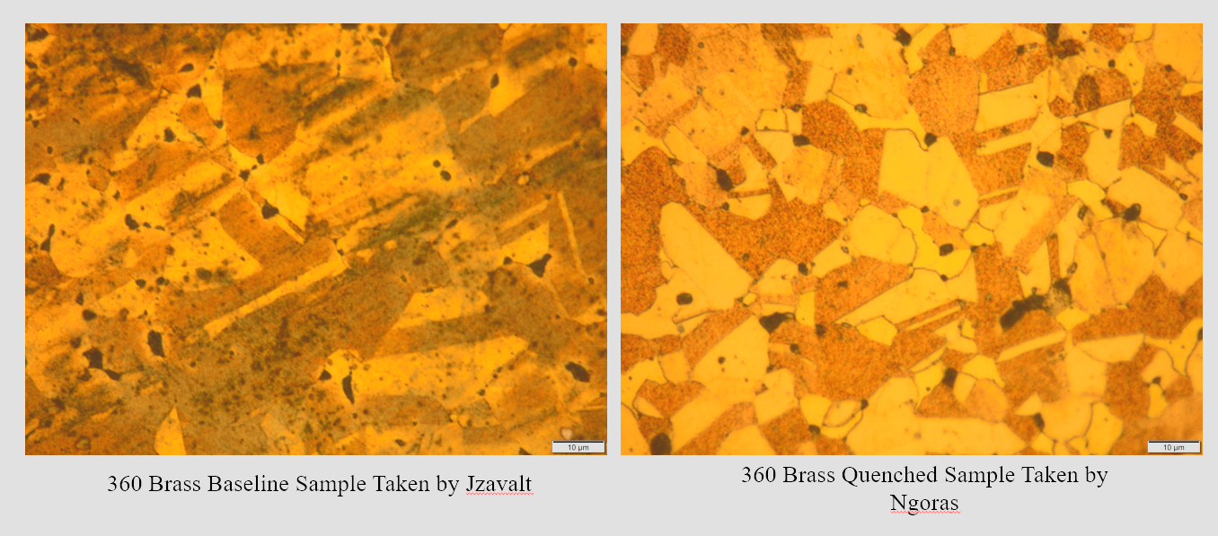
Figure 11. 360 Brass baseline sample vs quenched sample at 100x magnification
The 360 brass has two phases, alpha and beta, which are copper and zinc. After being quenched the 360 Brass does not undergo any phase transformation. However, the grain size is increased significantly by the heat and the presence of twinning starts to occur. The increase in grain size decreases the strength of the brass by lowering the amount of boundaries, this makes the brass more ductile. Twining lowers the energy in between the two grains by perfectly aligning them making it easier for planes to slip, lowering the strength of the brass. This effect is evident when the hardness of the sample is tested. Table 3 shows the hardness of the quenched brass samples and the baseline sample using the Rockwell Hardness Test.
Table 3. Rockwell Hardness of 360 Brass baseline and quenched samples
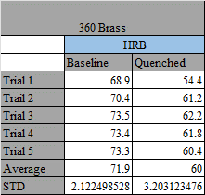
The baseline sample had a Rockwell hardness of HRB 71.9 which is almost 12 points higher than the quenched sample which had a hardness of HRB 60. Quenching brass does not harden it like steel but soften the metal and makes it more ductile.

Conclusions
The main purpose of the experiment was to test the effects of heat treatment on 4140 Steel, 1018 Steel, and 360 Brass. The heat treatments that were used were quenching, annealing, and tempering. It was concluded that the key factors in how well a material would harden and to what degree, were the cooling rate and carbon content. It was observed that a smaller cooling rate would result in a more ductile material while a much greater cooling rate would result in a much stronger material. From this experiment, quenching was best for hardening a material and increasing its strength at the expense of ductility. Annealing worked well for making a material more ductile but would also decrease its strength. Tempering was the best way to make a material as strong as a quenched material without the downside of being brittle. The results are supported by the phases associated with the microstructure of each sample. Martensite is the strongest phase whose downside is extreme brittleness, this showed up in the quenched samples as a needle like structure. Bainite is the second strongest phase and showed when the 4140 steel was air cooled leading to slightly stronger properties than its pearlite dominant baseline counterpart. If the phases were controlled and selected, the mechanical properties of a material could be controlled. Not all materials could be modified like the steels, the 360 Brass did not become stronger when quenched like the steel samples. The 360 Brass became weaker and more ductile showing a growth in grain size and the presence of twinning. Having the ability to modify the mechanical properties of materials through heat treatment would allow for limitless applications. Heat treatment could be a key component to design because it would allow modification of a limiting factor in design, and mechanical property.

References
- The UNC Charlotte William States Lee College of Engineering
Department of Mechanical Engineering and Engineering Science. 2024. “Lab Instruction 5_Heat Treatment_Spring 2024”. Last modified Spring 2024.
https://uncc.instructure.com/courses/218553/files/24236750?wrap=1
- The UNC Charlotte William States Lee College of Engineering
Department of Mechanical Engineering and Engineering Science. 2024.”Topic 5_Heat Treatment of Metals_Post-Lab” . Last modified Spring 2024.
https://uncc.instructure.com/courses/218553/files/24236747?wrap=1
- Keever, Robert. 2020. "Hardenability of Steel." Harvey Performance. April 10. Accessed 03 30, 2024. https://www.harveyperformance.com/in-the-loupe/hardenability-of-steel/#:~:text=Hardenability%20curves%20are%20dependent%20on,have%20an%20effect%20on%20hardenability.
- University of Kiel. n.d. The Iron Carbon Phase Diagram. Accessed 30 2024, 03. https://www.tf.uni-kiel.de/matwis/amat/iss/kap_6/illustr/s6_1_2.html.

