2 Problem #4
2.1 Task
Construct the minimum variance portfolio and tangent portfolio using 15 best performing stocks in US at the present day (use Yahoo! Finance: Market Data -> Market Stats -> Market Movers -> % Gainers). Assume that short-selling is allowed. For the historical data consider the horizon of the last 2 years. Estimate the tail exponent for the returns of this portfolio. Compare with the tail exponent of the S&P 500 index considered at the same horizon of 2 years.

2.2 Problem description
minimum-variance portfolio The portfolio of risky assets with lowest variance.
(http://www.nasdaq.com/investing/glossary/m/minimum-variance-portfolio)
A portfolio of individually risky assets that, when taken together, result in the lowest possible risk level for the rate of expected return. Such a portfolio hedges each investment with an offsetting investment; the individual investor's choice on how much to offset investments depends on the level of risk and expected return he/she is willing to accept. The investments in a minimum variance portfolio are individually riskier than the portfolio as a whole. The name of the term comes from how it is mathematically expressed in Markowitz Portfolio Theory, in which volatility is used as a replacement for risk, and in which less variance in volatility correlates to less risk in an investment.
(http://financial-dictionary.thefreedictionary.com/Minimum-Variance+Portfolio)

Modern Portfolio Theory A theory of investing stating that every rational investor, at a given level of risk, will accept only the largest expected return. More specifically, modern portfolio theory attempts to account for risk and expected return mathematically to help the investor find a portfolio with the maximum return for the minimum about of risk. A Markowitz efficient portfolio represents just that: the most expected return at a given amount of risk (sometimes excluding zero risk). Harry Markowitz first began developing this theory in an article published in 1952 and received the Nobel prize for economics for his work in 1990.
(http://financial-dictionary.thefreedictionary.com/Markowitz+Portfolio+Theory)
Tangent Portfolios The Tangent Portfolios are portfolios of stocks and bonds designed for long-term investors. Since people hate losing money about twice as much as they enjoy making it, the Tangent Portfolios start by asking how much you would be prepared to lose in a worst-case scenario without bailing out of the market: 20%, 25%,or 33%? Once the maximum loss level is selected, the Tangent Portfolios attempt to deliver a high rate of return for that amount of risk.
Most investors tend to take on too much risk during good times (“buy high”), and then sell out during bad times (“sell low”), ruining their returns in the process. The Tangent Portfolios are designed to let you do well enough during both good times and bad to keep you in the markets throughout. This lets you reap the long-term benefits form investing in stocks and bonds with a simple, low-maintenance solution.
(http://www.tangentportfolio.com/)
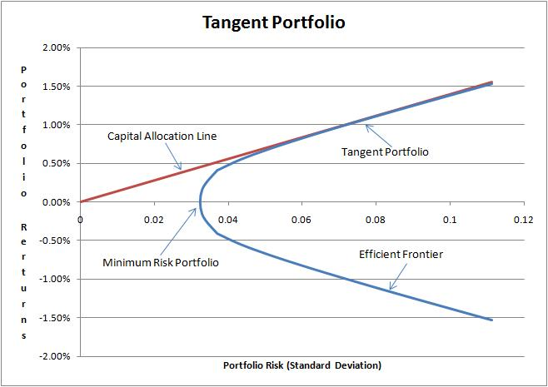
S&P 500 Or the Standard & Poor's 500, is a stock market index based on the market capitalizations of 500 large companies having common stock listed on the NYSE or NASDAQ. The S&P 500 index components and their weightings are determined by S&P Dow Jones Indices. It differs from other U.S. stock market indices, such as the Dow Jones Industrial Average or the Nasdaq Composite index, because of its diverse constituency and weighting methodology. It is one of the most commonly followed equity indices, and many consider it one of the best representations of the U.S. stock market, and a bellwether for the U.S. economy.The National Bureau of Economic Research has classified common stocks as a leading indicator of business cycles.

The S&P 500 was developed and continues to be maintained by S&P Dow Jones Indices, a joint venture majority-owned byMcGraw Hill Financial. S&P Dow Jones Indices publishes many stock market indices, such as the Dow Jones Industrial Average, S&P MidCap 400, the S&P SmallCap 600, and the S&P Composite 1500. It is a free-float capitalization-weighted index,[5] and has many ticker symbols, such as: ^GSPC, INX,and $SPX.
(http://en.wikipedia.org/wiki/S&P_500)

3 Problem #5
3.1 Task
For the 30 stocks that constitute the Dow Jones Industrial Average (Yahoo: ^DJIA) at the present day, find (a) the stock with the maximum P/E ratio, (b) the stock with the minimum P/E ratio and (c) the stock, which P/E ratio is the closest to the average value among all 30 components. Calculate annual returns, annual volatility, daily VaR and daily ES (using historical simulation method) for these stocks for the periods of 2010-2012 and 2005-2007. Calculate correlations between these 3 stocks in both of periods.

3.2 Problem description
The price-to-earnings ratio, or P/E ratio An equity valuation multiple. It is defined as market priceper share divided by annual earnings per share.
There are multiple versions of the P/E ratio, depending on whether earnings are projected or realized, and the type of earnings.
- "Trailing P/E" uses net income for the most recent 12 month period, divided by the weighted average number of common shares in issue during the period. This is the most common meaning of "P/E" if no other qualifier is specified. Monthly earnings data for individual companies are not available, and in any case usually fluctuate seasonally, so the previous four quarterly earnings reports are used and earnings per share are updated quarterly. Note, each company chooses its own financial year so the timing of updates varies from one to another.
- "Trailing P/E from continued operations" uses operating earnings, which exclude earnings from discontinued operations, extraordinary items (e.g. one-off windfalls and write-downs), and accounting changes.
- "Forward P/E": Instead of net income, this uses estimated net earnings over next 12 months. Estimates are typically derived as the mean of those published by a select group of analysts (selection criteria are rarely cited).
(http://en.wikipedia.org/wiki/Price%E2%80%93earnings_ratio)
Annual Return The return an investment provides over a period of time, expressed as a time-weighted annual percentage. Sources of returns can include dividends, returns of capital and capital appreciation. The rate of annual return is measured against the initial amount of the investment and represents a geometric mean rather than a simple arithmetic mean.
Annual return is the de facto method for comparing the performance of investments with liquidity, which includes stocks, bonds, funds, commodities and some types of derivatives. Different asset classes are considered to have different strata of annual returns. (http://www.investopedia.com/terms/a/annual-return.asp)

Volatility A measure for variation of price of a financial instrument over time. Historic volatility is derived from time series of past market prices. An implied volatility is derived from the market price of a market traded derivative (in particular an option). The symbol σ is used for volatility, and corresponds to standard deviation, which should not be confused with the similarly named variance, which is instead the square, σ2.The annualized volatility σ is the standard deviation of the instrument's yearly logarithmic returns.
The generalized volatility σT for time horizon T in years is expressed as:
(http://en.wikipedia.org/wiki/Volatility_(finance))

value at risk (VaR) A widely used risk measure of the risk of loss on a specific portfolio of financial assets. For a given portfolio, probability and time horizon, VaR is defined as a threshold value such that the probability that the mark-to-market loss on the portfolio over the given time horizon exceeds this value (assuming normal markets and no trading in the portfolio) is the given probability level.
(http://en.wikipedia.org/wiki/Value_at_risk)

Expected shortfall (ES) A risk measure, a concept used in finance (and more specifically in the field of financial risk measurement) to evaluate themarket risk or credit risk of a portfolio. It is an alternative to value at risk that is more sensitive to the shape of the loss distribution in the tail of the distribution. The "expected shortfall at q% level" is the expected return on the portfolio in the worst % of the cases.
Expected shortfall is also called conditional value at risk (CVaR), average value at risk (AVaR), and expected tail loss (ETL).
ES evaluates the value (or risk) of an investment in a conservative way, focusing on the less profitable outcomes. For high values of it ignores the most profitable but unlikely possibilities, for small values of it focuses on the worst losses. On the other hand, unlike the discounted maximum loss even for lower values of expected shortfall does not consider only the single most catastrophic outcome. A value of often used in practice is 5%.
Expected shortfall is a coherent, and moreover a spectral, measure of financial portfolio risk. It requires a quantile-level , and is defined to be the expected loss of portfolio value given that a loss is occurring at or below the -quantile.
(http://en.wikipedia.org/wiki/Expected_shortfall)

