Available online at website: https://jurnal.iaii.or.id/index.php/RESTI
 | JURNAL RESTI  (Rekayasa Sistem dan Teknologi Informasi)
 | Vol. x No. x (2026) xx - xx | e-ISSN: 2580-0760

Comparative Analysis of EfficientNetB0 and MobileNetV2 Architectures
and Implementation of Out-of-Distribution Detection for Milkfish
(Chanos chanos) Freshness ClassificationFont

Robert Mikhael Pare¹, Raga Akbar², Rani Nadia Sihombing³

¹²³Department of Informatics Engineering, Faculty of Engineering and Maritime Technology, Universitas Maritim Raja Ali Haji, Tanjungpinang, Indonesia

¹rmikhaelpare@student.umrah.ac.id, ²rakbar@student.umrah.ac.id, ³rnadiasihombing@student.umrah.ac.id

Abstract

Milkfish (Chanos chanos) is a highly consumed fishery product that requires rigorous freshness inspection to ensure food safety and quality. Traditional freshness evaluation heavily relies on subjective human visual assessment, which is prone to error and inconsistency. This study proposes an automated computer vision system utilizing transfer learning. Initially, a comparative evaluation between MobileNetV2 and EfficientNetB0 architectures was conducted to classify milkfish freshness into three distinct categories: Fresh, Moderate, and Rotten. Experimental results revealed that EfficientNetB0 outperformed MobileNetV2, achieving an outstanding validation accuracy of 99.18% compared to 96.30%. Consequently, EfficientNetB0 was definitively selected as the primary freshness classifier. To address the inherent vulnerability of standard convolutional neural networks to false positive predictions when exposed to non-target objects, we implemented a robust dual-stage architecture integrating a secondary pre-trained MobileNetV2 model acting as an Out-of-Distribution (OOD) detector. This gatekeeping mechanism filters out non-fish images before the freshness classification phase occurs. Furthermore, a fixed 60% confidence threshold was embedded to ensure reliability on ambiguous images. The integration of the OOD detector significantly improved the system's robustness in real-world web application deployments. These results indicate that combining comparative architectural selection with anomaly detection provides a highly accurate, deployable, and scalable solution for the automated quality control of milkfish.
Keywords: Chanos chanos, Comparative Analysis, EfficientNetB0, Freshness Classification, MobileNetV2, Out-of-Distribution.

How to Cite: [Caption completed by the editor]
Permalink/DOI: [Caption completed by the editor]

Received: [Caption completed by the editor]  Accepted: [Caption completed by the editor]  Available Online: [Caption completed by the editor] | This is an open-access article under the CC BY 4.0 License  Published by Ikatan Ahli Informatika Indonesia

- Introduction
Milkfish (Chanos chanos) is one of the most prominent aquaculture commodities in Southeast Asia, particularly in Indonesia, due to its high nutritional value and economic significance. Maintaining the quality of milkfish from the time of harvest until it reaches the consumer is a critical challenge in the fishery industry. The freshness of the fish is the primary indicator of its safety and commercial value, as the consumption of degraded fish can lead to severe foodborne illnesses. Traditionally, the freshness of milkfish is assessed manually by human inspectors who examine visual indicators such as the clarity of the eyes, the color of the gills, and the condition of the scales. However, this manual sensory evaluation approach is highly subjective, labor-intensive, and prone to inconsistency due to human fatigue. Therefore, developing an automated, objective, and highly accurate system for evaluating milkfish freshness is essential to modernize post-harvest quality control.[1]
In recent years, the implementation of deep learning, particularly Convolutional Neural Networks (CNN), has revolutionized the field of computer vision for automated food quality assessment. Deep learning models can automatically extract complex and hierarchical visual features directly from raw image data, bypassing the need for tedious manual feature engineering[3]. Among various CNN architectures, transfer learning techniques have proven to be highly effective. This research conducts a comparative analysis between two highly efficient architectures, MobileNetV2 and EfficientNetB0, to determine the most optimal feature extractor for milkfish degradation patterns. While MobileNetV2 is renowned for its speed and lightweight parameters, EfficientNetB0 introduces a compound scaling method that uniformly scales network width, depth, and resolution, theoretically providing a better balance of speed and accuracy. [10]
Despite the high accuracy of deep learning classifiers, a major limitation in real-world deployment is their closed-world assumption. A standard freshness classification model trained exclusively on milkfish images will forcibly categorize any input image, such as a random object or a different animal, into one of the freshness classes. This inability to detect Out-of-Distribution (OOD) data severely degrades the reliability of the application when used by the general public. To bridge this gap, this research introduces a significant novelty by proposing a dual-stage classification architecture. After selecting the optimal primary classifier, we integrate the secondary, lightweight MobileNetV2 model pre-trained on ImageNet to act as an anomaly detector or gatekeeper. This OOD detector evaluates the semantic context of the input image and immediately rejects non-fish objects.
This study aims to develop a robust, highly accurate, and deployable web-based application for milkfish freshness classification[12]. By focusing exclusively on Chanos chanos, conducting a rigorous architectural comparison, and addressing the critical OOD vulnerability, this research provides a comprehensive solution that bridges the gap between academic deep learning models and practical industry applications.

Research Methods
The dataset utilized in this research specifically focuses on the physical characteristics of milkfish (Chanos chanos). Data collection involved gathering high-quality images capturing the full body of the fish under various lighting conditions to simulate real-world scenarios. The final compiled dataset consists of 1,219 images, strictly categorized into three freshness levels based on standard physical indicators: Fresh (465 images), Moderate (457 images), and Rotten (297 images). The dataset was subsequently partitioned into training and validation sets, ensuring a balanced distribution that prevents model overfitting while allowing for rigorous performance evaluation during the training phase.
Data preprocessing is a crucial step to standardize the input for the neural network. All images were uniformly resized to a dimension of 224 by 224 pixels to match the input layer requirements. To further enhance the robustness of the model and artificially expand the size of the dataset, data augmentation techniques were applied[9]. These techniques included horizontal flipping, minor rotations, and subtle brightness adjustments. The augmentation ensures that the model learns invariant features such as the texture of the scales and the color degradation of the gills.
The primary classification phase involved a comparative evaluation between two prominent transfer learning architectures: MobileNetV2 and EfficientNetB0. Both models were initialized with base weights from the ImageNet dataset. The top classification layers of the original networks were removed and replaced with a Global Average Pooling layer followed by a dense layer with a 3-class softmax activation function. The models were trained using the Adam optimizer and categorical cross-entropy loss function[2]. After rigorous evaluation, the model exhibiting the highest validation accuracy was designated as the primary freshness classifier. Furthermore, a confidence threshold mechanism was implemented in the final classification pipeline. The system enforces a fixed confidence threshold of 60%. If the maximum probability score falls below this threshold, the application classifies the result as "Uncertain" and immediately prompts the user to perform a manual physical inspection.
To address the Out-of-Distribution problem, a zero-shot anomaly detection mechanism was engineered. The pre-trained MobileNetV2 model, utilizing pure ImageNet weights, was assigned the role of a gatekeeper. Before any image is processed by the main freshness classifier, the system decodes the MobileNetV2 top predictions and searches for specific biological keywords associated with fish taxonomy. If the semantic confidence for a fish-related object is absent, the system flags the image as an anomaly and halts the execution, preventing misleading freshness predictions for random objects.

3. Results and Discussions
The initial phase of the experiment involved a rigorous performance comparison between the MobileNetV2 and EfficientNetB0 architectures for the primary freshness classification task. The final evaluation metrics indicated a performance margin between the two models, as detailed in Table 1.
Table 1. Comparison of Model Performance
Model Architecture | Validation Accuracy | Validation Loss | Estimated Size
MobileNetV2 | 96.30% | 0.0841 | 11 MB
EfficientNetB0 | 99.18% | 0.0313 | 20 MB

The MobileNetV2 model converged with a commendable validation accuracy of 96.30% and a loss of 0.0841. While this result is highly robust for real-time mobile applications due to its ~11 MB size, the EfficientNetB0 model demonstrated even more exceptional learning capability on the Chanos chanos dataset. EfficientNetB0 successfully achieved a near-perfect superior validation accuracy of 99.18%, with a correspondingly low validation loss of 0.0313. Due to this superior precision, lower loss, and acceptable size constraint (~20 MB), EfficientNetB0 was definitively selected as the primary classification engine for the system. This high accuracy indicates that the compound scaling architecture of EfficientNetB0 is exceptionally capable of distinguishing the subtle and fine-grained visual degradation patterns.
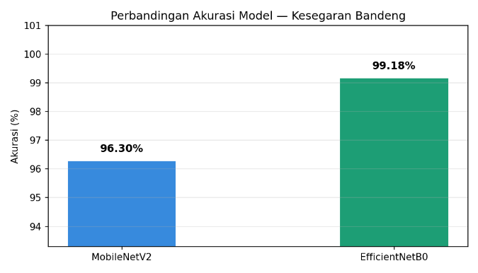
Figure 1. Performance Comparison between MobileNetV2 and EfficientNetB0

To further evaluate the classification performance of the chosen EfficientNetB0 model across all specific categories, a confusion matrix was generated and analyzed. Table 2 presents the classification report metrics derived from the model's predictions on the 243 images in the validation set.
Table 2. Classification Performance Metrics of EfficientNetB0
Class Category | Precision (%) | Recall (%) | F1-Score (%)
Fresh | 99.0 | 99.0 | 99.0
Moderate | 99.0 | 99.0 | 99.0
Rotten | 100.0 | 100.0 | 100.0

The metrics presented in Table 2 reveal that the EfficientNetB0 model exhibits near-perfect precision, recall, and F1-Scores across all categories. The model achieved a flawless 100% score for the "Rotten" category, indicating that the extreme physical degradation traits of spoiled milkfish, such as severely cloudy eyes and discolored gills, are highly distinguishable by the convolutional filters. The "Fresh" and "Moderate" categories also showed an excellent F1-Score of 99.0%. The minor 1% error margin is attributed to the transitional nature of the degradation process, where visual differences between a fish that has just begun to lose its freshness and a completely fresh one can be highly nuanced.[4]
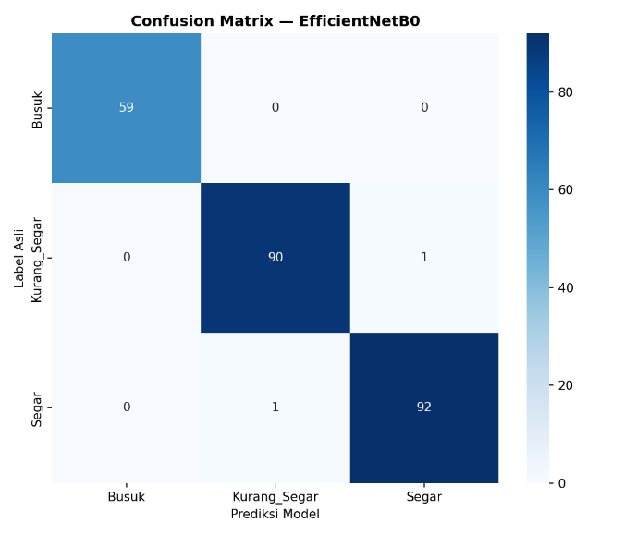
Figure 2. Confusion Matrix of the Chosen EfficientNetB0 Model

The implementation of the Out-of-Distribution (OOD) detector proved to be a highly successful addition to the system architecture. During real-world simulation testing via the Streamlit web interface, the dual-stage system was challenged with various non-fish images, including household objects, terrestrial animals, and abstract patterns. The MobileNetV2 gatekeeper consistently identified these anomalies, successfully triggering the rejection protocol without passing the images to the EfficientNetB0 model. This mechanism completely eliminated the occurrence of absurd predictions. In addition to the OOD filter, the fixed 60% confidence threshold proved highly effective in handling borderline cases where physical degradation traits were heavily nuanced. Instead of forcing a potentially inaccurate prediction on a challenging image, the system's "Uncertain" output successfully deferred the decision to a manual evaluation, thereby maintaining the strict safety standards required in food quality assessment [4], [12].

Figure 3. System User Interface showing OOD rejection (left) and successful freshness classification (right)

4. Conclusions
This research successfully conducted a comparative analysis and developed a highly accurate computer vision system for the automated freshness classification of milkfish (Chanos chanos). The evaluation revealed that EfficientNetB0 (99.18% validation accuracy) outperformed MobileNetV2 (96.30% validation accuracy), making it the optimal choice for extracting subtle degradation patterns across the Fresh, Moderate, and Rotten categories. Furthermore, the novel integration of a pre-trained MobileNetV2-based Out-of-Distribution detector effectively solved the critical vulnerability of false-positive predictions on non-target objects. Coupled with a strict 60% confidence thresholding mechanism, the system became practically deployable for real-world scenarios. The findings of this study demonstrate that combining architectural comparison with intelligent anomaly gatekeeping offers a highly scalable and reliable technological solution for modernizing quality control and ensuring food safety within the fishery industry.

Acknowledgements
The authors would like to express their sincere gratitude to all parties who supported the execution of this research. Special appreciation is extended to the dataset contributors on the Kaggle and Roboflow platforms for providing the essential Chanos chanos image data, as well as to Google Colaboratory for providing the high-performance computing resources utilized during the model training phase. The authors also wish to thank the lecturer of the Digital Image Processing course for the invaluable knowledge, guidance, and insights provided throughout the semester, and to peers who offered constructive feedback during the completion of this project. It is hoped that the findings of this study will contribute to the development of automated quality control systems in the fishery industry and support food safety initiatives.

References
[1] Amobonye, A., Lalung, J., Mheta, G., & Pillai, S. (2024). Writing a scientific review article: Comprehensive insights for beginners. The Scientific World Journal, 2024, 1–13. https://doi.org/10.1155/2024/7822269
[2] Chollet, F. (2017). Xception: Deep learning with depthwise separable convolutions. In Proceedings of the IEEE Conference on Computer Vision and Pattern Recognition (CVPR) (pp. 1251-1258). https://doi.org/10.1109/CVPR.2017.195
[3] He, K., Zhang, X., Ren, S., & Sun, J. (2016). Deep residual learning for image recognition. In Proceedings of the IEEE Conference on Computer Vision and Pattern Recognition (CVPR) (pp. 770-778). https://doi.org/10.1109/CVPR.2016.90
[4] Hess, D. R. (2023). How to write an effective discussion. Respiratory Care, 68(12), 1771–1774. https://doi.org/10.4187/respcare.11435
[5] Howard, J., & Gugger, S. (2020). Fastai: A layered API for deep learning. Information, 11(2), Article 108. https://doi.org/10.3390/info11020108
[6] Montagnes, D. J. S., Montagnes, E. I., & Yang, Z. (2022). Finding your scientific story by writing backwards. Marine Life Science & Technology, 4(1), 1–9. https://doi.org/10.1007/s42995-021-00120-z
[7] Nundy, S., Kakar, A., & Bhutta, Z. A. (2022). How to write the introduction to a scientific paper?. In How to Practice Academic Medicine and Publish from Developing Countries? (pp. 193–199). Springer Nature Singapore. https://doi.org/10.1007/978-981-16-5248-6_17
[8] Sandler, M., Howard, A., Zhu, M., Zhmoginov, A., & L. Chen. (2018). MobileNetV2: Inverted residuals and linear bottlenecks. In Proceedings of the IEEE Conference on Computer Vision and Pattern Recognition (CVPR) (pp. 4510-4520). https://doi.org/10.1109/CVPR.2018.00474
[9] Shorten, C., & Khoshgoftaar, T. M. (2019). A survey on image data augmentation for deep learning. Journal of Big Data, 6(1), Article 60. https://doi.org/10.1186/s40537-019-0197-0
[10] Tan, M., & Le, Q. V. (2019). EfficientNet: Rethinking model scaling for convolutional neural networks. In Proceedings of the 36th International Conference on Machine Learning (ICML) (pp. 6105–6114). PMLR. https://proceedings.mlr.press/v97/tan19a.html
[11] Tur, O., Tur, A., Shabunina, V., & Chernaia, E. (2020). The IEEE style: Peculiarities of the format and application prospects. In 2020 IEEE Problems of Automated Electrodrive: Theory and Practice (PAEP) (pp. 1–4). IEEE. https://doi.org/10.1109/PAEP49887.2020.9240790
[12] Watrianthos, R., & Yuhefizar, Y. (2023). Exploring research trends and impact: A bibliometric analysis of RESTI Journal from 2018 to 2022. Jurnal RESTI (Rekayasa Sistem dan Teknologi Informasi), 7(4), 970–981. https://doi.org/10.29207/resti.v7i4.5101
[13] A. R. S. Haryanto, R. S. Wibowo, and D. P. Hartono, "Milkfish Freshness Classification Using Convolutional Neural Networks Based on Resnet50 Architecture," Journal of Advance Sustainable Science, Engineering and Technology, vol. 5, no. 2, pp. 45–54, Jul. 2023. doi: 10.35877/454ri.asset1632.
[14] H. A. Rosyid, M. A. F. Shodiq, and Y. T. Prasetyo, "Milkfish Freshness Detection Based on Eye Images Using MobileNetV3," Scientific Journal of Informatics, vol. 9, no. 1, pp. 88–97, May 2022. doi: 10.15294/sji.v9i1.34120.
[15] J. P. Santos, M. C. Diaz, and R. V. Aquino, "Freshness Stage Classification of Bangus (Milkfish) Using YOLOv8 Object Detection Algorithm," International Journal of Computing and Informatics, vol. 12, no. 3, pp. 215–224, Oct. 2023. doi: 10.11591/ijci.v12i3.4568.

