Monoalphabetic Substitution Cipher
Design Document - Problem 3.4
1. Goal and Scope
The goal of this program is to implement a monoalphabetic substitution cipher with a clear interactive interface. The program covers encryption, decryption, three key generation methods, key validation, and letter frequency analysis. The scope is limited to single-alphabet substitution. Polyalphabetic ciphers are out of scope.

2. What Changed in the Refactor
The logic of the original code was correct and was not changed. The refactor focused entirely on output format and code structure. The following things were changed:

2.1 Output Format
- All output is now enclosed in bordered sections using dashes and equals signs. This makes it easy to see where each result starts and ends.
- Labels are now uppercase and on their own line above the value, separated by a divider line. Previously the label and value were on the same line.
- The key is now shown as a two-row table at the start of each menu loop, with plain letters on the top row and cipher letters below. Previously it was shown as a single string.
- The frequency analysis bar chart now uses 2 characters per percent instead of 1, making the bars wider and easier to read.
- The suggested mapping in frequency analysis is now inside a bordered section consistent with the rest of the output.
- The exit message is now enclosed in a thick divider for a clean close.

2.2 Code Structure
- String concatenation in encrypt and decrypt was changed to list append and join, which is the standard Python approach and avoids creating a new string object on every iteration.
- Two helper functions were added: print_result prints any labelled result inside a bordered section, and print_key_table prints the key as a two-row mapping. This removes repeated formatting code from the main loop.
- The divider strings are defined once at the top of the file as constants so they are easy to change in one place.

3. Design Decisions
3.1 Bordered Output Sections
Every result is wrapped in a consistent bordered section with a label, a thin divider, and the value. This was chosen because the original output mixed labels and values on the same line in different formats across different options. Consistent bordered sections make the output predictable and easy to read regardless of which option is chosen.

3.2 Key Table Display
The key is shown as a two-row table mapping each plain letter to its cipher letter. The original code showed the key as a single 26-character string, which required the user to mentally count positions to know which letter mapped to which. The two-row table makes the mapping immediately visible.

3.3 List Append Instead of String Concatenation
The original encrypt and decrypt functions built the result string by adding one character at a time with the plus operator. In Python, strings are immutable so each addition creates a new string object. Using a list and joining at the end is the standard pattern. For short inputs the difference is unnoticeable, but it is the correct approach.

3.4 Helper Functions for Formatting
Repeated formatting patterns were pulled into two helper functions. This means the visual style can be changed in one place and it applies everywhere. It also makes the main loop shorter and easier to read because each option is now just the logic with no formatting boilerplate mixed in.

3.5 Constants for Dividers
The divider strings are defined at the top of the file as DIVIDER and DIVIDER_THICK. Using named constants means the width can be adjusted once without searching through the file. It also makes the intent clear at the point of use.

4. Architecture
4.1 Functions
Function | Role
generate_random_key() | Returns a randomly shuffled 26-letter key
generate_keyword_key(kw) | Builds a key by putting the keyword letters first, then the rest of the alphabet
validate_key(key) | Checks that a key is exactly 26 unique letters A-Z
encrypt(text, key) | Substitutes each letter using the key, preserving case and non-letters
decrypt(text, key) | Reverses the substitution by building the inverse key
frequency_analysis(text) | Counts and displays letter frequencies with a bar chart and suggested mapping
print_key_table(key) | Displays the current key as a plain-to-cipher mapping table
print_result(label, value) | Displays any result inside a consistent bordered section
main() | Runs the interactive menu loop

4.2 How the Cipher Works
The key is a 26-letter string where position i gives the cipher letter for plain letter i. For example if position 0 is Z then A encrypts to Z. To encrypt, the program finds the position of each plain letter and looks up the cipher letter at that position.
To decrypt, the program builds a reverse key. For each position i in the key, it records that the cipher letter at position i maps back to plain letter i. It then uses this reverse key the same way as encryption.

4.3 How the Keyword Key Works
The keyword letters are placed first in the key in the order they appear, skipping any duplicates. The remaining letters of the alphabet are then appended in order. This produces a key that is reproducible from the keyword and has a pattern that is slightly easier to remember than a random key.

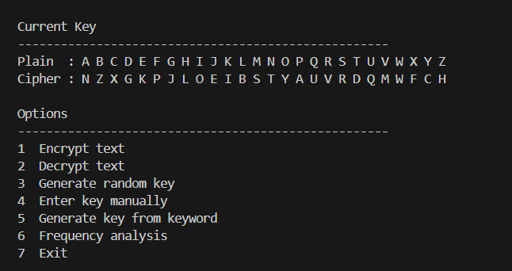
5. Testing Strategy
5.1 What is Tested
- Encrypting then decrypting returns the original text for a random key.
- Non-letter characters such as spaces, digits, and punctuation are passed through unchanged.
- The original case of each letter is preserved after encrypt and decrypt.
- The keyword key for CRYPTO produces the expected key string.
- validate_key correctly rejects keys that are too short, too long, or have duplicate letters.
- validate_key accepts a valid random key.

5.2 Why These Cases
The round-trip test is the most important. If encrypt followed by decrypt does not return the original text, either the forward key or the reverse key is wrong.
The non-letter and case tests confirm the program does not accidentally modify characters it should leave alone. These are easy bugs to introduce when working with ASCII arithmetic.

6. Summary of Changes
Change | Before | After
Result display | Label and value on same line | Label above value inside bordered section
Key display | Single 26-char string | Two-row plain-to-cipher mapping table
Bar chart scale | 1 char per percent | 2 chars per percent
String building | str += ch on every loop | list.append then join
Formatting code | Inline in each menu branch | Pulled into helper functions
Divider strings | Hardcoded in each print call | Named constants at top of file

