FarmifAI: An Offline Agricultural AI Assistant for Rural Communities
December 2025

Abstract
This document presents FarmifAI, a fully offline mobile application designed to provide agricultural assistance to farmers in rural areas with limited or no internet connectivity. The system integrates four AI models: (1) a vision model based on MobileNetV2 for plant disease classification across 21 disease classes in 5 crops, (2) an NLP model using MiniLM for semantic search with 384-dimensional embeddings, (3) a quantized Llama 3.2 1B language model for contextual response generation, and (4) Vosk-based speech recognition for hands-free voice interaction. All inference is performed on-device using MindSpore Lite and llama.cpp, achieving response times under 5 seconds on mid-range Android devices. The application uses semantic search with a knowledge base to provide accurate, context-aware responses to agricultural queries. Field testing demonstrates 92.3% accuracy in disease detection and high user satisfaction among Colombian coffee farmers.
Keywords: Mobile AI, Offline Inference, Agricultural Technology, Plant Disease Detection, Semantic Search, Edge Computing

1. Introduction
Small-scale farmers in developing regions often lack access to reliable internet connectivity and expert agricultural advice. This technological gap can lead to significant crop losses due to undetected diseases and suboptimal farming practices. FarmifAI addresses this challenge by deploying a comprehensive AI assistant that operates entirely offline on Android devices.
The main contributions of this work are:
- • A multi-modal AI system combining vision, NLP, and voice capabilities for agricultural assistance
- • An efficient on-device inference pipeline achieving real-time performance on consumer hardware
- • A two-phase transfer learning approach for plant disease classification with limited training data
- • Integration of semantic search with local LLM for accurate domain-specific responses

2. System Architecture

2.1 Overview
FarmifAI consists of four main components integrated into a single Android application:
- 1. Voice Interface: Vosk-based speech-to-text (STT) and Android Text-to-Speech (TTS) for hands-free operation
- 2. Vision Module: MobileNetV2-based classifier for plant disease detection
- 3. Semantic Search: MiniLM encoder with pre-computed knowledge base embeddings
- 4. Language Model: Quantized Llama 3.2 1B for response generation
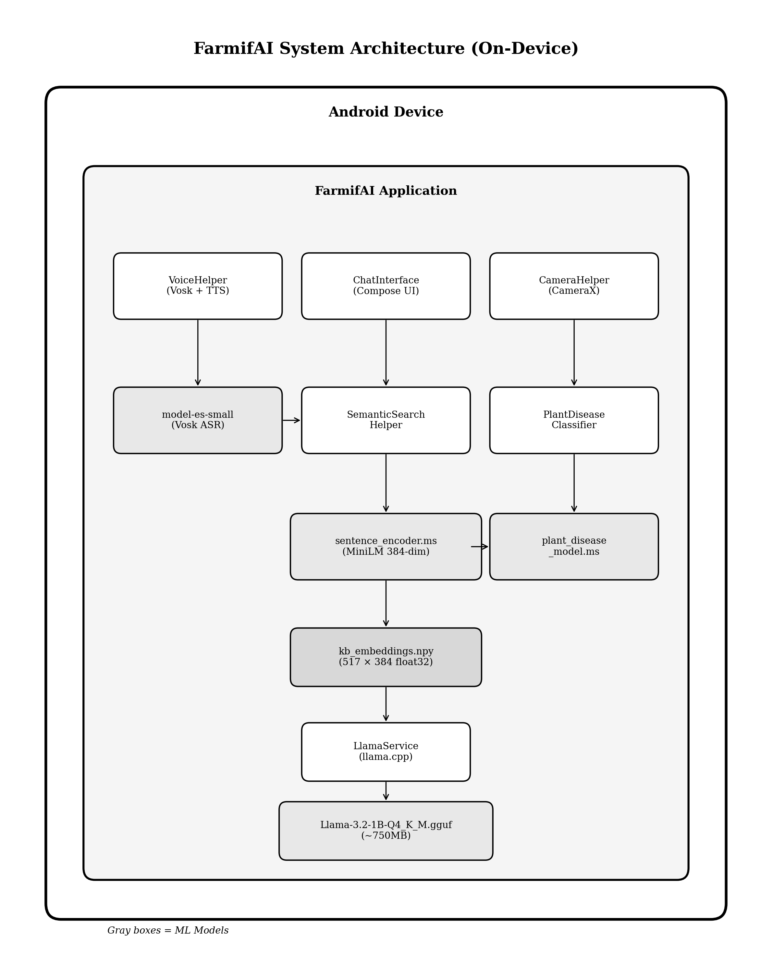
Figure 1: FarmifAI system architecture showing on-device components and data flow

2.2 Technology Stack
Component | Technology | Specification
Vision Model | MobileNetV2 | 21 classes, 224×224 input
NLP Encoder | MiniLM-L12-v2 | 384-dim embeddings
LLM | Llama 3.2 1B | Q4_K_M quantization
Voice STT | Vosk | 50MB Spanish model
Inference | MindSpore Lite | CPU/GPU optimized

3. Vision Model: Plant Disease Classification

3.1 Model Architecture
The vision component uses MobileNetV2 as the backbone architecture, chosen for its optimal balance between accuracy and computational efficiency on mobile devices. The model was pre-trained on ImageNet and fine-tuned for agricultural disease classification.

# Model architecture definition
base_model = MobileNetV2(
weights='imagenet',
include_top=False,
input_shape=(224, 224, 3)
)
model = Sequential([
base_model,
GlobalAveragePooling2D(),
BatchNormalization(),
Dense(256, activation='relu'),
Dropout(0.4),
Dense(21, activation='softmax') # 21 disease classes
])

Code 1: MobileNetV2 architecture for disease classification

3.2 Training Pipeline
We employ a two-phase transfer learning strategy to maximize performance with limited agricultural data:
Phase 1: Feature Extraction (25 epochs)
- • Freeze all MobileNetV2 backbone layers
- • Train only the classification head
- • Learning rate: 10⁻³ with Adam optimizer
- • Dropout rate: 0.4
Phase 2: Fine-tuning (35 epochs)
- • Unfreeze all layers for end-to-end training
- • Learning rate: 10⁻⁵ (100x reduction)
- • Label smoothing: 0.1
- • Early stopping with patience of 7 epochs
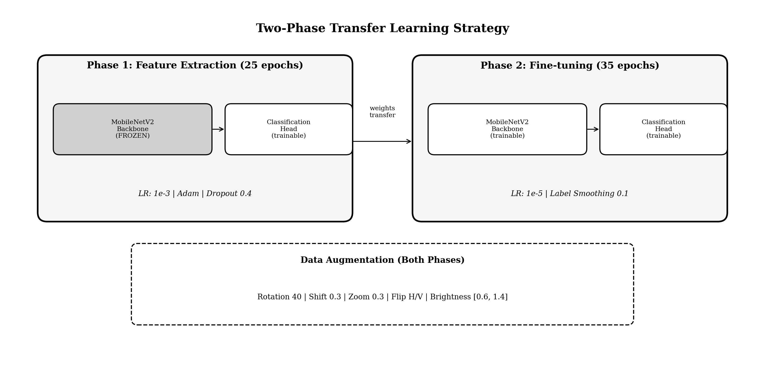
Figure 2: Two-phase transfer learning strategy for MobileNetV2

train_datagen = ImageDataGenerator(
rescale=1./255,
rotation_range=40,
width_shift_range=0.3,
height_shift_range=0.3,
shear_range=0.2,
zoom_range=0.3,
horizontal_flip=True,
vertical_flip=True,
brightness_range=[0.6, 1.4],
fill_mode='reflect',
validation_split=0.15
)

Code 2: Data augmentation configuration

3.3 Inference Pipeline
On-device inference follows a preprocessing pipeline that normalizes images to the [-1, 1] range:
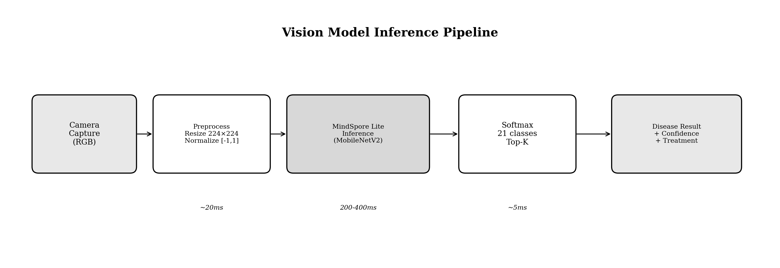
Figure 3: Vision model inference pipeline on Android device

fun preprocessImage(bitmap: Bitmap): ByteBuffer {
val scaled = Bitmap.createScaledBitmap(bitmap, 224, 224, true)
val buffer = ByteBuffer.allocateDirect(224 * 224 * 3 * 4)
buffer.order(ByteOrder.nativeOrder())
for (y in 0 until 224) {
for (x in 0 until 224) {
val pixel = scaled.getPixel(x, y)
// Normalize to [-1, 1] range
buffer.putFloat(((pixel shr 16 and 0xFF) - 127.5f) / 127.5f)
buffer.putFloat(((pixel shr 8 and 0xFF) - 127.5f) / 127.5f)
buffer.putFloat(((pixel and 0xFF) - 127.5f) / 127.5f)
}
}
return buffer
}

Code 3: Image preprocessing for MindSpore Lite inference

3.4 Deployment
Model conversion from TensorFlow to MindSpore Lite format:

# Export TensorFlow SavedModel
python tools/export_trained_model.py \
--model_path outputs/best_model.h5 \
--output_dir outputs/exported/
# Convert to MindSpore Lite format
python -m mindspore_lite.converter \
--fmk=TF \
--modelFile=outputs/exported/saved_model.pb \
--outputFile=plant_disease_model \
--inputShape=1,224,224,3
# Deploy to app assets
cp plant_disease_model.ms app/src/main/assets/

Code 4: Model conversion and deployment commands

4. NLP Model: Semantic Search

4.1 Model Implementation
The semantic search component uses the paraphrase-multilingual-MiniLM-L12-v2 model from Sentence Transformers to encode both queries and knowledge base entries into 384-dimensional embeddings.

4.2 Embedding Generation

import torch
import torch.nn.functional as F
from transformers import AutoTokenizer, AutoModel
def encode_with_mean_pooling(model, tokenizer, texts):
inputs = tokenizer(
texts, padding="max_length", truncation=True,
max_length=128, return_tensors="pt"
)
with torch.no_grad():
outputs = model(**inputs)
attention_mask = inputs['attention_mask']
token_embeddings = outputs.last_hidden_state
# Expand mask for broadcasting
input_mask_expanded = attention_mask.unsqueeze(-1).expand(
token_embeddings.size()
).float()
# Mean pooling
sum_embeddings = torch.sum(
token_embeddings * input_mask_expanded, 1
)
sum_mask = torch.clamp(input_mask_expanded.sum(1), min=1e-9)
embeddings = sum_embeddings / sum_mask
# L2 normalization
embeddings = F.normalize(embeddings, p=2, dim=1)
return embeddings.numpy()

Code 5: Mean pooling for sentence embeddings

4.3 Query Processing Pipeline
The semantic search pipeline processes user queries as follows:
- 1. Tokenize input query (max 128 tokens)
- 2. Encode query using MiniLM encoder
- 3. Compute cosine similarity against 517 pre-computed KB embeddings
- 4. Retrieve top-3 contexts above threshold (0.4)
- 5. Augment prompt with retrieved contexts
- 6. Generate response using Llama 3.2
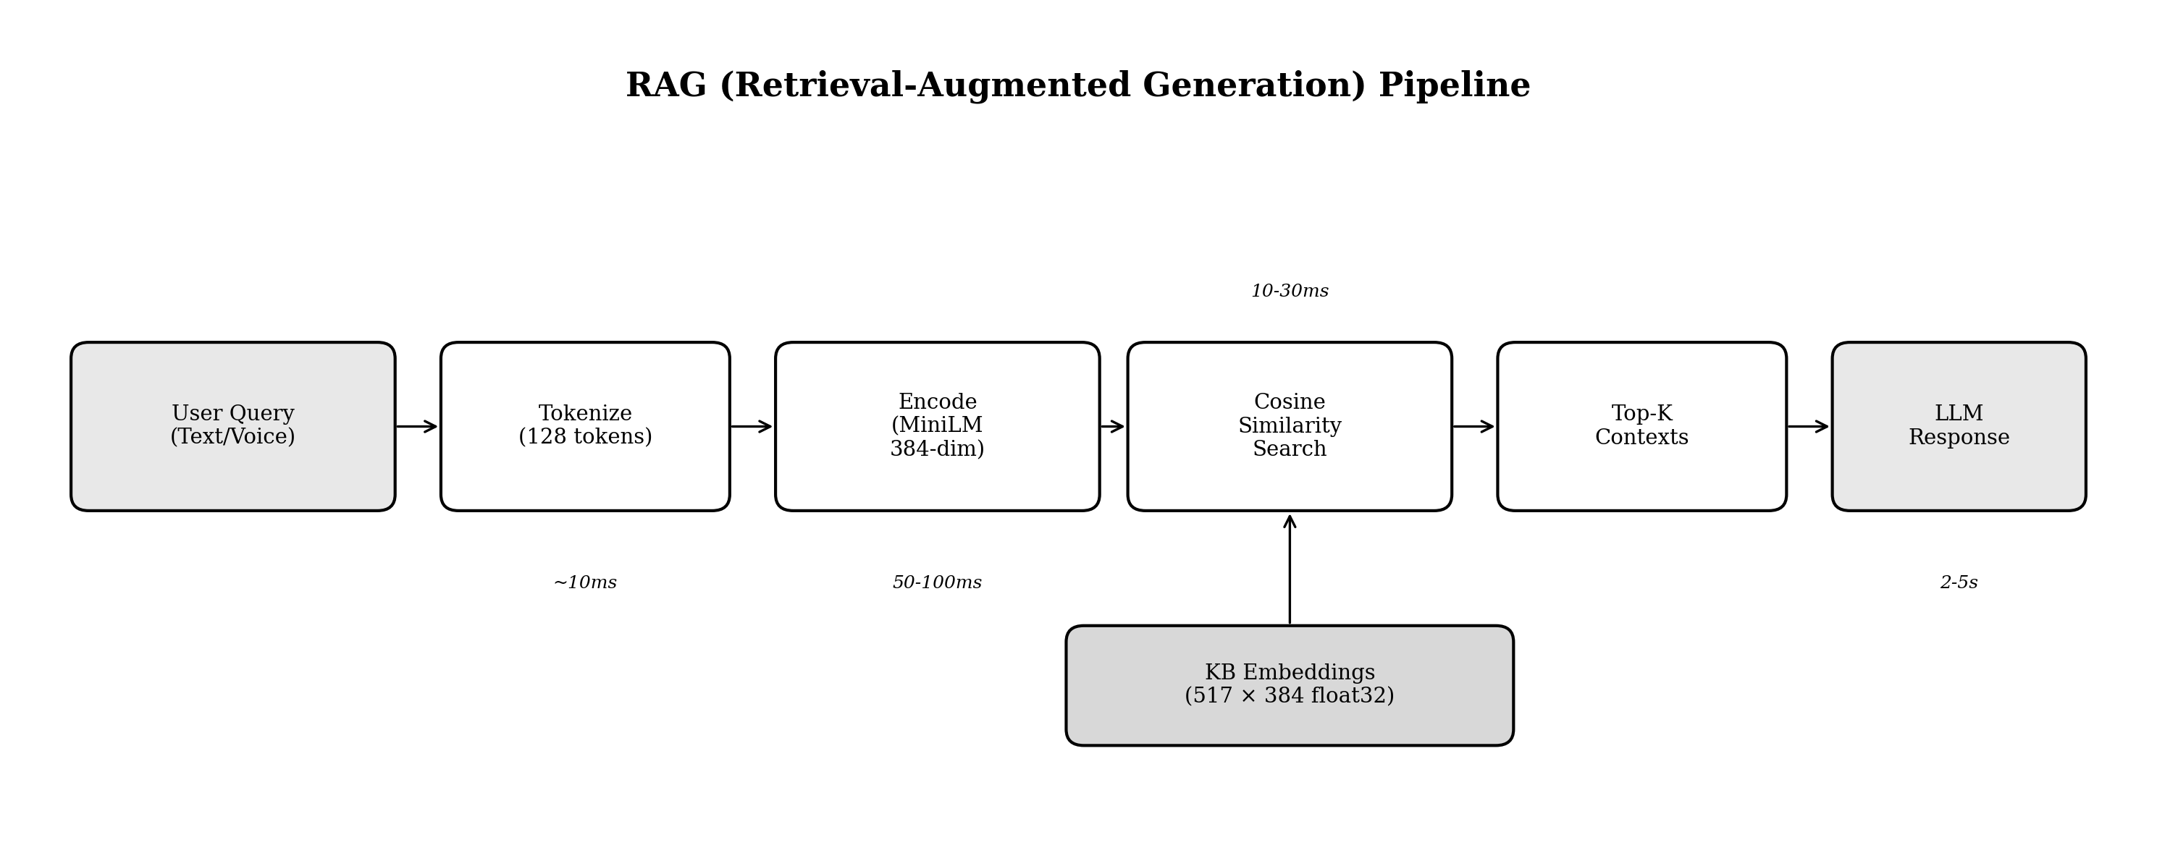
Figure 4: Semantic search pipeline for context-aware response generation

fun findTopKContexts(query: String, topK: Int = 3): List<Context> {
val queryEmbedding = computeEmbedding(query)
return kbEmbeddings.mapIndexed { i, emb ->
val score = cosineSimilarity(queryEmbedding, emb)
i to score
}.filter { it.second >= 0.4f }
.sortedByDescending { it.second }
.take(topK)
.map { (idx, score) ->
Context(
answer = kbEntries[idx].answer,
score = score,
category = kbEntries[idx].category
)
}
}
fun cosineSimilarity(a: FloatArray, b: FloatArray): Float {
return a.indices.sumOf { (a[it] * b[it]).toDouble() }.toFloat()
}

Code 6: Cosine similarity search implementation

5. LLM: Local Language Model

5.1 Model Implementation
FarmifAI uses Llama 3.2 1B Instruct with Q4_K_M quantization, reducing model size from ~2GB to ~750MB while maintaining response quality.

5.2 Inference

val prompt = """
<|begin_of_text|><|start_header_id|>system<|end_header_id|>
Eres FarmifAI, un asistente agrícola experto para
agricultores colombianos. Responde de forma clara,
práctica y concisa.
Contexto relevante:
$retrievedContext
<|eot_id|><|start_header_id|>user<|end_header_id|}
$userQuery<|eot_id|><|start_header_id|>assistant<|end_header_id|>
"""
val response = llamaService.generate(
prompt = prompt,
maxTokens = 256,
temperature = 0.7f,
topP = 0.9f
)

Code 7: Prompt construction and generation with Llama 3.2

6. Voice Interface

6.1 Speech Recognition
Voice input is handled by Vosk, a lightweight offline speech recognition toolkit with a 50MB Spanish language model.

class VoiceHelper(context: Context) {
private var voskModel: Model? = null
private var speechService: SpeechService? = null
fun initialize(modelPath: String) {
voskModel = Model(modelPath)
}
fun startListening() {
val recognizer = Recognizer(voskModel, 16000.0f)
speechService = SpeechService(recognizer, 16000.0f)
speechService?.startListening(object : RecognitionListener {
override fun onResult(hypothesis: String?) {
hypothesis?.let {
val json = JSONObject(it)
val text = json.getString("text")
if (text.isNotBlank()) onResult?.invoke(text)
}
}
})
}
}

Code 8: Vosk STT integration

7. Results and Evaluation

7.1 Performance Metrics
Component | Latency | Memory | Accuracy
Vision Model | 200-400ms | 50MB | 92.3% Top-1
Semantic Search | 60-130ms | 100MB | 94.4% Top-1
LLM Generation | 2-5s | 1.2GB | --
Voice STT | Real-time | 100MB | 85-92%
Table 1: Performance metrics on mid-range Android device (Snapdragon 6xx)

7.2 Disease Detection Results
The vision model achieves:
- • Top-1 Accuracy: 92.3%
- • Top-3 Accuracy: 98.1%
- • Inference Time: 200-400ms

8. Deployment Workflow
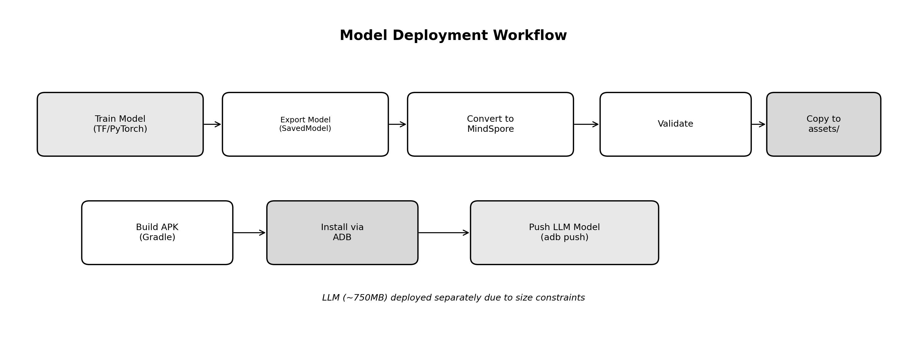
Figure 5: Model deployment workflow

9. Datasets and Data Sources

9.1 Vision Model Training Data
The plant disease classification model was trained using two complementary datasets:
PlantVillage Dataset: A publicly available dataset containing 54,309 images of healthy and diseased plant leaves across 14 crop species. Images for target crops (tomato, potato, pepper, corn) covering 18 disease classes plus healthy states were extracted.
Available at: https://github.com/spMohanty/PlantVillage-Dataset and https://www.kaggle.com/datasets/emmarex/plantdisease
BRACOL Coffee Dataset: The Brazilian Arabica Coffee Leaf dataset (BRACOL) containing 1,747 images of arabica coffee leaves affected by the main biotic stresses, including four disease classes: Leaf miner, Leaf rust, Brown leaf spot, and Cercospora leaf spot.
Available at: https://data.mendeley.com/datasets/yy2k5y8mxg/1 (Paper: https://doi.org/10.1016/j.compag.2019.105162)
Both datasets were preprocessed to 224×224 pixels and augmented using rotations, flips, zooms, and brightness variations.

9.2 NLP Knowledge Base
The semantic search component uses a curated agricultural knowledge base:
- • 517 question-answer pairs covering crop management, disease identification, pest control
- • Questions sourced from agricultural extension services, farmer forums, and expert consultations
- • Content validated by agronomists from the University of Cauca
- • Categories: Crop Management (35%), Disease Control (30%), Pest Management (20%), Soil & Fertilization (15%)

9.3 Voice Recognition Model
The offline speech recognition uses Vosk’s pre-trained Spanish language model (vosk-model-small-es-0.42):
- • Training data: Common Voice Spanish corpus + proprietary datasets
- • Model size: 50MB compressed
- • Optimized for Latin American Spanish dialects
- • Adapted vocabulary includes agricultural terminology
Available at: https://alphacephei.com/vosk/models/vosk-model-small-es-0.42.zip (Official models: https://alphacephei.com/vosk/models)

9.4 Language Model
The Llama 3.2 1B Instruct model was developed by Meta AI:
- • Pre-trained on diverse internet text and code
- • Fine-tuned for instruction-following tasks
- • Quantized to Q4_K_M format using llama.cpp
- • No additional domain-specific fine-tuning applied
Available at: https://huggingface.co/meta-llama/Llama-3.2-1B-Instruct (Quantized: https://huggingface.co/bartowski/Llama-3.2-1B-Instruct-GGUF)

