**Supplementary materials for the manuscript**

# **Relationships between synthesis conditions and TiN coating properties discovered from the data driven appro****ach**

Kulkov M.1, Guda S. A.1,2, Kudryakov O. V.2,3, Guda A. A.1,2, Pashkov D. M.1,2, Rusalev Yu.1,2, Soldatov A. V.1, Kolesnikov V. I.2

1 The Smart Materials Research Institute, Southern Federal University, Rostov-on-Don 344090, Russian Federation;

2 Department of Theoretical Mechanics, Rostov State Transport University, Rostov-on-Don, 344038, Russian Federation

3 Material Science Department, Don State Technical University, Rostov-on-Don, 344000, Russian Federation

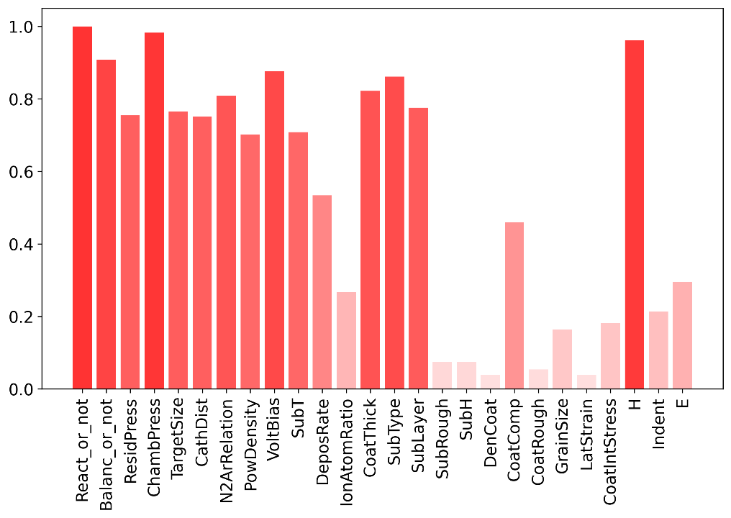

**Figure S1.** Bar-chart of the sparsity of the database by descriptors (1.0 - no missing values; 0.0 - no filled values).

|  |  |  |  |  |  |  |
| --- | --- | --- | --- | --- | --- | --- |
| **Imputer** | *const* | *const* | *const* | *simple* | *simple* | *simple* |
| **Model** | *ExtraTrees* | *RidgeCV* | *SVM* | *ExtraTrees* | *RidgeCV* | *SVM* |
| **R2 score, H prediction** | 0.77 | 0.35 | 0.67 | 0.8 | 0.33 | 0.73 |
| **Imputer** | *iterative* | *iterative* | *iterative* | *KNN* | *KNN* | *KNN* |
| **Model** | *ExtraTrees* | *RidgeCV* | *SVM* | *ExtraTrees* | *RidgeCV* | *SVM* |
| **R2 score, H prediction** | 0.7 | 0.35 | 0.71 | 0.73 | 0.35 | 0.7 |

**Table S1.** R2 of hardness prediction before filtration.

|  |  |  |  |  |  |  |
| --- | --- | --- | --- | --- | --- | --- |
| **Imputer** | *const* | *const* | *const* | *simple* | *simple* | *simple* |
| **Model** | *ExtraTrees* | *RidgeCV* | *SVM* | *ExtraTrees* | *RidgeCV* | *SVM* |
| **R2 score, H prediction** | 0.82 | 0.53 | 0.77 | 0.81 | 0.55 | 0.79 |
| **Imputer** | *iterative* | *iterative* | *iterative* | *KNN* | *KNN* | *KNN* |
| **Model** | *ExtraTrees* | *RidgeCV* | *SVM* | *ExtraTrees* | *RidgeCV* | *SVM* |
| **R2 score, H prediction** | 0.83 | 0.52 | 0.8 | 0.83 | 0.51 | 0.74 |

**Table S2.** R2 of hardness prediction after filtration.

**Table S3.** List of experimental descriptors related to the deposition process and properties of the resulting material. Duplicate from the main text.

|  |  |  |
| --- | --- | --- |
| **Descriptor** | **Type** | **Comments** |
| **1.1 Deposition parameters (DC magnetron)** | | |
| Reactive | cathegorial | Reactive or unreactive |
| Balance | cathegorial | Balanced or unbalanced. Authors in general do not provide quantitative details about magnetic field configuration for the unbalanced scheme. |
| P0 | Value | Residual pressure, Pa |
| Pwork | Working pressure during deposition, Pa |
| TargetSize | Target diameter (or average side in case of rectangular), mm |
| CathDist | Distance from the cathode to substrate, cm |
| N2/Ar | Ratio between partial pressures or flows of N2 and Ar gases during deposition |
| PowDensity | Power density applied on sputtered target (ratio of applied power to the target area), W/cm2 |
| Bias | Voltage bias on the substrate, V |
| T | Substrate temperature during deposition, °C |
| DeposRate | Rate of the film deposition, nm/min |
| IonAtomRatio | Ratio between ionized atoms to the total gas atoms in the direction of substrate during deposition. |
| Sublayer | cathegorial | Deposition of the buffer layer before coating deposition (usually metallic Ti) |
| **1.2 Substrate properties** | | |
| SubType | cathegorial | Substrate material (steel, silicon, etc) |
| SubRough | Value | Substrate roughness, nm |
| SubH | Value | Substrate hardness, GPa. Often authors report only substrate material, e.g. steel with a given composition. However, hardness of steel severely depends on the pretreatment conditions, e.g. annealing. We have filled this value based on standard parameters of materials in the engineering databases. |
| **2. Material testing** | | |
| Load | value | Indenter load in the hardness test, N. This parameter is mainly crucial for early publications. Authors in recent works ensure that indenter does not penetrate deeper than 10% of the coating thickness. |
| **3.1 Structural parameters of coating** | | |
| CoatThick | value | thickness, μm |
| CoatDen | density, g/cm3 |
| Ti/N | Ti/N ratio |
| CoatRough | roughness, nm |
| GrainSize | Grain size, nm |
| LatStrain | Lattice strain, %, as obtained from XRD |
| CoatIntStress | Internal stress, GPa |
| **3.2 Mechanical properties of coating** | | |
| H | value | Hardness, GPa |
| E | Yung modulus, GPa |

Figures S3 - S33 visualize the distribution of the experimental parameters across the database of published experiments.

