**HOW TO RUN CREATE ACCOUNTING (FINAL) FOR INVENTORY?**

* Cost Management SLA Super User - BeST / View / Requests

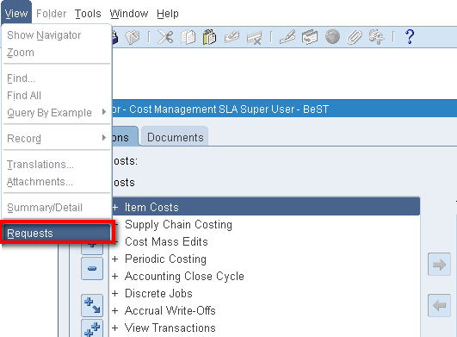

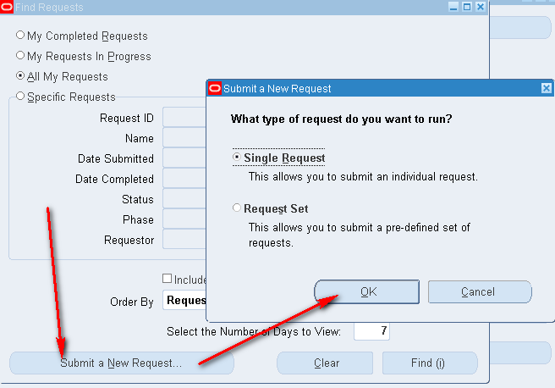

* “Create Accounting - Cost Management” / “**Создание учета - Управление затратами**”

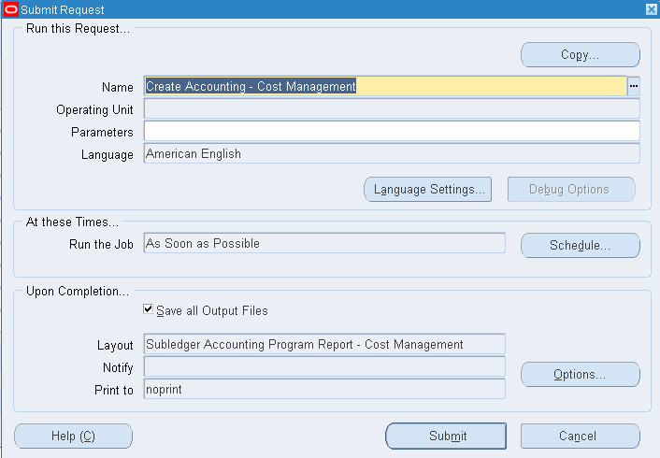

* Parameters:
  + Ledger: BEST TELECOM LEDGER
  + Process Category: *(leave empty)*
  + End Date: End of the month for which you want to run program (eg. 30-04-2018)
  + Mode: Final
  + Errors Only: No
  + Report: No Report
  + Transfer to General Ledger: **YES**
  + Post in General Ledger: *(leave empty)*
  + General Ledger Batch Name: *(leave empty)*
  + Include User Transaction Identifiers: No

