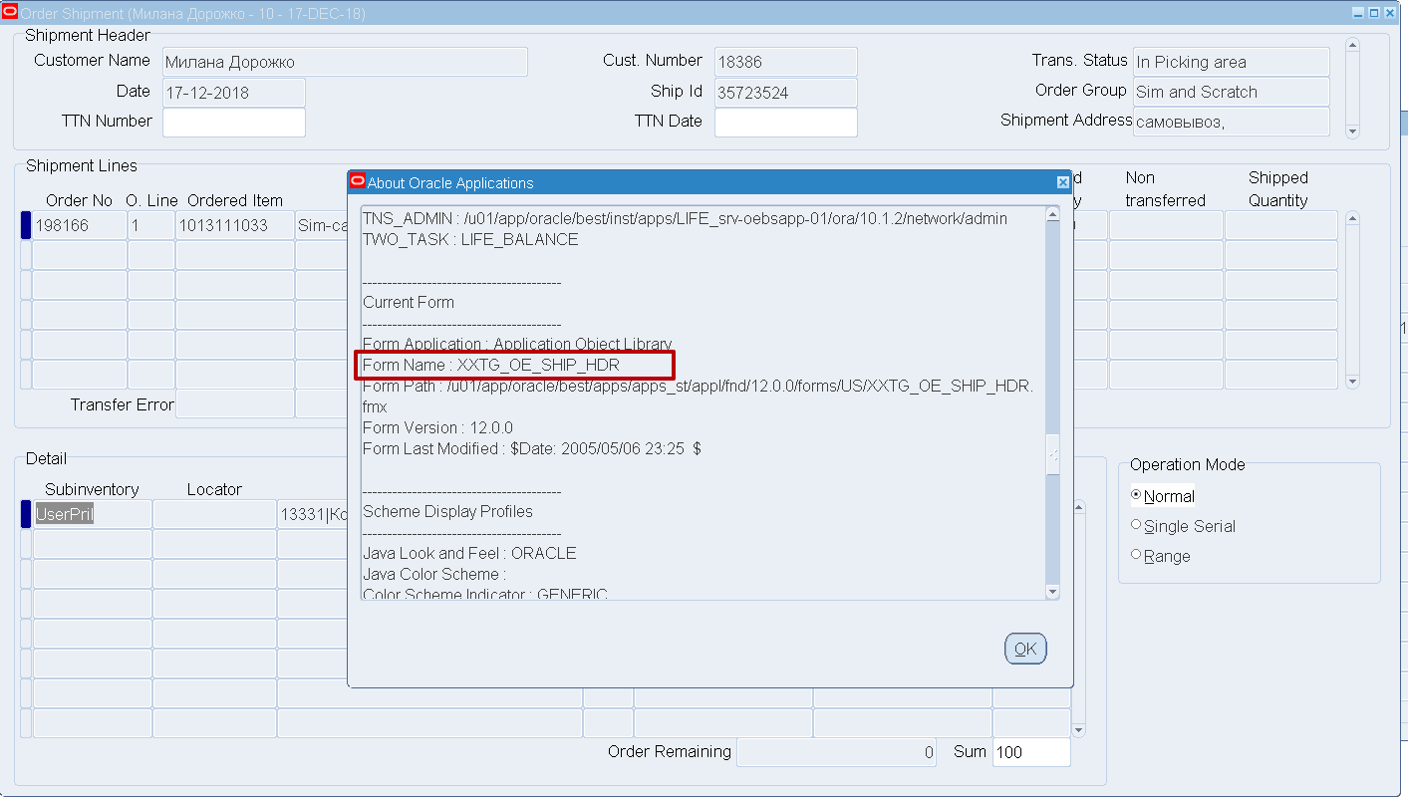

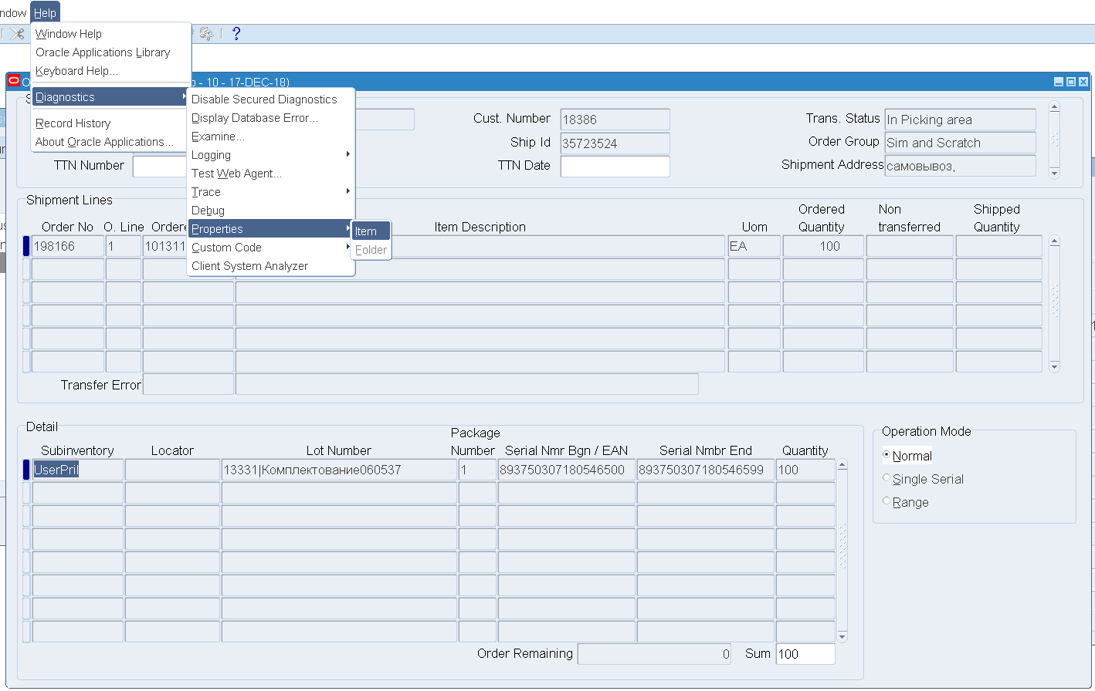

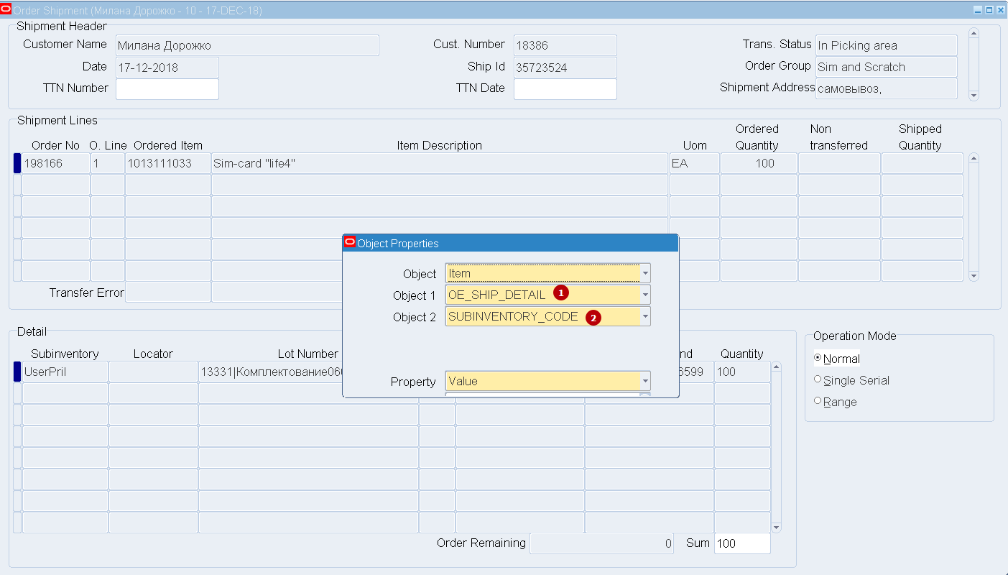

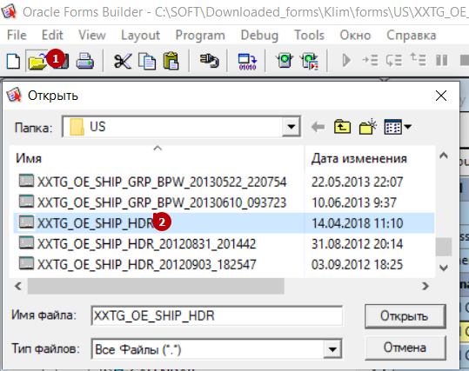

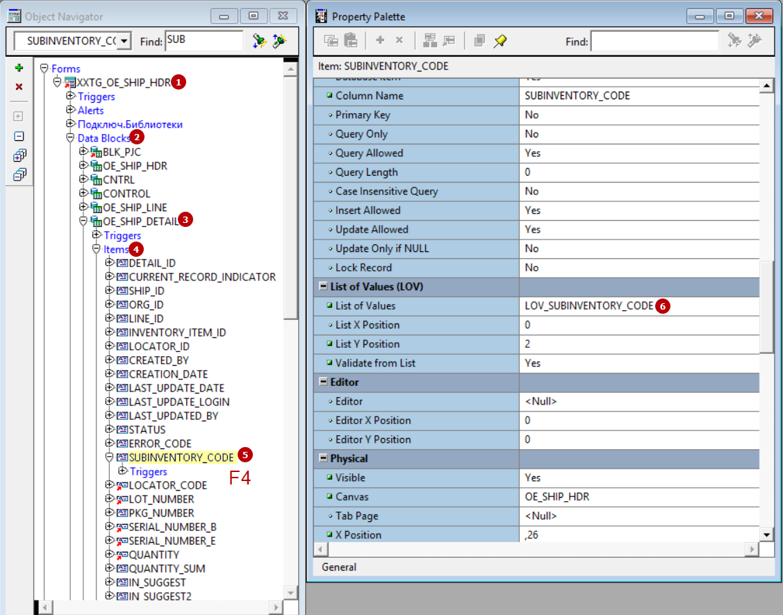

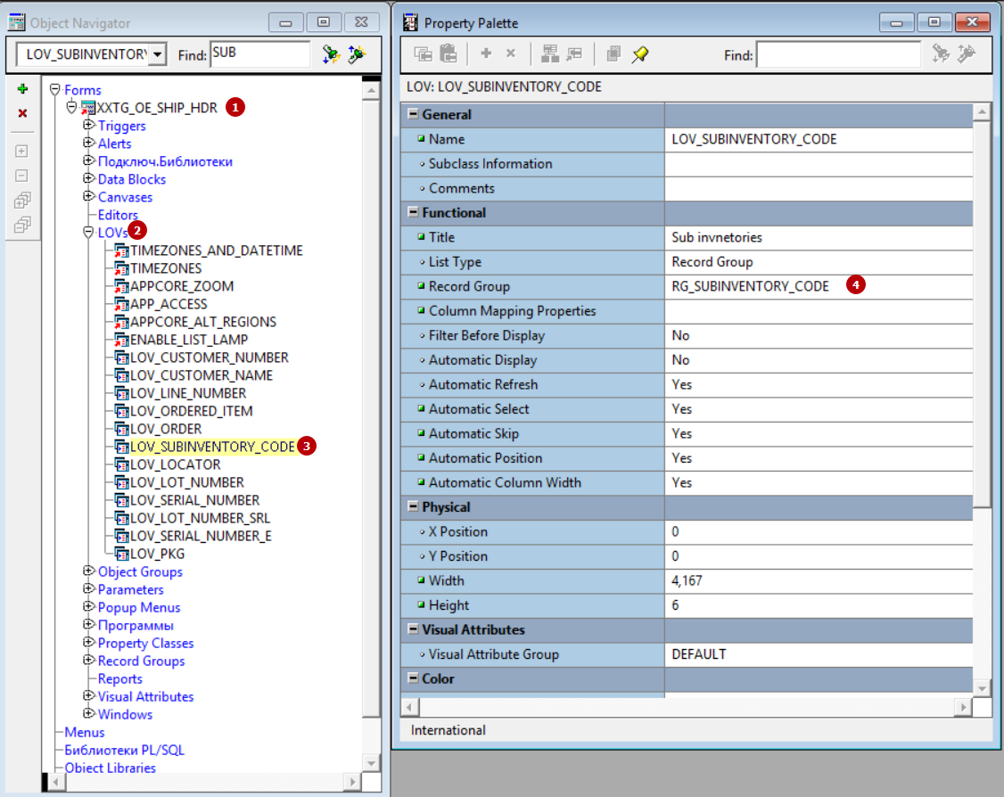

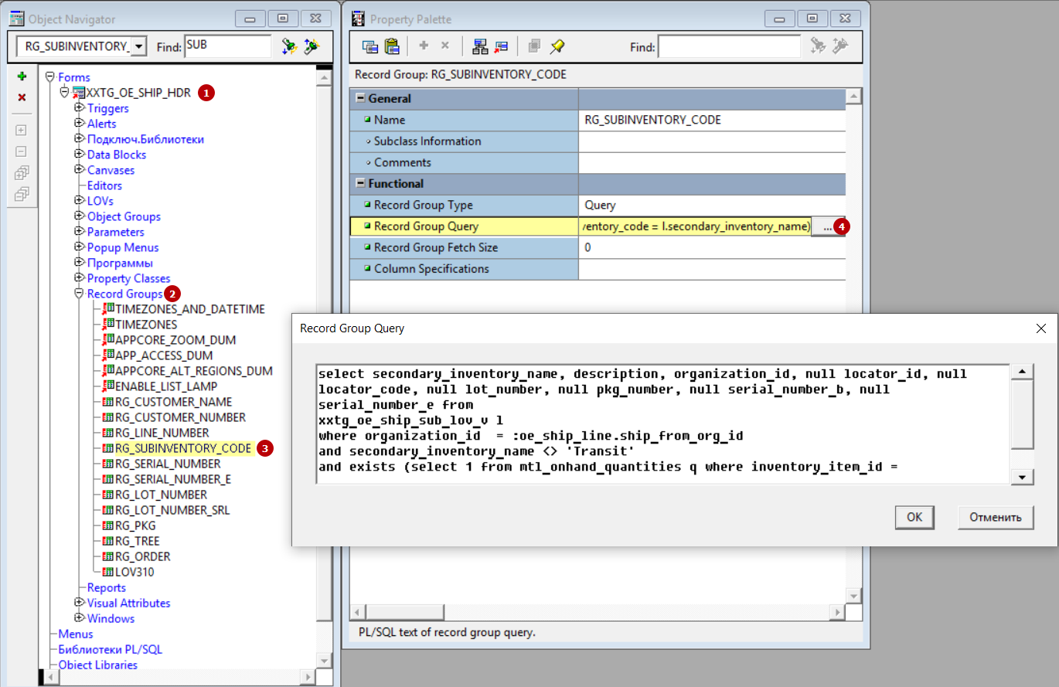

SELECT secondary_inventory_name,

description,

organization_id,

NULL locator_id,

NULL locator_code,

NULL lot_number,

NULL pkg_number,

NULL serial_number_b,

NULL serial_number_e

FROM xxtg_oe_ship_sub_lov_v l

WHERE organization_id = :oe_ship_line.ship_from_org_id

AND secondary_inventory_name <> 'Transit'

AND EXISTS

(SELECT **1**

FROM mtl_onhand_quantities q

WHERE inventory_item_id =

:oe_ship_line.inventory_item_id

AND organization_id = :oe_ship_line.ship_from_org_id

AND q.subinventory_code = l.secondary_inventory_name)

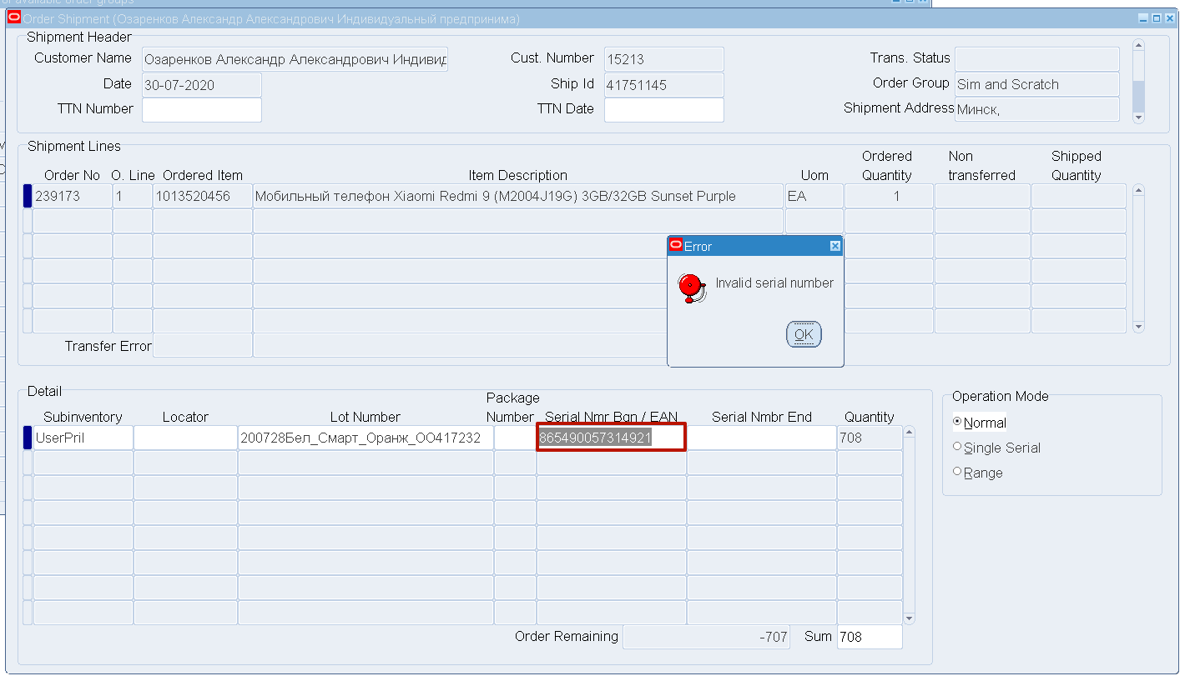

/*Invalid Serial*/

SELECT *

-- l.SUBINVENTORY_CODE,

-- l.LOCATOR_ID,

-- l.INVENTORY_ITEM_ID,

-- l.ORGANIZATION_ID,

-- l.LOT_NUMBER,

-- l.SERIAL_NUMBER,

-- 1 quantity,

-- NULL serial_number_e

FROM XXTG_OE_SHIP_SERIAL_LOV_V l

WHERE l.subinventory_code = 'UserPril' --:oe_ship_detail.subinventory_code

AND l.inventory_item_id = (SELECT DISTINCT INVENTORY_ITEM_ID

FROM inv.mtl_system_items_b a

WHERE SEGMENT1 IN ('1013520456'))--:oe_ship_line.inventory_item_id

AND l.organization_id = 83 --:oe_ship_line.ship_from_org_id

--( :oe_ship_detail.lot_number IS NULL

--OR

AND l.lot_number = '200728Бел_Смарт_Оранж_ОО417232'-- :oe_ship_detail.lot_number)

AND l.SERIAL_NUMBER = '865490057314921'

-- AND ( :oe_ship_detail.locator_id IS NULL

-- OR l.locator_id = :oe_ship_detail.locator_id)

-- AND ( :oe_ship_detail.pkg_number IS NULL

-- OR NVL (l.pkg, 1) = NVL ( :oe_ship_detail.pkg_number, 1))

/*

and not exists (select 1 from xxtg_oe_ship_srl1_v sr

where detail_id <> nvl(:oe_ship_detail.detail_id, -1) and sr.inventory_item_id = l.inventory_item_id

and sr.ship_from_org_id = l.organization_id and sr.serial_number = l.serial_number)

*/

-- AND NOT EXISTS

-- (SELECT 1

-- FROM xxtg_oe_Ship_Detail d, xxtg_oe_Ship_hdr h

-- WHERE d.ship_id = h.ship_id

-- AND NVL (inv_Trans, 'N') <> 'T'

---- AND detail_id <> NVL ( :oe_ship_detail.detail_id, -1)

-- AND d.inventory_item_id = l.inventory_item_id

-- AND NVL (d.locator_id, 0) = NVL (l.locator_id, 0)

-- AND d.subinventory_code = l.subinventory_code

-- AND l.serial_number BETWEEN serial_number_B

-- AND NVL (serial_number_e,

-- serial_Number_b)

-- )

ORDER BY serial_number

/* Trouble */

SELECT *

FROM xxtg_oe_Ship_Detail d, xxtg_oe_Ship_hdr h

WHERE d.ship_id = h.ship_id

AND NVL (inv_Trans, 'N') <> 'T'

-- AND detail_id <> NVL ( :oe_ship_detail.detail_id, -1)

AND d.inventory_item_id = (SELECT DISTINCT INVENTORY_ITEM_ID

FROM inv.mtl_system_items_b a

WHERE SEGMENT1 IN ('1013520456'))

-- AND NVL (d.locator_id, 0) = NVL (l.locator_id, 0)

AND d.subinventory_code = 'UserPril' --l.subinventory_code

AND serial_number_B = '865490057314921'

BETWEEN serial_number_B

AND NVL (serial_number_e,

serial_Number_b)