**Aim -**

Basics of HTML5, Structure of HTML5 Document.

Explain basic tags and their properties. (text formatting,anchor,img,list tag,tables etc)

Programs:

(a) To create a personal profile using basic HTML tags.

(b) Create Marksheet using advanced table tags.

**Theory-**

1. <a> for link
2. <b> to make bold text
3. <strong> for bold text with emphasis
4. <body> main HTML part
5. <br> for break
6. <div> it is a division or part of an HTML document
7. <h1>... for titles
8. <i> to make an italic text
9. <img> for images in document
10. <ol> is an ordered list
11. <ul> for an unordered list
12. <li> is a list item in a bulleted (ordered list)
13. <p> for paragraph
14. <span> to style part of text
15. <table> to create table
16. <tr> to make a table row
17. <th> to display table headers
18. <td> to display table data

**Screenshots-**

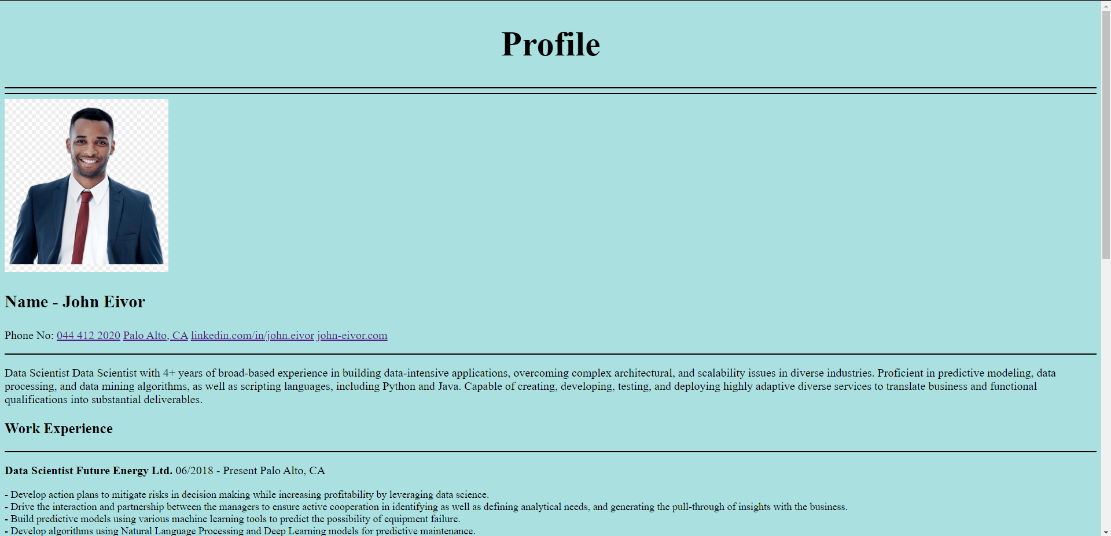

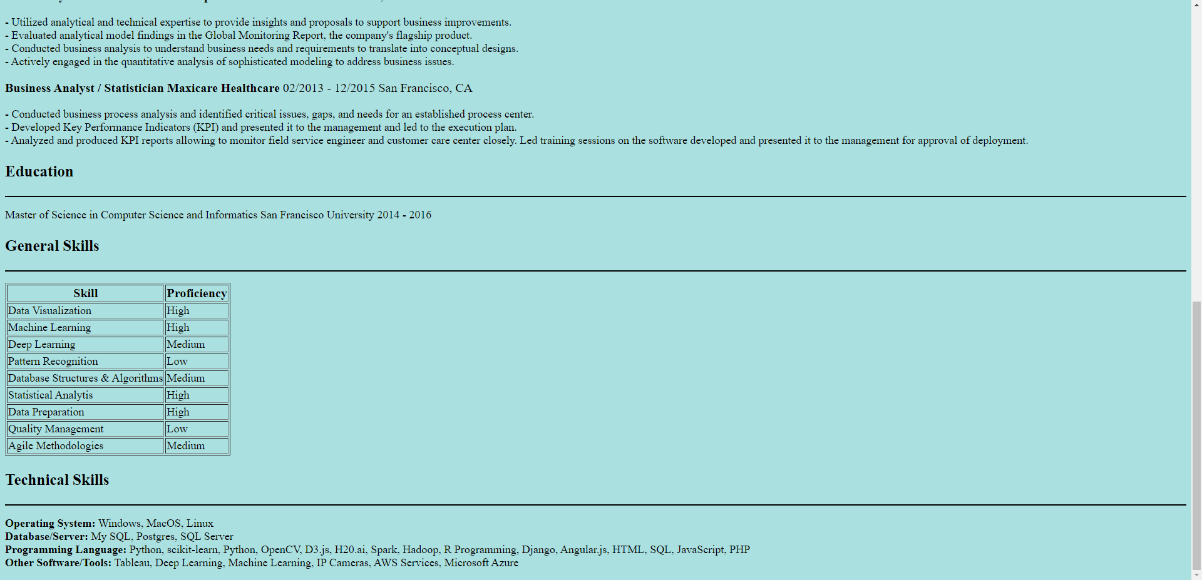

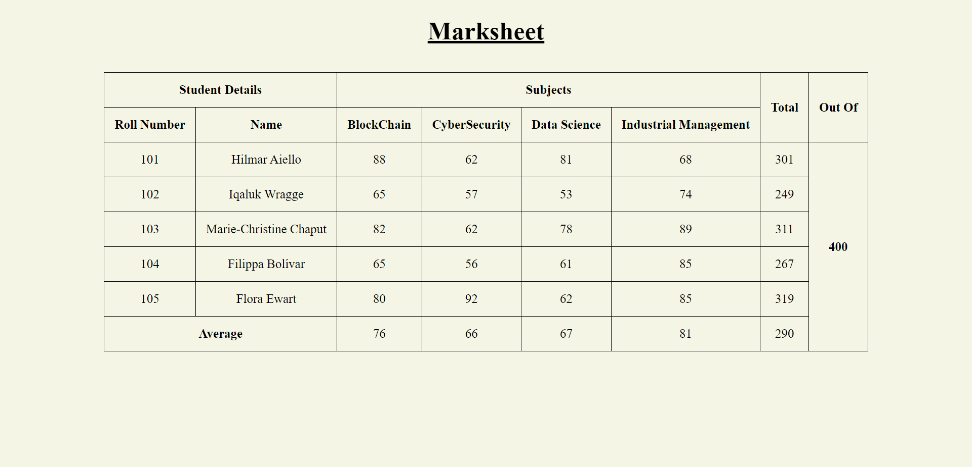

Conclusion-

We have successfully created a personal profile and mark sheet.