**Procedural Solution**

**Converting all currency from pounds to dollar:**

* Click and highlight the column
* Click on the dollar sign

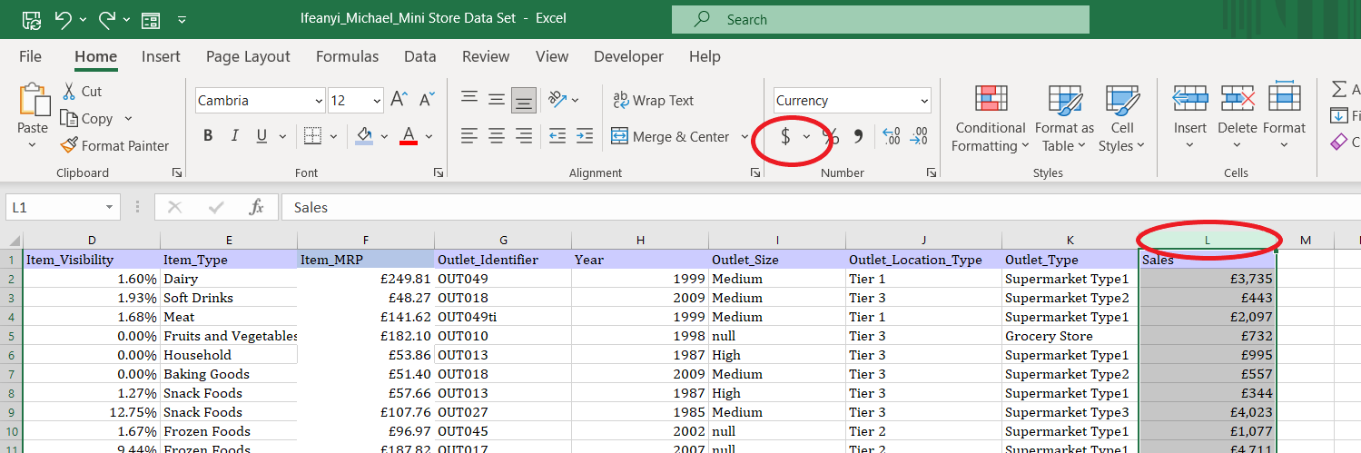

**Replace all blank field with the word Null**

* select the column, and on the keyboard click on CTRL + F to find and replace
* Then type null in the replace box click on replace all.

**Create a new column by categorizing sales over $5,000 as High and all sales below $5,000 as Low**

* **Right click on the column and click on insert, to insert new column**
* **Type the formula =MAX(L:L)to get maximum number**
* **On the next column, type =MIN(L:L) to get minimum number.**

**Show the top 5 item type with the highest sales**

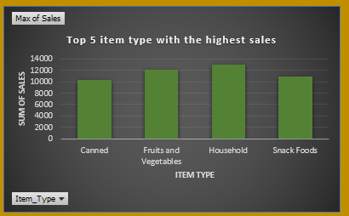

* Click on insert
* Click on pivot table
* Select new worksheet and click on OK

On the pivot table, click and drag “item type” into Axis (Categories) and click and drag “Sales” into the values.

Highlight the tables and click on pivot chart to insert a chart.

* **Show the bottom 5 item identifier by sales**

On the pivot table, click and drag “item type” into Axis (Categories) and click and drag “Sales” into the values.

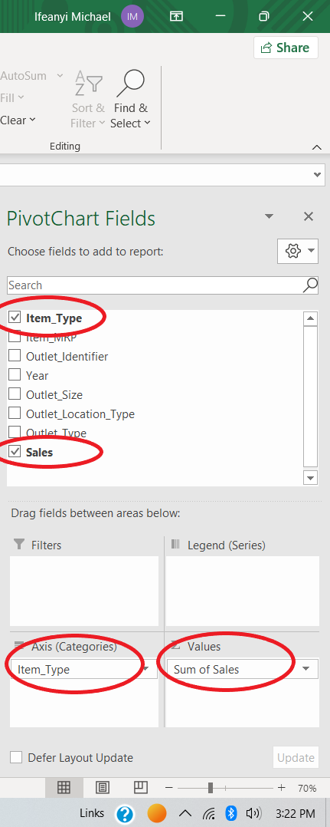

Highlight the tables and click on pivot chart to insert a chart.

* Click on value field settings and select “min” to select minimum of sales and click on OK

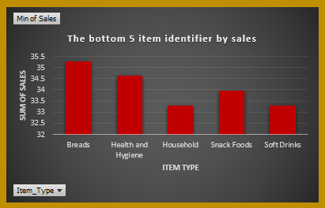

**Show the yearly trend of sales**

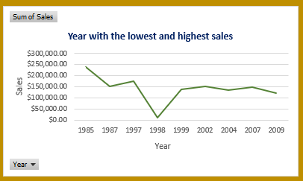

On the pivot table, click and drag “Year” into Axis (Categories) and click and drag “Sales” into the values.

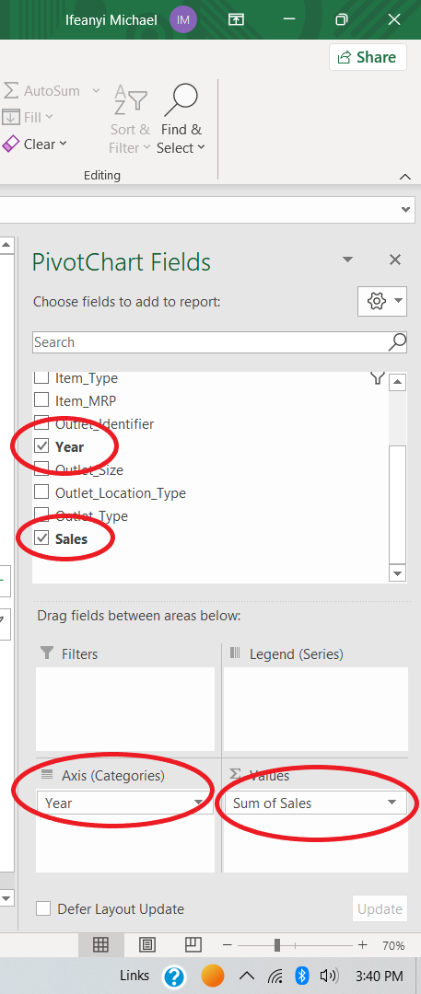

**Show average sales by all outlet type**

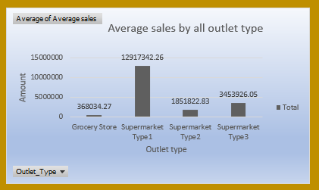

* Click on the first row
* click on “sort & filter” to insert filter
* click on the filter to select each outlet type
* on an empty cell, type the formula **=AVERAGE(L1:L4228)**to get exact average of that particular outlet type
* Do the same for all outlet types and select the table of averages
* Click on insert and click on pivot chat to insert new chat
* On the average field, click on value field settings and then click on Average and click OK
* Alternatively, click on the first cell, hold down the CTRL + SHIFT + press DOWN key the average will display below the ribbon.

**Show the total count of sales**

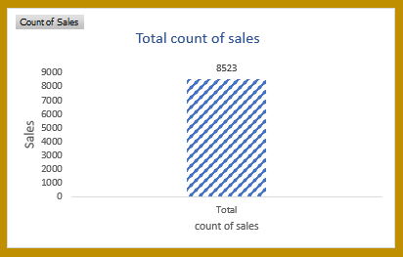

On the pivot table, click and drag “Sales” into the values.

**What year did the company generate the lowest and highest sales?**

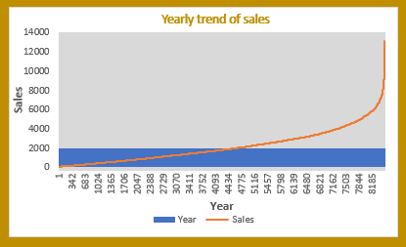

On the pivot table, click and drag “sales” into Axis (Categories) and click and drag “year” into the values.

**To add slicer**

right-click on the exact item and click on “Add Slicer”

Do the same for other items to add slicers.

