[UNIVERSITY NAME]
FACULTY OF [FACULTY NAME]
DEPARTMENT OF COMPUTER SCIENCE

UNIGUARD: AN AUTOMATED MONITORING, BACKUP AND RECOVERY SYSTEM FOR UNIVERSITY DIGITAL INFRASTRUCTURE
Designed for the operating conditions of Nigerian universities

A report submitted in partial fulfilment of the requirements of
CMP 468: Computer Security (2 Credit Units)

BY
[YOUR FULL NAME]
[MATRIC NUMBER]

LECTURER: [LECTURER'S NAME]

[MONTH, YEAR]

Abstract
Nigerian universities now run admissions, course registration, fee payment, result processing and transcripts on digital systems. The same universities work with unstable grid power, costly internet links, small ICT budgets and a known risk of insiders altering examination records. A single ransomware infection, a failed disk or a generator switch-over in the middle of a write can destroy records that took decades to build. Most institutions still depend on manual copies to external drives, with no monitoring and no tested recovery.
This project designs, builds and evaluates UniGuard, an open-source system that monitors university servers and services, backs data up automatically with strong encryption, detects ransomware and unauthorised changes to result files, and restores damaged data without human action. Backups are split into chunks, deduplicated, compressed and encrypted with AES-256-GCM under a key derived from a passphrase with scrypt. Each snapshot is complete on its own, so no long backup chain can break. A detector scores file activity on four signals (share of files changed, Shannon entropy, ransomware file extensions and ransom notes) and triggers an incident response that freezes backups, preserves evidence, restores every damaged file from the last clean snapshot and verifies each one with SHA-256. Result folders are protected by approval windows, and every event is written to a hash-chained audit log that exposes any later edit. The design adds features for local conditions: an emergency backup when mains power fails, night-time offsite copies with a bandwidth cap, SMS alerts through Nigerian gateways, and more frequent backups during examination periods.
The system was implemented in Python and tested with 23 automated tests, all passing. On a dataset of 2,000 files (195 MB), a full backup took 6.2 seconds, an incremental backup after 1% of files changed took 0.1 seconds, and a simulated ransomware attack on 600 files was detected and fully reversed in 2.7 seconds, with every restored file verified. The results show that a low-cost, locally maintainable tool can give a Nigerian university strong protection for the confidentiality, integrity and availability of its records.
Keywords: backup and recovery, ransomware detection, file integrity monitoring, AES-GCM, audit log, university information systems, Nigeria.

Table of Contents

Chapter One: Introduction

1.1 Background of the Study
Security in computing rests on three goals: confidentiality, integrity and availability, often called the CIA triad (Pfleeger et al., 2023). A university needs all three. Student records and staff payroll must stay private. Examination results must stay exactly as the Senate approved them. The student portal and result processing system must be available when thousands of students register or check results in the same week.
Nigerian universities have moved most of these processes online. Admission offers flow through the JAMB Central Admissions Processing System (CAPS). Fees are paid through Remita. Course registration, result computation and transcripts run on portals built in-house or by vendors. This shift brings speed, but it also concentrates risk. When a single file server holds every department's results, one incident can stop the whole institution.
The local environment adds pressure. In a survey of 90 researchers across Nigerian universities, polytechnics and research institutes, 39% reported power outages of 4 to 6 hours a day and 28% reported outages of more than 7 hours; most relied on diesel generators (85%), solar systems (60%) or inverters (30%) as backup (Ibrahim et al., 2026). At the Oleh campus of Delta State University, e-library equipment had power for only about 2.2 of every 8 working hours (Efenedo & Edegbo, 2023). Each abrupt switch between grid, generator and inverter can corrupt a file being written. Internet links are slow and expensive, so copying large backups to the cloud during working hours is often not practical. ICT units work with limited staff and budgets, which rules out costly commercial backup suites. Finally, cases of examination malpractice and unauthorised grade changes mean that a threat can come from inside the institution, not only from outside.
Security readiness is also low. Olugbile et al. (2025) assessed 20 Nigerian universities and placed 14 of them in the lower of two readiness tiers, with the largest gaps in handling incidents and recovering afterwards. Badamasi and Utulu (2021) observed that Nigerian universities keep suffering cyber attacks and losses even after buying security tools, largely because they run security without a structured framework.
The Nigeria Data Protection Act 2023 now requires every data controller, universities included, to put in place technical measures such as encryption and the ability to restore data promptly after an incident (Section 39), and to report personal data breaches to the Nigeria Data Protection Commission within 72 hours (Section 40). The Cybercrimes (Prohibition, Prevention, etc.) (Amendment) Act 2024 adds a duty to report attacks on computer systems to the national CERT within 72 hours. Good backup and monitoring practice is therefore a legal duty as well as a technical one.

1.2 Statement of the Problem
In many Nigerian universities, backup is manual and irregular. Staff copy folders to an external drive when they remember, the drive sits in the same office as the server, and nobody tests whether the copy can be restored. Monitoring is reactive: the ICT unit learns that the portal is down when students complain on social media. There is usually no record of who changed a result file and when.
These gaps leave the institution exposed to five specific failures:
- Ransomware encrypts the file server and any backup drive attached to it, leaving no clean copy.
- Insider tampering changes a student's grade after Senate approval, and nobody notices until a transcript is disputed.
- Power failure interrupts a write and corrupts a database or spreadsheet.
- Hardware failure of a disk destroys data that was never copied elsewhere.
- Service outage of the portal or result database goes unnoticed for hours during registration or result release.
No affordable tool addresses all five together in a way that suits local power, bandwidth and staffing conditions.

1.3 Aim and Objectives
The aim of this project is to develop an automated monitoring, backup and recovery system that protects the confidentiality, integrity and availability of university digital infrastructure under Nigerian operating conditions. The specific objectives are to:
- design an encrypted, deduplicated and incremental backup system in which every snapshot can be restored on its own;
- monitor server health, campus services and power supply continuously and alert the right staff through SMS, email and a web dashboard;
- detect ransomware activity and unauthorised changes to protected records such as examination results;
- recover damaged data automatically, preserve evidence and verify the recovery;
- keep a tamper-evident audit trail of every backup, alert, login and recovery; and
- evaluate the system with automated tests, a live demonstration and performance measurements.

1.4 Scope and Limitations
The system protects file-based data held on a university server: result sheets, student records, bursary files, admission lists, lecture materials and database backup files. It monitors services over HTTP and TCP and reads UPS status from Network UPS Tools or a status file. It does not replace endpoint antivirus, network firewalls or database-level replication, and it does not stop an attacker who steals the backup passphrase. The demonstration uses synthetic data; no real student information was used.

1.5 Significance of the Study
The project shows that a university can meet a large part of its data protection duty with free, auditable software that runs on an ordinary computer. It gives the Registry a way to prove that approved results have not changed, gives the ICT unit early warning of outages and attacks, and cuts recovery from ransomware from days of rebuilding to seconds. It also serves as a teaching tool: each module maps to a topic in the CMP 468 course outline, from encryption and decryption to security policies and standards.

Chapter Two: Literature Review

2.1 Characteristics of Computer Intrusion
Pfleeger et al. (2023) describe an intrusion by the method, opportunity and motive of the attacker. An attacker uses any available path, the weakest link, not the strongest defence. For a university, the weakest link is often a shared staff account on the result server or an unpatched office computer that has a mapped drive to the file share. In a systematic review of cybersecurity risk in higher education, Ulven and Wangen (2021) found compromised accounts, phishing and low security awareness among the most frequent threats, and noted that empirical research in the sector is scarce. A later review of studies published from 2018 to 2025 found phishing and malware to be the most reported threats to universities, with weak awareness and training raising the risk further (Salam et al., 2026).

2.2 Types of Security Breaches and Classes of Attacks
Security breaches are commonly grouped by the property they violate. Interception breaks confidentiality, modification and fabrication break integrity, and interruption breaks availability (Pfleeger et al., 2023). Table 2.1 maps these classes to the threats a Nigerian university faces.
Table 2.1: Classes of attack and university examples
Class of attack | University example | Property lost
Interruption | Ransomware encrypts the file server; portal DDoS during registration; grid collapse | Availability
Modification | Insider raises a student's CMP 468 score after Senate approval | Integrity
Fabrication | Fake admission list inserted into the CAPS upload folder | Integrity
Interception | Stolen backup drive exposes payroll and student phone numbers | Confidentiality

2.3 Security Vulnerabilities in University Environments
Universities are open by design. Many staff and students share networks, bring personal devices and use weak or shared passwords. Legacy systems stay in service for years because replacing them is expensive. In Nigeria, these general weaknesses combine with unstable power, which causes unclean shutdowns, and with low investment in security testing. A study of Chinese universities found that public disclosure of vulnerabilities increased the number of data breaches, while cloud adoption reduced them (Jin et al., 2023). Backups kept on a drive that stays connected to the server are especially weak, because ransomware encrypts every drive it can reach (CISA, 2023).

2.4 Backup Strategies
A full backup copies every file each time. It is simple to restore but slow and wasteful. An incremental backup copies only what changed since the last backup, which is fast, but a restore needs the full backup plus every increment in order; one bad link breaks the chain. A differential backup copies everything changed since the last full backup, trading space for a shorter chain.
Content-addressed, deduplicating storage removes this trade-off. Files are split into chunks, each chunk is named by a hash of its content, and a chunk that already exists is not stored again. Every snapshot is a full list of chunks, so it restores on its own, yet it costs only the space of the changed chunks. Recent schemes combine this kind of deduplication with encryption for cloud and backup storage (Song et al., 2024; Wu et al., 2023). UniGuard uses the same idea in a simpler, single-owner form.
The 3-2-1 rule recommends three copies of data, on two different media, with one copy offsite. Grandfather-father-son (GFS) retention keeps recent snapshots at fine intervals and older ones at coarser intervals (daily, weekly, monthly), so an institution can go back months without keeping every snapshot. Contingency planning adds two targets: the recovery point objective (RPO), the most data the organisation can afford to lose, and the recovery time objective (RTO), the longest it can afford to be down. In the NIST Cybersecurity Framework 2.0 these belong to the Recover function (National Institute of Standards and Technology [NIST], 2024).
Backups also change the economics of an attack. Game-theoretic modelling shows that a credible backup lets a victim refuse or lower a ransom, but only when recovery is cheap and reliable (Yin et al., 2023). Backups do not remove the harm when attackers also steal data and threaten to sell or publish it (Li & Liao, 2021), which is why UniGuard encrypts everything it stores.

2.5 Ransomware Detection
Ransomware can be caught by watching what it does to files rather than by matching known malware signatures. Encrypted data looks random, so a sharp rise in a file's Shannon entropy is a strong sign of encryption. Hsu et al. (2021) improved machine-learning detection of ransomware by refining file entropy analysis, Lee et al. (2023) used entropy estimation of files to detect ransomware in cloud services, and Davies et al. (2022) compared entropy calculation methods for telling ransomware-encrypted files from normal ones. The approach has known limits: attackers can encode ciphertext to lower its entropy (Lee & Lee, 2022) or share entropy across blocks to hide encryption (Bang et al., 2024). Entropy should therefore be one signal among several. UniGuard combines it with mass-change, file-extension and ransom-note signals, and adds automatic rollback from a protected copy. It works at the file-server level, so it needs no kernel driver and runs on any operating system.

2.6 Encryption and Decryption for Backups
Backups hold the most sensitive data an institution has, all in one place, so they must be encrypted. Authenticated encryption protects confidentiality and integrity together. AES in Galois/Counter Mode (GCM) is a NIST-approved authenticated cipher that produces a tag which fails to verify if even one bit of the ciphertext changes (Pfleeger et al., 2023). Its main rule is that a nonce must never repeat under the same key.
People remember passphrases, not 256-bit keys. A key derivation function turns a passphrase into a key and makes each guess expensive. Memory-hard functions such as scrypt and Argon2 make every guess cost memory as well as time, which blunts attacks with graphics cards and custom hardware (Biryukov et al., 2021). A 2024 comparison of password hashing functions found that fast hashes such as MD5 and SHA-256 give little protection against GPU cracking, while scrypt and Argon2 resist it far better (Fedorchenko et al., 2024). HKDF, a standard HMAC-based construction, then splits one master key into several independent keys for different jobs.

2.7 Tamper-Evident Logging
An audit log is only useful if an insider cannot quietly edit it. In a hash-chained log each entry stores the hash of the entry before it, so changing or deleting any entry breaks every link after it. Suwarno et al. (2026) compared a hash-chain logger with a traditional logger on 100,000 entries: the hash chain detected 100% of tampering attempts against 67% for the traditional log, at the cost of slower verification (59 ms against 24 ms) and more storage. UniGuard applies this simple hash-chain form rather than a blockchain.

2.8 Security Policies and Standards
- ISO/IEC 27001:2022: Annex A controls 8.13 (information backup), 8.15 (logging) and 8.16 (monitoring activities).
- NIST Cybersecurity Framework 2.0: six functions (Govern, Identify, Protect, Detect, Respond, Recover); backup, RPO and RTO sit under Recover (NIST, 2024).
- NIST SP 800-61 Rev. 3: incident response recommendations organised around the CSF 2.0 functions, replacing the earlier revision (Nelson et al., 2025).
- Nigeria Data Protection Act 2023: Section 39 (security, integrity and confidentiality, including encryption and timely restoration) and Section 40 (breach notification within 72 hours).
- Cybercrimes (Prohibition, Prevention, etc.) (Amendment) Act 2024: keeps unauthorised access to and modification of computer data as offences, which gives legal weight to audit evidence, and requires attacks to be reported to the national CERT within 72 hours.

2.9 Research Gap
Existing tools cover parts of the problem. Commercial suites are costly and assume steady power and bandwidth. Open-source backup tools encrypt and deduplicate but do not monitor services or detect ransomware. Research prototypes detect ransomware but do not manage backups, retention or offsite copies. Nigerian studies call for structured cybersecurity frameworks in universities but stop at assessment (Badamasi & Utulu, 2021; Olugbile et al., 2025). None of these treats examination records as a special class of data with approval windows, and none reacts to power loss. UniGuard fills this gap with one integrated, low-cost system.

Chapter Three: System Analysis and Design

3.1 Methodology
The project followed an iterative prototyping approach. Requirements came from the problems in Section 1.2 and the standards in Section 2.8. Each module was built, tested with automated tests, and then joined to the others. A threat model guided which controls to build.

3.2 Requirements

Functional requirements
- Take scheduled, encrypted, incremental backups of configured folders.
- Restore a whole snapshot, a folder or one file, and verify each restored file.
- Copy backups to a second site within a time window and a bandwidth budget.
- Check CPU, memory, disk, campus services and UPS state at a fixed interval.
- Detect ransomware and changes to protected folders outside approved windows.
- Respond to ransomware automatically: contain, preserve evidence, restore, verify, report.
- Send alerts by SMS, email, webhook and console, and show status on a web dashboard.
- Record every event in a tamper-evident audit log.

Non-functional requirements
- Security: backups unreadable without the passphrase; offsite site sees only ciphertext.
- Reliability: an interrupted backup must not corrupt the repository.
- Low cost: free software, runs on an ordinary PC.
- Bandwidth efficiency: send only changed data, at off-peak times.
- Usability: one command to start; clear dashboard for non-specialist staff.

3.3 Threat Model
Table 3.1: Threat model
Threat | Control in UniGuard
Ransomware on the file server | Entropy and mass-change detection; automatic restore from last clean snapshot; backups written read-only; offsite copy out of reach
Ransomware waits before striking (dwell time) | Retention always keeps the last clean snapshot, however old
Insider edits approved results | Protected paths with approval windows; critical alert; later backups marked SUSPECT and never used for recovery
Insider edits the audit log to hide tracks | Hash chain breaks; dashboard shows AUDIT LOG TAMPERED
Stolen backup drive or cloud bucket | AES-256-GCM encryption; keyed object names reveal nothing about content
Backup file altered or corrupted | GCM tag and content hash checked on every read; verify command decrypts every object
Power cut during backup | Atomic write (temp file, fsync, rename); SQLite WAL; emergency backup when mains fails
Dashboard password guessing | Constant-time compare; lockout after 5 failures; CSRF header; security headers

3.4 System Architecture
Figure 3.1 shows the architecture. On the left are the campus systems being protected. In the centre is the UniGuard engine with its modules. On the right are the storage locations and the people who receive alerts.
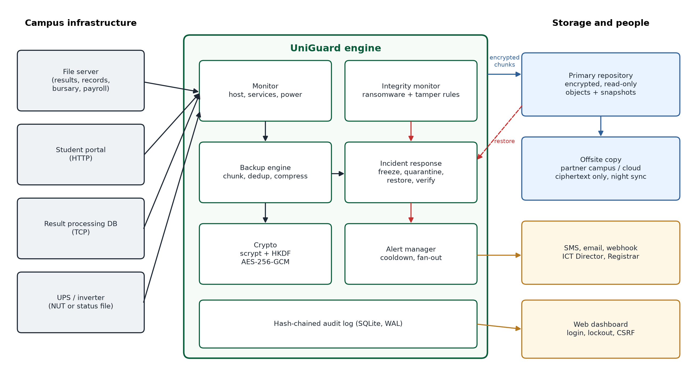
Figure 3.1: UniGuard architecture
Table 3.2: Modules
Module | File | Responsibility
Crypto | crypto.py | scrypt key derivation, HKDF key split, AES-256-GCM, keyed chunk names
Repository | repository.py | Encrypted chunk store, snapshots, verification, garbage collection, offsite replication
Backup engine | backup.py | Chunking, incremental backup, GFS retention, verified restore, diff
Monitor | monitor.py | Host metrics, service checks, UPS state, integrity scan, ransomware and tamper rules
Alert manager | alerts.py | Console, SMS (Africa's Talking, Termii), email, webhook; cooldown
Audit log | audit.py | Hash-chained events, metrics, persistent state
Engine | engine.py | Scheduler, peak periods, power response, incident response
Dashboard | dashboard.py | Authenticated web interface

3.5 Cryptographic Design
At setup, the administrator chooses a passphrase of at least 12 characters. UniGuard generates a random 16-byte salt and runs scrypt (N = 2^15, r = 8, p = 1) to produce a 256-bit master key. HKDF-SHA256 derives two keys from it: an encryption key for AES-256-GCM and a separate key for HMAC-SHA256. The repository stores the salt and an encrypted check value, never the key.
Each file is read in 1 MiB chunks. A chunk's name is HMAC-SHA256(key, chunk). Using a keyed hash instead of a plain SHA-256 means that someone who holds the backup cannot test whether it contains a known file. The chunk is compressed with zlib and encrypted with AES-256-GCM using a fresh random 96-bit nonce. The chunk's name is passed as associated data, so an attacker cannot swap two encrypted chunks without the swap being detected. Snapshot manifests are encrypted the same way. On restore, every chunk is decrypted, its tag is checked, its HMAC is recomputed, and finally the SHA-256 of the whole restored file is compared with the value recorded at backup time.
master = scrypt(passphrase, salt, N=2^15, r=8, p=1)
k_enc = HKDF(master, info='uniguard-encryption')
k_id = HKDF(master, info='uniguard-object-id')
id = HMAC-SHA256(k_id, chunk)
blob = nonce(12 bytes) || AES-256-GCM(k_enc, nonce, zlib(chunk), aad=id)

3.6 Detection Design

Ransomware scoring
The integrity monitor compares the live file tree with the last clean snapshot. Files whose size and modification time are unchanged are skipped, so a scan is cheap. For changed files it computes Shannon entropy over the first 64 KiB. Plain text scores about 4 to 5 bits per byte; encrypted data scores close to 8. File types that are already compressed (PDF, DOCX, JPEG, ZIP) are excluded from the entropy signal to avoid false alarms. Table 3.3 shows the scoring.
Table 3.3: Ransomware scoring (50 or more = critical, 20 to 49 = warning)
Signal | Condition | Points
Mass change | At least 5 files and 20% of all files modified or deleted | 40
High entropy | At least 3 changed files with entropy of 7.2 bits per byte or more | 30
Ransomware extension | New files ending in .locked, .encrypted, .lockbit and similar | 20
Ransom note | New text or HTML file with names like README, DECRYPT, RECOVER | 20

No single signal reaches the critical level alone. A lecturer who replaces many files at once gets at most a warning, while real ransomware, which changes many files and makes them look random, crosses 50 quickly.

Protected records
The Registry lists folders such as registry/results as protected and gives each one approved windows, for example the period between a Senate meeting and result publication. A change outside every window raises a critical alert naming the files. While that alert stays open, new backups are marked SUSPECT, and the recovery process ignores them. This keeps the last approved copy of the results available as evidence and for restoration.

3.7 Incident Response Design
The response maps to the Detect, Respond and Recover functions used in NIST SP 800-61 Rev. 3 (Nelson et al., 2025), as shown in Figure 3.2.
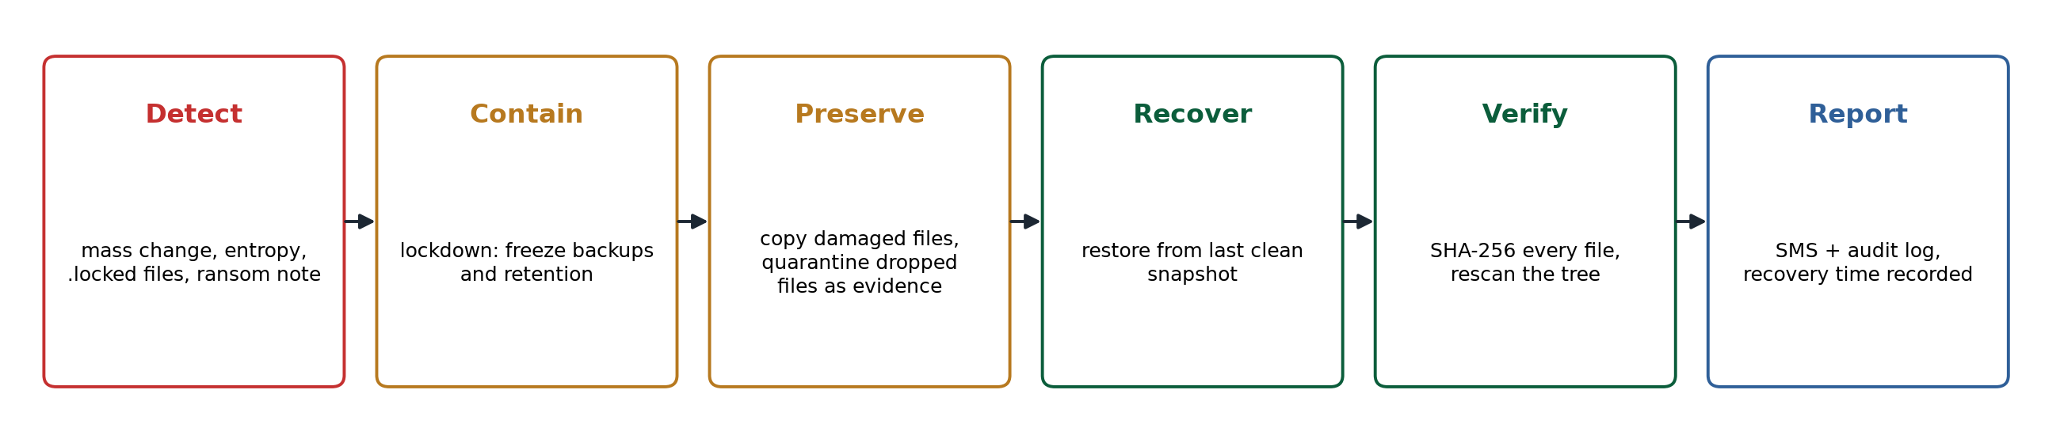
Figure 3.2: Automatic ransomware response
- Detect: the score reaches 50.
- Contain: lockdown mode stops new backups and retention, so encrypted files never replace good ones and no clean snapshot is deleted.
- Preserve: damaged files are copied, and files the attacker dropped are moved, into a quarantine folder named after the incident for forensic study.
- Recover: every modified or deleted file is restored from the last clean snapshot.
- Verify: each file's SHA-256 is checked, and the tree is scanned again.
- Report: SMS alerts go out, the recovery time is recorded, lockdown ends and a post-recovery snapshot is taken.

3.8 Adaptation to Nigerian Conditions
Table 3.4: Local conditions and design responses
Local condition | Design response
Frequent grid collapse and generator switch-over | Reads UPS state; emergency backup when mains fails; critical alert when battery is low; atomic writes and SQLite WAL survive sudden cuts
Costly, unreliable bandwidth | Deduplication and compression; offsite copy in a night window; per-run byte cap; resumes after link loss; snapshots copied only after all their chunks
Internet down during incidents | SMS alerts through Africa's Talking or Termii reach phones without data
Examination and registration peaks | Peak periods in the config shorten the backup interval (for example hourly to every 15 minutes)
Result tampering risk | Protected paths, approval windows, SUSPECT snapshots, hash-chained audit log
Small budget and staff | Free software, Python only, runs on an old PC; one command to start; web dashboard
NDPA 2023 duties | Encryption and timely restoration (s.39); audit trail and incident record support 72-hour breach report (s.40)

Chapter Four: Implementation and Testing

4.1 Tools and Environment
Table 4.1: Tools
Item | Choice | Reason
Language | Python 3.11 | Widely taught in Nigerian universities; runs on Windows and Linux
Cryptography | cryptography library (OpenSSL backend) | Audited implementations of AES-GCM, scrypt, HKDF
Database | SQLite | No server to manage; WAL mode survives power loss
Web | Flask | Small and simple for a dashboard
System metrics | psutil | CPU, memory and battery on all platforms
Testing | pytest | Automated regression tests

4.2 Using the System
An administrator writes a JSON configuration naming the folder to protect, the backup location, the offsite location, the services to check and the protected paths. The passphrase and dashboard password are read from environment variables so they never sit in a file. The main commands are:
python -m uniguard -c config.json init # create encrypted repository
python -m uniguard -c config.json run --dashboard
python -m uniguard -c config.json snapshots # list backups
python -m uniguard -c config.json restore latest ./restore registry/results
python -m uniguard -c config.json verify # decrypt and check every chunk
python -m uniguard -c config.json audit # show log and check the chain

4.3 The Dashboard
Figure 4.1 shows the dashboard after three staged incidents: mains power loss, a ransomware attack that was recovered automatically, and a grade change in the results folder, which is still open and shown in the red banner.
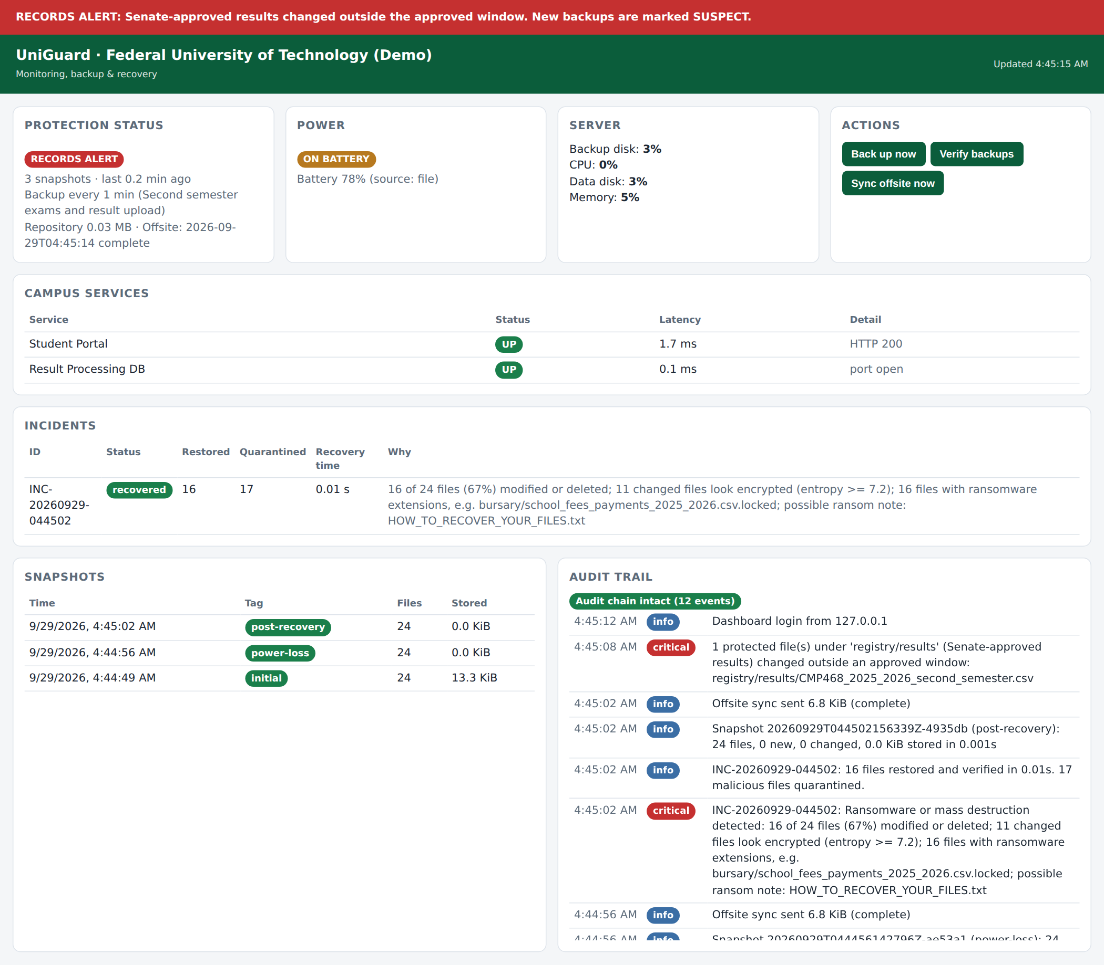
Figure 4.1: UniGuard dashboard during a records alert

4.4 Automated Tests
Twenty-three automated tests check the security properties of the system. All 23 pass.
Table 4.2: Test coverage (23 tests, 23 passed)
Area | What the tests prove
Encryption | Round trip works; one flipped bit is detected; swapping ciphertexts between names is detected; same plaintext encrypts differently each time; wrong and short passphrases are rejected; no plaintext appears anywhere in the repository
Backup and restore | Restored files match byte for byte; second backup stores only the change; files over 1 MiB are chunked; corrupted chunks fail verification; selective restore and diff work
Retention | Pinned and last clean snapshots survive pruning; repository still verifies after garbage collection
Offsite copy | Byte budget is respected; no snapshot is copied before its chunks; the offsite copy opens and verifies
Detection | Entropy values are correct; ransomware is flagged critical; normal lecturer edits are not; protected paths alert outside the window and stay quiet inside it
Audit log | Editing a row and deleting a row are both detected
Engine | Ransomware is fully reversed and quarantined; power loss triggers an emergency backup; tampering marks later backups SUSPECT; service outage raises an alert
Dashboard | Login required; wrong password rejected; CSRF header required; lockout after 5 failures

4.5 Demonstration Scenario Results
The narrated demonstration (demo/run_demo.py) runs seven scenes on synthetic data for a Nigerian university: 120 students, results for five 400-level courses, fee payments, a CAPS admission list, lecture notes and a staff payroll database.
Table 4.3: Demonstration results
Scene | Event | UniGuard response
1 | First backup of 24 files | Encrypted snapshot in 0.02 s
2 | One lecture note added | Second backup stores 56 bytes; offsite copy sent
3 | Grid power fails; battery falls to 20%; power returns | Warning SMS and emergency backup; critical SMS at 20%; restoration notice
4 | Student Portal stops | Critical SMS within one monitoring cycle
5 | Insider changes a CMP468 score from 43 (E) to 88 (A) | Critical SMS naming the file; next backup marked SUSPECT; Registrar restores approved results
6 | Ransomware scrambles 16 of 24 files and drops a note | Detected with score 110; 16 files restored and verified; 17 malicious files quarantined
7 | Insider edits the audit log | Chain check reports the exact row altered

4.6 Performance
To test beyond the small demo, the benchmark script (docs/benchmark.py) generated 2,000 CSV records of 100 KiB each (195 MB) on a 4-core cloud machine. Table 4.4 shows the results.
Table 4.4: Performance on 2,000 files
Measurement | Result
Full first backup (195 MB) | 6.2 s
Repository size after first backup | 22.3 MB (the synthetic text compresses well; real data compresses less)
Incremental backup after 1% of files changed | 0.1 s, 224 KiB stored
Full restore with SHA-256 check of every file | 1.7 s
Ransomware on 600 files (30%): detection to full recovery | 2.7 s end to end; 1.5 s from detection to verified recovery

In NIST terms, the achieved RTO for this attack is under three seconds, compared with days for manual rebuilding. The RPO equals the backup interval: 60 minutes in normal periods and 15 minutes during examination periods in the recommended configuration.

4.7 Mapping to the CMP 468 Course Outline
Table 4.5: Course topics covered
Course topic | Where it appears in UniGuard
Overview of security in computing | CIA triad drives the design (Section 1.1)
Characteristics of computer intrusion | Threat model; ransomware and insider behaviour (Sections 2.1, 3.3)
Types of security breaches | Interruption, modification, fabrication, interception (Table 2.1)
Security vulnerability | Attached backup drives, shared accounts, power cuts (Section 2.3)
Classes of attacks | Ransomware, insider tampering, log tampering, password guessing
Methods of defense and controls | Prevention (encryption, read-only backups), detection (scoring, integrity), recovery (automatic restore)
Encryption and decryption | scrypt, HKDF, AES-256-GCM, HMAC (Section 3.5)
Database security | SQLite audit log with hash chain; payroll database backed up and verified
Network security | Service monitoring; dashboard login, lockout, CSRF, security headers; ciphertext-only offsite link
Security policies and standards | ISO/IEC 27001:2022, NIST CSF 2.0, NIST SP 800-61 Rev. 3, NDPA 2023, Cybercrimes (Amendment) Act 2024

Chapter Five: Discussion

5.1 Strengths
- One system covers backup, monitoring, detection, recovery and audit, which small ICT units can run.
- Every snapshot restores on its own, so there is no fragile incremental chain.
- Recovery is automatic and verified, which removes the delay of waiting for staff.
- The design treats examination records as a special asset, which matches a real Nigerian risk.
- Offsite storage never sees plaintext, so a cheap cloud bucket or a partner university's server can hold the copy.

5.2 Limitations
- Changes made after the last clean backup are lost in a ransomware attack. A shorter interval reduces this window.
- Ransomware that encrypts files slowly, a few at a time, may stay below the mass-change threshold, and ransomware that disguises its entropy can weaken the entropy signal (Bang et al., 2024; Lee & Lee, 2022). The extension and ransom-note signals still apply, and thresholds can be tuned.
- The read-only permission on backup files stops ordinary malware but not an attacker with administrator rights on the same server. The offsite copy on a separate machine answers that case; an immutable object store would be stronger.
- Losing the passphrase makes every backup unreadable. The passphrase must be split or sealed and stored under dual control.
- Protected-path rules watch files, not database rows. Result systems that store grades only inside a database need database-level auditing as well.

5.3 Cost
UniGuard needs no licence. A university can run it on an existing server or a refurbished desktop with a second disk. The main recurring costs are an external or partner-site disk for the offsite copy and SMS credit for alerts. Commercial backup suites typically charge per server or per terabyte each year, which puts them out of reach for many departmental servers.

5.4 Deployment Plan for a Nigerian University
- Pilot on one faculty file server and the Registry result folder for one semester.
- Set the offsite copy to a server at a second campus, a partner university over NgREN, or a cloud bucket hosted in Nigeria to support data sovereignty.
- Register the ICT Director, Registrar and Deputy Registrar (Academic) for SMS alerts.
- Write the protected-path windows into the Senate-approved result processing calendar.
- Seal the passphrase in two envelopes held by the Registrar and the Director of ICT.
- Run a restore drill every month and record the time taken.
- Extend to the bursary, admissions and library servers after the pilot review.

Chapter Six: Conclusion and Recommendations

6.1 Summary
This project set out to protect university digital infrastructure under Nigerian conditions. It produced UniGuard, a working system that encrypts, deduplicates and schedules backups, copies them offsite over a limited link, monitors servers, services and power, detects ransomware and unauthorised changes to results, recovers automatically with verification, and records every event in a tamper-evident log. All six objectives in Section 1.3 were met, and 23 automated tests confirm the security properties.

6.2 Conclusion
Strong data protection does not require expensive software. Sound cryptography, content-addressed storage, simple behaviour-based detection and careful attention to local conditions give a university real protection against the threats it faces most: ransomware, insider tampering, power failure and service outages. The measured recovery time of under three seconds for a 600-file attack shows what automation makes possible.

6.3 Recommendations
- Universities should adopt the 3-2-1 rule with at least one offsite, encrypted copy, and test restores monthly.
- The Registry should define result approval windows formally and monitor result folders against them.
- ICT units should take backup media off the network, or use a pull-based offsite copy, so ransomware cannot reach every copy.
- Management should include backup and restoration in the institution's NDPA 2023 compliance plan and its 72-hour breach and incident reporting procedures under the NDPA 2023 and the Cybercrimes (Amendment) Act 2024.
- Future work: database row-level auditing for result systems, immutable object storage, per-process detection on staff PCs, and a mobile app for alerts.

References
Badamasi, B., & Utulu, S. C. A. (2021). Framework for managing cybercrime risks in Nigerian universities (arXiv:2108.09754). arXiv. https://doi.org/10.48550/arXiv.2108.09754
Bang, J., Kim, J. N., & Lee, S. (2024). Entropy sharing in ransomware: Bypassing entropy-based detection of cryptographic operations. Sensors, 24(5), 1446. https://doi.org/10.3390/s24051446
Biryukov, A., Dinu, D., Khovratovich, D., & Josefsson, S. (2021). Argon2 memory-hard function for password hashing and proof-of-work applications (RFC 9106). RFC Editor. https://doi.org/10.17487/RFC9106
CISA & MS-ISAC. (2023). #StopRansomware guide. Cybersecurity and Infrastructure Security Agency. https://www.cisa.gov/stopransomware/ransomware-guide
Davies, S., Macfarlane, R., & Buchanan, W. J. (2022). Comparison of entropy calculation methods for ransomware encrypted file identification. Entropy, 24(10), 1503. https://doi.org/10.3390/e24101503
Efenedo, G., & Edegbo, W. O. (2023). Internet connectivity and power outages in university electronic libraries in Nigeria. Journal of ICT Development, Applications and Research, 5(2), 83–89. https://doi.org/10.47524/jictdar.v5i2.84
Federal Republic of Nigeria. (2023). Nigeria Data Protection Act, 2023 (Act No. 37). Federal Government Printer.
Federal Republic of Nigeria. (2024). Cybercrimes (Prohibition, Prevention, etc.) (Amendment) Act, 2024. Federal Government Printer.
Fedorchenko, V., Yeroshenko, O., Shmatko, O., Kolomiitsev, O., & Omarov, M. (2024). Password hashing methods and algorithms on the .NET platform. Advanced Information Systems, 8(4), 82–92. https://doi.org/10.20998/2522-9052.2024.4.11
Hsu, C.-M., Yang, C.-C., Cheng, H.-H., Setiasabda, P. E., & Leu, J.-S. (2021). Enhancing file entropy analysis to improve machine learning detection rate of ransomware. IEEE Access, 9, 138345–138351. https://doi.org/10.1109/ACCESS.2021.3114148
Ibrahim, T., Adamu, A. S., Mustapha, I. M., Kabiru, M. S., & Muhammed, I. A. (2026). Energy reliability and its implications for translational research capacity in Nigeria's tertiary institutions. Physics Access, 6(1), 163–171. https://doi.org/10.47514/phyaccess.2026.6.1.018
International Organization for Standardization. (2022). ISO/IEC 27001:2022 Information security, cybersecurity and privacy protection: Information security management systems: Requirements. ISO.
Jin, L., Xiao, W. L., & Zhang, C. (2023). Data security crisis in universities: Identification of key factors affecting data breach incidents. Humanities and Social Sciences Communications, 10(1). https://doi.org/10.1057/s41599-023-01757-0
Lee, J., & Lee, K. (2022). A method for neutralizing entropy measurement-based ransomware detection technologies using encoding algorithms. Entropy, 24(2), 239. https://doi.org/10.3390/e24020239
Lee, K., Lee, J., Lee, S.-Y., & Yim, K. (2023). Effective ransomware detection using entropy estimation of files for cloud services. Sensors, 23(6), 3023. https://doi.org/10.3390/s23063023
Li, Z., & Liao, Q. (2021). Game theory of data-selling ransomware. Journal of Cyber Security and Mobility, 10(1). https://doi.org/10.13052/jcsm2245-1439.1013
National Institute of Standards and Technology. (2024). The NIST Cybersecurity Framework (CSF) 2.0 (NIST CSWP 29). https://doi.org/10.6028/NIST.CSWP.29
Nelson, A., Rekhi, S., Souppaya, M., & Scarfone, K. (2025). Incident response recommendations and considerations for cybersecurity risk management: A CSF 2.0 community profile (NIST Special Publication 800-61 Rev. 3). National Institute of Standards and Technology. https://doi.org/10.6028/NIST.SP.800-61r3
Olugbile, O. H., Ojeniyi, J. A., & Anyachebelu, T. K. (2025). Towards a standard framework for cybersecurity readiness for Nigerian universities. International Journal of Applied Mathematics, Sciences, and Technology for National Defense, 3(3), 131–142. https://doi.org/10.58524/app.sci.def.v3i3.780
Pfleeger, C. P., Pfleeger, S. L., & Coles-Kemp, L. (2023). Security in computing (6th ed.). Addison-Wesley.
Salam, M., Abu Bakar, K. A., Abdul Ghani, A. T., & Mohd Aman, A. H. (2026). Cybersecurity in higher education institutions digitalisation: Addressing threats and vulnerabilities. SAGE Open, 16(1). https://doi.org/10.1177/21582440251413473
Song, M., Hua, Z., Zheng, Y., Huang, H., & Jia, X. (2024). LSDedup: Layered secure deduplication for cloud storage. IEEE Transactions on Computers, 73(2), 422–435. https://doi.org/10.1109/TC.2023.3331953
Suwarno, S., Siahaan, M., & Lim, V. (2026). A comparative analysis of the effectiveness of hash-chain-based and traditional logging audit trail systems in detecting data manipulation. JOIV: International Journal on Informatics Visualization, 10(4), 1417. https://doi.org/10.62527/joiv.10.4.4749
Ulven, J. B., & Wangen, G. (2021). A systematic review of cybersecurity risks in higher education. Future Internet, 13(2), 39. https://doi.org/10.3390/fi13020039
Wu, X.-Y., Wang, H., Yuan, Y., & Li, F. (2023). A lightweight encrypted deduplication scheme supporting backup. Journal of Systems Architecture, 138, 102858. https://doi.org/10.1016/j.sysarc.2023.102858
Yin, T., Sarabi, A., & Liu, M. (2023). Deterrence, backup, or insurance: Game-theoretic modeling of ransomware. Games, 14(2), 20. https://doi.org/10.3390/g14020020

Appendix A: Running the Demonstration
pip install -r requirements.txt
python -m pytest -q # 23 passed
python demo/run_demo.py # narrated, seven scenes

# Live dashboard
python demo/seed_data.py
export UNIGUARD_PASSPHRASE="demo-passphrase-CMP468-2026"
export UNIGUARD_DASHBOARD_PASSWORD="cmp468"
python -m uniguard -c demo/demo_config.json init
python -m uniguard -c demo/demo_config.json run --dashboard
python demo/fake_portal.py # second terminal
python demo/simulate_incident.py power-off | tamper | ransomware

Appendix B: Sample Configuration (extract)
{
"institution": "Federal University of Technology",
"source": "/srv/fileshare",
"repository": "/mnt/backup_disk/uniguard",
"offsite": {"path": "/mnt/partner_campus", "window": {"start": "22:00", "end": "05:00"},
"max_mb_per_run": 2000},
"intervals": {"monitor_s": 30, "backup_s": 3600, "peak_backup_s": 900},
"peak_periods": [{"label": "Exams", "start": "2026-07-01T00:00", "end": "2026-08-15T23:59"}],
"services": [{"name": "Student Portal", "type": "http", "target": "https://portal.example.edu.ng"}],
"power": {"source": "nut", "ups": "ups@localhost"},
"protected_paths": [{"path": "registry/results", "allowed_windows": [...]}],
"alerts": [{"type": "termii", "api_key": "env:TERMII_KEY", "recipients": ["23480..."]}]
}

