CMP 468: COMPUTER SECURITY
HOW TO RUN BOTH PROJECTS
A step-by-step guide for beginners (Windows 10 or 11)
Project 1: VarsityShield (Monitoring, Backup and Recovery)
Project 2: Zaman Lafiya (GIS Early Warning for Farmer-Herder Conflict)
October 2026

BEFORE YOU START
Read this page once. It saves you an hour of confusion.
Table 1: What you need
Item | Details
A laptop | Windows 10 or Windows 11, at least 4 GB RAM, about 1.5 GB free space
Internet | Needed ONLY for Part 1 and the two setup steps (about 300 MB download). After setup, the systems run without internet. Only the street map background in Project 2 needs internet.
Time | About 30 minutes the first time. After that, starting a demo takes 1 minute.
The zip file | CMP468_Projects.zip

How to read this guide
Text in a grey box is something you type exactly as shown, then press Enter.
Text in a green box tells you what you should see if everything is working.
Text in a yellow box is a warning. Read it carefully.
Do the parts in order. Do not skip Part 1.

What is inside the zip
Table 2: Folders and files
Folder or file | What it is
project1-varsityshield | Project 1 program. You will double-click files whose names start with 1_, 2_, 3_, 4_
project2-zamanlafiya | Project 2 program. Same idea: files starting with 1_, 2_, 3_, 4_
reports | The two project reports (Word documents) and screenshots
HOW_TO_RUN_Step_by_Step.docx | This guide
Defence_Questions_and_Answers.docx | Questions and answers for the defence

PART 1: ONE-TIME PREPARATION

Step 1. Install Python
1. Open your browser and go to https://www.python.org/downloads/
2. Click the big yellow button that says Download Python 3.12 (or any number from 3.10 to 3.13).
3. When the download finishes, open the file (it is in your Downloads folder, named like python-3.12.x-amd64.exe).
4. On the FIRST screen of the installer, look at the bottom. Tick the box Add python.exe to PATH.
5. Click Install Now. Wait until it says Setup was successful. Click Close.
WARNING: the most common mistake
If you forget to tick Add python.exe to PATH, nothing will work.
Fix: run the installer again, choose Modify or Uninstall, then install again with the box ticked.

Step 2. Check that Python works
1. Press the Windows key on your keyboard, type cmd, then press Enter. A black window opens (Command Prompt).
2. Type this and press Enter:
python --version

You should see
Python 3.12.x (any version from 3.10 upwards is fine).

If instead the Microsoft Store opens or you see 'python is not recognized'
Python is not on the PATH. Go back to Step 1 and reinstall with the box ticked.
Then close the black window, open a new one, and try again.

Close the black window. You will not need to type commands again, the double-click files do the work.

Step 3. Unzip the projects
1. Find CMP468_Projects.zip (usually in Downloads, or your WhatsApp or Telegram download folder).
2. Right-click the zip file and choose Extract All...
3. Click Browse, click This PC, select Local Disk (C:), then click Select Folder.
4. Click Extract. Windows creates the folder C:\CMP468_Projects.
5. Open C:\CMP468_Projects. You should see the folders project1-varsityshield, project2-zamanlafiya and reports, plus this guide.
WARNING
Do NOT double-click files while you are still inside the zip. Windows lets you look inside a zip, but programs cannot run from there. Always extract first.
If extraction made an extra folder level (C:\CMP468_Projects\CMP468_Projects\project1-varsityshield), that is fine. Just open the folders until you see the 1_SETUP.bat files.

Step 4. Show file extensions (recommended)
1. In File Explorer, click View at the top (Windows 11: View, then Show).
2. Tick File name extensions. Now you will see names like 1_SETUP.bat, which makes this guide easier to follow.

Two pop-ups you may see, and what to click
Table 3: Normal Windows warnings
Pop-up | What to click
'Windows protected your PC' (blue window) when you double-click a .bat file | Click **More info**, then **Run anyway**. Windows shows this for any file downloaded from the internet.
'Windows Defender Firewall has blocked some features of Python' | Tick **Private networks**, then click **Allow access**. This lets the browser talk to the program on your own laptop.

PART 2: PROJECT 1, VARSITYSHIELD
VarsityShield watches a university server, takes encrypted backups, detects ransomware and restores the data. Open the folder C:\CMP468_Projects\project1-varsityshield.

Step 1. Setup (only once, internet ON)
1. Double-click 1_SETUP.bat.
2. A black window opens and shows steps [1/5] to [5/5]. Wait. Installing packages can take 1 to 5 minutes on slow internet.
3. When you see SETUP COMPLETE, press any key to close the window.
You should see at the end
Created users 'admin' (admin) and 'auditor' (read-only) with password: ChangeMe@468
Seeded university data ...
Backup ...: 19 files, 19 new objects ...
SETUP COMPLETE.

Step 2. Start the dashboard
1. Double-click 2_START_DASHBOARD.bat. A black window opens. Do not close it. It is the program running.
2. After a few seconds your browser opens at http://127.0.0.1:5000. If it shows 'This site can't be reached', wait 5 seconds and press F5.
3. Log in with username admin and password ChangeMe@468.
You should see
A dark dashboard with CPU, Memory, Disk, 'Last good backup', 'Ransomware canaries: Intact'.
Services table: Student Portal UP. The graph fills in over the next minute.

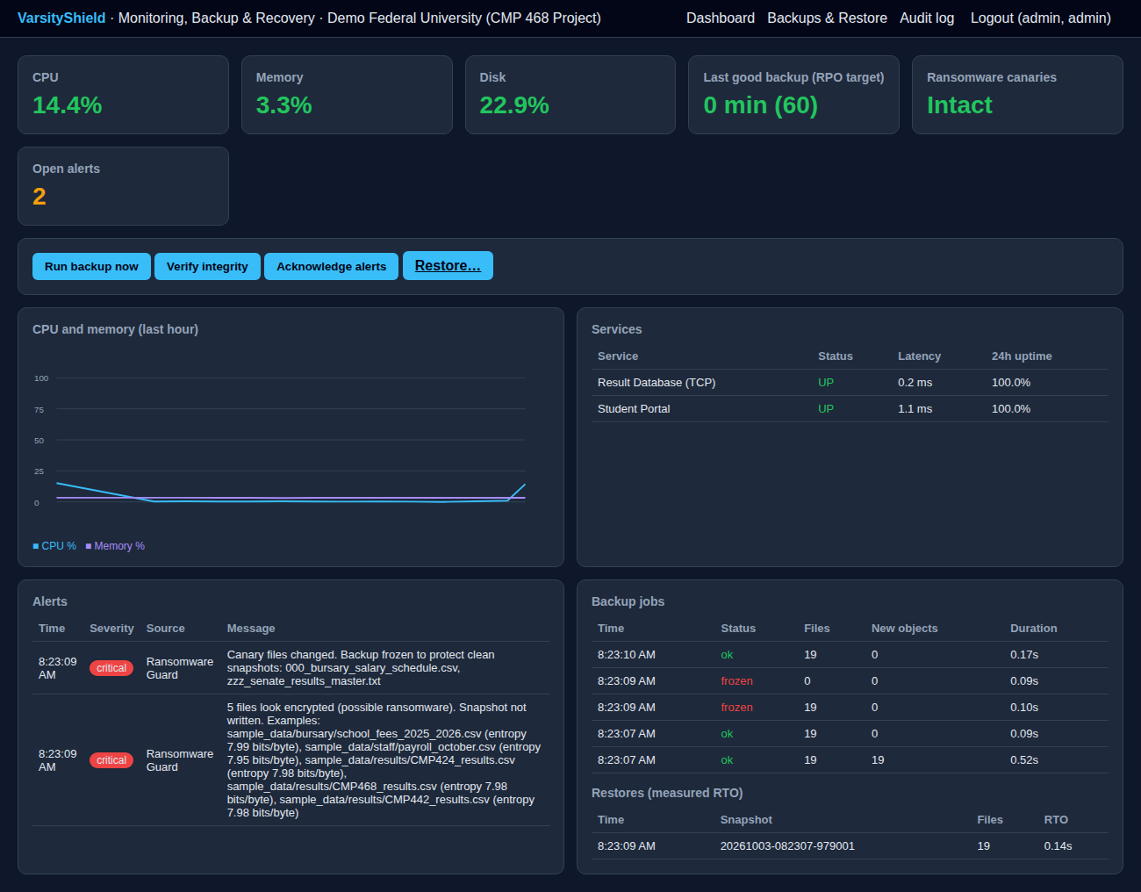
Figure 1: The VarsityShield dashboard

Step 3. Run the demonstration
1. Leave the dashboard open in the browser.
2. Go back to the project folder and double-click 3_DEMO_MENU.bat. A menu appears.
3. Type a number, press Enter, then look at the dashboard in the browser. Press any key to return to the menu.
Table 4: Demo order for the defence
Type | What happens | What to show and say
1 | Student Portal is crashed | Within 15 seconds: red alert 'Student Portal is DOWN', then it comes back UP by itself. Say: 'The system detects the outage and restarts the service automatically.'
2 | Five result files are encrypted secretly (names unchanged) | Nothing visible yet. Say: 'This is stealth ransomware.'
3 | Backup is attempted | Backup status shows **frozen** and a critical alert lists files with entropy near 8. Say: 'The encrypted files are refused, so our clean backup is protected.'
4 | Full ransomware attack | Canaries show **TRIPPED** in red. Type 8 to open sample_data and show the .locked files and READ_ME_TO_DECRYPT.txt.
5 | Restore from last clean backup | Files are back. The dashboard 'Restores (measured RTO)' table shows the time. Type 8 to show the folder is clean.
6 | Verify integrity | Prints "ok": true. Say: 'Every backup was decrypted and its SHA-256 checked.'
7 | Full automatic drill | Prints rto_seconds, rpo_seconds and byte_identical: true.

Also show in the browser
Backups & Restore page: list of encrypted snapshots with Restore buttons.
Audit log page: every action with its hash. 'Hash chain: INTACT'.
Log out and log in as auditor (same password): the Run backup and Restore buttons are gone. That is role-based access control.

Step 4. Stop and start again later
1. To stop: close the black 2_START_DASHBOARD window and the menu window.
2. Next time (no internet needed): double-click 2_START_DASHBOARD.bat, then 3_DEMO_MENU.bat. Do NOT run 1_SETUP.bat again.
3. To start completely fresh before the defence: close all windows, double-click 4_RESET_DEMO.bat, type YES, then run 1_SETUP.bat again.

PART 3: PROJECT 2, ZAMAN LAFIYA
Zaman Lafiya is a map-based early warning system for farmer-herder conflict. Open the folder C:\CMP468_Projects\project2-zamanlafiya.

Step 1. Setup (only once, internet ON)
1. Double-click 1_SETUP.bat.
2. Wait for steps [1/6] to [6/6]. This one installs scikit-learn (a machine learning library), so it can take 3 to 8 minutes.
3. When you see SETUP COMPLETE, press any key.
You should see near the end
Initialised ... 24 LGAs, zones, NDVI, contacts.
Generated 1056 synthetic incidents over 104 weeks for 24 LGAs.
A block of results with "auc" values, and "selected": "random_forest".
SETUP COMPLETE.

IMPORTANT: the keys.bat file
Setup creates keys.bat in the folder. It holds the encryption keys. Do not delete it and do not share it.
If you delete it, saved phone numbers can no longer be decrypted. Use 4_RESET_DEMO.bat to rebuild.

Step 2. Start the web app
1. Double-click 2_START_APP.bat. Keep the black window open.
2. The browser opens at http://127.0.0.1:5050. If not, wait 5 seconds and press F5.
3. Log in with admin / ChangeMe@468.
You should see
A map with coloured circles (green, yellow, orange, red) on Nigerian LGAs, small farm squares and a dashed stock route.
On the right: Highest risk LGAs, Selected LGA, Alerts dispatched, Mediation cases.
With internet, a street map shows behind. Without internet the background is plain, but everything else works.

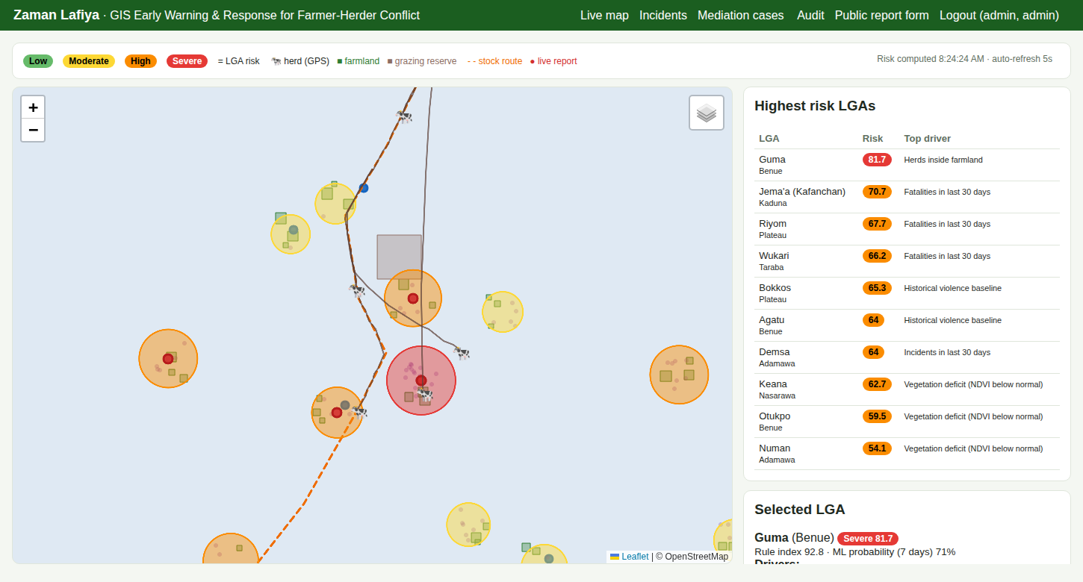
Figure 2: The Zaman Lafiya live map

Step 3. Start the live simulation
1. Keep the browser on the map.
2. Double-click 3_START_SIMULATION.bat. It runs for about 80 seconds.
3. Watch the map: cow icons move along the stock route, new red dots (reports) appear, and alerts appear on the right.
Table 5: Demo order for the defence
Do this | What to show and say
Click the Guma circle | The Selected LGA box shows the score, the reasons (drivers) and a trend line. Say: 'The system explains why an area is high risk.'
Wait for a geofence alert | An alert 'herd ... entered Guma yam farms' appears in English, Hausa and Pidgin, sent to the peace committee, the Ardo, the farmers' representative and the police.
Open Incidents (top menu) | Click **Confirm** or **False** on a report. Point to 'protected (encrypted)' for the reporter. Click **Reveal** to show only an admin can see the number, and it is logged.
Open Mediation cases | A case was opened automatically for the attack. Choose a status, type a mediator, click **Save**.
Open Audit | Shows logins, verifications and the Reveal. 'Hash chain INTACT'.
Log out, open Public report form | Anyone can report without logging in, with an 'anonymous' option.

Step 4. Stop and start again later
1. To stop: close the black windows.
2. Next time: double-click 2_START_APP.bat, then 3_START_SIMULATION.bat. Do NOT run 1_SETUP.bat again.
3. To start fresh: close all windows, double-click 4_RESET_DEMO.bat, type YES.

PART 4: DEFENCE DAY CHECKLIST
1. The day before, run both demos fully once on the laptop you will use.
2. Run 4_RESET_DEMO.bat then 1_SETUP.bat for Project 1 so the dashboard starts clean. No internet is needed because the packages are already installed.
3. Charge the laptop fully and carry the charger.
4. Record a short screen video of each demo (Windows key + G opens the Xbox Game Bar recorder). If anything fails on the day, play the video.
5. Open both browser tabs and log in BEFORE you are called, so you do not type passwords in front of the panel.
6. For the Project 2 street map, connect to a phone hotspot. The demo still works without it.
7. Keep the reports open in Word in case you are asked to show a chapter.

PART 5: TROUBLESHOOTING
Table 6: Problems and fixes
What you see | What to do
'Python was not found' or 'python is not recognized' | Reinstall Python with **Add python.exe to PATH** ticked (Part 1, Step 1). Close all black windows and try again.
Setup stops at 'Installing packages' with red error text about connection | No internet or very weak internet. Connect to better internet and double-click 1_SETUP.bat again. It continues from where it stopped.
'Setup has not been done yet' | Run **1_SETUP.bat** first and wait for SETUP COMPLETE.
Browser says 'This site can't be reached' | Check the black 2_START window is still open. Wait 5 seconds and press F5. Type the address exactly: 127.0.0.1:5000 (Project 1) or 127.0.0.1:5050 (Project 2).
Black window shows 'Address already in use' or closes immediately | An old copy is still running. Restart the laptop, then start again.
'Invalid username or password' | Username is **admin** (small letters), password is **ChangeMe@468** (capital C and M).
'Too many failed attempts' | This is the security lockout. Wait 5 minutes.
Project 1: 'Wrong backup passphrase' | env.bat was edited after setup. Run 4_RESET_DEMO.bat, then 1_SETUP.bat.
Project 2 map has no street background | No internet. Connect a hotspot and press F5. Everything else works without it.
Project 2 simulation shows 'HTTP Error 401' | keys.bat changed after the app started. Close all windows and start 2_START_APP.bat again.
Project 2 phone numbers show '<undecryptable>' | keys.bat was deleted or replaced. Run 4_RESET_DEMO.bat.
Antivirus deletes or blocks a file | The demo 'ransomware' is harmless and only touches the sample_data folder. Allow the folder C:\CMP468_Projects in your antivirus, or pause it during the demo.
Blue 'Windows protected your PC' box | Click **More info**, then **Run anyway**.

APPENDIX A: WHAT THE DOUBLE-CLICK FILES DO
If a lecturer asks you to run the system from the command line, these are the same steps by hand. Open the project folder, click the address bar at the top of File Explorer, type cmd and press Enter. A black window opens already inside the folder.

Project 1
python -m venv venv
venv\Scripts\activate
pip install -r requirements.txt
env.bat
python cli.py init
python simulate.py seed
python cli.py backup
python cli.py verify
python app.py

Project 2
python -m venv venv
venv\Scripts\activate
pip install -r requirements.txt
python manage.py genkey --save
keys.bat
python manage.py init
python manage.py history
python manage.py train
python manage.py risk
python app.py

To send a test SMS by hand while Project 2 runs (open a second black window in the same folder):
curl.exe -X POST -d "from=08031234567&text=ZL Guma CROP cows in yam farm" http://127.0.0.1:5050/api/sms

APPENDIX B: MAC OR LINUX
Install Python 3.10+ (Mac: from python.org. Ubuntu: sudo apt install python3 python3-venv). Open Terminal in the project folder and type:

Project 1
python3 -m venv venv
source venv/bin/activate
pip install -r requirements.txt
export VSHIELD_PASSPHRASE='CMP468-VarsityShield-Demo-Passphrase'
python cli.py init
python simulate.py seed
python cli.py backup
python simulate.py portal --background
python app.py

Project 2
python3 -m venv venv
source venv/bin/activate
pip install -r requirements.txt
python manage.py genkey --save
source keys.sh
python manage.py init
python manage.py history
python manage.py train
python app.py

In a second Terminal, activate the venv again (and run source keys.sh for Project 2) before running the demo commands from the menus: python simulate.py outage, tamper, attack, drill, or python simulate.py --steps 40 --interval 2 for Project 2.

