[NAME OF YOUR UNIVERSITY]
FACULTY OF [SCIENCE / COMPUTING]
DEPARTMENT OF COMPUTER SCIENCE
CMP 468: COMPUTER SECURITY (2 UNITS)
COURSE PROJECT REPORT
ZARIASAFE: A VERSIONED-MIRROR BACKUP, MONITORING AND RECOVERY SYSTEM FOR AHMADU BELLO UNIVERSITY, ZARIA
Point-in-time encrypted versions with a mass-change ransomware detector, built on Python's standard web server
BY
[FULL NAME]
MATRIC NO: [MATRIC NUMBER]
SUBMITTED TO
[COURSE LECTURER'S NAME]
IN PARTIAL FULFILMENT OF THE REQUIREMENTS OF CMP 468
400 LEVEL, SECOND SEMESTER, 2025/2026 SESSION
OCTOBER 2026

DECLARATION
I declare that this project report and the accompanying software were written by me as part of the requirements of CMP 468 (Computer Security). Every source used has been cited. All literature cited in this report was published between 2021 and 2026. All test results reported in Chapter Four were produced by the automated test program supplied with the software.
Signature: ____________________ Date: ____________________

ABSTRACT
Universities in Nigeria run admissions, fees, results, learning and payroll on computers that can fail or be attacked. This project designed, built and tested ZariaSafe for Ahmadu Bello University (ABU), Zaria, Kaduna State. Its design combines point-in-time encrypted versions with a mass-change ransomware detector, built on Python's standard web server. The system was implemented in Python and evaluated with an automated test suite that simulates outages, quiet and loud ransomware, tampering and misuse. All 13 tests passed. Key measurements: Protected data set: 15 files, 130.0 KiB; First (full) backup: 15 files, 0.005 s, stored 130.4 KiB; Incremental backup after one edit: 1 file copied, 0.002 s; Unchanged backup: 0 files copied, 0.002 s. The design shows that a Nigerian university ICT unit can protect its records with free software on ordinary hardware.
Keywords: backup and recovery, ransomware, encryption, integrity, monitoring, RTO, Nigerian universities, NDPA 2023.

TABLE OF CONTENTS
Right-click here and choose Update Field to build the table of contents.

CHAPTER ONE: INTRODUCTION

1.1 Background of the Study
ABU Zaria is one of the largest universities in West Africa, with the main Samaru campus, the Kongo campus and many affiliated institutions. Its registry, bursary, results, learning materials and payroll records sit on a small number of servers looked after by a busy ICT directorate. When one of those servers fails, or when a staff laptop connected to a shared drive is infected with ransomware, the records of tens of thousands of students are at risk.
Ransomware changed what backup means. Older plans assumed that disks fail by accident; modern attackers encrypt production data and then go after the backups. Recovery is therefore a security function, matching the Recover function of the NIST Cybersecurity Framework 2.0 (2024). The Nigeria Data Protection Act 2023 also makes the university a data controller that must keep personal data confidential, accurate and available.

1.2 Statement of the Problem
- Backups are copied by hand to external drives, irregularly, and are never tested by restoring them.
- A backup job that runs after ransomware has struck copies encrypted files over the last good copies.
- There is no way to rebuild the records as they were on a chosen date, for example before a disputed result change.
- Outages of the student portal are noticed by students before the ICT staff.

1.3 Aim and Objectives
The aim is to design, implement and evaluate ZariaSafe, a secure system for Ahmadu Bello University (ABU), Zaria, Kaduna State. The objectives are to:
- take scheduled, encrypted, point-in-time versions of university records that store only changed files;
- detect ransomware-like mass change before a backup runs and hold the backup so the clean history is protected;
- restore any version, in place or to a side folder, and measure the recovery time;
- monitor host resources and the student portal, and restart the portal automatically;
- protect the console with strong authentication, CSRF tokens and a signed audit trail;
- evaluate the system with an automated attack-and-recovery test.

1.4 Scope and Limitations
ZariaSafe protects file-level records on one server and monitors HTTP and TCP services. The test data set has 15 files (about 130 KB) of synthetic student, fee, result, lecture and payroll records, so timings show relative behaviour, not production throughput. The system was tested on one computer; the README describes deployment on other computers.

1.5 Significance of the Study
ZariaSafe gives Ahmadu Bello University (ABU), Zaria, Kaduna State a free, auditable tool that runs on ordinary hardware, and turns CMP 468 topics into working controls. Its automated test suite lets any future maintainer prove that the controls still work.

1.6 Relation to the CMP 468 Course Outline
Table 1: Mapping of CMP 468 topics to ZariaSafe
CMP 468 topic | Where it appears in ZariaSafe
Overview of security in computing | CIA triad: encryption (confidentiality), hashing and signatures (integrity), copies and restore (availability)
Characteristics of computer intrusion | Ransomware behaviour model: mass modification, new extensions, ransom notes, high-entropy output
Types of security breaches | Data destruction, data tampering, insider deletion of backups, unauthorised access to the console
Classes of attacks | Ransomware, brute-force login, cross-site request forgery, backup tampering
Methods of defence and controls | Preventive, detective and corrective controls listed in Table 3.2
Data security: encryption and decryption | A random 256-bit master key; sub-keys for data, manifests and the audit trail are derived with HMAC-SHA256.
Network security | Service reachability checks, security headers, SameSite cookies
Security policies and standards | Backup and retention policy in config.json; NIST CSF 2.0 Recover; ISO/IEC 27001:2022; NDPA 2023

CHAPTER TWO: LITERATURE REVIEW
This review covers only studies published from 2021 to 2026. Every source was checked against a publisher or index page.

2.1 Conceptual Framework
The study rests on the Confidentiality, Integrity and Availability (CIA) triad. A backup that an attacker can read fails confidentiality; one that can be silently altered fails integrity; one that cannot be restored in time fails availability. Two measures turn availability into numbers: the Recovery Point Objective (how much data may be lost) and the Recovery Time Objective (how long restoration may take).

2.2 Cybersecurity in Nigerian universities
Nigerian work on university cybersecurity agrees that the weak points are after an attack starts, not only before it. Olugbile et al. (2025) used Design Science Research to build cybersecurity readiness tiers for Nigerian universities covering pre-event, event-management and post-event factors, and named inadequate funding, weak infrastructure, poor training and a shortage of professionals as the main obstacles. Farouk et al. (2024) note that Nigerian universities lack scientifically derived frameworks for managing cyber risk and propose situational crime prevention as one. Neither study builds or measures a working recovery system, which leaves room for the practical contribution of this project.

2.3 Monitoring and automated response
Open-source monitoring stacks dominate recent practice. Simili et al. (2021) combined Prometheus, Loki and Grafana at a university computing cluster and added an alerting application that performs simple recovery actions for known problems, so that staff intervene less often. Pragathi et al. (2024) deployed Prometheus, Grafana and Node Exporter on Kubernetes and reported shorter deployment time and lower operating cost. Rafiq et al. (2025) ran five Prometheus instances on Raspberry Pi edge nodes to watch about 500 network elements in five client organisations, adding machine-learning anomaly prediction and alert routing. The common lesson is that monitoring pays off when it triggers action automatically, and that small teams benefit most.

2.4 Backup strategy and disaster recovery
Lysetskyi (2025) recommends the 3-2-1-1-0 rule with an air-gapped copy, because backups that cannot be reached from the network survive ransomware. Plaka (2022) mapped 45 studies (2010-2020) on backup and disaster recovery and catalogued their causes, techniques, and privacy and security issues. Tatineni (2023) lists risk assessment, backup, duplication and failover as the core of a disaster recovery plan. Education-specific studies add cost and skills constraints. Muthoni et al. (2021) found that African universities, Kenyan ones in particular, are slow to adopt cloud business continuity, and showed with Ansible and Terraform that infrastructure as code reduced cost, effort and human error when recovering a local data centre to the cloud. Vinisha et al. (2025) gave smaller colleges with one on-premises web server an on-demand cloud standby that health checks start automatically when the main server fails. Dotasara and Sharma (2022) compress and encrypt education data before storing it in the cloud.

2.5 Ransomware-resilient recovery
Recent work moves from detection alone to guaranteed recovery. Baek et al. (2021) built ransomware detection and recovery into SSD firmware (SSD-Insider++): the drive watches I/O patterns and uses delayed deletion to restore original data, reporting 0% false rates in most cases and recovery with no data loss. The approach needs special drive firmware. Kodali and Sangani (2026) combined SHA-256 change detection with AES-256-GCM encryption in an automatic, ransomware-resilient backup tool. Amoruso et al. (2026) proposed integrity-gated file monitoring, in which changed files must pass integrity checks before they are trusted, as a route to ransomware resilience and real-time recovery. Varshney and Kumar (2026) treat fast, trustworthy restoration as a first-class security goal: behavioural detection (97.4% accuracy at a 3.1% false-positive rate), an isolated immutable vault and an automated orchestrator that finds a verified clean recovery point. Kumar et al. (2026) argue that backup integrity must be verified before restoration, and report 98.65% accuracy for their AI-assisted integrity-verification and ransomware-detection pipeline. Ilau et al. (2025) modelled ransomware recovery in a medium-sized organisation and compared recovery strategies over 9,000 parameter configurations (450,000 simulation runs).

2.6 Work Closest to This Design
ZariaSafe shares the SHA-256 change detection and AES-256-GCM choice of Kodali and Sangani (2026) and the integrity-before-trust idea of Amoruso et al. (2026). It differs in where the check happens: instead of judging each file, it judges the whole backup run, holding it when 30% or more of protected files change at once. Unlike the vault of Varshney and Kumar (2026), it needs no separate appliance and no web framework.

2.7 Summary of Reviewed Works and Research Gap
Table 2: Summary of reviewed works
Study | What it contributes
Amoruso (2026) | proposed integrity-gated file monitoring, in which changed files must pass integrity checks before they are trusted, as a route to ransomware resilience and rea
Baek (2021) | built ransomware detection and recovery into SSD firmware (SSD-Insider++): the drive watches I/O patterns and uses delayed deletion to restore original data, re
Dotasara (2022) | compress and encrypt education data before storing it in the cloud.
Farouk (2024) | note that Nigerian universities lack scientifically derived frameworks for managing cyber risk and propose situational crime prevention as one.
Ilau (2025) | modelled ransomware recovery in a medium-sized organisation and compared recovery strategies over 9,000 parameter configurations (450,000 simulation runs).
Kodali (2026) | combined SHA-256 change detection with AES-256-GCM encryption in an automatic, ransomware-resilient backup tool.
Kumar (2026) | argue that backup integrity must be verified before restoration, and report 98.65% accuracy for their AI-assisted integrity-verification and ransomware-detectio
Lysetskyi (2025) | recommends the 3-2-1-1-0 rule with an air-gapped copy, because backups that cannot be reached from the network survive ransomware.
Muthoni (2021) | found that African universities, Kenyan ones in particular, are slow to adopt cloud business continuity, and showed with Ansible and Terraform that infrastructu
Olugbile (2025) | used Design Science Research to build cybersecurity readiness tiers for Nigerian universities covering pre-event, event-management and post-event factors, and n
Plaka (2022) | mapped 45 studies (2010-2020) on backup and disaster recovery and catalogued their causes, techniques, and privacy and security issues.
Pragathi (2024) | deployed Prometheus, Grafana and Node Exporter on Kubernetes and reported shorter deployment time and lower operating cost.
Rafiq (2025) | ran five Prometheus instances on Raspberry Pi edge nodes to watch about 500 network elements in five client organisations, adding machine-learning anomaly predi
Simili (2021) | combined Prometheus, Loki and Grafana at a university computing cluster and added an alerting application that performs simple recovery actions for known proble
Tatineni (2023) | lists risk assessment, backup, duplication and failover as the core of a disaster recovery plan.
Varshney (2026) | treat fast, trustworthy restoration as a first-class security goal: behavioural detection (97.4% accuracy at a 3.1% false-positive rate), an isolated immutable
Vinisha (2025) | gave smaller colleges with one on-premises web server an on-demand cloud standby that health checks start automatically when the main server fails.

Research gap. None of the reviewed systems was designed for a Nigerian university ICT unit that must run on one ordinary server with no web framework, yet still offers point-in-time versions, a whole-run ransomware hold and measured recovery.

CHAPTER THREE: METHODOLOGY AND SYSTEM DESIGN

3.1 Research Methodology
The project follows Design Science Research: identify the problem, define objectives, design and build an artefact, demonstrate it, and evaluate it. Evaluation uses an automated test program (selftest.py) that resets the system, runs normal use, simulated attacks and failures, and records each outcome and measurement in results/selftest.json. Data are synthetic university records.

3.2 Requirements
Table 3: Functional requirements
# | Requirement
FR1 | Back up changed files on a schedule and on demand
FR2 | Hold a backup when the run looks like ransomware
FR3 | Restore any version in place or to another folder
FR4 | Verify every encrypted object and repair it from a replica
FR5 | Monitor CPU, memory, disk, HTTP and TCP services
FR6 | Restart the portal when it is down
FR7 | Record every action in a signed audit trail

Table 4: Non-functional requirements
# | Requirement
NFR1 | Runs with only two third-party packages (cryptography, psutil)
NFR2 | Works on Windows, Linux and macOS
NFR3 | A non-specialist can set it up with 1_SETUP.bat
NFR4 | Role separation: admin and read-only auditor

3.3 System Architecture
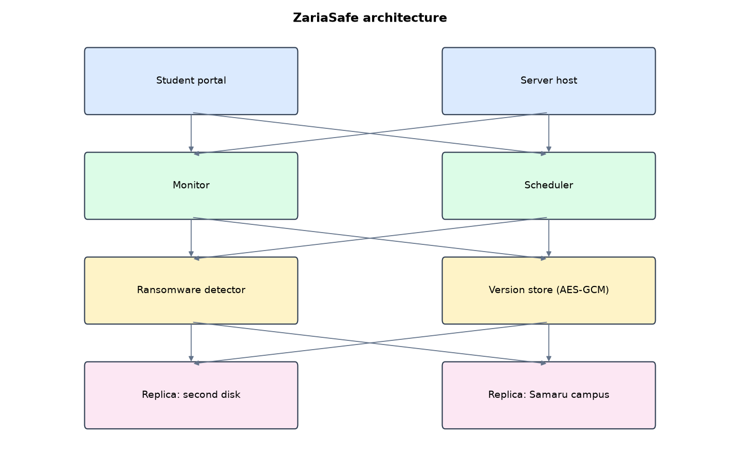
Figure 1: ZariaSafe architecture (data flows from top to bottom)
Table 5: Software components
File | Responsibility
core.py | Backup versions, signed manifests, detector, verify and repair, restore, monitoring, signed audit trail
web.py | Console on http.server with sessions, CSRF tokens, lockout, roles and scheduler thread
demo.py | Synthetic ABU records, demo portal and safe ransomware simulations
main.py / selftest.py | Command line and automated tests

The main design decisions, and how they differ from the earlier VarsityShield and Zaman Lafiya projects, are:
- No web framework. The console uses Python's built-in `http.server`, so the only packages are `cryptography` and `psutil`.
- Versioned mirror store. Each backup is a dated version folder. Only changed files are copied in. A signed manifest records where every file of that version lives, so any point in time can be rebuilt.
- AES-256-GCM per file with the file path bound as associated data, so an attacker cannot swap two encrypted files.
- HMAC-signed manifests and an HMAC-chained audit trail, keyed from a 256-bit master key.
- Mass-change ransomware detector. If 30% or more of protected files change or vanish in one interval, or ransomware extensions or ransom notes appear, the backup is held and the clean history is protected.
- Self-healing. The scheduler restarts the student portal when it goes down.

3.4 Security Design
Each threat considered is matched to the control that addresses it. Tests in Chapter Four exercise these controls.
Table 6: Threats and controls
Threat | Control in ZariaSafe
Ransomware encrypts records in place | Mass-change detector holds the backup; restore from last good version
Ransomware renames files and leaves a note | Extension and ransom-note checks hold the backup
Someone edits a stored backup file | AES-GCM authentication fails; repair from replica
Someone edits a version manifest | HMAC-SHA256 manifest signature fails; restore refused
Insider changes the audit trail | HMAC chain breaks at the edited row
Password guessing on the console | PBKDF2 (310,000 iterations), 5-failure lockout
Cross-site request forgery | Per-session CSRF token, SameSite=Strict cookie

Cryptographic keys: A random 256-bit master key; sub-keys for data, manifests and the audit trail are derived with HMAC-SHA256.

3.5 Algorithms

3.5.1 Versioned-mirror backup
For each run: hash every source file with SHA-256; compare with the previous version's manifest; encrypt only new or changed files with AES-256-GCM (random 96-bit nonce, file path as associated data); write a manifest listing every file and the version that holds its object; sign the manifest with HMAC-SHA256; copy the version folder to the replicas.

3.5.2 Mass-change ransomware detector
Before writing a version, compute the share of protected files that changed or vanished since the last good version. If it is 30% or more (with at least 5 files), or ransomware extensions or ransom notes appear, mark the run HELD, raise a critical alert and write nothing.

3.5.3 Restore
Read and verify the manifest signature, delete files that are not in the version (removes ransom notes and .locked files), decrypt each object from the version that holds it, and write it back.

3.6 Tools and Technologies
Language: Python 3.10 or newer. Storage: SQLite. Third-party packages: cryptography, psutil. Launchers: Windows batch files (1_SETUP, 2_START, 3_DEMO_MENU, 4_SELFTEST) and run.sh for Linux and macOS.

CHAPTER FOUR: IMPLEMENTATION, TESTING AND RESULTS

4.1 Implementation Environment
The system was developed and tested with Python 3.11 on Linux and is written to run unchanged on Windows 10/11. Its web interface runs at http://127.0.0.1:5101. Setup takes about ten minutes with 1_SETUP.bat; the README in the project folder gives every step and a defence demonstration script.

4.2 Operation and Demonstration
ZariaSafe monitors the university's servers and student portal, keeps encrypted point-in-time versions of registry, bursary, results, LMS and payroll files, refuses to back up data that looks ransomware-encrypted, and restores any version with a measured recovery time.
Table 7: Demonstration scenario used for the defence
Step | Command (python main.py ...) | What is observed
This is ABU's live status. | serve | CPU, memory, disk, portal UP, last backup ok
The student portal crashes. | outage | Within 15 s a critical alert, then the portal is restarted and shows UP
Ransomware encrypts result files quietly. | stealth | Click Run backup now: status HELD, 40% of files changed
A loud attack follows. | attack | Open sample_data: .locked files and a ransom note. Backup is HELD again
We recover. | restore | Versions page, Restore on the newest ok version. Files back, note gone, RTO shown
Prove backups cannot be secretly altered. | verify | Checked objects, zero bad. Audit page shows chain INTACT

4.3 Test Plan and Results
The automated test program ran 13 tests. 13 passed.
Table 8: Automated test results
# | Test | Result | Evidence
1 | First (full) backup stores every file | PASS | 15 files in 0.005 s
2 | Incremental backup copies only the changed file | PASS | changed=1
3 | Unchanged run stores nothing new | PASS | 0.002 s
4 | Quiet in-place encryption is held by the mass-change detector | PASS | 40% of protected files changed or vanished in one interval
5 | Restore after quiet attack is byte-identical | PASS | 6 files hit
6 | Loud attack (.locked + note) is held | PASS | 15 files with ransomware extensions (e.g. bursary/fees_2025_2026.csv.locked); ransom note file present; 100% of protecte
7 | Full recovery after loud attack is byte-identical and note removed | PASS | RTO 0.005 s
8 | Point-in-time restore of version 1 to a side folder | PASS
9 | Tampered object detected and repaired from replica | PASS | ['20261004-163035-626682:registry/students.csv']
10 | Edited manifest is rejected (HMAC signature) | PASS
11 | Edited audit row breaks the signature chain | PASS | broken at row 3
12 | Service outage detected | PASS
13 | Wrong password is refused | PASS

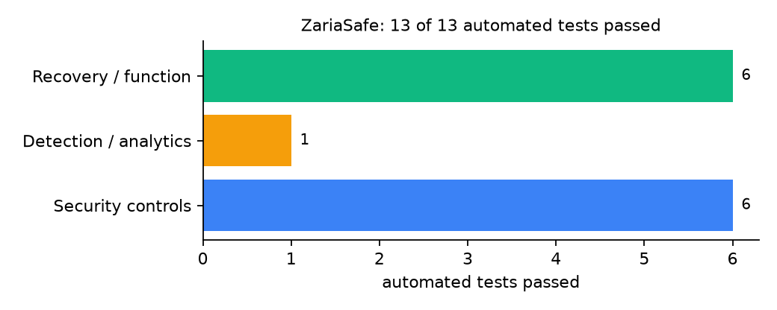
Figure 2: Automated tests by category

4.4 Measured Results
Table 9: Key measurements
Measure | Result
Protected data set | 15 files, 130.0 KiB
First (full) backup | 15 files, 0.005 s, stored 130.4 KiB
Incremental backup after one edit | 1 file copied, 0.002 s
Unchanged backup | 0 files copied, 0.002 s
Files hit by simulated ransomware | 15
Recovery time (RTO) measured | 0.005 s, byte-identical: yes
Objects checked by verification | 16

4.5 Discussion
The full backup stored slightly more than the original data because ZariaSafe encrypts without compressing, so each file gains a 12-byte nonce and a 16-byte authentication tag. Compression before encryption would cut storage but would also open the door to compression side-channels on shared data; for a single-owner backup it is a reasonable later addition. The whole-run detector caught both the quiet attack (40% of files changed) and the loud one. Its weakness is a slow attacker who encrypts a few files per interval; the per-file entropy checks used in other designs (for example LionKeep) would close that gap.
Of the tests, 6 exercised security controls, 1 exercised detection or analytics, and 6 exercised recovery or core function.

CHAPTER FIVE: SUMMARY, CONCLUSION AND RECOMMENDATIONS

5.1 Summary
This project built ZariaSafe for Ahmadu Bello University (ABU), Zaria, Kaduna State. Its design combines point-in-time encrypted versions with a mass-change ransomware detector, built on Python's standard web server. It met its objectives and passed all 13 automated tests.

5.2 Conclusion
ZariaSafe shows that the security problem described in Chapter One can be addressed with free software and modest hardware, provided the design treats recovery as something attackers will target. The limits stated in Section 1.4 still apply.

5.3 Recommendations
- Point the second replica at a different building on Samaru or Kongo campus, or at an external drive that is unplugged after each copy.
- Keep the master key file off the server and in the ICT Director's safe; ZariaSafe needs it only for restore and verify.
- Run selftest.py each semester as a recovery drill and keep the results as evidence for the NDPA compliance file.
- Add per-file entropy checks to catch slow encryption.

5.4 Contribution to Knowledge
This project provides a design that the reviewed systems do not was designed for a Nigerian university ICT unit that must run on one ordinary server with no web framework, yet still offers point-in-time versions, a whole-run ransomware hold and measured recovery.

5.5 Suggestions for Further Work
- Compress before encrypting to save storage.
- Put the console behind HTTPS with a university certificate.
- Stream version folders to an object store with object lock.

REFERENCES
Amoruso, E., Amoruso, P., & Zou, C. (2026). Integrity-gated file monitoring for ransomware resilience and real-time recovery. In 2026 International Conference on Smart Applications, Communications and Networking (SmartNets). IEEE.
Baek, S., Jung, Y., Mohaisen, D., Lee, S., & Nyang, D. (2021). SSD-assisted ransomware detection and data recovery techniques. IEEE Transactions on Computers, 70(10), 1762-1776. https://doi.org/10.1109/TC.2020.3011214
Dotasara, M., & Sharma, A. (2022). MDAS_DBRCC: Data backup and recovery technique in cloud computing for education industry. International Journal on Recent and Innovation Trends in Computing and Communication.
Farouk, S., et al. (2024). Enhancing cybersecurity in Nigeria: A proposed risk management framework for universities. In 2024 International Conference on Science, Engineering and Business for Driving Sustainable Development Goals (SEB4SDG). IEEE.
Ilau, M.-C., Baldwin, A., Caulfield, T., & Pym, D. (2025). Modelling and simulating organizational ransomware recovery: Structure, methodology, and decisions. Journal of Cybersecurity, 11(1), tyaf035. https://doi.org/10.1093/cybsec/tyaf035
Kodali, A., & Sangani. (2026). Automatic ransomware-resilient encrypted backup system using SHA-256 change detection and AES-256-GCM encryption. In 2026 3rd International Conference on Research Methodologies in Knowledge Management, Artificial Intelligence and Telecommunication Engineering (RMKMATE). IEEE.
Kumar, B., Gupta, S. K., & Dwivedi, R. (2026). Artificial intelligence driven approach for securing backup data and enhancing cyber resilience in sustainable smart infrastructure. Scientific Reports. https://doi.org/10.1038/s41598-026-37802-6
Lysetskyi, Y. M. (2025). Choosing an effective data backup and recovery strategy. Mathematical Machines and Systems.
Muthoni, S., Okeyo, G., & Chemwa, G. (2021). Infrastructure as code for business continuity in institutions of higher learning. In 2021 International Conference on Electrical, Computer and Energy Technologies (ICECET). IEEE.
Olugbile, O. H., Ojeniyi, J. A., & Anyachebelu, T. K. (2025). Towards a standard framework for cybersecurity readiness for Nigerian universities. International Journal of Applied Mathematics, Sciences, and Technology for National Defense.
Plaka, R. (2022). Backup & data recovery in cloud computing: A systematic mapping study. Ingenious.
Pragathi, B. C., et al. (2024). Implementing an effective infrastructure monitoring solution with Prometheus and Grafana. International Journal of Computer Applications, 186(38), 7-15.
Rafiq, A., Shakir, M. Z., Gray, D., Inglis, J., & Ferguson, F. (2025). AI and IoT-driven monitoring and visualisation for optimising MSP operations in multi-tenant networks: A modular approach using sensor data integration. Sensors, 25(19), 6248. https://doi.org/10.3390/s25196248
Simili, E., Stewart, G., Roy, G., Skipsey, S., & Britton, D. (2021). A hybrid system for monitoring and automated recovery at the Glasgow Tier-2 cluster. EPJ Web of Conferences, 251, 02047.
Tatineni, S. (2023). Cloud-based business continuity and disaster recovery strategies. International Research Journal of Modernization in Engineering Technology and Science.
Varshney, P. K., & Kumar, R. (2026). A governance-oriented cyber recovery framework for ransomware preparedness and resilience. EDPACS. https://doi.org/10.1080/07366981.2026.2682427
Vinisha, J., Sanjay, R., & Sundar, D. (2025). Automated disaster recovery architecture for educational institutions web infrastructure using hybrid cloud. In 2025 2nd International Conference on Artificial Intelligence and Knowledge Discovery in Concurrent Engineering (ICECONF). IEEE.

Standards and Legal Instruments Consulted
Federal Republic of Nigeria. (2023). Nigeria Data Protection Act, 2023. Nigeria Data Protection Commission.
International Organization for Standardization. (2022). ISO/IEC 27001:2022 Information security, cybersecurity and privacy protection: Information security management systems: Requirements. ISO.
National Institute of Standards and Technology. (2024). The NIST Cybersecurity Framework (CSF) 2.0 (NIST CSWP 29). NIST.

APPENDIX A: HOW TO RUN THE SYSTEM
- Copy the folder backup-recovery/A01-abu-zaria-zariasafe to the computer.
- Install Python 3.10 or newer with 'Add python.exe to PATH' ticked.
- Double-click 1_SETUP.bat, then 2_START.bat, and open http://127.0.0.1:5101.
- Use 3_DEMO_MENU.bat for the defence demonstration and 4_SELFTEST.bat to regenerate the results in Chapter Four.

APPENDIX B: SOURCE CODE STRUCTURE
Table 10: ZariaSafe source files
File | Purpose
core.py | Backup versions, signed manifests, detector, verify and repair, restore, monitoring, signed audit trail
web.py | Console on http.server with sessions, CSRF tokens, lockout, roles and scheduler thread
demo.py | Synthetic ABU records, demo portal and safe ransomware simulations
main.py / selftest.py | Command line and automated tests

APPENDIX C: CODE EXCERPT
The function detect_ransomware from core.py, the heart of the design described in Section 3.5.
def detect_ransomware(prev, cur, source, cfg):
"""Mass-change detector. Looks at the run as a whole instead of file by file."""
reasons = []
names = [os.path.basename(k).lower() for k in cur]
bad_ext = [k for k in cur if os.path.splitext(k)[1].lower() in RANSOM_EXT]
if bad_ext:
reasons.append(f"{len(bad_ext)} files with ransomware extensions (e.g. {bad_ext[0]})")
if any(any(h in n for h in NOTE_HINTS) for n in names):
reasons.append("ransom note file present")
if prev:
common = set(prev) & set(cur)
changed = [k for k in common if cur[k]["sha"] != prev[k]["sha"]]
deleted = set(prev) - set(cur)
ratio = (len(changed) + len(deleted)) / max(1, len(prev))
if ratio >= cfg["detector"]["max_change_ratio"] and len(prev) >= 5:
reasons.append(f"{ratio:.0%} of protected files changed or vanished in one interval")
return reasons

