[NAME OF YOUR UNIVERSITY]
FACULTY OF [SCIENCE / COMPUTING]
DEPARTMENT OF COMPUTER SCIENCE
CMP 468: COMPUTER SECURITY (2 UNITS)
COURSE PROJECT REPORT
LIONKEEP: FULL AND DIFFERENTIAL ENCRYPTED BACKUP WITH GRANDFATHER-FATHER-SON RETENTION FOR THE UNIVERSITY OF NIGERIA, NSUKKA
Signature and entropy validation keeps suspicious files out of the archives
BY
[FULL NAME]
MATRIC NO: [MATRIC NUMBER]
SUBMITTED TO
[COURSE LECTURER'S NAME]
IN PARTIAL FULFILMENT OF THE REQUIREMENTS OF CMP 468
400 LEVEL, SECOND SEMESTER, 2025/2026 SESSION
OCTOBER 2026

DECLARATION
I declare that this project report and the accompanying software were written by me as part of the requirements of CMP 468 (Computer Security). Every source used has been cited. All literature cited in this report was published between 2021 and 2026. All test results reported in Chapter Four were produced by the automated test program supplied with the software.
Signature: ____________________ Date: ____________________

ABSTRACT
Universities in Nigeria run admissions, fees, results, learning and payroll on computers that can fail or be attacked. This project designed, built and tested LionKeep for the University of Nigeria (UNN), Nsukka, Enugu State. Its design combines signature and entropy validation keeps suspicious files out of the archives. The system was implemented in Python and evaluated with an automated test suite that simulates outages, quiet and loud ransomware, tampering and misuse. All 15 tests passed. Key measurements: Protected data set: 15 files, 127.5 KiB; Full archive: 127.5 KiB compressed and encrypted to 35.6 KiB in 0.283 s; Differential after 1 change: 1 file, 13.5 KiB; Differential after 2 changes: 2 files (cumulative), 15.2 KiB. The design shows that a Nigerian university ICT unit can protect its records with free software on ordinary hardware.
Keywords: backup and recovery, ransomware, encryption, integrity, monitoring, RTO, Nigerian universities, NDPA 2023.

TABLE OF CONTENTS
Right-click here and choose Update Field to build the table of contents.

CHAPTER ONE: INTRODUCTION

1.1 Background of the Study
UNN runs campuses in Nsukka and Enugu and a teaching hospital at Ituku-Ozalla. Its ICT staff are used to tape-style thinking: a weekly full backup and smaller backups in between. That model is easy to explain to auditors, but it breaks when ransomware turns the files themselves into rubbish before the next differential runs.
Ransomware changed what backup means. Older plans assumed that disks fail by accident; modern attackers encrypt production data and then go after the backups. Recovery is therefore a security function, matching the Recover function of the NIST Cybersecurity Framework 2.0 (2024). The Nigeria Data Protection Act 2023 also makes the university a data controller that must keep personal data confidential, accurate and available.

1.2 Statement of the Problem
- Differential and incremental jobs copy whatever is on disk, including files that ransomware has just encrypted.
- There is no written retention rule, so old backups are either kept forever or deleted at random.
- Restores need a chain of many archives, which takes long and fails if one archive is missing.
- Backups are not encrypted, so a stolen external drive exposes student data.

1.3 Aim and Objectives
The aim is to design, implement and evaluate LionKeep, a secure system for the University of Nigeria (UNN), Nsukka, Enugu State. The objectives are to:
- implement full and differential archives so that any restore needs at most two archives;
- encrypt archives with a key derived from an operator passphrase;
- validate every file's signature and entropy before it enters an archive, and quarantine suspicious files;
- apply Grandfather-Father-Son retention automatically;
- monitor services and keep a hash-linked activity log;
- evaluate with an automated attack-and-recovery test.

1.4 Scope and Limitations
LionKeep protects one folder tree per server and three storage copies. Tests used 15 synthetic UNN files (about 128 KB). The system was tested on one computer; the README describes deployment on other computers.

1.5 Significance of the Study
LionKeep gives the University of Nigeria (UNN), Nsukka, Enugu State a free, auditable tool that runs on ordinary hardware, and turns CMP 468 topics into working controls. Its automated test suite lets any future maintainer prove that the controls still work.

1.6 Relation to the CMP 468 Course Outline
Table 1: Mapping of CMP 468 topics to LionKeep
CMP 468 topic | Where it appears in LionKeep
Overview of security in computing | CIA triad: encryption (confidentiality), hashing and signatures (integrity), copies and restore (availability)
Characteristics of computer intrusion | Ransomware behaviour model: mass modification, new extensions, ransom notes, high-entropy output
Types of security breaches | Data destruction, data tampering, insider deletion of backups, unauthorised access to the console
Classes of attacks | Ransomware, brute-force login, cross-site request forgery, backup tampering
Methods of defence and controls | Preventive, detective and corrective controls listed in Table 3.2
Data security: encryption and decryption | Fernet (AES-128-CBC with HMAC-SHA256) under a key derived from the operator passphrase with PBKDF2-HMAC-SHA256, 600,000 iterations and a random salt.
Network security | Service reachability checks, security headers, SameSite cookies
Security policies and standards | Backup and retention policy in config.json; NIST CSF 2.0 Recover; ISO/IEC 27001:2022; NDPA 2023

CHAPTER TWO: LITERATURE REVIEW
This review covers only studies published from 2021 to 2026. Every source was checked against a publisher or index page.

2.1 Conceptual Framework
The study rests on the Confidentiality, Integrity and Availability (CIA) triad. A backup that an attacker can read fails confidentiality; one that can be silently altered fails integrity; one that cannot be restored in time fails availability. Two measures turn availability into numbers: the Recovery Point Objective (how much data may be lost) and the Recovery Time Objective (how long restoration may take).

2.2 Cybersecurity in Nigerian universities
Nigerian work on university cybersecurity agrees that the weak points are after an attack starts, not only before it. Olugbile et al. (2025) used Design Science Research to build cybersecurity readiness tiers for Nigerian universities covering pre-event, event-management and post-event factors, and named inadequate funding, weak infrastructure, poor training and a shortage of professionals as the main obstacles. Farouk et al. (2024) note that Nigerian universities lack scientifically derived frameworks for managing cyber risk and propose situational crime prevention as one. Neither study builds or measures a working recovery system, which leaves room for the practical contribution of this project.

2.3 Monitoring and automated response
Open-source monitoring stacks dominate recent practice. Simili et al. (2021) combined Prometheus, Loki and Grafana at a university computing cluster and added an alerting application that performs simple recovery actions for known problems, so that staff intervene less often. Pragathi et al. (2024) deployed Prometheus, Grafana and Node Exporter on Kubernetes and reported shorter deployment time and lower operating cost. Rafiq et al. (2025) ran five Prometheus instances on Raspberry Pi edge nodes to watch about 500 network elements in five client organisations, adding machine-learning anomaly prediction and alert routing. The common lesson is that monitoring pays off when it triggers action automatically, and that small teams benefit most.

2.4 Backup strategy and disaster recovery
Lysetskyi (2025) recommends the 3-2-1-1-0 rule with an air-gapped copy, because backups that cannot be reached from the network survive ransomware. Plaka (2022) mapped 45 studies (2010-2020) on backup and disaster recovery and catalogued their causes, techniques, and privacy and security issues. Tatineni (2023) lists risk assessment, backup, duplication and failover as the core of a disaster recovery plan. Education-specific studies add cost and skills constraints. Muthoni et al. (2021) found that African universities, Kenyan ones in particular, are slow to adopt cloud business continuity, and showed with Ansible and Terraform that infrastructure as code reduced cost, effort and human error when recovering a local data centre to the cloud. Vinisha et al. (2025) gave smaller colleges with one on-premises web server an on-demand cloud standby that health checks start automatically when the main server fails. Dotasara and Sharma (2022) compress and encrypt education data before storing it in the cloud.

2.5 Ransomware-resilient recovery
Recent work moves from detection alone to guaranteed recovery. Baek et al. (2021) built ransomware detection and recovery into SSD firmware (SSD-Insider++): the drive watches I/O patterns and uses delayed deletion to restore original data, reporting 0% false rates in most cases and recovery with no data loss. The approach needs special drive firmware. Kodali and Sangani (2026) combined SHA-256 change detection with AES-256-GCM encryption in an automatic, ransomware-resilient backup tool. Amoruso et al. (2026) proposed integrity-gated file monitoring, in which changed files must pass integrity checks before they are trusted, as a route to ransomware resilience and real-time recovery. Varshney and Kumar (2026) treat fast, trustworthy restoration as a first-class security goal: behavioural detection (97.4% accuracy at a 3.1% false-positive rate), an isolated immutable vault and an automated orchestrator that finds a verified clean recovery point. Kumar et al. (2026) argue that backup integrity must be verified before restoration, and report 98.65% accuracy for their AI-assisted integrity-verification and ransomware-detection pipeline. Ilau et al. (2025) modelled ransomware recovery in a medium-sized organisation and compared recovery strategies over 9,000 parameter configurations (450,000 simulation runs).

2.6 Work Closest to This Design
LionKeep applies the integrity-before-trust idea of Amoruso et al. (2026) at file level and checks integrity before data is trusted, as Kumar et al. (2026) argue. Like Dotasara and Sharma (2022) it compresses and encrypts education data before storage. Unlike them, it combines this with a classic full + differential schedule and a formal retention scheme that an auditor can check.

2.7 Summary of Reviewed Works and Research Gap
Table 2: Summary of reviewed works
Study | What it contributes
Amoruso (2026) | proposed integrity-gated file monitoring, in which changed files must pass integrity checks before they are trusted, as a route to ransomware resilience and rea
Baek (2021) | built ransomware detection and recovery into SSD firmware (SSD-Insider++): the drive watches I/O patterns and uses delayed deletion to restore original data, re
Dotasara (2022) | compress and encrypt education data before storing it in the cloud.
Farouk (2024) | note that Nigerian universities lack scientifically derived frameworks for managing cyber risk and propose situational crime prevention as one.
Ilau (2025) | modelled ransomware recovery in a medium-sized organisation and compared recovery strategies over 9,000 parameter configurations (450,000 simulation runs).
Kodali (2026) | combined SHA-256 change detection with AES-256-GCM encryption in an automatic, ransomware-resilient backup tool.
Kumar (2026) | argue that backup integrity must be verified before restoration, and report 98.65% accuracy for their AI-assisted integrity-verification and ransomware-detectio
Lysetskyi (2025) | recommends the 3-2-1-1-0 rule with an air-gapped copy, because backups that cannot be reached from the network survive ransomware.
Muthoni (2021) | found that African universities, Kenyan ones in particular, are slow to adopt cloud business continuity, and showed with Ansible and Terraform that infrastructu
Olugbile (2025) | used Design Science Research to build cybersecurity readiness tiers for Nigerian universities covering pre-event, event-management and post-event factors, and n
Plaka (2022) | mapped 45 studies (2010-2020) on backup and disaster recovery and catalogued their causes, techniques, and privacy and security issues.
Pragathi (2024) | deployed Prometheus, Grafana and Node Exporter on Kubernetes and reported shorter deployment time and lower operating cost.
Rafiq (2025) | ran five Prometheus instances on Raspberry Pi edge nodes to watch about 500 network elements in five client organisations, adding machine-learning anomaly predi
Simili (2021) | combined Prometheus, Loki and Grafana at a university computing cluster and added an alerting application that performs simple recovery actions for known proble
Tatineni (2023) | lists risk assessment, backup, duplication and failover as the core of a disaster recovery plan.
Varshney (2026) | treat fast, trustworthy restoration as a first-class security goal: behavioural detection (97.4% accuracy at a 3.1% false-positive rate), an isolated immutable
Vinisha (2025) | gave smaller colleges with one on-premises web server an on-demand cloud standby that health checks start automatically when the main server fails.

Research gap. Classic differential schedules and modern ransomware gating are usually studied apart. LionKeep shows they can live together on one server at a Nigerian university.

CHAPTER THREE: METHODOLOGY AND SYSTEM DESIGN

3.1 Research Methodology
The project follows Design Science Research: identify the problem, define objectives, design and build an artefact, demonstrate it, and evaluate it. Evaluation uses an automated test program (selftest.py) that resets the system, runs normal use, simulated attacks and failures, and records each outcome and measurement in results/selftest.json. Data are synthetic university records.

3.2 Requirements
Table 3: Functional requirements
# | Requirement
FR1 | Take full and differential archives
FR2 | Quarantine files that fail signature or entropy checks
FR3 | Abort a backup when three or more files are suspicious
FR4 | Restore from the full archive plus at most one differential
FR5 | Rotate archives by Grandfather-Father-Son
FR6 | Verify archive hashes and repair from copies
FR7 | Monitor services, restart the portal

Table 4: Non-functional requirements
# | Requirement
NFR1 | Flask dashboard with admin, operator and viewer roles
NFR2 | Per-account lockout
NFR3 | Runs on Windows and Linux

3.3 System Architecture
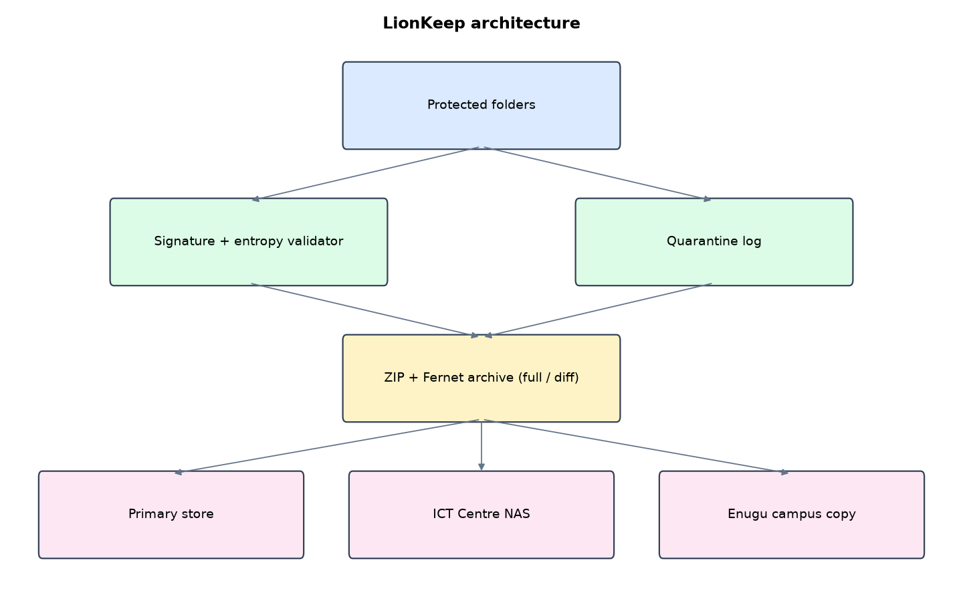
Figure 1: LionKeep architecture (data flows from top to bottom)
Table 5: Software components
File | Responsibility
core.py | Archives, validation, quarantine, GFS rotation, verify, restore, monitoring, hash-linked log
app.py | Flask dashboard, roles, lockout, scheduler
demo.py | Synthetic UNN records and simulations
main.py / selftest.py | Commands and tests

The main design decisions, and how they differ from the earlier VarsityShield and Zaman Lafiya projects, are:
- Flask web dashboard with three roles: admin (restore), operator (backup and verify), viewer (read only).
- Full + differential archives. A full ZIP holds everything. Each differential holds only files changed since the last full, so a restore never needs more than two archives.
- Fernet encryption (AES-128-CBC with HMAC-SHA256) under a key derived by PBKDF2 with 600,000 iterations and a random salt.
- Grandfather-Father-Son retention: 7 daily sons, 5 Friday fathers, 12 month-end grandfathers.
- File-signature and entropy validation. PDFs must start with %PDF, CSVs must still be UTF-8 text, and plain files above 7.2 bits per byte are treated as encrypted. Suspicious files are quarantined instead of overwriting the clean copy. Three or more aborts the backup.
- SHA-256 hash-linked activity log and per-account lockout after 5 wrong passwords.

3.4 Security Design
Each threat considered is matched to the control that addresses it. Tests in Chapter Four exercise these controls.
Table 6: Threats and controls
Threat | Control in LionKeep
Ransomware encrypts CSV files in place | UTF-8 and entropy checks quarantine them; three or more abort the backup
A PDF or DOCX is replaced with ciphertext | Magic-byte signature check fails
Archive file damaged on disk | SHA-256 catalogue check fails; replaced from NAS copy
Stolen backup drive | Fernet encryption, PBKDF2 key (600,000 iterations)
Brute-force on an account | Lock for 15 minutes after 5 failures
Viewer tries to restore | Role check returns 403

Cryptographic keys: Fernet (AES-128-CBC with HMAC-SHA256) under a key derived from the operator passphrase with PBKDF2-HMAC-SHA256, 600,000 iterations and a random salt.

3.5 Algorithms

3.5.1 File validation
For each file read the first 64 KiB. If the extension is a known binary type, the leading bytes must match its signature (PDF starts with %PDF, DOCX/XLSX with PK). Text types must decode as UTF-8. Other files must have Shannon entropy at or below 7.2 bits per byte. Failing files are quarantined, their last clean copy stays listed in the manifest.

3.5.2 Full + differential
A full archive holds every file. A differential holds files whose SHA-256 differs from the last full. Restore = unzip the full, overlay the chosen differential, delete files not in the manifest, check every SHA-256.

3.5.3 Grandfather-Father-Son
Month-end archives are grandfathers (keep 12), Fridays are fathers (keep 5), other days are sons (keep 7). A full archive is never deleted while a kept differential depends on it.

3.6 Tools and Technologies
Language: Python 3.10 or newer. Storage: SQLite. Third-party packages: flask, cryptography, psutil. Launchers: Windows batch files (1_SETUP, 2_START, 3_DEMO_MENU, 4_SELFTEST) and run.sh for Linux and macOS.

CHAPTER FOUR: IMPLEMENTATION, TESTING AND RESULTS

4.1 Implementation Environment
The system was developed and tested with Python 3.11 on Linux and is written to run unchanged on Windows 10/11. Its web interface runs at http://127.0.0.1:5102. Setup takes about ten minutes with 1_SETUP.bat; the README in the project folder gives every step and a defence demonstration script.

4.2 Operation and Demonstration
LionKeep protects UNN registry, bursary, results, LMS and payroll files with classic full + differential encrypted archives, three storage copies and Grandfather-Father-Son retention. It checks every file's signature and entropy before backup, keeps suspicious files out of the archives, and watches the student portal.
Table 7: Demonstration scenario used for the defence
Step | Command (python main.py ...) | What is observed
This is UNN's ICT overview. | serve | CPU, memory, disk, services UP, last archive
The portal goes down. | outage | Critical alert, the scheduler restarts it
Ransomware quietly encrypts results. | stealth | Click Differential backup now: aborted. Quarantine page lists 6 files
Full attack. | attack | sample_data shows .locked files and a note
Recover from full + differential. | restore | Archives page, Restore. Files back, restore time shown on Overview
Prove the archives are intact. | verify | Verify all archives: ok count, zero lost. Activity log hash chain INTACT

4.3 Test Plan and Results
The automated test program ran 15 tests. 15 passed.
Table 8: Automated test results
# | Test | Result | Evidence
1 | Full archive holds every file | PASS | 130564 B -> 36492 B in 0.283 s
2 | Differentials are cumulative since the last full | PASS | diff1=1 diff2=2
3 | Single encrypted file is quarantined, rest still backed up | PASS
4 | Restore brings back the last clean copy of the quarantined file | PASS
5 | Quiet attack on 6 CSVs aborts the backup | PASS | {'status': 'aborted', 'suspicious': 6}
6 | Restore after quiet attack is byte-identical | PASS
7 | Loud attack aborts the backup | PASS | {'status': 'aborted', 'suspicious': 15}
8 | Full + differential restore after loud attack is byte-identical | PASS | RTO 0.438 s, chain 2
9 | Damaged archive detected and repaired from NAS copy | PASS | {'ok': 4, 'repaired': ['20261004-163038-263788-full.lk'], 'lost': []}
10 | GFS tiers (31 Oct = grandfather, Fri = father, Tue = son) | PASS
11 | Edited activity log row is detected | PASS
12 | Portal outage detected | PASS
13 | Account locks after 5 wrong passwords | PASS | [200, 200, 200, 200, 200]
14 | Viewer role cannot restore | PASS
15 | POST without CSRF token is rejected | PASS

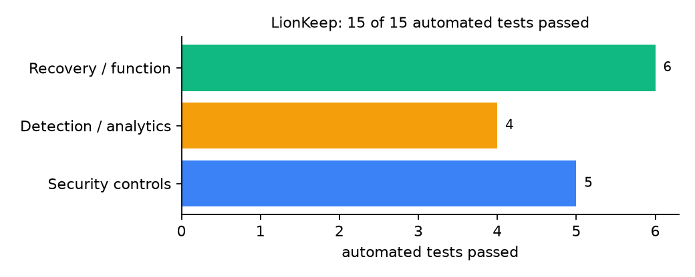
Figure 2: Automated tests by category

4.4 Measured Results
Table 9: Key measurements
Measure | Result
Protected data set | 15 files, 127.5 KiB
Full archive | 127.5 KiB compressed and encrypted to 35.6 KiB in 0.283 s
Differential after 1 change | 1 file, 13.5 KiB
Differential after 2 changes | 2 files (cumulative), 15.2 KiB
Archives used by restore | 2
Recovery time (RTO) measured | 0.438 s, byte-identical: yes

4.5 Discussion
Compression shrank the archive to about 28% of the original because CSV and text records compress well. Most of the 0.2-0.4 s per run is the PBKDF2 key derivation, which is deliberately slow to protect the passphrase. Partial quarantine is the main strength: when one results file was encrypted, the backup still ran for everything else and the clean copy of that file stayed restorable. Differentials grow until the next full archive, which is the price of needing only two archives to restore.
Of the tests, 5 exercised security controls, 4 exercised detection or analytics, and 6 exercised recovery or core function.

CHAPTER FIVE: SUMMARY, CONCLUSION AND RECOMMENDATIONS

5.1 Summary
This project built LionKeep for the University of Nigeria (UNN), Nsukka, Enugu State. Its design combines signature and entropy validation keeps suspicious files out of the archives. It met its objectives and passed all 15 automated tests.

5.2 Conclusion
LionKeep shows that the security problem described in Chapter One can be addressed with free software and modest hardware, provided the design treats recovery as something attackers will target. The limits stated in Section 1.4 still apply.

5.3 Recommendations
- Set LIONKEEP_PASSPHRASE in the environment and delete the demo passphrase file before real use.
- Take the full archive weekly, on Friday night, so it becomes a 'father'.
- Keep the Enugu campus copy on a separate network segment.

5.4 Contribution to Knowledge
This project addresses the gap identified in Chapter Two: Classic differential schedules and modern ransomware gating are usually studied apart. LionKeep shows they can live together on one server at a Nigerian university.

5.5 Suggestions for Further Work
- Add signatures for more university file types (images of certificates, scanned transcripts).
- Send the quarantine list by email to the ICT Director each morning.

REFERENCES
Amoruso, E., Amoruso, P., & Zou, C. (2026). Integrity-gated file monitoring for ransomware resilience and real-time recovery. In 2026 International Conference on Smart Applications, Communications and Networking (SmartNets). IEEE.
Baek, S., Jung, Y., Mohaisen, D., Lee, S., & Nyang, D. (2021). SSD-assisted ransomware detection and data recovery techniques. IEEE Transactions on Computers, 70(10), 1762-1776. https://doi.org/10.1109/TC.2020.3011214
Dotasara, M., & Sharma, A. (2022). MDAS_DBRCC: Data backup and recovery technique in cloud computing for education industry. International Journal on Recent and Innovation Trends in Computing and Communication.
Farouk, S., et al. (2024). Enhancing cybersecurity in Nigeria: A proposed risk management framework for universities. In 2024 International Conference on Science, Engineering and Business for Driving Sustainable Development Goals (SEB4SDG). IEEE.
Ilau, M.-C., Baldwin, A., Caulfield, T., & Pym, D. (2025). Modelling and simulating organizational ransomware recovery: Structure, methodology, and decisions. Journal of Cybersecurity, 11(1), tyaf035. https://doi.org/10.1093/cybsec/tyaf035
Kodali, A., & Sangani. (2026). Automatic ransomware-resilient encrypted backup system using SHA-256 change detection and AES-256-GCM encryption. In 2026 3rd International Conference on Research Methodologies in Knowledge Management, Artificial Intelligence and Telecommunication Engineering (RMKMATE). IEEE.
Kumar, B., Gupta, S. K., & Dwivedi, R. (2026). Artificial intelligence driven approach for securing backup data and enhancing cyber resilience in sustainable smart infrastructure. Scientific Reports. https://doi.org/10.1038/s41598-026-37802-6
Lysetskyi, Y. M. (2025). Choosing an effective data backup and recovery strategy. Mathematical Machines and Systems.
Muthoni, S., Okeyo, G., & Chemwa, G. (2021). Infrastructure as code for business continuity in institutions of higher learning. In 2021 International Conference on Electrical, Computer and Energy Technologies (ICECET). IEEE.
Olugbile, O. H., Ojeniyi, J. A., & Anyachebelu, T. K. (2025). Towards a standard framework for cybersecurity readiness for Nigerian universities. International Journal of Applied Mathematics, Sciences, and Technology for National Defense.
Plaka, R. (2022). Backup & data recovery in cloud computing: A systematic mapping study. Ingenious.
Pragathi, B. C., et al. (2024). Implementing an effective infrastructure monitoring solution with Prometheus and Grafana. International Journal of Computer Applications, 186(38), 7-15.
Rafiq, A., Shakir, M. Z., Gray, D., Inglis, J., & Ferguson, F. (2025). AI and IoT-driven monitoring and visualisation for optimising MSP operations in multi-tenant networks: A modular approach using sensor data integration. Sensors, 25(19), 6248. https://doi.org/10.3390/s25196248
Simili, E., Stewart, G., Roy, G., Skipsey, S., & Britton, D. (2021). A hybrid system for monitoring and automated recovery at the Glasgow Tier-2 cluster. EPJ Web of Conferences, 251, 02047.
Tatineni, S. (2023). Cloud-based business continuity and disaster recovery strategies. International Research Journal of Modernization in Engineering Technology and Science.
Varshney, P. K., & Kumar, R. (2026). A governance-oriented cyber recovery framework for ransomware preparedness and resilience. EDPACS. https://doi.org/10.1080/07366981.2026.2682427
Vinisha, J., Sanjay, R., & Sundar, D. (2025). Automated disaster recovery architecture for educational institutions web infrastructure using hybrid cloud. In 2025 2nd International Conference on Artificial Intelligence and Knowledge Discovery in Concurrent Engineering (ICECONF). IEEE.

Standards and Legal Instruments Consulted
Federal Republic of Nigeria. (2023). Nigeria Data Protection Act, 2023. Nigeria Data Protection Commission.
International Organization for Standardization. (2022). ISO/IEC 27001:2022 Information security, cybersecurity and privacy protection: Information security management systems: Requirements. ISO.
National Institute of Standards and Technology. (2024). The NIST Cybersecurity Framework (CSF) 2.0 (NIST CSWP 29). NIST.

APPENDIX A: HOW TO RUN THE SYSTEM
- Copy the folder backup-recovery/A02-unn-nsukka-lionkeep to the computer.
- Install Python 3.10 or newer with 'Add python.exe to PATH' ticked.
- Double-click 1_SETUP.bat, then 2_START.bat, and open http://127.0.0.1:5102.
- Use 3_DEMO_MENU.bat for the defence demonstration and 4_SELFTEST.bat to regenerate the results in Chapter Four.

APPENDIX B: SOURCE CODE STRUCTURE
Table 10: LionKeep source files
File | Purpose
core.py | Archives, validation, quarantine, GFS rotation, verify, restore, monitoring, hash-linked log
app.py | Flask dashboard, roles, lockout, scheduler
demo.py | Synthetic UNN records and simulations
main.py / selftest.py | Commands and tests

APPENDIX C: CODE EXCERPT
The function validate from core.py, the heart of the design described in Section 3.5.
def validate(path):
"""Return None if the file looks normal, else the reason it is suspicious."""
ext = os.path.splitext(path)[1].lower()
with open(path, "rb") as fh:
head = fh.read(65536)
if ext in SIGNATURES and not any(head.startswith(s) for s in SIGNATURES[ext]):
return f"signature mismatch for {ext}"
if ext in TEXT_TYPES:
try:
head.decode("utf-8")
except UnicodeDecodeError:
return "text file no longer decodes as UTF-8"
if ext not in (".zip", ".docx", ".xlsx", ".png", ".jpg", ".jpeg") and len(head) > 512:
e = entropy(head)
if e > cfg()["entropy_limit"]:
return f"entropy {e:.2f} bits/byte (looks encrypted)"
return None

