[NAME OF YOUR UNIVERSITY]
FACULTY OF [SCIENCE / COMPUTING]
DEPARTMENT OF COMPUTER SCIENCE
CMP 468: COMPUTER SECURITY (2 UNITS)
COURSE PROJECT REPORT
PREMIERGUARD: DE-DUPLICATED, MERKLE-VERIFIED SNAPSHOT BACKUP FOR THE UNIVERSITY OF IBADAN
Content-defined chunking, ChaCha20-Poly1305 and a compressibility-based ransomware detector
BY
[FULL NAME]
MATRIC NO: [MATRIC NUMBER]
SUBMITTED TO
[COURSE LECTURER'S NAME]
IN PARTIAL FULFILMENT OF THE REQUIREMENTS OF CMP 468
400 LEVEL, SECOND SEMESTER, 2025/2026 SESSION
OCTOBER 2026

DECLARATION
I declare that this project report and the accompanying software were written by me as part of the requirements of CMP 468 (Computer Security). Every source used has been cited. All literature cited in this report was published between 2021 and 2026. All test results reported in Chapter Four were produced by the automated test program supplied with the software.
Signature: ____________________ Date: ____________________

ABSTRACT
Universities in Nigeria run admissions, fees, results, learning and payroll on computers that can fail or be attacked. This project designed, built and tested PremierGuard for the University of Ibadan (UI), Ibadan, Oyo State. Its design combines content-defined chunking, ChaCha20-Poly1305 and a compressibility-based ransomware detector. The system was implemented in Python and evaluated with an automated test suite that simulates outages, quiet and loud ransomware, tampering and misuse. All 15 tests passed. Key measurements: Protected data set: 15 files, 123.4 KiB; First snapshot: 18 chunks, stored 23.9 KiB in 0.072 s; Unchanged snapshot: 0 new chunks; Insert one line at the top of a 250 KB file: 1 new chunk of 31. The design shows that a Nigerian university ICT unit can protect its records with free software on ordinary hardware.
Keywords: backup and recovery, ransomware, encryption, integrity, monitoring, RTO, Nigerian universities, NDPA 2023.

TABLE OF CONTENTS
Right-click here and choose Update Field to build the table of contents.

CHAPTER ONE: INTRODUCTION

1.1 Background of the Study
UI keeps large, slowly changing collections: decades of results, theses in the Kenneth Dike Library, and lecture material that is edited a little every session. Copying everything every night wastes disk and time, and fixed-block de-duplication fails when one line is inserted near the top of a file.
Ransomware changed what backup means. Older plans assumed that disks fail by accident; modern attackers encrypt production data and then go after the backups. Recovery is therefore a security function, matching the Recover function of the NIST Cybersecurity Framework 2.0 (2024). The Nigeria Data Protection Act 2023 also makes the university a data controller that must keep personal data confidential, accurate and available.

1.2 Statement of the Problem
- Nightly full copies waste storage on files that hardly change.
- Simple block de-duplication breaks when text is inserted.
- There is no way to prove later that a snapshot has not been altered.
- Ransomware output is backed up without question.

1.3 Aim and Objectives
The aim is to design, implement and evaluate PremierGuard, a secure system for the University of Ibadan (UI), Ibadan, Oyo State. The objectives are to:
- split files into content-defined chunks and store each unique chunk once;
- encrypt chunks with ChaCha20-Poly1305 and keyed chunk IDs;
- seal each snapshot with a Merkle root kept at a separate anchor location;
- block snapshots when text files stop compressing like text;
- provide a JSON API and single-page dashboard; monitor CPU with an adaptive baseline;
- evaluate de-duplication, detection and recovery.

1.4 Scope and Limitations
Tests used 15 synthetic UI files plus a 250 KB handbook for the chunking experiment. The system was tested on one computer; the README describes deployment on other computers.

1.5 Significance of the Study
PremierGuard gives the University of Ibadan (UI), Ibadan, Oyo State a free, auditable tool that runs on ordinary hardware, and turns CMP 468 topics into working controls. Its automated test suite lets any future maintainer prove that the controls still work.

1.6 Relation to the CMP 468 Course Outline
Table 1: Mapping of CMP 468 topics to PremierGuard
CMP 468 topic | Where it appears in PremierGuard
Overview of security in computing | CIA triad: encryption (confidentiality), hashing and signatures (integrity), copies and restore (availability)
Characteristics of computer intrusion | Ransomware behaviour model: mass modification, new extensions, ransom notes, high-entropy output
Types of security breaches | Data destruction, data tampering, insider deletion of backups, unauthorised access to the console
Classes of attacks | Ransomware, brute-force login, cross-site request forgery, backup tampering
Methods of defence and controls | Preventive, detective and corrective controls listed in Table 3.2
Data security: encryption and decryption | One 256-bit root key; HKDF-SHA256 derives separate keys for chunk IDs, chunk encryption and snapshot trees.
Network security | Service reachability checks, security headers, SameSite cookies
Security policies and standards | Backup and retention policy in config.json; NIST CSF 2.0 Recover; ISO/IEC 27001:2022; NDPA 2023

CHAPTER TWO: LITERATURE REVIEW
This review covers only studies published from 2021 to 2026. Every source was checked against a publisher or index page.

2.1 Conceptual Framework
The study rests on the Confidentiality, Integrity and Availability (CIA) triad. A backup that an attacker can read fails confidentiality; one that can be silently altered fails integrity; one that cannot be restored in time fails availability. Two measures turn availability into numbers: the Recovery Point Objective (how much data may be lost) and the Recovery Time Objective (how long restoration may take).

2.2 Cybersecurity in Nigerian universities
Nigerian work on university cybersecurity agrees that the weak points are after an attack starts, not only before it. Olugbile et al. (2025) used Design Science Research to build cybersecurity readiness tiers for Nigerian universities covering pre-event, event-management and post-event factors, and named inadequate funding, weak infrastructure, poor training and a shortage of professionals as the main obstacles. Farouk et al. (2024) note that Nigerian universities lack scientifically derived frameworks for managing cyber risk and propose situational crime prevention as one. Neither study builds or measures a working recovery system, which leaves room for the practical contribution of this project.

2.3 Monitoring and automated response
Open-source monitoring stacks dominate recent practice. Simili et al. (2021) combined Prometheus, Loki and Grafana at a university computing cluster and added an alerting application that performs simple recovery actions for known problems, so that staff intervene less often. Pragathi et al. (2024) deployed Prometheus, Grafana and Node Exporter on Kubernetes and reported shorter deployment time and lower operating cost. Rafiq et al. (2025) ran five Prometheus instances on Raspberry Pi edge nodes to watch about 500 network elements in five client organisations, adding machine-learning anomaly prediction and alert routing. The common lesson is that monitoring pays off when it triggers action automatically, and that small teams benefit most.

2.4 Backup strategy and disaster recovery
Lysetskyi (2025) recommends the 3-2-1-1-0 rule with an air-gapped copy, because backups that cannot be reached from the network survive ransomware. Plaka (2022) mapped 45 studies (2010-2020) on backup and disaster recovery and catalogued their causes, techniques, and privacy and security issues. Tatineni (2023) lists risk assessment, backup, duplication and failover as the core of a disaster recovery plan. Education-specific studies add cost and skills constraints. Muthoni et al. (2021) found that African universities, Kenyan ones in particular, are slow to adopt cloud business continuity, and showed with Ansible and Terraform that infrastructure as code reduced cost, effort and human error when recovering a local data centre to the cloud. Vinisha et al. (2025) gave smaller colleges with one on-premises web server an on-demand cloud standby that health checks start automatically when the main server fails. Dotasara and Sharma (2022) compress and encrypt education data before storing it in the cloud.

2.5 Ransomware-resilient recovery
Recent work moves from detection alone to guaranteed recovery. Baek et al. (2021) built ransomware detection and recovery into SSD firmware (SSD-Insider++): the drive watches I/O patterns and uses delayed deletion to restore original data, reporting 0% false rates in most cases and recovery with no data loss. The approach needs special drive firmware. Kodali and Sangani (2026) combined SHA-256 change detection with AES-256-GCM encryption in an automatic, ransomware-resilient backup tool. Amoruso et al. (2026) proposed integrity-gated file monitoring, in which changed files must pass integrity checks before they are trusted, as a route to ransomware resilience and real-time recovery. Varshney and Kumar (2026) treat fast, trustworthy restoration as a first-class security goal: behavioural detection (97.4% accuracy at a 3.1% false-positive rate), an isolated immutable vault and an automated orchestrator that finds a verified clean recovery point. Kumar et al. (2026) argue that backup integrity must be verified before restoration, and report 98.65% accuracy for their AI-assisted integrity-verification and ransomware-detection pipeline. Ilau et al. (2025) modelled ransomware recovery in a medium-sized organisation and compared recovery strategies over 9,000 parameter configurations (450,000 simulation runs).

2.6 Work Closest to This Design
Where Kodali and Sangani (2026) detect change with whole-file SHA-256, PremierGuard detects it at chunk level, so a small edit to a large file costs one chunk. Kumar et al. (2026) verify integrity before restoration; PremierGuard does the same with a Merkle root compared against an anchor kept elsewhere. Plaka (2022) lists data integrity as an open problem; the anchor gives a cheap, checkable answer.

2.7 Summary of Reviewed Works and Research Gap
Table 2: Summary of reviewed works
Study | What it contributes
Amoruso (2026) | proposed integrity-gated file monitoring, in which changed files must pass integrity checks before they are trusted, as a route to ransomware resilience and rea
Baek (2021) | built ransomware detection and recovery into SSD firmware (SSD-Insider++): the drive watches I/O patterns and uses delayed deletion to restore original data, re
Dotasara (2022) | compress and encrypt education data before storing it in the cloud.
Farouk (2024) | note that Nigerian universities lack scientifically derived frameworks for managing cyber risk and propose situational crime prevention as one.
Ilau (2025) | modelled ransomware recovery in a medium-sized organisation and compared recovery strategies over 9,000 parameter configurations (450,000 simulation runs).
Kodali (2026) | combined SHA-256 change detection with AES-256-GCM encryption in an automatic, ransomware-resilient backup tool.
Kumar (2026) | argue that backup integrity must be verified before restoration, and report 98.65% accuracy for their AI-assisted integrity-verification and ransomware-detectio
Lysetskyi (2025) | recommends the 3-2-1-1-0 rule with an air-gapped copy, because backups that cannot be reached from the network survive ransomware.
Muthoni (2021) | found that African universities, Kenyan ones in particular, are slow to adopt cloud business continuity, and showed with Ansible and Terraform that infrastructu
Olugbile (2025) | used Design Science Research to build cybersecurity readiness tiers for Nigerian universities covering pre-event, event-management and post-event factors, and n
Plaka (2022) | mapped 45 studies (2010-2020) on backup and disaster recovery and catalogued their causes, techniques, and privacy and security issues.
Pragathi (2024) | deployed Prometheus, Grafana and Node Exporter on Kubernetes and reported shorter deployment time and lower operating cost.
Rafiq (2025) | ran five Prometheus instances on Raspberry Pi edge nodes to watch about 500 network elements in five client organisations, adding machine-learning anomaly predi
Simili (2021) | combined Prometheus, Loki and Grafana at a university computing cluster and added an alerting application that performs simple recovery actions for known proble
Tatineni (2023) | lists risk assessment, backup, duplication and failover as the core of a disaster recovery plan.
Varshney (2026) | treat fast, trustworthy restoration as a first-class security goal: behavioural detection (97.4% accuracy at a 3.1% false-positive rate), an isolated immutable
Vinisha (2025) | gave smaller colleges with one on-premises web server an on-demand cloud standby that health checks start automatically when the main server fails.

Research gap. Content-defined de-duplication, Merkle anchoring and a ransomware gate are rarely combined in a tool small enough for a single university server.

CHAPTER THREE: METHODOLOGY AND SYSTEM DESIGN

3.1 Research Methodology
The project follows Design Science Research: identify the problem, define objectives, design and build an artefact, demonstrate it, and evaluate it. Evaluation uses an automated test program (selftest.py) that resets the system, runs normal use, simulated attacks and failures, and records each outcome and measurement in results/selftest.json. Data are synthetic university records.

3.2 Requirements
Table 3: Functional requirements
# | Requirement
FR1 | Snapshot with content-defined chunking
FR2 | Store each unique chunk once
FR3 | Block snapshots with three or more encrypted-looking files
FR4 | Verify Merkle roots and chunks, repair from mirrors
FR5 | Restore any snapshot
FR6 | Garbage-collect unreferenced chunks
FR7 | Monitor CPU with EWMA, probe services

Table 4: Non-functional requirements
# | Requirement
NFR1 | JSON API with header-based CSRF token
NFR2 | Roles: admin and observer
NFR3 | Standard Python plus Flask and cryptography

3.3 System Architecture
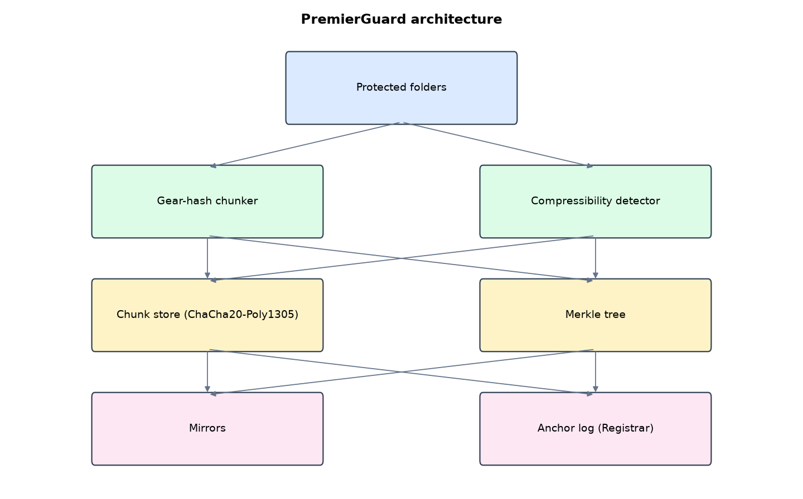
Figure 1: PremierGuard architecture (data flows from top to bottom)
Table 5: Software components
File | Responsibility
engine.py | Chunking, encryption, Merkle trees, detector, snapshots, verify, restore, GC, monitoring
server.py | JSON API, single-page dashboard, scheduler
demo.py | Synthetic UI records and simulations
main.py / selftest.py | Commands and tests

The main design decisions, and how they differ from the earlier VarsityShield and Zaman Lafiya projects, are:
- Single-page dashboard over a JSON API. The browser calls the API with fetch(). Every POST needs an X-CSRF-Token header.
- Content-defined chunking with a Gear rolling hash (2 KiB to 64 KiB chunks, about 8 KiB average). Inserting one line at the start of a 250 KB file changed 1 chunk out of 31 in testing.
- De-duplication with keyed chunk IDs (HMAC-SHA256), so the store does not reveal whether a known file is inside.
- ChaCha20-Poly1305 per chunk, keys derived from one root key with HKDF-SHA256 (separate keys for chunk IDs, chunk data and snapshot trees).
- Merkle tree per snapshot. The root is written to an anchor log kept elsewhere (the Registrar's office in the demo). Restore refuses a tree whose root does not match.
- Compressibility detector. CSV and text files normally compress to under 40%. Ciphertext does not compress. Three or more incompressible text files block the snapshot.
- EWMA CPU baseline instead of a fixed threshold.

3.4 Security Design
Each threat considered is matched to the control that addresses it. Tests in Chapter Four exercise these controls.
Table 6: Threats and controls
Threat | Control in PremierGuard
Ransomware encrypts CSVs quietly | Incompressible text detected; snapshot blocked
Corrupted chunk | Poly1305 tag and keyed ID fail; repaired from mirror
Snapshot tree swapped or edited | Merkle root differs from the anchor; restore refused
Attacker tests whether a known file is stored | Chunk IDs are HMAC-keyed, not plain hashes
Forged API call from another site | X-CSRF-Token header required

Cryptographic keys: One 256-bit root key; HKDF-SHA256 derives separate keys for chunk IDs, chunk encryption and snapshot trees.

3.5 Algorithms

3.5.1 Gear content-defined chunking
Roll h = (h << 1) + GEAR[byte] over the file. Cut a chunk when the top 13 bits of h are zero (average about 8 KiB), never below 2 KiB or above 64 KiB. Because cuts depend on content, an insertion changes only nearby chunks.

3.5.2 Compressibility detector
For CSV, TXT, SQL, JSON and similar files over 1 KiB, compress with zlib level 1. Text normally shrinks below 40%; a ratio above 0.95 means ciphertext. Three such files block the snapshot.

3.5.3 Merkle anchoring
Leaves are 'path:chunk-ids' strings. Pairs are hashed upward with SHA-256 to one root. The root is appended to an anchor log held by the Registrar's office. Verify and restore recompute the root and compare.

3.6 Tools and Technologies
Language: Python 3.10 or newer. Storage: SQLite. Third-party packages: flask, cryptography, psutil. Launchers: Windows batch files (1_SETUP, 2_START, 3_DEMO_MENU, 4_SELFTEST) and run.sh for Linux and macOS.

CHAPTER FOUR: IMPLEMENTATION, TESTING AND RESULTS

4.1 Implementation Environment
The system was developed and tested with Python 3.11 on Linux and is written to run unchanged on Windows 10/11. Its web interface runs at http://127.0.0.1:5103. Setup takes about ten minutes with 1_SETUP.bat; the README in the project folder gives every step and a defence demonstration script.

4.2 Operation and Demonstration
PremierGuard cuts every protected file into content-defined chunks, stores each unique chunk once (encrypted with ChaCha20-Poly1305), and seals each snapshot with a Merkle root that is copied to a separate anchor location. It blocks snapshots when files stop compressing like text, which is how encrypted ransomware output behaves, and it monitors the student portal with an adaptive CPU baseline.
Table 7: Demonstration scenario used for the defence
Step | Command (python main.py ...) | What is observed
This is UI's live dashboard. | serve | CPU with its normal level, portal UP, de-dup saving
The portal fails. | outage | DOWN event within 15 s, then UP after automatic restart
Quiet ransomware. | stealth | Snapshot now: status blocked, 6 files look encrypted
Loud ransomware. | attack | .locked files and a ransom note in sample_data
Recover. | restore | Restore on the newest ok snapshot. Files back byte-for-byte
Prove nothing was altered. | verify | Snapshots and chunks verified against the Merkle anchors

4.3 Test Plan and Results
The automated test program ran 15 tests. 15 passed.
Table 8: Automated test results
# | Test | Result | Evidence
1 | First snapshot stores all files | PASS | 126357 B -> 24515 B, 18 chunks
2 | Unchanged snapshot writes zero new chunks | PASS | 0.067 s
3 | Inserting text at the start changes only a few chunks (CDC) | PASS | 1 new of about 31
4 | Quiet encryption of CSV files is blocked (incompressible content) | PASS | {'status': 'blocked', 'suspects': 6}
5 | Restore after quiet attack is byte-identical | PASS
6 | Loud attack is blocked | PASS | {'status': 'blocked', 'suspects': 16}
7 | Recovery after loud attack is byte-identical | PASS | RTO 0.011 s
8 | Corrupted chunk detected and repaired from mirror | PASS | ['f7826bf6a0d0']
9 | Mismatched Merkle anchor is reported | PASS
10 | Garbage collection keeps newest snapshots restorable | PASS
11 | Portal outage detected | PASS
12 | Wrong password refused | PASS
13 | POST without CSRF header refused | PASS
14 | POST with CSRF header accepted | PASS
15 | Observer cannot restore | PASS

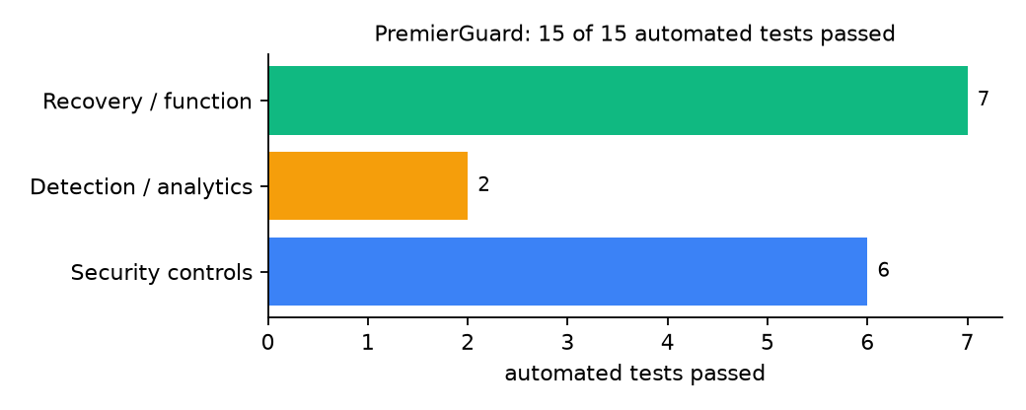
Figure 2: Automated tests by category

4.4 Measured Results
Table 9: Key measurements
Measure | Result
Protected data set | 15 files, 123.4 KiB
First snapshot | 18 chunks, stored 23.9 KiB in 0.072 s
Unchanged snapshot | 0 new chunks
Insert one line at the top of a 250 KB file | 1 new chunk of 31
Storage saved by de-duplication and compression | 92.9%
Recovery time (RTO) measured | 0.011 s, byte-identical: yes

4.5 Discussion
An early version cut chunks on the low bits of the Gear hash and failed the insertion test: repetitive text never produced a cut, so every chunk was forced at 64 KiB and shifted. Testing on the top 13 bits fixed it (1 new chunk of 31). This shows why the self-test exists. Chunking in pure Python is slow for gigabytes; production use would need a compiled chunker. The compressibility detector is simple and strong for text, but it cannot judge files that are already compressed (ZIP, JPEG), which therefore skip the check.
Of the tests, 6 exercised security controls, 2 exercised detection or analytics, and 7 exercised recovery or core function.

CHAPTER FIVE: SUMMARY, CONCLUSION AND RECOMMENDATIONS

5.1 Summary
This project built PremierGuard for the University of Ibadan (UI), Ibadan, Oyo State. Its design combines content-defined chunking, ChaCha20-Poly1305 and a compressibility-based ransomware detector. It met its objectives and passed all 15 automated tests.

5.2 Conclusion
PremierGuard shows that the security problem described in Chapter One can be addressed with free software and modest hardware, provided the design treats recovery as something attackers will target. The limits stated in Section 1.4 still apply.

5.3 Recommendations
- Print the anchor log weekly and file it at the Registrar's office.
- Move one mirror to a different campus building.
- Exclude huge media files or move chunking to a compiled library.

5.4 Contribution to Knowledge
This project addresses the gap identified in Chapter Two: Content-defined de-duplication, Merkle anchoring and a ransomware gate are rarely combined in a tool small enough for a single university server.

5.5 Suggestions for Further Work
- Publish Merkle roots to an external timestamping service.
- Add per-user restore of single files from the dashboard.

REFERENCES
Amoruso, E., Amoruso, P., & Zou, C. (2026). Integrity-gated file monitoring for ransomware resilience and real-time recovery. In 2026 International Conference on Smart Applications, Communications and Networking (SmartNets). IEEE.
Baek, S., Jung, Y., Mohaisen, D., Lee, S., & Nyang, D. (2021). SSD-assisted ransomware detection and data recovery techniques. IEEE Transactions on Computers, 70(10), 1762-1776. https://doi.org/10.1109/TC.2020.3011214
Dotasara, M., & Sharma, A. (2022). MDAS_DBRCC: Data backup and recovery technique in cloud computing for education industry. International Journal on Recent and Innovation Trends in Computing and Communication.
Farouk, S., et al. (2024). Enhancing cybersecurity in Nigeria: A proposed risk management framework for universities. In 2024 International Conference on Science, Engineering and Business for Driving Sustainable Development Goals (SEB4SDG). IEEE.
Ilau, M.-C., Baldwin, A., Caulfield, T., & Pym, D. (2025). Modelling and simulating organizational ransomware recovery: Structure, methodology, and decisions. Journal of Cybersecurity, 11(1), tyaf035. https://doi.org/10.1093/cybsec/tyaf035
Kodali, A., & Sangani. (2026). Automatic ransomware-resilient encrypted backup system using SHA-256 change detection and AES-256-GCM encryption. In 2026 3rd International Conference on Research Methodologies in Knowledge Management, Artificial Intelligence and Telecommunication Engineering (RMKMATE). IEEE.
Kumar, B., Gupta, S. K., & Dwivedi, R. (2026). Artificial intelligence driven approach for securing backup data and enhancing cyber resilience in sustainable smart infrastructure. Scientific Reports. https://doi.org/10.1038/s41598-026-37802-6
Lysetskyi, Y. M. (2025). Choosing an effective data backup and recovery strategy. Mathematical Machines and Systems.
Muthoni, S., Okeyo, G., & Chemwa, G. (2021). Infrastructure as code for business continuity in institutions of higher learning. In 2021 International Conference on Electrical, Computer and Energy Technologies (ICECET). IEEE.
Olugbile, O. H., Ojeniyi, J. A., & Anyachebelu, T. K. (2025). Towards a standard framework for cybersecurity readiness for Nigerian universities. International Journal of Applied Mathematics, Sciences, and Technology for National Defense.
Plaka, R. (2022). Backup & data recovery in cloud computing: A systematic mapping study. Ingenious.
Pragathi, B. C., et al. (2024). Implementing an effective infrastructure monitoring solution with Prometheus and Grafana. International Journal of Computer Applications, 186(38), 7-15.
Rafiq, A., Shakir, M. Z., Gray, D., Inglis, J., & Ferguson, F. (2025). AI and IoT-driven monitoring and visualisation for optimising MSP operations in multi-tenant networks: A modular approach using sensor data integration. Sensors, 25(19), 6248. https://doi.org/10.3390/s25196248
Simili, E., Stewart, G., Roy, G., Skipsey, S., & Britton, D. (2021). A hybrid system for monitoring and automated recovery at the Glasgow Tier-2 cluster. EPJ Web of Conferences, 251, 02047.
Tatineni, S. (2023). Cloud-based business continuity and disaster recovery strategies. International Research Journal of Modernization in Engineering Technology and Science.
Varshney, P. K., & Kumar, R. (2026). A governance-oriented cyber recovery framework for ransomware preparedness and resilience. EDPACS. https://doi.org/10.1080/07366981.2026.2682427
Vinisha, J., Sanjay, R., & Sundar, D. (2025). Automated disaster recovery architecture for educational institutions web infrastructure using hybrid cloud. In 2025 2nd International Conference on Artificial Intelligence and Knowledge Discovery in Concurrent Engineering (ICECONF). IEEE.

Standards and Legal Instruments Consulted
Federal Republic of Nigeria. (2023). Nigeria Data Protection Act, 2023. Nigeria Data Protection Commission.
International Organization for Standardization. (2022). ISO/IEC 27001:2022 Information security, cybersecurity and privacy protection: Information security management systems: Requirements. ISO.
National Institute of Standards and Technology. (2024). The NIST Cybersecurity Framework (CSF) 2.0 (NIST CSWP 29). NIST.

APPENDIX A: HOW TO RUN THE SYSTEM
- Copy the folder backup-recovery/A03-ui-ibadan-premierguard to the computer.
- Install Python 3.10 or newer with 'Add python.exe to PATH' ticked.
- Double-click 1_SETUP.bat, then 2_START.bat, and open http://127.0.0.1:5103.
- Use 3_DEMO_MENU.bat for the defence demonstration and 4_SELFTEST.bat to regenerate the results in Chapter Four.

APPENDIX B: SOURCE CODE STRUCTURE
Table 10: PremierGuard source files
File | Purpose
engine.py | Chunking, encryption, Merkle trees, detector, snapshots, verify, restore, GC, monitoring
server.py | JSON API, single-page dashboard, scheduler
demo.py | Synthetic UI records and simulations
main.py / selftest.py | Commands and tests

APPENDIX C: CODE EXCERPT
The function chunk from engine.py, the heart of the design described in Section 3.5.
def chunk(data):
"""Gear-hash content-defined chunking. Returns a list of byte strings."""
out, start, h, n = [], 0, 0, len(data)
i = 0
while i < n:
h = ((h << 1) + GEAR[data[i]]) & 0xFFFFFFFF
size = i - start + 1
if (size >= MIN_CHUNK and (h & AVG_MASK) == 0) or size >= MAX_CHUNK:
out.append(data[start:i + 1])
start, h = i + 1, 0
i += 1
if start < n:
out.append(data[start:])
return out

