[NAME OF YOUR UNIVERSITY]
FACULTY OF [SCIENCE / COMPUTING]
DEPARTMENT OF COMPUTER SCIENCE
CMP 468: COMPUTER SECURITY (2 UNITS)
COURSE PROJECT REPORT
BENINVAULT: ERASURE-CODED ENCRYPTED BACKUP AND SERVICE-LEVEL MONITORING FOR THE UNIVERSITY OF BENIN
Two data shards and one XOR parity shard over three sites, with scrubbing and SLA tracking
BY
[FULL NAME]
MATRIC NO: [MATRIC NUMBER]
SUBMITTED TO
[COURSE LECTURER'S NAME]
IN PARTIAL FULFILMENT OF THE REQUIREMENTS OF CMP 468
400 LEVEL, SECOND SEMESTER, 2025/2026 SESSION
OCTOBER 2026

DECLARATION
I declare that this project report and the accompanying software were written by me as part of the requirements of CMP 468 (Computer Security). Every source used has been cited. All literature cited in this report was published between 2021 and 2026. All test results reported in Chapter Four were produced by the automated test program supplied with the software.
Signature: ____________________ Date: ____________________

ABSTRACT
Universities in Nigeria run admissions, fees, results, learning and payroll on computers that can fail or be attacked. This project designed, built and tested BeninVault for the University of Benin (UNIBEN), Benin City, Edo State. Its design combines two data shards and one XOR parity shard over three sites, with scrubbing and SLA tracking. The system was implemented in Python and evaluated with an automated test suite that simulates outages, quiet and loud ransomware, tampering and misuse. All 17 tests passed. Key measurements: Protected data set: 15 files, 128.7 KiB; Encrypted archive: 26.1 KiB in 0.112 s; Each shard: 13.0 KiB; Storage overhead over one archive: 50.0% (three full copies would be 200%). The design shows that a Nigerian university ICT unit can protect its records with free software on ordinary hardware.
Keywords: backup and recovery, ransomware, encryption, integrity, monitoring, RTO, Nigerian universities, NDPA 2023.

TABLE OF CONTENTS
Right-click here and choose Update Field to build the table of contents.

CHAPTER ONE: INTRODUCTION

1.1 Background of the Study
UNIBEN has two main campuses, Ugbowo and Ekehuan. Keeping three full copies of every backup triples storage cost, while keeping one copy means a single fire or theft can destroy it. Management also asks a question the ICT team cannot answer: how many hours was the portal actually up this month?
Ransomware changed what backup means. Older plans assumed that disks fail by accident; modern attackers encrypt production data and then go after the backups. Recovery is therefore a security function, matching the Recover function of the NIST Cybersecurity Framework 2.0 (2024). The Nigeria Data Protection Act 2023 also makes the university a data controller that must keep personal data confidential, accurate and available.

1.2 Statement of the Problem
- Three full copies are too expensive; one copy is too risky.
- Damaged backup copies are discovered only during a crisis.
- Ransomware that renames files is not noticed until students complain.
- There is no uptime figure to compare with a service target.

1.3 Aim and Objectives
The aim is to design, implement and evaluate BeninVault, a secure system for the University of Benin (UNIBEN), Benin City, Edo State. The objectives are to:
- split each encrypted backup into two data shards and one parity shard on three sites;
- rebuild a missing or damaged shard automatically (scrubbing);
- refuse backups that show rename bursts, ransom notes or unreadable text;
- track service uptime against SLA targets;
- provide a Flask console with roles and a hash-linked trail;
- evaluate loss of each site and attack recovery.

1.4 Scope and Limitations
Three directories stand in for the three sites in the demonstration; in production they are mounts of different buildings or a cloud bucket. The system was tested on one computer; the README describes deployment on other computers.

1.5 Significance of the Study
BeninVault gives the University of Benin (UNIBEN), Benin City, Edo State a free, auditable tool that runs on ordinary hardware, and turns CMP 468 topics into working controls. Its automated test suite lets any future maintainer prove that the controls still work.

1.6 Relation to the CMP 468 Course Outline
Table 1: Mapping of CMP 468 topics to BeninVault
CMP 468 topic | Where it appears in BeninVault
Overview of security in computing | CIA triad: encryption (confidentiality), hashing and signatures (integrity), copies and restore (availability)
Characteristics of computer intrusion | Ransomware behaviour model: mass modification, new extensions, ransom notes, high-entropy output
Types of security breaches | Data destruction, data tampering, insider deletion of backups, unauthorised access to the console
Classes of attacks | Ransomware, brute-force login, cross-site request forgery, backup tampering
Methods of defence and controls | Preventive, detective and corrective controls listed in Table 3.2
Data security: encryption and decryption | scrypt (n = 2^15, r = 8, p = 1) derives the AES-256-GCM key from a passphrase and random salt; the backup ID is associated data.
Network security | Service reachability checks, security headers, SameSite cookies
Security policies and standards | Backup and retention policy in config.json; NIST CSF 2.0 Recover; ISO/IEC 27001:2022; NDPA 2023

CHAPTER TWO: LITERATURE REVIEW
This review covers only studies published from 2021 to 2026. Every source was checked against a publisher or index page.

2.1 Conceptual Framework
The study rests on the Confidentiality, Integrity and Availability (CIA) triad. A backup that an attacker can read fails confidentiality; one that can be silently altered fails integrity; one that cannot be restored in time fails availability. Two measures turn availability into numbers: the Recovery Point Objective (how much data may be lost) and the Recovery Time Objective (how long restoration may take).

2.2 Cybersecurity in Nigerian universities
Nigerian work on university cybersecurity agrees that the weak points are after an attack starts, not only before it. Olugbile et al. (2025) used Design Science Research to build cybersecurity readiness tiers for Nigerian universities covering pre-event, event-management and post-event factors, and named inadequate funding, weak infrastructure, poor training and a shortage of professionals as the main obstacles. Farouk et al. (2024) note that Nigerian universities lack scientifically derived frameworks for managing cyber risk and propose situational crime prevention as one. Neither study builds or measures a working recovery system, which leaves room for the practical contribution of this project.

2.3 Monitoring and automated response
Open-source monitoring stacks dominate recent practice. Simili et al. (2021) combined Prometheus, Loki and Grafana at a university computing cluster and added an alerting application that performs simple recovery actions for known problems, so that staff intervene less often. Pragathi et al. (2024) deployed Prometheus, Grafana and Node Exporter on Kubernetes and reported shorter deployment time and lower operating cost. Rafiq et al. (2025) ran five Prometheus instances on Raspberry Pi edge nodes to watch about 500 network elements in five client organisations, adding machine-learning anomaly prediction and alert routing. The common lesson is that monitoring pays off when it triggers action automatically, and that small teams benefit most.

2.4 Backup strategy and disaster recovery
Lysetskyi (2025) recommends the 3-2-1-1-0 rule with an air-gapped copy, because backups that cannot be reached from the network survive ransomware. Plaka (2022) mapped 45 studies (2010-2020) on backup and disaster recovery and catalogued their causes, techniques, and privacy and security issues. Tatineni (2023) lists risk assessment, backup, duplication and failover as the core of a disaster recovery plan. Education-specific studies add cost and skills constraints. Muthoni et al. (2021) found that African universities, Kenyan ones in particular, are slow to adopt cloud business continuity, and showed with Ansible and Terraform that infrastructure as code reduced cost, effort and human error when recovering a local data centre to the cloud. Vinisha et al. (2025) gave smaller colleges with one on-premises web server an on-demand cloud standby that health checks start automatically when the main server fails. Dotasara and Sharma (2022) compress and encrypt education data before storing it in the cloud.

2.5 Ransomware-resilient recovery
Recent work moves from detection alone to guaranteed recovery. Baek et al. (2021) built ransomware detection and recovery into SSD firmware (SSD-Insider++): the drive watches I/O patterns and uses delayed deletion to restore original data, reporting 0% false rates in most cases and recovery with no data loss. The approach needs special drive firmware. Kodali and Sangani (2026) combined SHA-256 change detection with AES-256-GCM encryption in an automatic, ransomware-resilient backup tool. Amoruso et al. (2026) proposed integrity-gated file monitoring, in which changed files must pass integrity checks before they are trusted, as a route to ransomware resilience and real-time recovery. Varshney and Kumar (2026) treat fast, trustworthy restoration as a first-class security goal: behavioural detection (97.4% accuracy at a 3.1% false-positive rate), an isolated immutable vault and an automated orchestrator that finds a verified clean recovery point. Kumar et al. (2026) argue that backup integrity must be verified before restoration, and report 98.65% accuracy for their AI-assisted integrity-verification and ransomware-detection pipeline. Ilau et al. (2025) modelled ransomware recovery in a medium-sized organisation and compared recovery strategies over 9,000 parameter configurations (450,000 simulation runs).

2.6 Work Closest to This Design
Lysetskyi (2025) and Tatineni (2023) rely on multiple full copies. BeninVault reaches the same survive-one-site goal with 1.5 times the storage instead of 3 times. Plaka (2022) names integrity of stored backups as an open issue; per-shard SHA-256 and scheduled scrubbing address it directly.

2.7 Summary of Reviewed Works and Research Gap
Table 2: Summary of reviewed works
Study | What it contributes
Amoruso (2026) | proposed integrity-gated file monitoring, in which changed files must pass integrity checks before they are trusted, as a route to ransomware resilience and rea
Baek (2021) | built ransomware detection and recovery into SSD firmware (SSD-Insider++): the drive watches I/O patterns and uses delayed deletion to restore original data, re
Dotasara (2022) | compress and encrypt education data before storing it in the cloud.
Farouk (2024) | note that Nigerian universities lack scientifically derived frameworks for managing cyber risk and propose situational crime prevention as one.
Ilau (2025) | modelled ransomware recovery in a medium-sized organisation and compared recovery strategies over 9,000 parameter configurations (450,000 simulation runs).
Kodali (2026) | combined SHA-256 change detection with AES-256-GCM encryption in an automatic, ransomware-resilient backup tool.
Kumar (2026) | argue that backup integrity must be verified before restoration, and report 98.65% accuracy for their AI-assisted integrity-verification and ransomware-detectio
Lysetskyi (2025) | recommends the 3-2-1-1-0 rule with an air-gapped copy, because backups that cannot be reached from the network survive ransomware.
Muthoni (2021) | found that African universities, Kenyan ones in particular, are slow to adopt cloud business continuity, and showed with Ansible and Terraform that infrastructu
Olugbile (2025) | used Design Science Research to build cybersecurity readiness tiers for Nigerian universities covering pre-event, event-management and post-event factors, and n
Plaka (2022) | mapped 45 studies (2010-2020) on backup and disaster recovery and catalogued their causes, techniques, and privacy and security issues.
Pragathi (2024) | deployed Prometheus, Grafana and Node Exporter on Kubernetes and reported shorter deployment time and lower operating cost.
Rafiq (2025) | ran five Prometheus instances on Raspberry Pi edge nodes to watch about 500 network elements in five client organisations, adding machine-learning anomaly predi
Simili (2021) | combined Prometheus, Loki and Grafana at a university computing cluster and added an alerting application that performs simple recovery actions for known proble
Tatineni (2023) | lists risk assessment, backup, duplication and failover as the core of a disaster recovery plan.
Varshney (2026) | treat fast, trustworthy restoration as a first-class security goal: behavioural detection (97.4% accuracy at a 3.1% false-positive rate), an isolated immutable
Vinisha (2025) | gave smaller colleges with one on-premises web server an on-demand cloud standby that health checks start automatically when the main server fails.

Research gap. Erasure coding is common in large storage systems but absent from the reviewed university backup work.

CHAPTER THREE: METHODOLOGY AND SYSTEM DESIGN

3.1 Research Methodology
The project follows Design Science Research: identify the problem, define objectives, design and build an artefact, demonstrate it, and evaluate it. Evaluation uses an automated test program (selftest.py) that resets the system, runs normal use, simulated attacks and failures, and records each outcome and measurement in results/selftest.json. Data are synthetic university records.

3.2 Requirements
Table 3: Functional requirements
# | Requirement
FR1 | Encrypt and split each backup into A, B and P shards
FR2 | Restore from any two healthy shards
FR3 | Scrub: rebuild missing or damaged shards
FR4 | Refuse backups showing ransomware signs
FR5 | Uptime per service against SLA
FR6 | Roles: admin and auditor

Table 4: Non-functional requirements
# | Requirement
NFR1 | Storage overhead 50% over the archive
NFR2 | Jinja templates for easy changes
NFR3 | Runs on one server

3.3 System Architecture
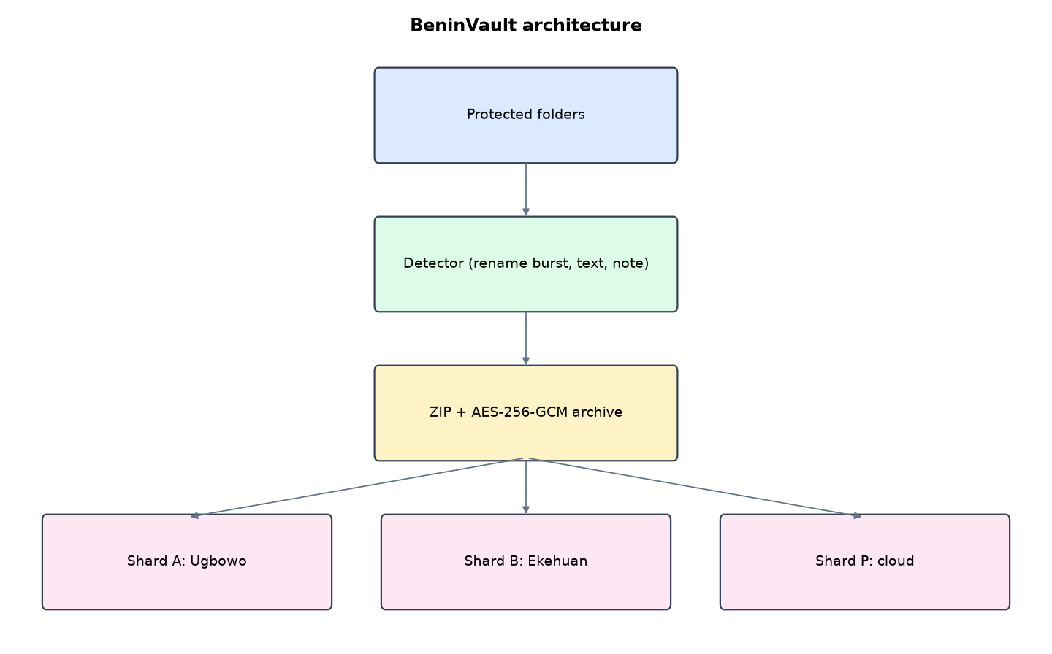
Figure 1: BeninVault architecture (data flows from top to bottom)
Table 5: Software components
File | Responsibility
vault.py | Encryption, erasure coding, scrubbing, detection, restore, SLA
app.py | Flask console and scheduler
templates/ | Jinja page templates
main.py / selftest.py | Commands and tests

The main design decisions, and how they differ from the earlier VarsityShield and Zaman Lafiya projects, are:
- 2 + 1 XOR erasure coding across three sites. Storage cost is 1.5 times the archive, instead of 3 times for three full copies.
- Scrubbing: a scheduled job checks every shard's SHA-256 and rebuilds a missing or damaged shard from the other two.
- AES-256-GCM with the backup ID bound as associated data, key derived by scrypt (n = 2^15, r = 8).
- Rename-burst detector: old file names that reappear with a new extension (students.csv to students.csv.locked) in one interval.
- Printable-text check for CSV and TXT files, plus ransom-note detection.
- SLA uptime chart per service over 24 hours against a target (99.5% for the portal).
- Flask with Jinja template files and a SHA-256 linked activity trail.

3.4 Security Design
Each threat considered is matched to the control that addresses it. Tests in Chapter Four exercise these controls.
Table 6: Threats and controls
Threat | Control in BeninVault
One site destroyed | Restore from the other two shards
Shard silently damaged | SHA-256 per shard; scrub rebuilds
Two sites lost | Reported as unrecoverable instead of restoring wrong data
Rename-style ransomware | Rename burst detector
Stolen shard | Shards are halves or parity of ciphertext; key derived with scrypt
Auditor tries to restore | 403

Cryptographic keys: scrypt (n = 2^15, r = 8, p = 1) derives the AES-256-GCM key from a passphrase and random salt; the backup ID is associated data.

3.5 Algorithms

3.5.1 2 + 1 XOR erasure coding
archive = nonce || AES-GCM(zip). A = first half, B = second half padded, P = A XOR B. Any one missing shard is rebuilt: A = B XOR P or B = A XOR P. Each shard's SHA-256 is stored in the catalogue.

3.5.2 Scrubbing
For every backup: read the three shards, keep those whose hash matches; if two remain, rebuild the archive and rewrite the missing shard; if fewer than two remain, raise a critical alert.

3.5.3 Rename-burst detection
An old file name that now exists only as a stem of a new name (students.csv to students.csv.locked) counts as renamed; three or more in one interval refuse the backup.

3.6 Tools and Technologies
Language: Python 3.10 or newer. Storage: SQLite. Third-party packages: flask, cryptography. Launchers: Windows batch files (1_SETUP, 2_START, 3_DEMO_MENU, 4_SELFTEST) and run.sh for Linux and macOS.

CHAPTER FOUR: IMPLEMENTATION, TESTING AND RESULTS

4.1 Implementation Environment
The system was developed and tested with Python 3.11 on Linux and is written to run unchanged on Windows 10/11. Its web interface runs at http://127.0.0.1:5105. Setup takes about ten minutes with 1_SETUP.bat; the README in the project folder gives every step and a defence demonstration script.

4.2 Operation and Demonstration
BeninVault encrypts each backup and splits it into two data shards and one parity shard stored in three different places (Ugbowo ICT Centre, Ekehuan campus, and a cloud bucket). Any one place can burn, flood or be stolen and the backup still restores. It refuses backups that show a rename burst, a ransom note or unreadable text files, and it reports each service's uptime against its SLA target.
Table 7: Demonstration scenario used for the defence
Step | Command (python main.py ...) | What is observed
UNIBEN's backups live in three buildings. | serve | Three site cards, SLA bars green
The ICT Centre server room burns. | lose-site A | Site A card shows missing shards
We still restore everything. | restore | Restore uses shards B and P. Files byte-identical
And we rebuild the lost site. | scrub | Scrub rebuilt N shards. Site A healthy again
Ransomware renames our files. | attack | Back up now: refused, rename burst and ransom note
The portal goes down for a while. | outage | SLA bar for the portal turns red below the 99.5% line

4.3 Test Plan and Results
The automated test program ran 17 tests. 17 passed.
Table 8: Automated test results
# | Test | Result | Evidence
1 | Backup split into 3 shards, each about half the archive | PASS | 26689 B archive -> 3 x 13345 B
2 | Restore works with site A lost | PASS | ['B', 'P']
3 | Restore works with site B lost | PASS | ['A', 'P']
4 | Restore works with site P lost | PASS | ['A', 'B']
5 | Losing two sites is reported, not silently wrong | PASS
6 | Scrub sees 1 healthy shard + 1 damaged + 1 missing as unrecoverable | PASS
7 | Scrub rebuilds a missing parity shard | PASS | {'healthy': 0, 'rebuilt': ['20261004163051396673.P'], 'unrecoverable': []}
8 | All three shards healthy after scrub | PASS
9 | Quiet attack refused (text files unreadable) | PASS | ['6 text files are no longer readable text']
10 | Restore after quiet attack is byte-identical | PASS
11 | Loud attack refused (rename burst + ransom note) | PASS | ['rename burst: 15 files got a new extension (e.g. lms/CSC468_lecture_08.txt)', 'ransom note found']
12 | Recovery after loud attack is byte-identical | PASS | RTO 0.005 s
13 | SLA computed: 3 of 4 checks up = 75%, below 99.5% target | PASS
14 | Edited trail entry detected | PASS
15 | Auditor cannot trigger restore | PASS
16 | Admin POST without CSRF token refused | PASS
17 | Pages render | PASS

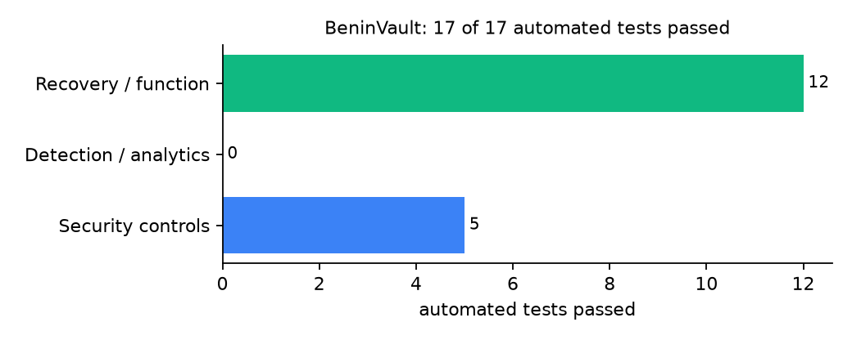
Figure 2: Automated tests by category

4.4 Measured Results
Table 9: Key measurements
Measure | Result
Protected data set | 15 files, 128.7 KiB
Encrypted archive | 26.1 KiB in 0.112 s
Each shard | 13.0 KiB
Storage overhead over one archive | 50.0% (three full copies would be 200%)
Recovery time (RTO) measured | 0.005 s, byte-identical: yes
SLA example (3 of 4 checks up) | 75.0% against 99.5% target

4.5 Discussion
Restores succeeded with any one site removed, and losing two sites was reported clearly instead of producing a wrong file. XOR parity tolerates exactly one loss; Reed-Solomon coding would tolerate more at higher complexity. Because shards are made from ciphertext, one stolen shard reveals nothing useful. The SLA figure is only as good as the check interval: a 15-second check cannot see a 5-second outage.
Of the tests, 5 exercised security controls, 0 exercised detection or analytics, and 12 exercised recovery or core function.

CHAPTER FIVE: SUMMARY, CONCLUSION AND RECOMMENDATIONS

5.1 Summary
This project built BeninVault for the University of Benin (UNIBEN), Benin City, Edo State. Its design combines two data shards and one XOR parity shard over three sites, with scrubbing and SLA tracking. It met its objectives and passed all 17 automated tests.

5.2 Conclusion
BeninVault shows that the security problem described in Chapter One can be addressed with free software and modest hardware, provided the design treats recovery as something attackers will target. The limits stated in Section 1.4 still apply.

5.3 Recommendations
- Mount shard P on a cloud bucket with Object Lock, shards A and B in different campus buildings.
- Report monthly uptime to the Vice-Chancellor's office from the SLA chart.
- Run scrub at least daily.

5.4 Contribution to Knowledge
This project addresses the gap identified in Chapter Two: Erasure coding is common in large storage systems but absent from the reviewed university backup work.

5.5 Suggestions for Further Work
- Reed-Solomon (k of n) coding for more sites.
- Incremental archives to reduce shard size.

REFERENCES
Amoruso, E., Amoruso, P., & Zou, C. (2026). Integrity-gated file monitoring for ransomware resilience and real-time recovery. In 2026 International Conference on Smart Applications, Communications and Networking (SmartNets). IEEE.
Baek, S., Jung, Y., Mohaisen, D., Lee, S., & Nyang, D. (2021). SSD-assisted ransomware detection and data recovery techniques. IEEE Transactions on Computers, 70(10), 1762-1776. https://doi.org/10.1109/TC.2020.3011214
Dotasara, M., & Sharma, A. (2022). MDAS_DBRCC: Data backup and recovery technique in cloud computing for education industry. International Journal on Recent and Innovation Trends in Computing and Communication.
Farouk, S., et al. (2024). Enhancing cybersecurity in Nigeria: A proposed risk management framework for universities. In 2024 International Conference on Science, Engineering and Business for Driving Sustainable Development Goals (SEB4SDG). IEEE.
Ilau, M.-C., Baldwin, A., Caulfield, T., & Pym, D. (2025). Modelling and simulating organizational ransomware recovery: Structure, methodology, and decisions. Journal of Cybersecurity, 11(1), tyaf035. https://doi.org/10.1093/cybsec/tyaf035
Kodali, A., & Sangani. (2026). Automatic ransomware-resilient encrypted backup system using SHA-256 change detection and AES-256-GCM encryption. In 2026 3rd International Conference on Research Methodologies in Knowledge Management, Artificial Intelligence and Telecommunication Engineering (RMKMATE). IEEE.
Kumar, B., Gupta, S. K., & Dwivedi, R. (2026). Artificial intelligence driven approach for securing backup data and enhancing cyber resilience in sustainable smart infrastructure. Scientific Reports. https://doi.org/10.1038/s41598-026-37802-6
Lysetskyi, Y. M. (2025). Choosing an effective data backup and recovery strategy. Mathematical Machines and Systems.
Muthoni, S., Okeyo, G., & Chemwa, G. (2021). Infrastructure as code for business continuity in institutions of higher learning. In 2021 International Conference on Electrical, Computer and Energy Technologies (ICECET). IEEE.
Olugbile, O. H., Ojeniyi, J. A., & Anyachebelu, T. K. (2025). Towards a standard framework for cybersecurity readiness for Nigerian universities. International Journal of Applied Mathematics, Sciences, and Technology for National Defense.
Plaka, R. (2022). Backup & data recovery in cloud computing: A systematic mapping study. Ingenious.
Pragathi, B. C., et al. (2024). Implementing an effective infrastructure monitoring solution with Prometheus and Grafana. International Journal of Computer Applications, 186(38), 7-15.
Rafiq, A., Shakir, M. Z., Gray, D., Inglis, J., & Ferguson, F. (2025). AI and IoT-driven monitoring and visualisation for optimising MSP operations in multi-tenant networks: A modular approach using sensor data integration. Sensors, 25(19), 6248. https://doi.org/10.3390/s25196248
Simili, E., Stewart, G., Roy, G., Skipsey, S., & Britton, D. (2021). A hybrid system for monitoring and automated recovery at the Glasgow Tier-2 cluster. EPJ Web of Conferences, 251, 02047.
Tatineni, S. (2023). Cloud-based business continuity and disaster recovery strategies. International Research Journal of Modernization in Engineering Technology and Science.
Varshney, P. K., & Kumar, R. (2026). A governance-oriented cyber recovery framework for ransomware preparedness and resilience. EDPACS. https://doi.org/10.1080/07366981.2026.2682427
Vinisha, J., Sanjay, R., & Sundar, D. (2025). Automated disaster recovery architecture for educational institutions web infrastructure using hybrid cloud. In 2025 2nd International Conference on Artificial Intelligence and Knowledge Discovery in Concurrent Engineering (ICECONF). IEEE.

Standards and Legal Instruments Consulted
Federal Republic of Nigeria. (2023). Nigeria Data Protection Act, 2023. Nigeria Data Protection Commission.
International Organization for Standardization. (2022). ISO/IEC 27001:2022 Information security, cybersecurity and privacy protection: Information security management systems: Requirements. ISO.
National Institute of Standards and Technology. (2024). The NIST Cybersecurity Framework (CSF) 2.0 (NIST CSWP 29). NIST.

APPENDIX A: HOW TO RUN THE SYSTEM
- Copy the folder backup-recovery/A05-uniben-beninvault to the computer.
- Install Python 3.10 or newer with 'Add python.exe to PATH' ticked.
- Double-click 1_SETUP.bat, then 2_START.bat, and open http://127.0.0.1:5105.
- Use 3_DEMO_MENU.bat for the defence demonstration and 4_SELFTEST.bat to regenerate the results in Chapter Four.

APPENDIX B: SOURCE CODE STRUCTURE
Table 10: BeninVault source files
File | Purpose
vault.py | Encryption, erasure coding, scrubbing, detection, restore, SLA
app.py | Flask console and scheduler
templates/ | Jinja page templates
main.py / selftest.py | Commands and tests

APPENDIX C: CODE EXCERPT
The function split from vault.py, the heart of the design described in Section 3.5.
def split(blob):
half = (len(blob) + 1) // 2
a, b = blob[:half], blob[half:].ljust(half, b"\0")
return {"A": a, "B": b, "P": xor(a, b)}

