[NAME OF YOUR UNIVERSITY]
FACULTY OF [SCIENCE / COMPUTING]
DEPARTMENT OF COMPUTER SCIENCE
CMP 468: COMPUTER SECURITY (2 UNITS)
COURSE PROJECT REPORT
SAHELSTORE: LOW-BANDWIDTH, POWER-AWARE BACKUP AND RECOVERY FOR THE UNIVERSITY OF MAIDUGURI
rsync-style delta transfer to an offsite mirror, a daily data budget and an inverter-aware scheduler
BY
[FULL NAME]
MATRIC NO: [MATRIC NUMBER]
SUBMITTED TO
[COURSE LECTURER'S NAME]
IN PARTIAL FULFILMENT OF THE REQUIREMENTS OF CMP 468
400 LEVEL, SECOND SEMESTER, 2025/2026 SESSION
OCTOBER 2026

DECLARATION
I declare that this project report and the accompanying software were written by me as part of the requirements of CMP 468 (Computer Security). Every source used has been cited. All literature cited in this report was published between 2021 and 2026. All test results reported in Chapter Four were produced by the automated test program supplied with the software.
Signature: ____________________ Date: ____________________

ABSTRACT
Universities in Nigeria run admissions, fees, results, learning and payroll on computers that can fail or be attacked. This project designed, built and tested SahelStore for the University of Maiduguri (UNIMAID), Maiduguri, Borno State. Its design combines rsync-style delta transfer to an offsite mirror, a daily data budget and an inverter-aware scheduler. The system was implemented in Python and evaluated with an automated test suite that simulates outages, quiet and loud ransomware, tampering and misuse. All 18 tests passed. Key measurements: Protected data set: 15 files, 130.3 KiB; First snapshot: stored 21.2 KiB in 0.091 s; Delta sync of edited register: 756 bytes sent for 37.1 KiB file; Local recovery time: 0.006 s. The design shows that a Nigerian university ICT unit can protect its records with free software on ordinary hardware.
Keywords: backup and recovery, ransomware, encryption, integrity, monitoring, RTO, Nigerian universities, NDPA 2023.

TABLE OF CONTENTS
Right-click here and choose Update Field to build the table of contents.

CHAPTER ONE: INTRODUCTION

1.1 Background of the Study
UNIMAID works under conditions few backup products expect: long power outages served by inverters and generators, expensive and slow internet, and a security situation in Borno State that makes an offsite copy essential. Sending whole files offsite every night is not affordable, and a backup that runs while the inverter is dying can corrupt data.
Ransomware changed what backup means. Older plans assumed that disks fail by accident; modern attackers encrypt production data and then go after the backups. Recovery is therefore a security function, matching the Recover function of the NIST Cybersecurity Framework 2.0 (2024). The Nigeria Data Protection Act 2023 also makes the university a data controller that must keep personal data confidential, accurate and available.

1.2 Statement of the Problem
- Full offsite copies exceed the bandwidth budget.
- Heavy backup jobs drain the inverter during power cuts.
- There is no plan if the server room itself is lost.
- A web page that can trigger restores is a target.

1.3 Aim and Objectives
The aim is to design, implement and evaluate SahelStore, a secure system for the University of Maiduguri (UNIMAID), Maiduguri, Borno State. The objectives are to:
- keep compressed, encrypted local snapshots;
- send only changed byte ranges offsite within a daily budget and an off-peak window;
- defer heavy jobs on low battery and take one emergency snapshot at a critical level;
- recover everything from the offsite copy if the local store is lost;
- provide a read-only status page; detect bursts of file modification;
- evaluate bandwidth, power behaviour and recovery.

1.4 Scope and Limitations
The offsite mirror is a folder in the demonstration; battery state comes from the laptop or a simulated UPS file. The system was tested on one computer; the README describes deployment on other computers.

1.5 Significance of the Study
SahelStore gives the University of Maiduguri (UNIMAID), Maiduguri, Borno State a free, auditable tool that runs on ordinary hardware, and turns CMP 468 topics into working controls. Its automated test suite lets any future maintainer prove that the controls still work.

1.6 Relation to the CMP 468 Course Outline
Table 1: Mapping of CMP 468 topics to SahelStore
CMP 468 topic | Where it appears in SahelStore
Overview of security in computing | CIA triad: encryption (confidentiality), hashing and signatures (integrity), copies and restore (availability)
Characteristics of computer intrusion | Ransomware behaviour model: mass modification, new extensions, ransom notes, high-entropy output
Types of security breaches | Data destruction, data tampering, insider deletion of backups, unauthorised access to the console
Classes of attacks | Ransomware, brute-force login, cross-site request forgery, backup tampering
Methods of defence and controls | Preventive, detective and corrective controls listed in Table 3.2
Data security: encryption and decryption | One 256-bit AES-GCM key; objects are labelled by their SHA-256 and the label is bound as associated data.
Network security | Service reachability checks, security headers, SameSite cookies
Security policies and standards | Backup and retention policy in config.json; NIST CSF 2.0 Recover; ISO/IEC 27001:2022; NDPA 2023

CHAPTER TWO: LITERATURE REVIEW
This review covers only studies published from 2021 to 2026. Every source was checked against a publisher or index page.

2.1 Conceptual Framework
The study rests on the Confidentiality, Integrity and Availability (CIA) triad. A backup that an attacker can read fails confidentiality; one that can be silently altered fails integrity; one that cannot be restored in time fails availability. Two measures turn availability into numbers: the Recovery Point Objective (how much data may be lost) and the Recovery Time Objective (how long restoration may take).

2.2 Cybersecurity in Nigerian universities
Nigerian work on university cybersecurity agrees that the weak points are after an attack starts, not only before it. Olugbile et al. (2025) used Design Science Research to build cybersecurity readiness tiers for Nigerian universities covering pre-event, event-management and post-event factors, and named inadequate funding, weak infrastructure, poor training and a shortage of professionals as the main obstacles. Farouk et al. (2024) note that Nigerian universities lack scientifically derived frameworks for managing cyber risk and propose situational crime prevention as one. Neither study builds or measures a working recovery system, which leaves room for the practical contribution of this project.

2.3 Monitoring and automated response
Open-source monitoring stacks dominate recent practice. Simili et al. (2021) combined Prometheus, Loki and Grafana at a university computing cluster and added an alerting application that performs simple recovery actions for known problems, so that staff intervene less often. Pragathi et al. (2024) deployed Prometheus, Grafana and Node Exporter on Kubernetes and reported shorter deployment time and lower operating cost. Rafiq et al. (2025) ran five Prometheus instances on Raspberry Pi edge nodes to watch about 500 network elements in five client organisations, adding machine-learning anomaly prediction and alert routing. The common lesson is that monitoring pays off when it triggers action automatically, and that small teams benefit most.

2.4 Backup strategy and disaster recovery
Lysetskyi (2025) recommends the 3-2-1-1-0 rule with an air-gapped copy, because backups that cannot be reached from the network survive ransomware. Plaka (2022) mapped 45 studies (2010-2020) on backup and disaster recovery and catalogued their causes, techniques, and privacy and security issues. Tatineni (2023) lists risk assessment, backup, duplication and failover as the core of a disaster recovery plan. Education-specific studies add cost and skills constraints. Muthoni et al. (2021) found that African universities, Kenyan ones in particular, are slow to adopt cloud business continuity, and showed with Ansible and Terraform that infrastructure as code reduced cost, effort and human error when recovering a local data centre to the cloud. Vinisha et al. (2025) gave smaller colleges with one on-premises web server an on-demand cloud standby that health checks start automatically when the main server fails. Dotasara and Sharma (2022) compress and encrypt education data before storing it in the cloud.

2.5 Ransomware-resilient recovery
Recent work moves from detection alone to guaranteed recovery. Baek et al. (2021) built ransomware detection and recovery into SSD firmware (SSD-Insider++): the drive watches I/O patterns and uses delayed deletion to restore original data, reporting 0% false rates in most cases and recovery with no data loss. The approach needs special drive firmware. Kodali and Sangani (2026) combined SHA-256 change detection with AES-256-GCM encryption in an automatic, ransomware-resilient backup tool. Amoruso et al. (2026) proposed integrity-gated file monitoring, in which changed files must pass integrity checks before they are trusted, as a route to ransomware resilience and real-time recovery. Varshney and Kumar (2026) treat fast, trustworthy restoration as a first-class security goal: behavioural detection (97.4% accuracy at a 3.1% false-positive rate), an isolated immutable vault and an automated orchestrator that finds a verified clean recovery point. Kumar et al. (2026) argue that backup integrity must be verified before restoration, and report 98.65% accuracy for their AI-assisted integrity-verification and ransomware-detection pipeline. Ilau et al. (2025) modelled ransomware recovery in a medium-sized organisation and compared recovery strategies over 9,000 parameter configurations (450,000 simulation runs).

2.6 Work Closest to This Design
Vinisha et al. (2025) and Muthoni et al. (2021) assume steady cloud connectivity. SahelStore assumes the opposite and saves bandwidth with block-level deltas. It keeps the offsite copy of Lysetskyi (2025) affordable on a 200 MB daily budget.

2.7 Summary of Reviewed Works and Research Gap
Table 2: Summary of reviewed works
Study | What it contributes
Amoruso (2026) | proposed integrity-gated file monitoring, in which changed files must pass integrity checks before they are trusted, as a route to ransomware resilience and rea
Baek (2021) | built ransomware detection and recovery into SSD firmware (SSD-Insider++): the drive watches I/O patterns and uses delayed deletion to restore original data, re
Dotasara (2022) | compress and encrypt education data before storing it in the cloud.
Farouk (2024) | note that Nigerian universities lack scientifically derived frameworks for managing cyber risk and propose situational crime prevention as one.
Ilau (2025) | modelled ransomware recovery in a medium-sized organisation and compared recovery strategies over 9,000 parameter configurations (450,000 simulation runs).
Kodali (2026) | combined SHA-256 change detection with AES-256-GCM encryption in an automatic, ransomware-resilient backup tool.
Kumar (2026) | argue that backup integrity must be verified before restoration, and report 98.65% accuracy for their AI-assisted integrity-verification and ransomware-detectio
Lysetskyi (2025) | recommends the 3-2-1-1-0 rule with an air-gapped copy, because backups that cannot be reached from the network survive ransomware.
Muthoni (2021) | found that African universities, Kenyan ones in particular, are slow to adopt cloud business continuity, and showed with Ansible and Terraform that infrastructu
Olugbile (2025) | used Design Science Research to build cybersecurity readiness tiers for Nigerian universities covering pre-event, event-management and post-event factors, and n
Plaka (2022) | mapped 45 studies (2010-2020) on backup and disaster recovery and catalogued their causes, techniques, and privacy and security issues.
Pragathi (2024) | deployed Prometheus, Grafana and Node Exporter on Kubernetes and reported shorter deployment time and lower operating cost.
Rafiq (2025) | ran five Prometheus instances on Raspberry Pi edge nodes to watch about 500 network elements in five client organisations, adding machine-learning anomaly predi
Simili (2021) | combined Prometheus, Loki and Grafana at a university computing cluster and added an alerting application that performs simple recovery actions for known proble
Tatineni (2023) | lists risk assessment, backup, duplication and failover as the core of a disaster recovery plan.
Varshney (2026) | treat fast, trustworthy restoration as a first-class security goal: behavioural detection (97.4% accuracy at a 3.1% false-positive rate), an isolated immutable
Vinisha (2025) | gave smaller colleges with one on-premises web server an on-demand cloud standby that health checks start automatically when the main server fails.

Research gap. None of the reviewed systems treats power and bandwidth scarcity as design inputs, although both shape daily ICT work in north-east Nigeria.

CHAPTER THREE: METHODOLOGY AND SYSTEM DESIGN

3.1 Research Methodology
The project follows Design Science Research: identify the problem, define objectives, design and build an artefact, demonstrate it, and evaluate it. Evaluation uses an automated test program (selftest.py) that resets the system, runs normal use, simulated attacks and failures, and records each outcome and measurement in results/selftest.json. Data are synthetic university records.

3.2 Requirements
Table 3: Functional requirements
# | Requirement
FR1 | Local snapshots with LZMA + AES-GCM
FR2 | Delta sync offsite within window and budget
FR3 | Defer jobs below 40% battery; emergency snapshot at 15%
FR4 | Restore locally or from offsite
FR5 | Burst detector
FR6 | Read-only status page

Table 4: Non-functional requirements
# | Requirement
NFR1 | Standard library web server
NFR2 | Actions only from the server's command line
NFR3 | Two packages: cryptography, psutil

3.3 System Architecture
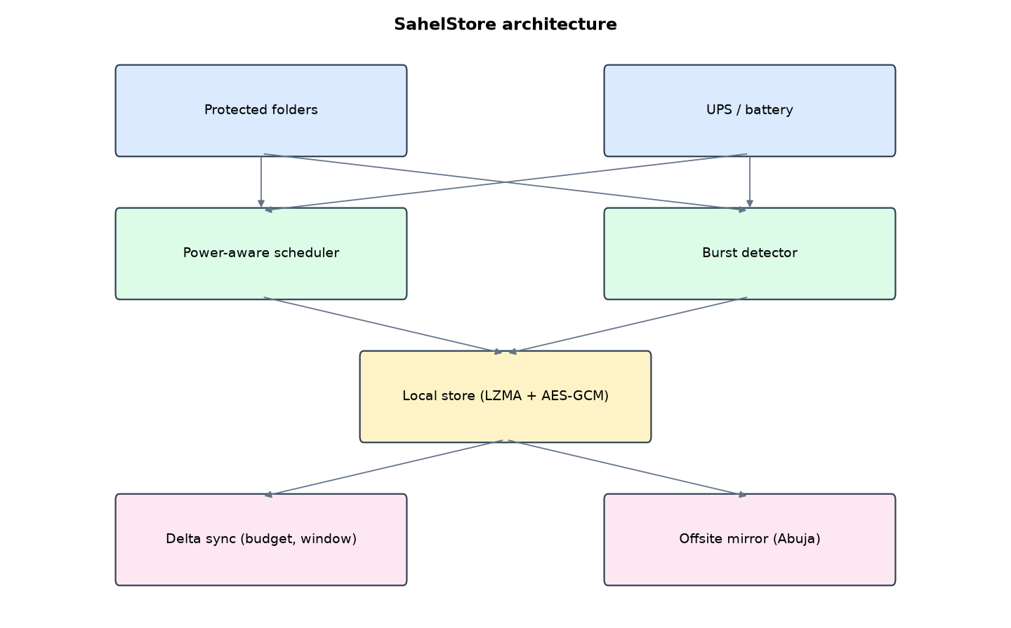
Figure 1: SahelStore architecture (data flows from top to bottom)
Table 5: Software components
File | Responsibility
sahel.py | Snapshots, delta algorithm, offsite sync and restore, power logic, detection, hash-chained log
status_page.py | Read-only page with HTTP Basic over PBKDF2, scheduler
main.py / selftest.py | Commands, simulations, tests

The main design decisions, and how they differ from the earlier VarsityShield and Zaman Lafiya projects, are:
- Read-only web page (standard library, HTTP Basic login over a PBKDF2 hash). Nothing on the web page can delete or restore data. That shrinks the attack surface.
- rsync-style delta sync. A weak rolling checksum and SHA-256 per 2 KiB block find the parts already offsite. In testing a changed 38 KB student register went offsite as 756 bytes.
- Daily bandwidth budget and off-peak window (00:00 to 05:30 by default). Files that do not fit wait in a queue for the next night.
- Power-aware scheduler. On inverter battery below 40% heavy jobs wait. At 15% it takes one emergency snapshot, then stays idle until mains power returns.
- LZMA compression + AES-256-GCM, content-addressed objects so identical files are stored once.
- Burst detector: many existing files modified within 60 seconds, or ransomware extensions, refuse the snapshot.

3.4 Security Design
Each threat considered is matched to the control that addresses it. Tests in Chapter Four exercise these controls.
Table 6: Threats and controls
Threat | Control in SahelStore
Local server room destroyed | Offsite base + delta restore
Offsite object altered | AES-GCM tag fails
Burst encryption | Modified-file burst refuses the snapshot
Web session hijacked | Page is read-only; no destructive action exists on the web
Password guessing on status page | PBKDF2 and a 1-second delay on failure

Cryptographic keys: One 256-bit AES-GCM key; objects are labelled by their SHA-256 and the label is bound as associated data.

3.5 Algorithms

3.5.1 rsync-style delta
Split the offsite copy into 2 KiB blocks, index each by a weak rolling checksum (a, b mod 2^16) and a truncated SHA-256. Slide over the new file one byte at a time, updating the weak checksum in O(1); on a weak match confirm with SHA-256 and emit 'copy block i', else collect literal bytes. Send the encrypted op list.

3.5.2 Power-aware scheduling
On mains: normal. On battery at or below 40%: defer snapshots and syncs. At or below 15%: take one emergency snapshot, then stay idle until mains power returns.

3.5.3 Burst detection
Count files that already existed in the last snapshot and were modified in the last 60 s; if five or more and at least 30% of files, refuse the snapshot.

3.6 Tools and Technologies
Language: Python 3.10 or newer. Storage: SQLite. Third-party packages: cryptography, psutil. Launchers: Windows batch files (1_SETUP, 2_START, 3_DEMO_MENU, 4_SELFTEST) and run.sh for Linux and macOS.

CHAPTER FOUR: IMPLEMENTATION, TESTING AND RESULTS

4.1 Implementation Environment
The system was developed and tested with Python 3.11 on Linux and is written to run unchanged on Windows 10/11. Its web interface runs at http://127.0.0.1:5106. Setup takes about ten minutes with 1_SETUP.bat; the README in the project folder gives every step and a defence demonstration script.

4.2 Operation and Demonstration
SahelStore is designed for a campus where the internet link is slow and expensive and mains power drops often. It keeps compressed, encrypted snapshots on the local server, sends only the changed parts of files to an offsite mirror at night within a daily data budget, and changes its behaviour when the inverter battery runs low. If the local server room is lost, everything comes back from the offsite copy.
Table 7: Demonstration scenario used for the defence
Step | Command (python main.py ...) | What is observed
This is UNIMAID's backup status. | serve | Power on mains, services UP, offsite queue and bandwidth saved
NEPA takes the light. | power-cut | Within 20 s: battery 35%, heavy jobs deferred
The inverter is nearly flat. | battery-critical | Emergency snapshot logged once
Ransomware strikes. | attack | snapshot: REFUSED, ransomware extension
The server room floods too. | lose-local | Local store gone
We still recover from Abuja. | restore-offsite | All files rebuilt from offsite base + deltas, byte-identical

4.3 Test Plan and Results
The automated test program ran 18 tests. 18 passed.
Table 8: Automated test results
# | Test | Result | Evidence
1 | Initial snapshot (LZMA + AES-GCM) | PASS | 133395 B -> 21756 B
2 | Delta algorithm rebuilds the new file exactly | PASS
3 | Delta sends only the blocks around the two edits | PASS | 6018 literal bytes of 49026
4 | Changed 40 KB register synced as a small delta | PASS | 756 B sent for 37998 B
5 | On battery at 35%: heavy jobs deferred | PASS
6 | At 12% battery: one emergency snapshot | PASS
7 | Next tick on low battery stays idle (no second snapshot) | PASS
8 | Off-peak window logic (01:00 in, 14:00 out) | PASS
9 | Quiet attack refused (burst of modified files) | PASS | ['6 files modified within 60 s']
10 | Restore after quiet attack is byte-identical | PASS
11 | Loud attack refused (ransomware extension) | PASS | ['15 files carry a ransomware extension']
12 | Local recovery after loud attack is byte-identical | PASS | RTO 0.006 s
13 | Local store destroyed: full recovery from offsite base + deltas | PASS | 0.010 s
14 | Tampered offsite object is rejected (GCM tag) | PASS
15 | Portal outage detected | PASS
16 | Status page refuses a wrong password | PASS
17 | Status page accepts the right password | PASS
18 | Edited log entry detected | PASS

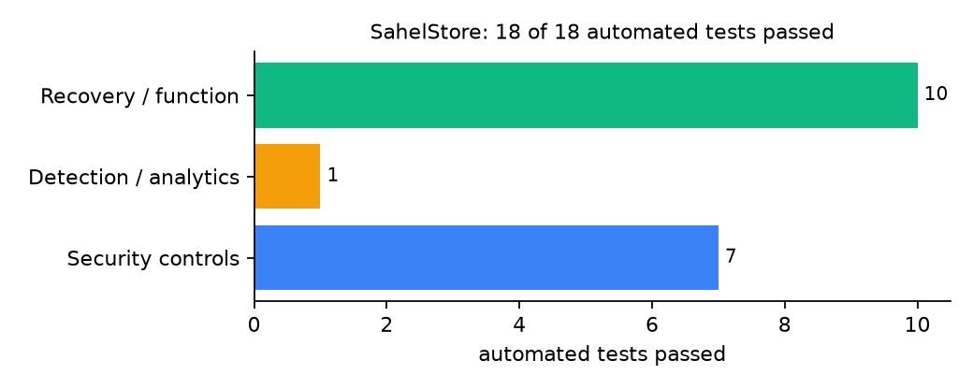
Figure 2: Automated tests by category

4.4 Measured Results
Table 9: Key measurements
Measure | Result
Protected data set | 15 files, 130.3 KiB
First snapshot | stored 21.2 KiB in 0.091 s
Delta sync of edited register | 756 bytes sent for 37.1 KiB file
Local recovery time | 0.006 s
Offsite recovery time (local store deleted) | 0.01 s, byte-identical: yes

4.5 Discussion
Sending 756 bytes instead of 38 KB is a 98% saving for a typical edit. The test also found a real logic error: after the emergency snapshot, the scheduler fell through to normal jobs while still on a critical battery. The fixed version stays idle until mains returns. Delta chains are capped at 8 so a corrupt delta cannot spoil an unlimited history. The read-only page is a deliberate trade-off: less convenient, much smaller attack surface.
Of the tests, 7 exercised security controls, 1 exercised detection or analytics, and 10 exercised recovery or core function.

CHAPTER FIVE: SUMMARY, CONCLUSION AND RECOMMENDATIONS

5.1 Summary
This project built SahelStore for the University of Maiduguri (UNIMAID), Maiduguri, Borno State. Its design combines rsync-style delta transfer to an offsite mirror, a daily data budget and an inverter-aware scheduler. It met its objectives and passed all 18 automated tests.

5.2 Conclusion
SahelStore shows that the security problem described in Chapter One can be addressed with free software and modest hardware, provided the design treats recovery as something attackers will target. The limits stated in Section 1.4 still apply.

5.3 Recommendations
- Use an offsite location outside Borno State (for example a partner university in Abuja).
- Connect the server's UPS by USB so psutil reports the real battery.
- Set the daily budget from the actual data plan.

5.4 Contribution to Knowledge
This project provides a design that the reviewed systems do not treats power and bandwidth scarcity as design inputs, although both shape daily ICT work in north-east Nigeria.

5.5 Suggestions for Further Work
- Resume interrupted transfers mid-file.
- Encrypt the transport with TLS when the offsite end is a server.

REFERENCES
Amoruso, E., Amoruso, P., & Zou, C. (2026). Integrity-gated file monitoring for ransomware resilience and real-time recovery. In 2026 International Conference on Smart Applications, Communications and Networking (SmartNets). IEEE.
Baek, S., Jung, Y., Mohaisen, D., Lee, S., & Nyang, D. (2021). SSD-assisted ransomware detection and data recovery techniques. IEEE Transactions on Computers, 70(10), 1762-1776. https://doi.org/10.1109/TC.2020.3011214
Dotasara, M., & Sharma, A. (2022). MDAS_DBRCC: Data backup and recovery technique in cloud computing for education industry. International Journal on Recent and Innovation Trends in Computing and Communication.
Farouk, S., et al. (2024). Enhancing cybersecurity in Nigeria: A proposed risk management framework for universities. In 2024 International Conference on Science, Engineering and Business for Driving Sustainable Development Goals (SEB4SDG). IEEE.
Ilau, M.-C., Baldwin, A., Caulfield, T., & Pym, D. (2025). Modelling and simulating organizational ransomware recovery: Structure, methodology, and decisions. Journal of Cybersecurity, 11(1), tyaf035. https://doi.org/10.1093/cybsec/tyaf035
Kodali, A., & Sangani. (2026). Automatic ransomware-resilient encrypted backup system using SHA-256 change detection and AES-256-GCM encryption. In 2026 3rd International Conference on Research Methodologies in Knowledge Management, Artificial Intelligence and Telecommunication Engineering (RMKMATE). IEEE.
Kumar, B., Gupta, S. K., & Dwivedi, R. (2026). Artificial intelligence driven approach for securing backup data and enhancing cyber resilience in sustainable smart infrastructure. Scientific Reports. https://doi.org/10.1038/s41598-026-37802-6
Lysetskyi, Y. M. (2025). Choosing an effective data backup and recovery strategy. Mathematical Machines and Systems.
Muthoni, S., Okeyo, G., & Chemwa, G. (2021). Infrastructure as code for business continuity in institutions of higher learning. In 2021 International Conference on Electrical, Computer and Energy Technologies (ICECET). IEEE.
Olugbile, O. H., Ojeniyi, J. A., & Anyachebelu, T. K. (2025). Towards a standard framework for cybersecurity readiness for Nigerian universities. International Journal of Applied Mathematics, Sciences, and Technology for National Defense.
Plaka, R. (2022). Backup & data recovery in cloud computing: A systematic mapping study. Ingenious.
Pragathi, B. C., et al. (2024). Implementing an effective infrastructure monitoring solution with Prometheus and Grafana. International Journal of Computer Applications, 186(38), 7-15.
Rafiq, A., Shakir, M. Z., Gray, D., Inglis, J., & Ferguson, F. (2025). AI and IoT-driven monitoring and visualisation for optimising MSP operations in multi-tenant networks: A modular approach using sensor data integration. Sensors, 25(19), 6248. https://doi.org/10.3390/s25196248
Simili, E., Stewart, G., Roy, G., Skipsey, S., & Britton, D. (2021). A hybrid system for monitoring and automated recovery at the Glasgow Tier-2 cluster. EPJ Web of Conferences, 251, 02047.
Tatineni, S. (2023). Cloud-based business continuity and disaster recovery strategies. International Research Journal of Modernization in Engineering Technology and Science.
Varshney, P. K., & Kumar, R. (2026). A governance-oriented cyber recovery framework for ransomware preparedness and resilience. EDPACS. https://doi.org/10.1080/07366981.2026.2682427
Vinisha, J., Sanjay, R., & Sundar, D. (2025). Automated disaster recovery architecture for educational institutions web infrastructure using hybrid cloud. In 2025 2nd International Conference on Artificial Intelligence and Knowledge Discovery in Concurrent Engineering (ICECONF). IEEE.

Standards and Legal Instruments Consulted
Federal Republic of Nigeria. (2023). Nigeria Data Protection Act, 2023. Nigeria Data Protection Commission.
International Organization for Standardization. (2022). ISO/IEC 27001:2022 Information security, cybersecurity and privacy protection: Information security management systems: Requirements. ISO.
National Institute of Standards and Technology. (2024). The NIST Cybersecurity Framework (CSF) 2.0 (NIST CSWP 29). NIST.

APPENDIX A: HOW TO RUN THE SYSTEM
- Copy the folder backup-recovery/A06-unimaid-sahelstore to the computer.
- Install Python 3.10 or newer with 'Add python.exe to PATH' ticked.
- Double-click 1_SETUP.bat, then 2_START.bat, and open http://127.0.0.1:5106.
- Use 3_DEMO_MENU.bat for the defence demonstration and 4_SELFTEST.bat to regenerate the results in Chapter Four.

APPENDIX B: SOURCE CODE STRUCTURE
Table 10: SahelStore source files
File | Purpose
sahel.py | Snapshots, delta algorithm, offsite sync and restore, power logic, detection, hash-chained log
status_page.py | Read-only page with HTTP Basic over PBKDF2, scheduler
main.py / selftest.py | Commands, simulations, tests

APPENDIX C: CODE EXCERPT
The function delta from sahel.py, the heart of the design described in Section 3.5.
def delta(old, new):
"""Return a list of ops: ("C", block_index) to copy from old, or ("L", bytes) literal."""
sig = signature(old)
ops, lit, i, n = [], bytearray(), 0, len(new)
if n < BLOCK:
return [("L", bytes(new))]
a, b = weak(new[0:BLOCK])
while i <= n - BLOCK:
hit = None
for idx, strong in sig.get((a, b), []):
if hashlib.sha256(new[i:i + BLOCK]).digest()[:8] == strong:
hit = idx
break
if hit is not None:
if lit:
ops.append(("L", bytes(lit)))
lit = bytearray()
ops.append(("C", hit))
i += BLOCK
if i <= n - BLOCK:
a, b = weak(new[i:i + BLOCK])
continue
lit.append(new[i])
if i + BLOCK < n: # roll the weak checksum one byte forward
out_b, in_b = new[i], new[i + BLOCK]
a = (a - out_b + in_b) % MOD
b = (b - BLOCK * out_b + a) % MOD
i += 1
lit.extend(new[i:])
if lit:
ops.append(("L", bytes(lit)))
return ops

