[NAME OF YOUR UNIVERSITY]
FACULTY OF [SCIENCE / COMPUTING]
DEPARTMENT OF COMPUTER SCIENCE
CMP 468: COMPUTER SECURITY (2 UNITS)
COURSE PROJECT REPORT
HARMONYVAULT: A SIGNED, GIT-STYLE BACKUP HISTORY WITH HONEY DIRECTORIES FOR THE UNIVERSITY OF ILORIN
Ed25519-signed commits, content-addressed encrypted objects and change-rate anomaly detection
BY
[FULL NAME]
MATRIC NO: [MATRIC NUMBER]
SUBMITTED TO
[COURSE LECTURER'S NAME]
IN PARTIAL FULFILMENT OF THE REQUIREMENTS OF CMP 468
400 LEVEL, SECOND SEMESTER, 2025/2026 SESSION
OCTOBER 2026

DECLARATION
I declare that this project report and the accompanying software were written by me as part of the requirements of CMP 468 (Computer Security). Every source used has been cited. All literature cited in this report was published between 2021 and 2026. All test results reported in Chapter Four were produced by the automated test program supplied with the software.
Signature: ____________________ Date: ____________________

ABSTRACT
Universities in Nigeria run admissions, fees, results, learning and payroll on computers that can fail or be attacked. This project designed, built and tested HarmonyVault for the University of Ilorin (UNILORIN), Ilorin, Kwara State. Its design combines ed25519-signed commits, content-addressed encrypted objects and change-rate anomaly detection. The system was implemented in Python and evaluated with an automated test suite that simulates outages, quiet and loud ransomware, tampering and misuse. All 15 tests passed. Key measurements: Protected data set: 18 files (including honey files), 136.6 KiB; First commit: 18 blobs in 0.012 s; Daily commit after one edit: 1 new blob; History verification: 5 commits, 90 blob checks. The design shows that a Nigerian university ICT unit can protect its records with free software on ordinary hardware.
Keywords: backup and recovery, ransomware, encryption, integrity, monitoring, RTO, Nigerian universities, NDPA 2023.

TABLE OF CONTENTS
Right-click here and choose Update Field to build the table of contents.

CHAPTER ONE: INTRODUCTION

1.1 Background of the Study
UNILORIN is widely known for keeping a stable academic calendar, which depends on records nobody can dispute. Disputes about results usually ask two questions: what did the record say on a given day, and has anyone altered the backup itself? Ordinary backups answer neither with proof.
Ransomware changed what backup means. Older plans assumed that disks fail by accident; modern attackers encrypt production data and then go after the backups. Recovery is therefore a security function, matching the Recover function of the NIST Cybersecurity Framework 2.0 (2024). The Nigeria Data Protection Act 2023 also makes the university a data controller that must keep personal data confidential, accurate and available.

1.2 Statement of the Problem
- Backups can be quietly replaced or deleted by someone with storage access.
- There is no readable history of what changed between two backups.
- Intruders browsing the share are not noticed.
- Fixed thresholds miss unusual change rates.

1.3 Aim and Objectives
The aim is to design, implement and evaluate HarmonyVault, a secure system for the University of Ilorin (UNILORIN), Ilorin, Kwara State. The objectives are to:
- store backups as signed commits in an encrypted object store;
- verify the full history from HEAD to the first commit;
- show what changed between any two commits and each file's history;
- plant honey directories and refuse commits when they change;
- detect unusual change rates with a z-score;
- evaluate tamper detection and recovery.

1.4 Scope and Limitations
One repository per server; signing key on the server; public key fingerprint displayed for checking. The system was tested on one computer; the README describes deployment on other computers.

1.5 Significance of the Study
HarmonyVault gives the University of Ilorin (UNILORIN), Ilorin, Kwara State a free, auditable tool that runs on ordinary hardware, and turns CMP 468 topics into working controls. Its automated test suite lets any future maintainer prove that the controls still work.

1.6 Relation to the CMP 468 Course Outline
Table 1: Mapping of CMP 468 topics to HarmonyVault
CMP 468 topic | Where it appears in HarmonyVault
Overview of security in computing | CIA triad: encryption (confidentiality), hashing and signatures (integrity), copies and restore (availability)
Characteristics of computer intrusion | Ransomware behaviour model: mass modification, new extensions, ransom notes, high-entropy output
Types of security breaches | Data destruction, data tampering, insider deletion of backups, unauthorised access to the console
Classes of attacks | Ransomware, brute-force login, cross-site request forgery, backup tampering
Methods of defence and controls | Preventive, detective and corrective controls listed in Table 3.2
Data security: encryption and decryption | 256-bit object key; Ed25519 signing key pair with the public key fingerprint shown on screen.
Network security | Service reachability checks, security headers, SameSite cookies
Security policies and standards | Backup and retention policy in config.json; NIST CSF 2.0 Recover; ISO/IEC 27001:2022; NDPA 2023

CHAPTER TWO: LITERATURE REVIEW
This review covers only studies published from 2021 to 2026. Every source was checked against a publisher or index page.

2.1 Conceptual Framework
The study rests on the Confidentiality, Integrity and Availability (CIA) triad. A backup that an attacker can read fails confidentiality; one that can be silently altered fails integrity; one that cannot be restored in time fails availability. Two measures turn availability into numbers: the Recovery Point Objective (how much data may be lost) and the Recovery Time Objective (how long restoration may take).

2.2 Cybersecurity in Nigerian universities
Nigerian work on university cybersecurity agrees that the weak points are after an attack starts, not only before it. Olugbile et al. (2025) used Design Science Research to build cybersecurity readiness tiers for Nigerian universities covering pre-event, event-management and post-event factors, and named inadequate funding, weak infrastructure, poor training and a shortage of professionals as the main obstacles. Farouk et al. (2024) note that Nigerian universities lack scientifically derived frameworks for managing cyber risk and propose situational crime prevention as one. Neither study builds or measures a working recovery system, which leaves room for the practical contribution of this project.

2.3 Monitoring and automated response
Open-source monitoring stacks dominate recent practice. Simili et al. (2021) combined Prometheus, Loki and Grafana at a university computing cluster and added an alerting application that performs simple recovery actions for known problems, so that staff intervene less often. Pragathi et al. (2024) deployed Prometheus, Grafana and Node Exporter on Kubernetes and reported shorter deployment time and lower operating cost. Rafiq et al. (2025) ran five Prometheus instances on Raspberry Pi edge nodes to watch about 500 network elements in five client organisations, adding machine-learning anomaly prediction and alert routing. The common lesson is that monitoring pays off when it triggers action automatically, and that small teams benefit most.

2.4 Backup strategy and disaster recovery
Lysetskyi (2025) recommends the 3-2-1-1-0 rule with an air-gapped copy, because backups that cannot be reached from the network survive ransomware. Plaka (2022) mapped 45 studies (2010-2020) on backup and disaster recovery and catalogued their causes, techniques, and privacy and security issues. Tatineni (2023) lists risk assessment, backup, duplication and failover as the core of a disaster recovery plan. Education-specific studies add cost and skills constraints. Muthoni et al. (2021) found that African universities, Kenyan ones in particular, are slow to adopt cloud business continuity, and showed with Ansible and Terraform that infrastructure as code reduced cost, effort and human error when recovering a local data centre to the cloud. Vinisha et al. (2025) gave smaller colleges with one on-premises web server an on-demand cloud standby that health checks start automatically when the main server fails. Dotasara and Sharma (2022) compress and encrypt education data before storing it in the cloud.

2.5 Ransomware-resilient recovery
Recent work moves from detection alone to guaranteed recovery. Baek et al. (2021) built ransomware detection and recovery into SSD firmware (SSD-Insider++): the drive watches I/O patterns and uses delayed deletion to restore original data, reporting 0% false rates in most cases and recovery with no data loss. The approach needs special drive firmware. Kodali and Sangani (2026) combined SHA-256 change detection with AES-256-GCM encryption in an automatic, ransomware-resilient backup tool. Amoruso et al. (2026) proposed integrity-gated file monitoring, in which changed files must pass integrity checks before they are trusted, as a route to ransomware resilience and real-time recovery. Varshney and Kumar (2026) treat fast, trustworthy restoration as a first-class security goal: behavioural detection (97.4% accuracy at a 3.1% false-positive rate), an isolated immutable vault and an automated orchestrator that finds a verified clean recovery point. Kumar et al. (2026) argue that backup integrity must be verified before restoration, and report 98.65% accuracy for their AI-assisted integrity-verification and ransomware-detection pipeline. Ilau et al. (2025) modelled ransomware recovery in a medium-sized organisation and compared recovery strategies over 9,000 parameter configurations (450,000 simulation runs).

2.6 Work Closest to This Design
Ilau et al. (2025) stress that recovery decisions depend on knowing which state is trustworthy; HarmonyVault proves it with signatures. Kodali and Sangani (2026) detect change by hash; HarmonyVault adds a signed chain so the change record itself cannot be rewritten. The honey directories apply the deterrence idea behind situational crime prevention discussed by Farouk et al. (2024).

2.7 Summary of Reviewed Works and Research Gap
Table 2: Summary of reviewed works
Study | What it contributes
Amoruso (2026) | proposed integrity-gated file monitoring, in which changed files must pass integrity checks before they are trusted, as a route to ransomware resilience and rea
Baek (2021) | built ransomware detection and recovery into SSD firmware (SSD-Insider++): the drive watches I/O patterns and uses delayed deletion to restore original data, re
Dotasara (2022) | compress and encrypt education data before storing it in the cloud.
Farouk (2024) | note that Nigerian universities lack scientifically derived frameworks for managing cyber risk and propose situational crime prevention as one.
Ilau (2025) | modelled ransomware recovery in a medium-sized organisation and compared recovery strategies over 9,000 parameter configurations (450,000 simulation runs).
Kodali (2026) | combined SHA-256 change detection with AES-256-GCM encryption in an automatic, ransomware-resilient backup tool.
Kumar (2026) | argue that backup integrity must be verified before restoration, and report 98.65% accuracy for their AI-assisted integrity-verification and ransomware-detectio
Lysetskyi (2025) | recommends the 3-2-1-1-0 rule with an air-gapped copy, because backups that cannot be reached from the network survive ransomware.
Muthoni (2021) | found that African universities, Kenyan ones in particular, are slow to adopt cloud business continuity, and showed with Ansible and Terraform that infrastructu
Olugbile (2025) | used Design Science Research to build cybersecurity readiness tiers for Nigerian universities covering pre-event, event-management and post-event factors, and n
Plaka (2022) | mapped 45 studies (2010-2020) on backup and disaster recovery and catalogued their causes, techniques, and privacy and security issues.
Pragathi (2024) | deployed Prometheus, Grafana and Node Exporter on Kubernetes and reported shorter deployment time and lower operating cost.
Rafiq (2025) | ran five Prometheus instances on Raspberry Pi edge nodes to watch about 500 network elements in five client organisations, adding machine-learning anomaly predi
Simili (2021) | combined Prometheus, Loki and Grafana at a university computing cluster and added an alerting application that performs simple recovery actions for known proble
Tatineni (2023) | lists risk assessment, backup, duplication and failover as the core of a disaster recovery plan.
Varshney (2026) | treat fast, trustworthy restoration as a first-class security goal: behavioural detection (97.4% accuracy at a 3.1% false-positive rate), an isolated immutable
Vinisha (2025) | gave smaller colleges with one on-premises web server an on-demand cloud standby that health checks start automatically when the main server fails.

Research gap. Version-control style signed histories are standard for source code but missing from the reviewed backup systems.

CHAPTER THREE: METHODOLOGY AND SYSTEM DESIGN

3.1 Research Methodology
The project follows Design Science Research: identify the problem, define objectives, design and build an artefact, demonstrate it, and evaluate it. Evaluation uses an automated test program (selftest.py) that resets the system, runs normal use, simulated attacks and failures, and records each outcome and measurement in results/selftest.json. Data are synthetic university records.

3.2 Requirements
Table 3: Functional requirements
# | Requirement
FR1 | Commit blobs, trees and signed commits
FR2 | Verify signatures and every object
FR3 | Diff any two commits; per-file history
FR4 | Honey files refuse commits
FR5 | z-score change anomaly
FR6 | Checkout any commit

Table 4: Non-functional requirements
# | Requirement
NFR1 | Roles: custodian and reviewer
NFR2 | Timeline user interface
NFR3 | Two packages: flask, cryptography

3.3 System Architecture
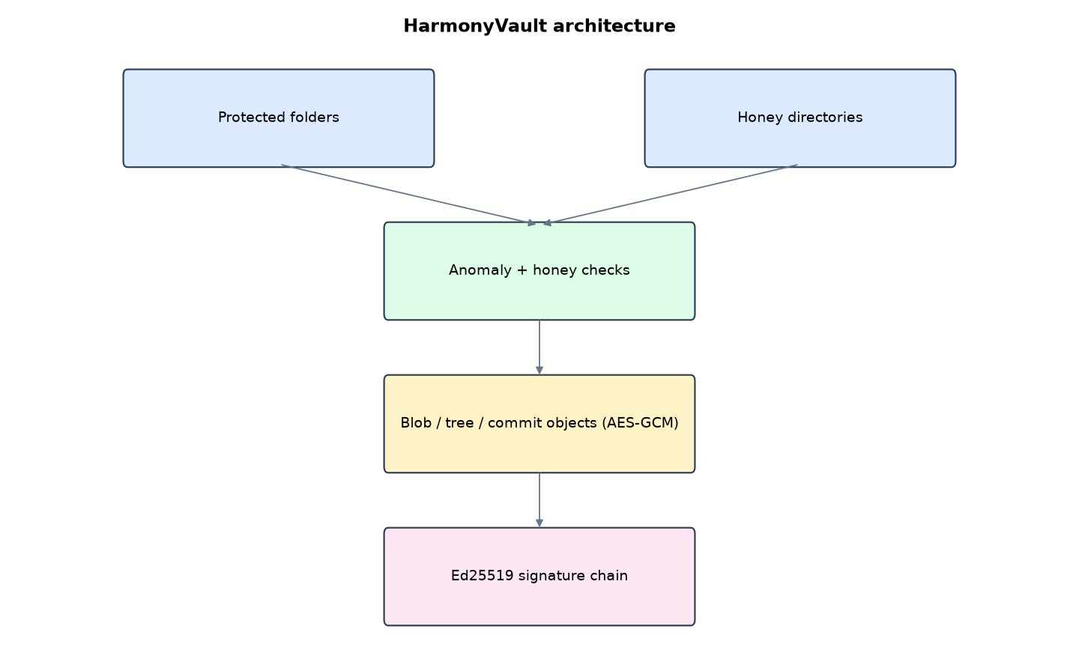
Figure 1: HarmonyVault architecture (data flows from top to bottom)
Table 5: Software components
File | Responsibility
history.py | Object store, signing, honey files, anomaly, verify, diff, checkout
web.py | Timeline console and scheduler
main.py / selftest.py | Commands and tests

The main design decisions, and how they differ from the earlier VarsityShield and Zaman Lafiya projects, are:
- Git-style object model: blob (file), tree (folder listing) and commit (tree + parent + author + message). Identical files are stored once.
- Ed25519 digital signatures on every commit, with the public-key fingerprint shown on screen. Verification walks HEAD back to the first commit.
- AES-256-GCM per object with keyed object IDs (HMAC-SHA256).
- Timeline interface with 'what changed' diffs between backups and per-file history.
- Honey directories (Exam_Questions_2026_CONFIDENTIAL, Senate_Approved_Results). One edit refuses the commit.
- Change-rate anomaly: z-score of changed files against the last 30 commits (share-of-files rule while history is short).

3.4 Security Design
Each threat considered is matched to the control that addresses it. Tests in Chapter Four exercise these controls.
Table 6: Threats and controls
Threat | Control in HarmonyVault
Insider rewrites a commit with the storage key | Ed25519 signature fails
Commit object edited | Keyed object ID mismatch
Intruder edits exam questions folder | Honey file check refuses the commit
Quiet encryption of 6 files | z = 5 against history
Reviewer tries to restore | 403

Cryptographic keys: 256-bit object key; Ed25519 signing key pair with the public key fingerprint shown on screen.

3.5 Algorithms

3.5.1 Object model
blob = file bytes; tree = {path: blob id}; commit = {tree, parent, time, author, message, stats}. IDs are HMAC-SHA256(key, type || content). Each object is stored AES-256-GCM encrypted with the type and ID as associated data.

3.5.2 Signing and verification
The commit body is serialised with sorted keys and signed with Ed25519. Verification walks parent links from HEAD, checking each signature, then decrypts and re-hashes every tree and blob.

3.5.3 Change-rate anomaly
z = (changed files now - mean of last 30 incremental commits) / standard deviation (minimum 1). z above 3 refuses the commit; with fewer than 3 past commits a 30%-of-files rule applies.

3.6 Tools and Technologies
Language: Python 3.10 or newer. Storage: SQLite. Third-party packages: flask, cryptography. Launchers: Windows batch files (1_SETUP, 2_START, 3_DEMO_MENU, 4_SELFTEST) and run.sh for Linux and macOS.

CHAPTER FOUR: IMPLEMENTATION, TESTING AND RESULTS

4.1 Implementation Environment
The system was developed and tested with Python 3.11 on Linux and is written to run unchanged on Windows 10/11. Its web interface runs at http://127.0.0.1:5107. Setup takes about ten minutes with 1_SETUP.bat; the README in the project folder gives every step and a defence demonstration script.

4.2 Operation and Demonstration
HarmonyVault stores UNILORIN's records the way Git stores source code: encrypted blobs, trees and commits, each commit pointing to its parent. Every commit is signed with an Ed25519 key, so nobody (not even an insider who steals the storage key) can insert, remove or edit a backup without detection. It watches decoy 'honey' folders that attract intruders, and it flags unusual change rates with a z-score against past backups.
Table 7: Demonstration scenario used for the defence
Step | Command (python main.py ...) | What is observed
UNILORIN's backups form a signed timeline. | serve | Timeline with commits, key fingerprint, portal UP
Someone opens the exam questions folder and copies a file. | peek-honey | Commit backup now: refused, honey file touched
Ransomware quietly encrypts 6 result files. | stealth | Refused: 6 files changed, z = 5 against history
We roll back. | restore | Restore this point on the newest commit. Files byte-identical
Show exactly what changed between two days. | (click 'what changed') | Diff page lists students.csv only
Prove the history is genuine. | verify | Every signature, tree and blob verified

4.3 Test Plan and Results
The automated test program ran 15 tests. 15 passed.
Table 8: Automated test results
# | Test | Result | Evidence
1 | Initial signed commit | PASS | {'status': 'ok', 'commit': '3bf3020043eb', 'files': 18, 'added': 18, 'changed': 0, 'removed': 0, 'new_blobs': 18, 'secon
2 | Daily commits store only the changed blob | PASS
3 | Whole history verifies (signatures, trees, blobs) | PASS | {'ok': True, 'commits': 5, 'blob_checks': 90}
4 | Quiet attack refused by change-rate anomaly (z-score) | PASS | ['6 files changed/removed (z = 5.0 against history)']
5 | Checkout after quiet attack is byte-identical | PASS
6 | Loud attack refused (honey files + extensions + anomaly) | PASS | ['honey file touched: Exam_Questions_2026_CONFIDENTIAL/CSC468_exam_paper.txt', 'ransomware extensions among new files',
7 | Recovery after loud attack is byte-identical | PASS | RTO 0.009 s
8 | A single edit to a honey file refuses the commit | PASS
9 | Point-in-time checkout of the first commit | PASS
10 | Diff lists exactly the edited file | PASS | {'added': [], 'removed': [], 'changed': ['registry/students.csv']}
11 | Re-encrypted, edited commit is caught (signature or id mismatch) | PASS | {'ok': False, 'commits': 2, 'failed_at': 'c6a113dc4270', 'error': 'ValueError'}
12 | Insider with the storage key still cannot forge a commit (Ed25519) | PASS | {'ok': False, 'commits': 0, 'failed_at': 'abf6f3329084', 'error': 'InvalidSignature'}
13 | Portal outage detected | PASS
14 | Reviewer cannot restore | PASS
15 | Custodian POST without CSRF refused | PASS

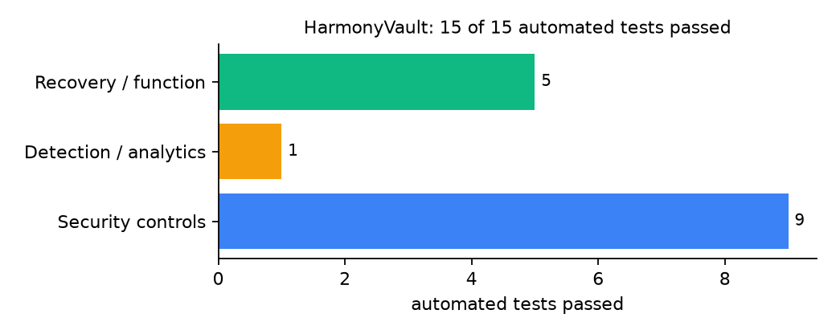
Figure 2: Automated tests by category

4.4 Measured Results
Table 9: Key measurements
Measure | Result
Protected data set | 18 files (including honey files), 136.6 KiB
First commit | 18 blobs in 0.012 s
Daily commit after one edit | 1 new blob
History verification | 5 commits, 90 blob checks
Recovery time (RTO) measured | 0.009 s, byte-identical: yes

4.5 Discussion
Two tamper tests show the layering. An edited commit re-encrypted with the storage key was caught because its keyed ID no longer matched. A forged commit with a correct ID, made by someone holding the storage key, was still caught by the Ed25519 signature. Protection therefore depends on the signing key staying separate from the storage key. The z-score works well once a few commits exist; on day one the share rule takes over.
Of the tests, 9 exercised security controls, 1 exercised detection or analytics, and 5 exercised recovery or core function.

CHAPTER FIVE: SUMMARY, CONCLUSION AND RECOMMENDATIONS

5.1 Summary
This project built HarmonyVault for the University of Ilorin (UNILORIN), Ilorin, Kwara State. Its design combines ed25519-signed commits, content-addressed encrypted objects and change-rate anomaly detection. It met its objectives and passed all 15 automated tests.

5.2 Conclusion
HarmonyVault shows that the security problem described in Chapter One can be addressed with free software and modest hardware, provided the design treats recovery as something attackers will target. The limits stated in Section 1.4 still apply.

5.3 Recommendations
- Keep the signing key on a separate encrypted volume or hardware token.
- Publish the public-key fingerprint in the ICT policy document.
- Make honey folder names match real departmental naming.

5.4 Contribution to Knowledge
This project addresses the gap identified in Chapter Two: Version-control style signed histories are standard for source code but missing from the reviewed backup systems.

5.5 Suggestions for Further Work
- Branches for staging approved result changes.
- Garbage collection of unreachable objects.

REFERENCES
Amoruso, E., Amoruso, P., & Zou, C. (2026). Integrity-gated file monitoring for ransomware resilience and real-time recovery. In 2026 International Conference on Smart Applications, Communications and Networking (SmartNets). IEEE.
Baek, S., Jung, Y., Mohaisen, D., Lee, S., & Nyang, D. (2021). SSD-assisted ransomware detection and data recovery techniques. IEEE Transactions on Computers, 70(10), 1762-1776. https://doi.org/10.1109/TC.2020.3011214
Dotasara, M., & Sharma, A. (2022). MDAS_DBRCC: Data backup and recovery technique in cloud computing for education industry. International Journal on Recent and Innovation Trends in Computing and Communication.
Farouk, S., et al. (2024). Enhancing cybersecurity in Nigeria: A proposed risk management framework for universities. In 2024 International Conference on Science, Engineering and Business for Driving Sustainable Development Goals (SEB4SDG). IEEE.
Ilau, M.-C., Baldwin, A., Caulfield, T., & Pym, D. (2025). Modelling and simulating organizational ransomware recovery: Structure, methodology, and decisions. Journal of Cybersecurity, 11(1), tyaf035. https://doi.org/10.1093/cybsec/tyaf035
Kodali, A., & Sangani. (2026). Automatic ransomware-resilient encrypted backup system using SHA-256 change detection and AES-256-GCM encryption. In 2026 3rd International Conference on Research Methodologies in Knowledge Management, Artificial Intelligence and Telecommunication Engineering (RMKMATE). IEEE.
Kumar, B., Gupta, S. K., & Dwivedi, R. (2026). Artificial intelligence driven approach for securing backup data and enhancing cyber resilience in sustainable smart infrastructure. Scientific Reports. https://doi.org/10.1038/s41598-026-37802-6
Lysetskyi, Y. M. (2025). Choosing an effective data backup and recovery strategy. Mathematical Machines and Systems.
Muthoni, S., Okeyo, G., & Chemwa, G. (2021). Infrastructure as code for business continuity in institutions of higher learning. In 2021 International Conference on Electrical, Computer and Energy Technologies (ICECET). IEEE.
Olugbile, O. H., Ojeniyi, J. A., & Anyachebelu, T. K. (2025). Towards a standard framework for cybersecurity readiness for Nigerian universities. International Journal of Applied Mathematics, Sciences, and Technology for National Defense.
Plaka, R. (2022). Backup & data recovery in cloud computing: A systematic mapping study. Ingenious.
Pragathi, B. C., et al. (2024). Implementing an effective infrastructure monitoring solution with Prometheus and Grafana. International Journal of Computer Applications, 186(38), 7-15.
Rafiq, A., Shakir, M. Z., Gray, D., Inglis, J., & Ferguson, F. (2025). AI and IoT-driven monitoring and visualisation for optimising MSP operations in multi-tenant networks: A modular approach using sensor data integration. Sensors, 25(19), 6248. https://doi.org/10.3390/s25196248
Simili, E., Stewart, G., Roy, G., Skipsey, S., & Britton, D. (2021). A hybrid system for monitoring and automated recovery at the Glasgow Tier-2 cluster. EPJ Web of Conferences, 251, 02047.
Tatineni, S. (2023). Cloud-based business continuity and disaster recovery strategies. International Research Journal of Modernization in Engineering Technology and Science.
Varshney, P. K., & Kumar, R. (2026). A governance-oriented cyber recovery framework for ransomware preparedness and resilience. EDPACS. https://doi.org/10.1080/07366981.2026.2682427
Vinisha, J., Sanjay, R., & Sundar, D. (2025). Automated disaster recovery architecture for educational institutions web infrastructure using hybrid cloud. In 2025 2nd International Conference on Artificial Intelligence and Knowledge Discovery in Concurrent Engineering (ICECONF). IEEE.

Standards and Legal Instruments Consulted
Federal Republic of Nigeria. (2023). Nigeria Data Protection Act, 2023. Nigeria Data Protection Commission.
International Organization for Standardization. (2022). ISO/IEC 27001:2022 Information security, cybersecurity and privacy protection: Information security management systems: Requirements. ISO.
National Institute of Standards and Technology. (2024). The NIST Cybersecurity Framework (CSF) 2.0 (NIST CSWP 29). NIST.

APPENDIX A: HOW TO RUN THE SYSTEM
- Copy the folder backup-recovery/A07-unilorin-harmonyvault to the computer.
- Install Python 3.10 or newer with 'Add python.exe to PATH' ticked.
- Double-click 1_SETUP.bat, then 2_START.bat, and open http://127.0.0.1:5107.
- Use 3_DEMO_MENU.bat for the defence demonstration and 4_SELFTEST.bat to regenerate the results in Chapter Four.

APPENDIX B: SOURCE CODE STRUCTURE
Table 10: HarmonyVault source files
File | Purpose
history.py | Object store, signing, honey files, anomaly, verify, diff, checkout
web.py | Timeline console and scheduler
main.py / selftest.py | Commands and tests

APPENDIX C: CODE EXCERPT
The function verify_chain from history.py, the heart of the design described in Section 3.5.
def verify_chain():
"""Walk HEAD -> root, checking every signature, tree and blob."""
cid, n, blobs = head(), 0, 0
try:
while cid:
c = read_commit(cid)
tree = json.loads(get("tree", c["tree"]))
for rel, b in tree.items():
get("blob", b)
blobs += 1
n += 1
cid = c["parent"]
return {"ok": True, "commits": n, "blob_checks": blobs}
except Exception as exc: # noqa: BLE001
alarm("critical", f"history verification failed at commit {str(cid)[:12]}: {type(exc).__name__}")
return {"ok": False, "commits": n, "failed_at": str(cid)[:12], "error": type(exc).__name__}

