[NAME OF YOUR UNIVERSITY]
FACULTY OF [SCIENCE / COMPUTING]
DEPARTMENT OF COMPUTER SCIENCE
CMP 468: COMPUTER SECURITY (2 UNITS)
COURSE PROJECT REPORT
KANOSHIELD: A WORM BACKUP VAULT WITH FOUR-EYES APPROVAL AND TWO-FACTOR SIGN-IN FOR BAYERO UNIVERSITY KANO
Database-enforced retention locks, dual control of restores and RFC 6238 authenticator codes
BY
[FULL NAME]
MATRIC NO: [MATRIC NUMBER]
SUBMITTED TO
[COURSE LECTURER'S NAME]
IN PARTIAL FULFILMENT OF THE REQUIREMENTS OF CMP 468
400 LEVEL, SECOND SEMESTER, 2025/2026 SESSION
OCTOBER 2026

DECLARATION
I declare that this project report and the accompanying software were written by me as part of the requirements of CMP 468 (Computer Security). Every source used has been cited. All literature cited in this report was published between 2021 and 2026. All test results reported in Chapter Four were produced by the automated test program supplied with the software.
Signature: ____________________ Date: ____________________

ABSTRACT
Universities in Nigeria run admissions, fees, results, learning and payroll on computers that can fail or be attacked. This project designed, built and tested KanoShield for Bayero University Kano (BUK), Kano, Kano State. Its design combines database-enforced retention locks, dual control of restores and RFC 6238 authenticator codes. The system was implemented in Python and evaluated with an automated test suite that simulates outages, quiet and loud ransomware, tampering and misuse. All 18 tests passed. Key measurements: Protected data set: 15 files, 134.2 KiB; Sealing a backup: 0.03 s, locked until 2026-11-03 16:30:56; Approvals needed for restore: 2; Recovery time after approval: 0.005 s, byte-identical: yes. The design shows that a Nigerian university ICT unit can protect its records with free software on ordinary hardware.
Keywords: backup and recovery, ransomware, encryption, integrity, monitoring, RTO, Nigerian universities, NDPA 2023.

TABLE OF CONTENTS
Right-click here and choose Update Field to build the table of contents.

CHAPTER ONE: INTRODUCTION

1.1 Background of the Study
BUK, with its old and new campuses, holds records that matter for decades. The biggest risk to backups is often not an outsider but a single privileged insider, or a stolen administrator password, that can delete the history or restore old data over current records.
Ransomware changed what backup means. Older plans assumed that disks fail by accident; modern attackers encrypt production data and then go after the backups. Recovery is therefore a security function, matching the Recover function of the NIST Cybersecurity Framework 2.0 (2024). The Nigeria Data Protection Act 2023 also makes the university a data controller that must keep personal data confidential, accurate and available.

1.2 Statement of the Problem
- One administrator can delete all backups.
- Restores over live data need no second opinion.
- Passwords alone protect administrator accounts.
- Retention periods are not enforced by the system itself.

1.3 Aim and Objectives
The aim is to design, implement and evaluate KanoShield, a secure system for Bayero University Kano (BUK), Kano, Kano State. The objectives are to:
- store backups in a vault that refuses early deletion and any edit;
- require two different administrators for restores and early releases;
- add TOTP two-factor sign-in for administrators;
- lock accounts under brute force;
- replicate the vault to a second campus and offline media;
- evaluate governance controls and recovery.

1.4 Scope and Limitations
The vault is an SQLite file; triggers enforce WORM behaviour inside the database engine. The system was tested on one computer; the README describes deployment on other computers.

1.5 Significance of the Study
KanoShield gives Bayero University Kano (BUK), Kano, Kano State a free, auditable tool that runs on ordinary hardware, and turns CMP 468 topics into working controls. Its automated test suite lets any future maintainer prove that the controls still work.

1.6 Relation to the CMP 468 Course Outline
Table 1: Mapping of CMP 468 topics to KanoShield
CMP 468 topic | Where it appears in KanoShield
Overview of security in computing | CIA triad: encryption (confidentiality), hashing and signatures (integrity), copies and restore (availability)
Characteristics of computer intrusion | Ransomware behaviour model: mass modification, new extensions, ransom notes, high-entropy output
Types of security breaches | Data destruction, data tampering, insider deletion of backups, unauthorised access to the console
Classes of attacks | Ransomware, brute-force login, cross-site request forgery, backup tampering
Methods of defence and controls | Preventive, detective and corrective controls listed in Table 3.2
Data security: encryption and decryption | 256-bit AES-GCM vault key; per-admin 160-bit TOTP secrets; scrypt password hashes.
Network security | Service reachability checks, security headers, SameSite cookies
Security policies and standards | Backup and retention policy in config.json; NIST CSF 2.0 Recover; ISO/IEC 27001:2022; NDPA 2023

CHAPTER TWO: LITERATURE REVIEW
This review covers only studies published from 2021 to 2026. Every source was checked against a publisher or index page.

2.1 Conceptual Framework
The study rests on the Confidentiality, Integrity and Availability (CIA) triad. A backup that an attacker can read fails confidentiality; one that can be silently altered fails integrity; one that cannot be restored in time fails availability. Two measures turn availability into numbers: the Recovery Point Objective (how much data may be lost) and the Recovery Time Objective (how long restoration may take).

2.2 Cybersecurity in Nigerian universities
Nigerian work on university cybersecurity agrees that the weak points are after an attack starts, not only before it. Olugbile et al. (2025) used Design Science Research to build cybersecurity readiness tiers for Nigerian universities covering pre-event, event-management and post-event factors, and named inadequate funding, weak infrastructure, poor training and a shortage of professionals as the main obstacles. Farouk et al. (2024) note that Nigerian universities lack scientifically derived frameworks for managing cyber risk and propose situational crime prevention as one. Neither study builds or measures a working recovery system, which leaves room for the practical contribution of this project.

2.3 Monitoring and automated response
Open-source monitoring stacks dominate recent practice. Simili et al. (2021) combined Prometheus, Loki and Grafana at a university computing cluster and added an alerting application that performs simple recovery actions for known problems, so that staff intervene less often. Pragathi et al. (2024) deployed Prometheus, Grafana and Node Exporter on Kubernetes and reported shorter deployment time and lower operating cost. Rafiq et al. (2025) ran five Prometheus instances on Raspberry Pi edge nodes to watch about 500 network elements in five client organisations, adding machine-learning anomaly prediction and alert routing. The common lesson is that monitoring pays off when it triggers action automatically, and that small teams benefit most.

2.4 Backup strategy and disaster recovery
Lysetskyi (2025) recommends the 3-2-1-1-0 rule with an air-gapped copy, because backups that cannot be reached from the network survive ransomware. Plaka (2022) mapped 45 studies (2010-2020) on backup and disaster recovery and catalogued their causes, techniques, and privacy and security issues. Tatineni (2023) lists risk assessment, backup, duplication and failover as the core of a disaster recovery plan. Education-specific studies add cost and skills constraints. Muthoni et al. (2021) found that African universities, Kenyan ones in particular, are slow to adopt cloud business continuity, and showed with Ansible and Terraform that infrastructure as code reduced cost, effort and human error when recovering a local data centre to the cloud. Vinisha et al. (2025) gave smaller colleges with one on-premises web server an on-demand cloud standby that health checks start automatically when the main server fails. Dotasara and Sharma (2022) compress and encrypt education data before storing it in the cloud.

2.5 Ransomware-resilient recovery
Recent work moves from detection alone to guaranteed recovery. Baek et al. (2021) built ransomware detection and recovery into SSD firmware (SSD-Insider++): the drive watches I/O patterns and uses delayed deletion to restore original data, reporting 0% false rates in most cases and recovery with no data loss. The approach needs special drive firmware. Kodali and Sangani (2026) combined SHA-256 change detection with AES-256-GCM encryption in an automatic, ransomware-resilient backup tool. Amoruso et al. (2026) proposed integrity-gated file monitoring, in which changed files must pass integrity checks before they are trusted, as a route to ransomware resilience and real-time recovery. Varshney and Kumar (2026) treat fast, trustworthy restoration as a first-class security goal: behavioural detection (97.4% accuracy at a 3.1% false-positive rate), an isolated immutable vault and an automated orchestrator that finds a verified clean recovery point. Kumar et al. (2026) argue that backup integrity must be verified before restoration, and report 98.65% accuracy for their AI-assisted integrity-verification and ransomware-detection pipeline. Ilau et al. (2025) modelled ransomware recovery in a medium-sized organisation and compared recovery strategies over 9,000 parameter configurations (450,000 simulation runs).

2.6 Work Closest to This Design
Varshney and Kumar (2026) and Lysetskyi (2025) rely on immutable copies; KanoShield enforces immutability with database triggers that even the application cannot bypass. It adds governance that the reviewed work leaves to policy documents: dual control and two-factor authentication. Farouk et al. (2024) call for structured risk controls in Nigerian universities; four-eyes approval is one.

2.7 Summary of Reviewed Works and Research Gap
Table 2: Summary of reviewed works
Study | What it contributes
Amoruso (2026) | proposed integrity-gated file monitoring, in which changed files must pass integrity checks before they are trusted, as a route to ransomware resilience and rea
Baek (2021) | built ransomware detection and recovery into SSD firmware (SSD-Insider++): the drive watches I/O patterns and uses delayed deletion to restore original data, re
Dotasara (2022) | compress and encrypt education data before storing it in the cloud.
Farouk (2024) | note that Nigerian universities lack scientifically derived frameworks for managing cyber risk and propose situational crime prevention as one.
Ilau (2025) | modelled ransomware recovery in a medium-sized organisation and compared recovery strategies over 9,000 parameter configurations (450,000 simulation runs).
Kodali (2026) | combined SHA-256 change detection with AES-256-GCM encryption in an automatic, ransomware-resilient backup tool.
Kumar (2026) | argue that backup integrity must be verified before restoration, and report 98.65% accuracy for their AI-assisted integrity-verification and ransomware-detectio
Lysetskyi (2025) | recommends the 3-2-1-1-0 rule with an air-gapped copy, because backups that cannot be reached from the network survive ransomware.
Muthoni (2021) | found that African universities, Kenyan ones in particular, are slow to adopt cloud business continuity, and showed with Ansible and Terraform that infrastructu
Olugbile (2025) | used Design Science Research to build cybersecurity readiness tiers for Nigerian universities covering pre-event, event-management and post-event factors, and n
Plaka (2022) | mapped 45 studies (2010-2020) on backup and disaster recovery and catalogued their causes, techniques, and privacy and security issues.
Pragathi (2024) | deployed Prometheus, Grafana and Node Exporter on Kubernetes and reported shorter deployment time and lower operating cost.
Rafiq (2025) | ran five Prometheus instances on Raspberry Pi edge nodes to watch about 500 network elements in five client organisations, adding machine-learning anomaly predi
Simili (2021) | combined Prometheus, Loki and Grafana at a university computing cluster and added an alerting application that performs simple recovery actions for known proble
Tatineni (2023) | lists risk assessment, backup, duplication and failover as the core of a disaster recovery plan.
Varshney (2026) | treat fast, trustworthy restoration as a first-class security goal: behavioural detection (97.4% accuracy at a 3.1% false-positive rate), an isolated immutable
Vinisha (2025) | gave smaller colleges with one on-premises web server an on-demand cloud standby that health checks start automatically when the main server fails.

Research gap. Reviewed backup systems treat governance as paperwork. KanoShield makes it a technical control.

CHAPTER THREE: METHODOLOGY AND SYSTEM DESIGN

3.1 Research Methodology
The project follows Design Science Research: identify the problem, define objectives, design and build an artefact, demonstrate it, and evaluate it. Evaluation uses an automated test program (selftest.py) that resets the system, runs normal use, simulated attacks and failures, and records each outcome and measurement in results/selftest.json. Data are synthetic university records.

3.2 Requirements
Table 3: Functional requirements
# | Requirement
FR1 | Seal backups into a WORM vault
FR2 | Refuse edits and early deletion
FR3 | Request and approve restore/release by two admins
FR4 | TOTP sign-in for admins
FR5 | Brute-force lock with alert
FR6 | Replicate vault with SQLite backup API
FR7 | Verify every blob

Table 4: Non-functional requirements
# | Requirement
NFR1 | Admins and auditor roles
NFR2 | Works with any authenticator app
NFR3 | Demo code command for defence without a phone

3.3 System Architecture
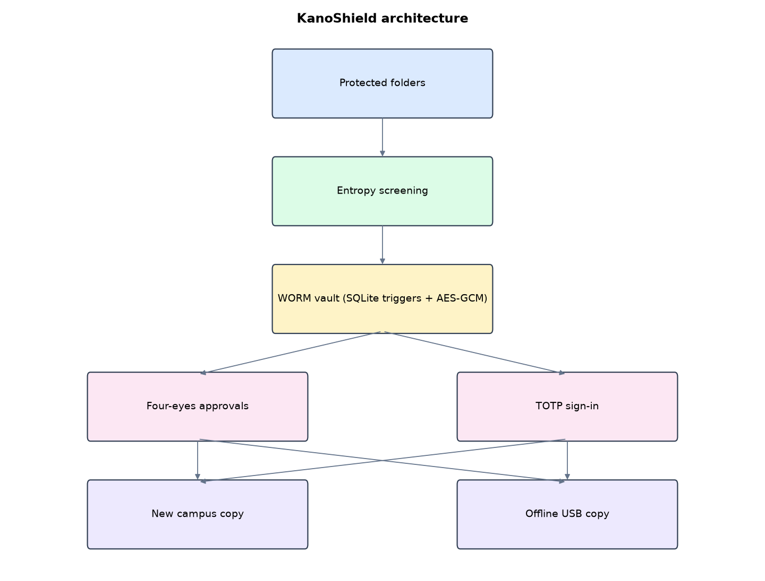
Figure 1: KanoShield architecture (data flows from top to bottom)
Table 5: Software components
File | Responsibility
shield.py | Vault and triggers, TOTP, users, approvals, verify, replicate, monitoring
app.py | Flask console and scheduler
main.py / selftest.py | Commands and tests

The main design decisions, and how they differ from the earlier VarsityShield and Zaman Lafiya projects, are:
- WORM vault in SQLite. Database triggers refuse any UPDATE of a sealed backup and any DELETE before its retention date (30 days by default).
- Four-eyes rule. Restore and early release are requests. A second, different admin must approve. Self-approval raises a critical alert.
- TOTP two-factor sign-in implemented from RFC 6238 (checked against the RFC test vector) and compatible with phone authenticator apps.
- scrypt password hashing and brute-force lock after 5 failures in 15 minutes, with an alert.
- AES-256-GCM per file with backup ID and path bound as associated data, HMAC-sealed manifests.
- Vault replication with SQLite's online backup API to a second campus and an offline USB copy.
- Entropy screening blocks a backup when three or more files look encrypted.

3.4 Security Design
Each threat considered is matched to the control that addresses it. Tests in Chapter Four exercise these controls.
Table 6: Threats and controls
Threat | Control in KanoShield
Insider deletes backups | Trigger: retention lock still active
Insider edits a backup | Trigger: write-once
Rogue admin restores old data | Needs a second, different admin
Stolen admin password | TOTP code required
Password guessing | Lock after 5 failures, critical alert
Ransomware data | Entropy screening blocks the backup

Cryptographic keys: 256-bit AES-GCM vault key; per-admin 160-bit TOTP secrets; scrypt password hashes.

3.5 Algorithms

3.5.1 WORM triggers
BEFORE UPDATE of sealed columns: abort. BEFORE DELETE when retain_until is in the future and the backup is not released: abort. Blobs: no update ever; no delete while the parent backup is locked.

3.5.2 TOTP (RFC 6238)
counter = floor(time / 30); mac = HMAC-SHA1(secret, counter); dynamic truncation gives a 6-digit code. One step of clock drift is accepted either way. Checked against the RFC test vector (T = 59 s gives 287082).

3.5.3 Four-eyes workflow
An admin files a request (restore or early release) with a reason. Any different admin can approve or reject. Self-approval is refused and raises a critical alert. Approval executes the action and logs both names.

3.6 Tools and Technologies
Language: Python 3.10 or newer. Storage: SQLite. Third-party packages: flask, cryptography, psutil. Launchers: Windows batch files (1_SETUP, 2_START, 3_DEMO_MENU, 4_SELFTEST) and run.sh for Linux and macOS.

CHAPTER FOUR: IMPLEMENTATION, TESTING AND RESULTS

4.1 Implementation Environment
The system was developed and tested with Python 3.11 on Linux and is written to run unchanged on Windows 10/11. Its web interface runs at http://127.0.0.1:5108. Setup takes about ten minutes with 1_SETUP.bat; the README in the project folder gives every step and a defence demonstration script.

4.2 Operation and Demonstration
KanoShield treats backup as a governance problem. Backups are sealed into a write-once vault that the database itself protects. Restoring over live records or releasing a retention lock early needs two different administrators. Administrators sign in with a password and a 6-digit authenticator code. The system also blocks ransomware-looking data and watches the student portal.
Table 7: Demonstration scenario used for the defence
Step | Command (python main.py ...) | What is observed
Admins need a password and a phone code. | code --user ictdirector | Sign in with ictdirector + the 6 digits
Can an angry insider delete our backups? | try-delete --id 1 | WORM: retention lock still active
Ransomware hits the registry share. | attack | Seal a backup now: BLOCKED
The ICT Director requests a restore. | (WORM vault page, Request restore) | Approvals shows 1 pending; ictdirector cannot approve it
The Deputy Registrar approves. | (sign in as deputyregistrar, Approve) | Files restored, alert names both people
Prove the vault is intact. | verify | All blobs checked, zero problems

4.3 Test Plan and Results
The automated test program ran 18 tests. 18 passed.
Table 8: Automated test results
# | Test | Result | Evidence
1 | Backup sealed into the WORM vault | PASS | {'status': 'ok', 'id': 1, 'files': 15, 'bytes': 137439, 'seconds': 0.03, 'retain_until': '2026-11-03 16:30:56'}
2 | RFC 6238 test vector (SHA-1, T=59 s) gives 287082 | PASS
3 | Admin sign-in fails without the authenticator code | PASS
4 | Admin sign-in works with password + current code | PASS
5 | Brute force locks the account even with the right password | PASS
6 | Deleting a locked backup is refused by the database trigger | PASS | WORM: retention lock still active
7 | Editing a backup blob is refused (write-once) | PASS | WORM: blobs are write-once
8 | Requester cannot approve their own request | PASS
9 | Auditor cannot approve | PASS
10 | Second admin approval releases the lock | PASS
11 | Released backup can now be deleted | PASS
12 | Quiet attack blocked (high-entropy CSV files) | PASS | {'status': 'blocked', 'high_entropy': 6, 'bad_extension': 0}
13 | Loud attack blocked | PASS | {'status': 'blocked', 'high_entropy': 15, 'bad_extension': 15}
14 | Approved restore after attack is byte-identical | PASS | RTO 0.005 s
15 | Vault replicated to offline copy with SQLite backup API | PASS | 15 blobs
16 | Vault verification clean | PASS | 15
17 | Portal outage detected | PASS
18 | Auditor cannot seal or request | PASS

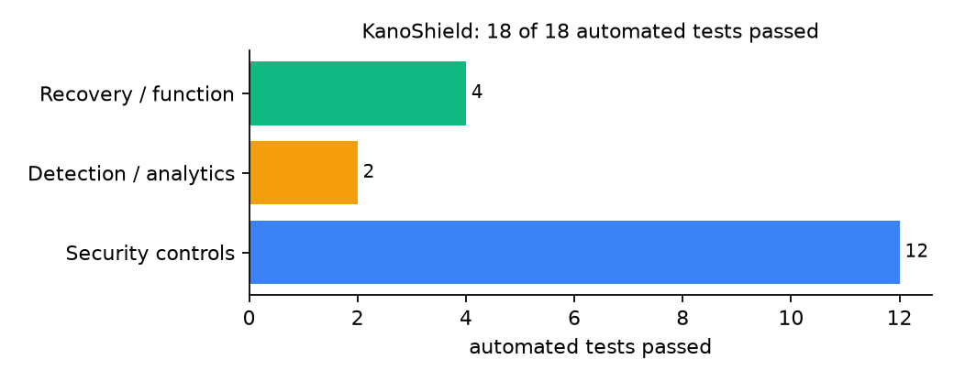
Figure 2: Automated tests by category

4.4 Measured Results
Table 9: Key measurements
Measure | Result
Protected data set | 15 files, 134.2 KiB
Sealing a backup | 0.03 s, locked until 2026-11-03 16:30:56
Approvals needed for restore | 2
Recovery time after approval | 0.005 s, byte-identical: yes
Vault verification | 15 blobs, 0 problems

4.5 Discussion
Governance controls slow recovery in human terms (a second person must approve) but not in machine terms. That delay is the point. The WORM triggers protect against the application and its users; someone with direct access to the database file could still delete the file, which is why replicas include an offline USB copy.
Of the tests, 12 exercised security controls, 2 exercised detection or analytics, and 4 exercised recovery or core function.

CHAPTER FIVE: SUMMARY, CONCLUSION AND RECOMMENDATIONS

5.1 Summary
This project built KanoShield for Bayero University Kano (BUK), Kano, Kano State. Its design combines database-enforced retention locks, dual control of restores and RFC 6238 authenticator codes. It met its objectives and passed all 18 automated tests.

5.2 Conclusion
KanoShield shows that the security problem described in Chapter One can be addressed with free software and modest hardware, provided the design treats recovery as something attackers will target. The limits stated in Section 1.4 still apply.

5.3 Recommendations
- Give the two admin roles to people in different reporting lines (for example ICT Director and Deputy Registrar).
- Keep one vault copy on a USB drive stored outside the server room.
- Remove the demo 'code' command in production.

5.4 Contribution to Knowledge
This project addresses the gap identified in Chapter Two: Reviewed backup systems treat governance as paperwork. KanoShield makes it a technical control.

5.5 Suggestions for Further Work
- Store vault copies on object storage with legal hold.
- Add a third approver for early release.

REFERENCES
Amoruso, E., Amoruso, P., & Zou, C. (2026). Integrity-gated file monitoring for ransomware resilience and real-time recovery. In 2026 International Conference on Smart Applications, Communications and Networking (SmartNets). IEEE.
Baek, S., Jung, Y., Mohaisen, D., Lee, S., & Nyang, D. (2021). SSD-assisted ransomware detection and data recovery techniques. IEEE Transactions on Computers, 70(10), 1762-1776. https://doi.org/10.1109/TC.2020.3011214
Dotasara, M., & Sharma, A. (2022). MDAS_DBRCC: Data backup and recovery technique in cloud computing for education industry. International Journal on Recent and Innovation Trends in Computing and Communication.
Farouk, S., et al. (2024). Enhancing cybersecurity in Nigeria: A proposed risk management framework for universities. In 2024 International Conference on Science, Engineering and Business for Driving Sustainable Development Goals (SEB4SDG). IEEE.
Ilau, M.-C., Baldwin, A., Caulfield, T., & Pym, D. (2025). Modelling and simulating organizational ransomware recovery: Structure, methodology, and decisions. Journal of Cybersecurity, 11(1), tyaf035. https://doi.org/10.1093/cybsec/tyaf035
Kodali, A., & Sangani. (2026). Automatic ransomware-resilient encrypted backup system using SHA-256 change detection and AES-256-GCM encryption. In 2026 3rd International Conference on Research Methodologies in Knowledge Management, Artificial Intelligence and Telecommunication Engineering (RMKMATE). IEEE.
Kumar, B., Gupta, S. K., & Dwivedi, R. (2026). Artificial intelligence driven approach for securing backup data and enhancing cyber resilience in sustainable smart infrastructure. Scientific Reports. https://doi.org/10.1038/s41598-026-37802-6
Lysetskyi, Y. M. (2025). Choosing an effective data backup and recovery strategy. Mathematical Machines and Systems.
Muthoni, S., Okeyo, G., & Chemwa, G. (2021). Infrastructure as code for business continuity in institutions of higher learning. In 2021 International Conference on Electrical, Computer and Energy Technologies (ICECET). IEEE.
Olugbile, O. H., Ojeniyi, J. A., & Anyachebelu, T. K. (2025). Towards a standard framework for cybersecurity readiness for Nigerian universities. International Journal of Applied Mathematics, Sciences, and Technology for National Defense.
Plaka, R. (2022). Backup & data recovery in cloud computing: A systematic mapping study. Ingenious.
Pragathi, B. C., et al. (2024). Implementing an effective infrastructure monitoring solution with Prometheus and Grafana. International Journal of Computer Applications, 186(38), 7-15.
Rafiq, A., Shakir, M. Z., Gray, D., Inglis, J., & Ferguson, F. (2025). AI and IoT-driven monitoring and visualisation for optimising MSP operations in multi-tenant networks: A modular approach using sensor data integration. Sensors, 25(19), 6248. https://doi.org/10.3390/s25196248
Simili, E., Stewart, G., Roy, G., Skipsey, S., & Britton, D. (2021). A hybrid system for monitoring and automated recovery at the Glasgow Tier-2 cluster. EPJ Web of Conferences, 251, 02047.
Tatineni, S. (2023). Cloud-based business continuity and disaster recovery strategies. International Research Journal of Modernization in Engineering Technology and Science.
Varshney, P. K., & Kumar, R. (2026). A governance-oriented cyber recovery framework for ransomware preparedness and resilience. EDPACS. https://doi.org/10.1080/07366981.2026.2682427
Vinisha, J., Sanjay, R., & Sundar, D. (2025). Automated disaster recovery architecture for educational institutions web infrastructure using hybrid cloud. In 2025 2nd International Conference on Artificial Intelligence and Knowledge Discovery in Concurrent Engineering (ICECONF). IEEE.

Standards and Legal Instruments Consulted
Federal Republic of Nigeria. (2023). Nigeria Data Protection Act, 2023. Nigeria Data Protection Commission.
International Organization for Standardization. (2022). ISO/IEC 27001:2022 Information security, cybersecurity and privacy protection: Information security management systems: Requirements. ISO.
National Institute of Standards and Technology. (2024). The NIST Cybersecurity Framework (CSF) 2.0 (NIST CSWP 29). NIST.

APPENDIX A: HOW TO RUN THE SYSTEM
- Copy the folder backup-recovery/A08-buk-kano-kanoshield to the computer.
- Install Python 3.10 or newer with 'Add python.exe to PATH' ticked.
- Double-click 1_SETUP.bat, then 2_START.bat, and open http://127.0.0.1:5108.
- Use 3_DEMO_MENU.bat for the defence demonstration and 4_SELFTEST.bat to regenerate the results in Chapter Four.

APPENDIX B: SOURCE CODE STRUCTURE
Table 10: KanoShield source files
File | Purpose
shield.py | Vault and triggers, TOTP, users, approvals, verify, replicate, monitoring
app.py | Flask console and scheduler
main.py / selftest.py | Commands and tests

APPENDIX C: CODE EXCERPT
The function decide from shield.py, the heart of the design described in Section 3.5.
def decide(req_id, who, approve):
with ops() as con:
r = con.execute("SELECT * FROM requests WHERE id=?", (req_id,)).fetchone()
role = con.execute("SELECT role FROM users WHERE name=?", (who,)).fetchone()
if not r or r["status"] != "pending":
return {"error": "no such pending request"}
if not role or role["role"] != "admin":
return {"error": "only an admin can decide"}
if who == r["requested_by"]:
alert("critical", f"{who} tried to approve their own {r['kind']} request")
return {"error": "four-eyes rule: the requester cannot approve"}
with ops() as con:
con.execute("UPDATE requests SET status=?, decided_by=?, decided_at=? WHERE id=?",
("approved" if approve else "rejected", who, now(), req_id))
if not approve:
return {"status": "rejected"}
if r["kind"] == "restore":
res = restore(r["backup_id"])
else: # early release of a retention lock (for example a court order or a data-subject erasure)
with vault() as v:
v.execute("UPDATE backups SET released=1 WHERE id=?", (r["backup_id"],))
res = {"released": r["backup_id"]}
alert("info", f"{r['kind']} of backup {r['backup_id']} approved by {who} (requested by {r['requested_by']})")
return {"status": "approved", "result": res}

