[NAME OF YOUR UNIVERSITY]
FACULTY OF [SCIENCE / COMPUTING]
DEPARTMENT OF COMPUTER SCIENCE
CMP 468: COMPUTER SECURITY (2 UNITS)
COURSE PROJECT REPORT
RIVERSRECOVER: CONTINUOUS DATA PROTECTION AND POINT-IN-TIME RECOVERY FOR THE UNIVERSITY OF PORT HARCOURT RESULTS DATABASE
Trigger-based change journal, hash-chained encrypted shipping, Senate locks and a database freeze switch
BY
[FULL NAME]
MATRIC NO: [MATRIC NUMBER]
SUBMITTED TO
[COURSE LECTURER'S NAME]
IN PARTIAL FULFILMENT OF THE REQUIREMENTS OF CMP 468
400 LEVEL, SECOND SEMESTER, 2025/2026 SESSION
OCTOBER 2026

DECLARATION
I declare that this project report and the accompanying software were written by me as part of the requirements of CMP 468 (Computer Security). Every source used has been cited. All literature cited in this report was published between 2021 and 2026. All test results reported in Chapter Four were produced by the automated test program supplied with the software.
Signature: ____________________ Date: ____________________

ABSTRACT
Universities in Nigeria run admissions, fees, results, learning and payroll on computers that can fail or be attacked. This project designed, built and tested RiversRecover for the University of Port Harcourt (UNIPORT), Choba, Rivers State. Its design combines trigger-based change journal, hash-chained encrypted shipping, Senate locks and a database freeze switch. The system was implemented in Python and evaluated with an automated test suite that simulates outages, quiet and loud ransomware, tampering and misuse. All 15 tests passed. Key measurements: Live database: 400 students, 787 results, 308.0 KiB; Base snapshot: up to journal row 1187, 308.0 KiB; Journal rows replayed in recovery: 13; Recovery time after ransomware: 0.051 s, exact match: yes. The design shows that a Nigerian university ICT unit can protect its records with free software on ordinary hardware.
Keywords: backup and recovery, ransomware, encryption, integrity, monitoring, RTO, Nigerian universities, NDPA 2023.

TABLE OF CONTENTS
Right-click here and choose Update Field to build the table of contents.

CHAPTER ONE: INTRODUCTION

1.1 Background of the Study
The most sensitive asset at UNIPORT is not a file share but the examination results database. Two threats dominate: insiders changing grades, and malware that destroys the database file. A nightly backup loses a day of work and says nothing about who changed what.
Ransomware changed what backup means. Older plans assumed that disks fail by accident; modern attackers encrypt production data and then go after the backups. Recovery is therefore a security function, matching the Recover function of the NIST Cybersecurity Framework 2.0 (2024). The Nigeria Data Protection Act 2023 also makes the university a data controller that must keep personal data confidential, accurate and available.

1.2 Statement of the Problem
- Nightly backups lose up to a day of results entry.
- Approved results can be edited by anyone with database access.
- Grade tampering is found long after it happens.
- There is no way to rebuild the database as it was at a precise moment.

1.3 Aim and Objectives
The aim is to design, implement and evaluate RiversRecover, a secure system for the University of Port Harcourt (UNIPORT), Choba, Rivers State. The objectives are to:
- journal every row change with database triggers;
- ship the journal every few seconds as encrypted, hash-chained segments;
- lock Senate-approved results unless an amendment window is opened;
- freeze the database automatically on mass changes;
- rebuild the database at any chosen second (point-in-time recovery);
- evaluate tamper, freeze and recovery.

1.4 Scope and Limitations
SQLite stands in for the production DBMS; the same trigger and journal approach applies to MySQL or PostgreSQL. The system was tested on one computer; the README describes deployment on other computers.

1.5 Significance of the Study
RiversRecover gives the University of Port Harcourt (UNIPORT), Choba, Rivers State a free, auditable tool that runs on ordinary hardware, and turns CMP 468 topics into working controls. Its automated test suite lets any future maintainer prove that the controls still work.

1.6 Relation to the CMP 468 Course Outline
Table 1: Mapping of CMP 468 topics to RiversRecover
CMP 468 topic | Where it appears in RiversRecover
Overview of security in computing | CIA triad: encryption (confidentiality), hashing and signatures (integrity), copies and restore (availability)
Characteristics of computer intrusion | Ransomware behaviour model: mass modification, new extensions, ransom notes, high-entropy output
Types of security breaches | Data destruction, data tampering, insider deletion of backups, unauthorised access to the console
Classes of attacks | Ransomware, brute-force login, cross-site request forgery, backup tampering
Methods of defence and controls | Preventive, detective and corrective controls listed in Table 3.2
Data security: encryption and decryption | One 256-bit AES-GCM recovery key for segments and base snapshots.
Network security | Service reachability checks, security headers, SameSite cookies
Security policies and standards | Backup and retention policy in config.json; NIST CSF 2.0 Recover; ISO/IEC 27001:2022; NDPA 2023

CHAPTER TWO: LITERATURE REVIEW
This review covers only studies published from 2021 to 2026. Every source was checked against a publisher or index page.

2.1 Conceptual Framework
The study rests on the Confidentiality, Integrity and Availability (CIA) triad. A backup that an attacker can read fails confidentiality; one that can be silently altered fails integrity; one that cannot be restored in time fails availability. Two measures turn availability into numbers: the Recovery Point Objective (how much data may be lost) and the Recovery Time Objective (how long restoration may take).

2.2 Cybersecurity in Nigerian universities
Nigerian work on university cybersecurity agrees that the weak points are after an attack starts, not only before it. Olugbile et al. (2025) used Design Science Research to build cybersecurity readiness tiers for Nigerian universities covering pre-event, event-management and post-event factors, and named inadequate funding, weak infrastructure, poor training and a shortage of professionals as the main obstacles. Farouk et al. (2024) note that Nigerian universities lack scientifically derived frameworks for managing cyber risk and propose situational crime prevention as one. Neither study builds or measures a working recovery system, which leaves room for the practical contribution of this project.

2.3 Monitoring and automated response
Open-source monitoring stacks dominate recent practice. Simili et al. (2021) combined Prometheus, Loki and Grafana at a university computing cluster and added an alerting application that performs simple recovery actions for known problems, so that staff intervene less often. Pragathi et al. (2024) deployed Prometheus, Grafana and Node Exporter on Kubernetes and reported shorter deployment time and lower operating cost. Rafiq et al. (2025) ran five Prometheus instances on Raspberry Pi edge nodes to watch about 500 network elements in five client organisations, adding machine-learning anomaly prediction and alert routing. The common lesson is that monitoring pays off when it triggers action automatically, and that small teams benefit most.

2.4 Backup strategy and disaster recovery
Lysetskyi (2025) recommends the 3-2-1-1-0 rule with an air-gapped copy, because backups that cannot be reached from the network survive ransomware. Plaka (2022) mapped 45 studies (2010-2020) on backup and disaster recovery and catalogued their causes, techniques, and privacy and security issues. Tatineni (2023) lists risk assessment, backup, duplication and failover as the core of a disaster recovery plan. Education-specific studies add cost and skills constraints. Muthoni et al. (2021) found that African universities, Kenyan ones in particular, are slow to adopt cloud business continuity, and showed with Ansible and Terraform that infrastructure as code reduced cost, effort and human error when recovering a local data centre to the cloud. Vinisha et al. (2025) gave smaller colleges with one on-premises web server an on-demand cloud standby that health checks start automatically when the main server fails. Dotasara and Sharma (2022) compress and encrypt education data before storing it in the cloud.

2.5 Ransomware-resilient recovery
Recent work moves from detection alone to guaranteed recovery. Baek et al. (2021) built ransomware detection and recovery into SSD firmware (SSD-Insider++): the drive watches I/O patterns and uses delayed deletion to restore original data, reporting 0% false rates in most cases and recovery with no data loss. The approach needs special drive firmware. Kodali and Sangani (2026) combined SHA-256 change detection with AES-256-GCM encryption in an automatic, ransomware-resilient backup tool. Amoruso et al. (2026) proposed integrity-gated file monitoring, in which changed files must pass integrity checks before they are trusted, as a route to ransomware resilience and real-time recovery. Varshney and Kumar (2026) treat fast, trustworthy restoration as a first-class security goal: behavioural detection (97.4% accuracy at a 3.1% false-positive rate), an isolated immutable vault and an automated orchestrator that finds a verified clean recovery point. Kumar et al. (2026) argue that backup integrity must be verified before restoration, and report 98.65% accuracy for their AI-assisted integrity-verification and ransomware-detection pipeline. Ilau et al. (2025) modelled ransomware recovery in a medium-sized organisation and compared recovery strategies over 9,000 parameter configurations (450,000 simulation runs).

2.6 Work Closest to This Design
Varshney and Kumar (2026) locate a verified clean recovery point; RiversRecover can choose any second as that point. Kumar et al. (2026) verify backups before restoration; RiversRecover verifies the journal hash chain. Ilau et al. (2025) show that recovery strategy changes outcomes; continuous journalling moves the recovery point objective from hours to seconds.

2.7 Summary of Reviewed Works and Research Gap
Table 2: Summary of reviewed works
Study | What it contributes
Amoruso (2026) | proposed integrity-gated file monitoring, in which changed files must pass integrity checks before they are trusted, as a route to ransomware resilience and rea
Baek (2021) | built ransomware detection and recovery into SSD firmware (SSD-Insider++): the drive watches I/O patterns and uses delayed deletion to restore original data, re
Dotasara (2022) | compress and encrypt education data before storing it in the cloud.
Farouk (2024) | note that Nigerian universities lack scientifically derived frameworks for managing cyber risk and propose situational crime prevention as one.
Ilau (2025) | modelled ransomware recovery in a medium-sized organisation and compared recovery strategies over 9,000 parameter configurations (450,000 simulation runs).
Kodali (2026) | combined SHA-256 change detection with AES-256-GCM encryption in an automatic, ransomware-resilient backup tool.
Kumar (2026) | argue that backup integrity must be verified before restoration, and report 98.65% accuracy for their AI-assisted integrity-verification and ransomware-detectio
Lysetskyi (2025) | recommends the 3-2-1-1-0 rule with an air-gapped copy, because backups that cannot be reached from the network survive ransomware.
Muthoni (2021) | found that African universities, Kenyan ones in particular, are slow to adopt cloud business continuity, and showed with Ansible and Terraform that infrastructu
Olugbile (2025) | used Design Science Research to build cybersecurity readiness tiers for Nigerian universities covering pre-event, event-management and post-event factors, and n
Plaka (2022) | mapped 45 studies (2010-2020) on backup and disaster recovery and catalogued their causes, techniques, and privacy and security issues.
Pragathi (2024) | deployed Prometheus, Grafana and Node Exporter on Kubernetes and reported shorter deployment time and lower operating cost.
Rafiq (2025) | ran five Prometheus instances on Raspberry Pi edge nodes to watch about 500 network elements in five client organisations, adding machine-learning anomaly predi
Simili (2021) | combined Prometheus, Loki and Grafana at a university computing cluster and added an alerting application that performs simple recovery actions for known proble
Tatineni (2023) | lists risk assessment, backup, duplication and failover as the core of a disaster recovery plan.
Varshney (2026) | treat fast, trustworthy restoration as a first-class security goal: behavioural detection (97.4% accuracy at a 3.1% false-positive rate), an isolated immutable
Vinisha (2025) | gave smaller colleges with one on-premises web server an on-demand cloud standby that health checks start automatically when the main server fails.

Research gap. The reviewed work protects files. Database-level protection of examination records, including tamper prevention, is not covered.

CHAPTER THREE: METHODOLOGY AND SYSTEM DESIGN

3.1 Research Methodology
The project follows Design Science Research: identify the problem, define objectives, design and build an artefact, demonstrate it, and evaluate it. Evaluation uses an automated test program (selftest.py) that resets the system, runs normal use, simulated attacks and failures, and records each outcome and measurement in results/selftest.json. Data are synthetic university records.

3.2 Requirements
Table 3: Functional requirements
# | Requirement
FR1 | Triggers journal every insert, update and delete
FR2 | Ship encrypted, chained segments every 5 s
FR3 | Senate lock on approved results
FR4 | Freeze on 40 changes per minute or 10 grade-A updates
FR5 | Point-in-time recovery to any second
FR6 | Verify store; DBA and auditor roles

Table 4: Non-functional requirements
# | Requirement
NFR1 | No downtime for base snapshots (online backup API)
NFR2 | Recovery starts a new timeline safely

3.3 System Architecture
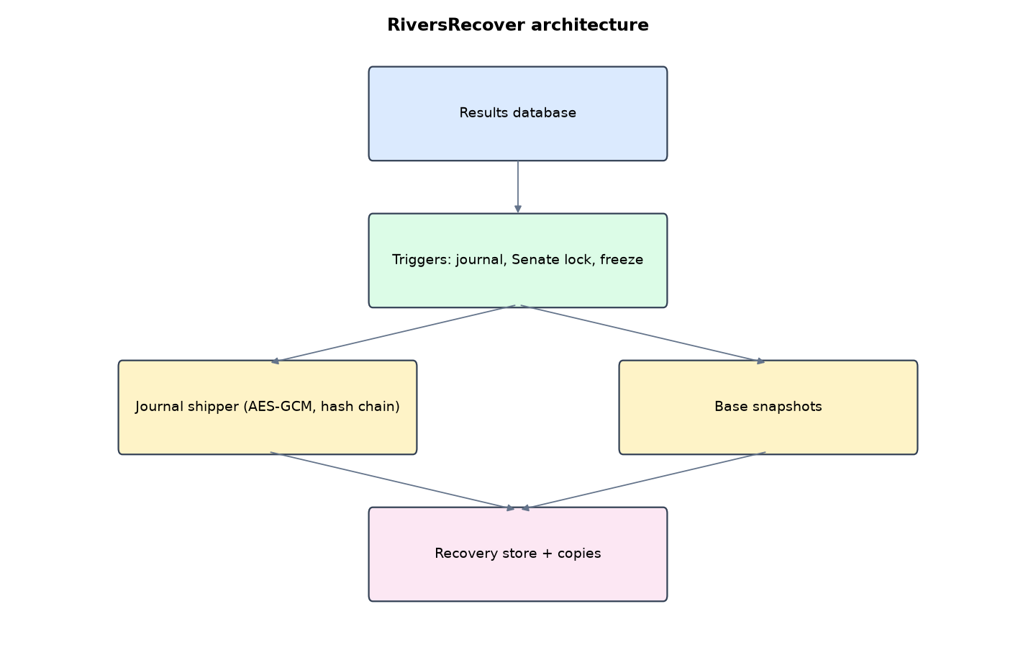
Figure 1: RiversRecover architecture (data flows from top to bottom)
Table 5: Software components
File | Responsibility
cdp.py | Schema, triggers, shipping, detection, freeze, base snapshots, verification, PITR
app.py | Flask console and shipper
main.py / selftest.py | Commands, simulations, tests

The main design decisions, and how they differ from the earlier VarsityShield and Zaman Lafiya projects, are:
- Continuous data protection. SQLite triggers write a row image of every change into a journal. Recovery point objective is the 5-second ship interval, not the last nightly backup.
- Point-in-time recovery to any second: newest encrypted base snapshot before that moment + replay of the journal. A recovery starts a new timeline, so rolled-back changes are never replayed by mistake.
- Hash-chained, encrypted journal segments (AES-256-GCM with the previous segment's SHA-256 bound as associated data).
- Senate lock. Database triggers refuse any edit or delete of an approved result unless a DBA opens a short, logged amendment window.
- Freeze switch. 40 result changes in 60 seconds, or 10 results turned into an A, freezes every table through triggers.
- Online base snapshots with SQLite's backup API (no downtime), copied to two other locations.

3.4 Security Design
Each threat considered is matched to the control that addresses it. Tests in Chapter Four exercise these controls.
Table 6: Threats and controls
Threat | Control in RiversRecover
Insider edits approved grade | Trigger refuses without amendment window
Burst of grade changes | Freeze triggers on every table
Mass delete | Refused while frozen
Database file encrypted | PITR from base + journal
Journal segment altered | Hash chain and GCM fail
Auditor runs recovery | 403

Cryptographic keys: One 256-bit AES-GCM recovery key for segments and base snapshots.

3.5 Algorithms

3.5.1 Journal and shipping
AFTER triggers append (time, table, op, key, row JSON) to a journal. Every 5 s new rows are serialised, encrypted with AES-256-GCM using the previous segment's SHA-256 as associated data, and recorded with their own hash.

3.5.2 Point-in-time recovery
Choose the newest base taken before time T; restore it; drop triggers; replay journal rows after the base up to T; recreate triggers; mark later shipped rows as an abandoned timeline so they are never replayed.

3.5.3 Freeze
Counting result updates and deletes in the last 60 s; 40 or more, or 10 updates to grade A, set control.frozen = 1; BEFORE triggers on every table then abort writes.

3.6 Tools and Technologies
Language: Python 3.10 or newer. Storage: SQLite. Third-party packages: flask, cryptography. Launchers: Windows batch files (1_SETUP, 2_START, 3_DEMO_MENU, 4_SELFTEST) and run.sh for Linux and macOS.

CHAPTER FOUR: IMPLEMENTATION, TESTING AND RESULTS

4.1 Implementation Environment
The system was developed and tested with Python 3.11 on Linux and is written to run unchanged on Windows 10/11. Its web interface runs at http://127.0.0.1:5109. Setup takes about ten minutes with 1_SETUP.bat; the README in the project folder gives every step and a defence demonstration script.

4.2 Operation and Demonstration
RiversRecover protects a live examination results database instead of a folder of files. Every insert, update and delete is captured by database triggers, shipped every 5 seconds to an encrypted recovery store, and can be replayed to rebuild the database as it was at any second. Senate-approved results cannot be edited without a logged amendment window, and a burst of grade changes freezes the whole database until a DBA investigates.
Table 7: Demonstration scenario used for the defence
Step | Command (python main.py ...) | What is observed
This is UNIPORT's live results database. | serve | Writable, row counts, changes-per-minute chart
A staff member edits a Senate-approved grade. | grade-tamper | Approved rows refused. After 33 current grades become A: FROZEN
They try to delete the evidence. | mass-delete | DATABASE FROZEN error
We roll back to 2 minutes ago. | (Point-in-time recovery page) | Pick a time before the tamper. Database rebuilt and writable
Ransomware encrypts the database file. | ransomware | Dashboard: LIVE DATABASE UNREADABLE
We recover to the last second. | recover | Rebuilt from base + journal, no shipped change lost

4.3 Test Plan and Results
The automated test program ran 15 tests. 15 passed.
Table 8: Automated test results
# | Test | Result | Evidence
1 | Base snapshot taken with the online backup API | PASS | {'base': 'base_000001187_1791131458.enc', 'upto_seq': 1187, 'bytes': 315420}
2 | Normal edits are journalled and shipped | PASS | {'rows': 6, 'segment': 'seg_000001188_000001193.enc'}
3 | Editing a Senate-approved result is refused | PASS
4 | Amendment window allows a logged edit | PASS
5 | Grade-tamper burst freezes the database | PASS | 33 results updated to grade A in one burst
6 | Approved results were never changed by the insider | PASS | {'changed': 33, 'blocked': 27}
7 | Frozen database refuses a mass delete | PASS | {'deleted': 'DATABASE FROZEN by RiversRecover: suspected attack'}
8 | Point-in-time recovery to the moment before the tamper is exact | PASS | {'target_time': '2026-10-04 16:31:02.309644', 'base': 1, 'replayed_rows': 7, 'seconds': 0.049}
9 | Recovered database is writable and triggers are back | PASS
10 | Ransomware made the live database unreadable | PASS
11 | Recovery after ransomware loses no shipped change (RPO = ship interval) | PASS | RTO 0.051 s
12 | Recovery store chain verifies | PASS | {'segments': 5, 'bases': 1, 'problems': []}
13 | Tampered journal segment detected | PASS
14 | Auditor cannot run recovery | PASS
15 | Auditor can view the journal | PASS

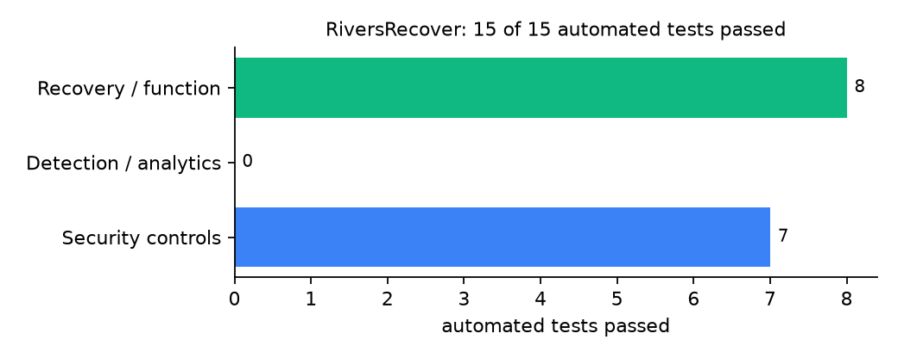
Figure 2: Automated tests by category

4.4 Measured Results
Table 9: Key measurements
Measure | Result
Live database | 400 students, 787 results, 308.0 KiB
Base snapshot | up to journal row 1187, 308.0 KiB
Journal rows replayed in recovery | 13
Recovery time after ransomware | 0.051 s, exact match: yes
Recovery point objective | last shipped journal row (ship interval 5 s)

4.5 Discussion
The first version failed one test, and the failure was instructive: after rolling back, new journal rows reused sequence numbers from the abandoned timeline, so a later recovery could have replayed tampered rows. Real database systems solve this with timelines; RiversRecover now does the same. The freeze is blunt: it stops all writes, including legitimate ones, until a DBA investigates. That suits examination periods better than silent damage.
Of the tests, 7 exercised security controls, 0 exercised detection or analytics, and 8 exercised recovery or core function.

CHAPTER FIVE: SUMMARY, CONCLUSION AND RECOMMENDATIONS

5.1 Summary
This project built RiversRecover for the University of Port Harcourt (UNIPORT), Choba, Rivers State. Its design combines trigger-based change journal, hash-chained encrypted shipping, Senate locks and a database freeze switch. It met its objectives and passed all 15 automated tests.

5.2 Conclusion
RiversRecover shows that the security problem described in Chapter One can be addressed with free software and modest hardware, provided the design treats recovery as something attackers will target. The limits stated in Section 1.4 still apply.

5.3 Recommendations
- Keep the recovery store on a different server from the database.
- Open amendment windows only after Senate minutes are signed.
- Port the triggers to the production DBMS used by the results portal.

5.4 Contribution to Knowledge
This project addresses the gap identified in Chapter Two: The reviewed work protects files. Database-level protection of examination records, including tamper prevention, is not covered.

5.5 Suggestions for Further Work
- Per-user attribution of changes through database accounts.
- Streaming the journal over TLS to a remote site.

REFERENCES
Amoruso, E., Amoruso, P., & Zou, C. (2026). Integrity-gated file monitoring for ransomware resilience and real-time recovery. In 2026 International Conference on Smart Applications, Communications and Networking (SmartNets). IEEE.
Baek, S., Jung, Y., Mohaisen, D., Lee, S., & Nyang, D. (2021). SSD-assisted ransomware detection and data recovery techniques. IEEE Transactions on Computers, 70(10), 1762-1776. https://doi.org/10.1109/TC.2020.3011214
Dotasara, M., & Sharma, A. (2022). MDAS_DBRCC: Data backup and recovery technique in cloud computing for education industry. International Journal on Recent and Innovation Trends in Computing and Communication.
Farouk, S., et al. (2024). Enhancing cybersecurity in Nigeria: A proposed risk management framework for universities. In 2024 International Conference on Science, Engineering and Business for Driving Sustainable Development Goals (SEB4SDG). IEEE.
Ilau, M.-C., Baldwin, A., Caulfield, T., & Pym, D. (2025). Modelling and simulating organizational ransomware recovery: Structure, methodology, and decisions. Journal of Cybersecurity, 11(1), tyaf035. https://doi.org/10.1093/cybsec/tyaf035
Kodali, A., & Sangani. (2026). Automatic ransomware-resilient encrypted backup system using SHA-256 change detection and AES-256-GCM encryption. In 2026 3rd International Conference on Research Methodologies in Knowledge Management, Artificial Intelligence and Telecommunication Engineering (RMKMATE). IEEE.
Kumar, B., Gupta, S. K., & Dwivedi, R. (2026). Artificial intelligence driven approach for securing backup data and enhancing cyber resilience in sustainable smart infrastructure. Scientific Reports. https://doi.org/10.1038/s41598-026-37802-6
Lysetskyi, Y. M. (2025). Choosing an effective data backup and recovery strategy. Mathematical Machines and Systems.
Muthoni, S., Okeyo, G., & Chemwa, G. (2021). Infrastructure as code for business continuity in institutions of higher learning. In 2021 International Conference on Electrical, Computer and Energy Technologies (ICECET). IEEE.
Olugbile, O. H., Ojeniyi, J. A., & Anyachebelu, T. K. (2025). Towards a standard framework for cybersecurity readiness for Nigerian universities. International Journal of Applied Mathematics, Sciences, and Technology for National Defense.
Plaka, R. (2022). Backup & data recovery in cloud computing: A systematic mapping study. Ingenious.
Pragathi, B. C., et al. (2024). Implementing an effective infrastructure monitoring solution with Prometheus and Grafana. International Journal of Computer Applications, 186(38), 7-15.
Rafiq, A., Shakir, M. Z., Gray, D., Inglis, J., & Ferguson, F. (2025). AI and IoT-driven monitoring and visualisation for optimising MSP operations in multi-tenant networks: A modular approach using sensor data integration. Sensors, 25(19), 6248. https://doi.org/10.3390/s25196248
Simili, E., Stewart, G., Roy, G., Skipsey, S., & Britton, D. (2021). A hybrid system for monitoring and automated recovery at the Glasgow Tier-2 cluster. EPJ Web of Conferences, 251, 02047.
Tatineni, S. (2023). Cloud-based business continuity and disaster recovery strategies. International Research Journal of Modernization in Engineering Technology and Science.
Varshney, P. K., & Kumar, R. (2026). A governance-oriented cyber recovery framework for ransomware preparedness and resilience. EDPACS. https://doi.org/10.1080/07366981.2026.2682427
Vinisha, J., Sanjay, R., & Sundar, D. (2025). Automated disaster recovery architecture for educational institutions web infrastructure using hybrid cloud. In 2025 2nd International Conference on Artificial Intelligence and Knowledge Discovery in Concurrent Engineering (ICECONF). IEEE.

Standards and Legal Instruments Consulted
Federal Republic of Nigeria. (2023). Nigeria Data Protection Act, 2023. Nigeria Data Protection Commission.
International Organization for Standardization. (2022). ISO/IEC 27001:2022 Information security, cybersecurity and privacy protection: Information security management systems: Requirements. ISO.
National Institute of Standards and Technology. (2024). The NIST Cybersecurity Framework (CSF) 2.0 (NIST CSWP 29). NIST.

APPENDIX A: HOW TO RUN THE SYSTEM
- Copy the folder backup-recovery/A09-uniport-riversrecover to the computer.
- Install Python 3.10 or newer with 'Add python.exe to PATH' ticked.
- Double-click 1_SETUP.bat, then 2_START.bat, and open http://127.0.0.1:5109.
- Use 3_DEMO_MENU.bat for the defence demonstration and 4_SELFTEST.bat to regenerate the results in Chapter Four.

APPENDIX B: SOURCE CODE STRUCTURE
Table 10: RiversRecover source files
File | Purpose
cdp.py | Schema, triggers, shipping, detection, freeze, base snapshots, verification, PITR
app.py | Flask console and shipper
main.py / selftest.py | Commands, simulations, tests

APPENDIX C: CODE EXCERPT
The function detect from cdp.py, the heart of the design described in Section 3.5.
def detect(rows):
c = cfg()["detector"]
cutoff = (dt.datetime.now() - dt.timedelta(seconds=c["window_seconds"])).strftime("%Y-%m-%d %H:%M:%S")
recent = [r for r in rows if r["ts"] >= cutoff and r["op"] in ("U", "D") and r["tbl"] == "results"]
grade_flips = 0
for r in recent:
if r["op"] == "U" and r["row"]:
if json.loads(r["row"]).get("grade") == "A":
grade_flips += 1
reasons = []
if len(recent) >= c["max_changes"]:
reasons.append(f"{len(recent)} result rows changed or deleted in {c['window_seconds']} s")
if grade_flips >= c["max_grade_a_updates"]:
reasons.append(f"{grade_flips} results updated to grade A in one burst")
if reasons:
freeze("; ".join(reasons))

